April 11, 2022, 9:00 AM STUDENT CONVERSATION
(Light Refreshments) Hill Auditorium-Barrows Hall
Mona Siegel has offered these essays for interested students who would like to read them before the conversation
https://www.nytimes.com/2019/11/29/opinion/mothers-paid-family-leave.html
Op-Ed: Will Disney's 'Mulan' be liberated enough? - Los Angeles Times
The legendary gender-bending warrior of ancient Chinese lore radicalized at least one 20th century revolutionary. Today's young women will want to be equally challenged and inspired.
www.latimes.com
https://www.latimes.com/opinion/story/2020-08-06/disney-mulan-soumay-tcheng-china-revolution-feminism
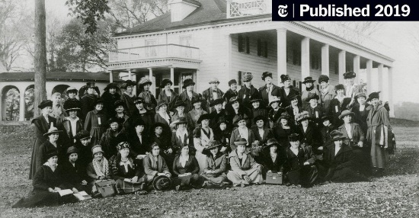 | The Forgotten Origins of Paid Family Leave - The New York Times  International Congress of Working Women, Nov. 3, 1919. First row, fourth and sixth from left: Mary Anderson and Rose Schneiderman. Second row, fifth and eighth from left: Jeanne Bouvier and Tanaka ...  www.nytimes.com
APRIL 11, 2021 2:00PM LECTURE
(Light Refreshments) Hill Auditorium-Barrows Hall
Mona Siegel has shared two readings to read before the lecture. (above)

