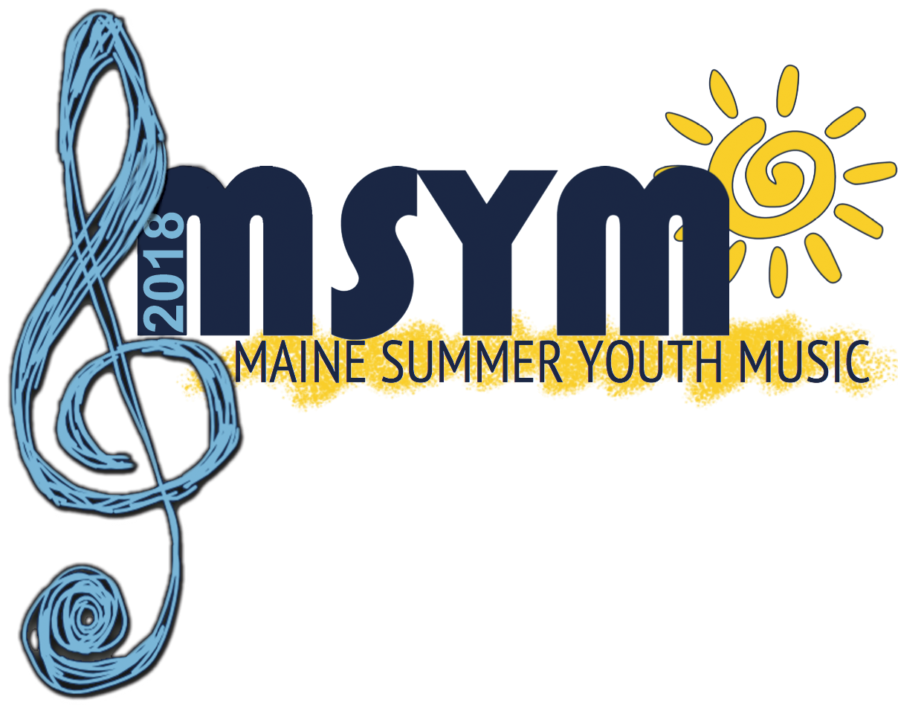



**MSYM ADMISSION APPLICATION**

**Please print this form, then complete and send to:**

Kerry Davis

University of Maine School of Performing Arts

5788 Class of 1944 Hall, Rm. 208

Orono, ME 04469-5788

Phone: (207) 581-4703  
UMAINE.EDU/SPA~facebook.com/mainemusicmsym

Junior Camp~grades 5-8*~July 8-13~Commuter $320~Resident $615

Senior Camp~grades 8*-12~July 15-20~Commuter $320~Resident $615

*8th grade students are permitted to attend both camps

(Resident Camper) Junior ____ / Senior ____

(Commuter Camper) Junior ____ / Senior ____

Optional Meal Plan for Commuter ($120.70) _________

Grade in school as of spring 2018 (circle one): 5 6 7 8 9 10 11 12

Name

Mailing Address

Email______________________________________

Birthdate______________ Male/Female

Telephone ( ) Name of School

Music Teacher

Instrument/Voice (please be specific)

Parent or Guardian Signature_______________________________

**Permission to take photo for publicity purposes**: Yes/No

**Check to request scholarship form** (DEADLINE: May 15, 2018) ____

**Please note that a NON-REFUNDABLE Registration/Deposit fee of $100.00 is required for each application to be processed. This registration/deposit fee will be credited towards the camper’s total bill.**

**FINAL PAYMENT DUE: July 1, 2018**

Please make checks or money orders payable to the University of Maine. For more information, please email: [msym@maine.edu](mailto:msym@maine.edu)