**How to Request a New Semester Accommodation Letter in Accommodate:**

# Log into [Accommodate](https://umaine-accommodate.symplicity.com/)

Using your UMS single sign on (maine.edu email and password) log into Accommodate

[How to Access Accommodate through the MyCampus Portal](https://docs.google.com/document/d/1dtC8GELAgUu2yfAa3hrFt1PmIQmzJdCaZtkgXaQ4pr8/edit?usp=sharing)

# Use the tools on the left side of the page under the **Accommodation** hotlink

## **To Request a New Semester Accommodation Letter**

* Click on the Accommodation tab on the left
* Click on the “Semester Request” subtab
* “Click Here for New Request” button.

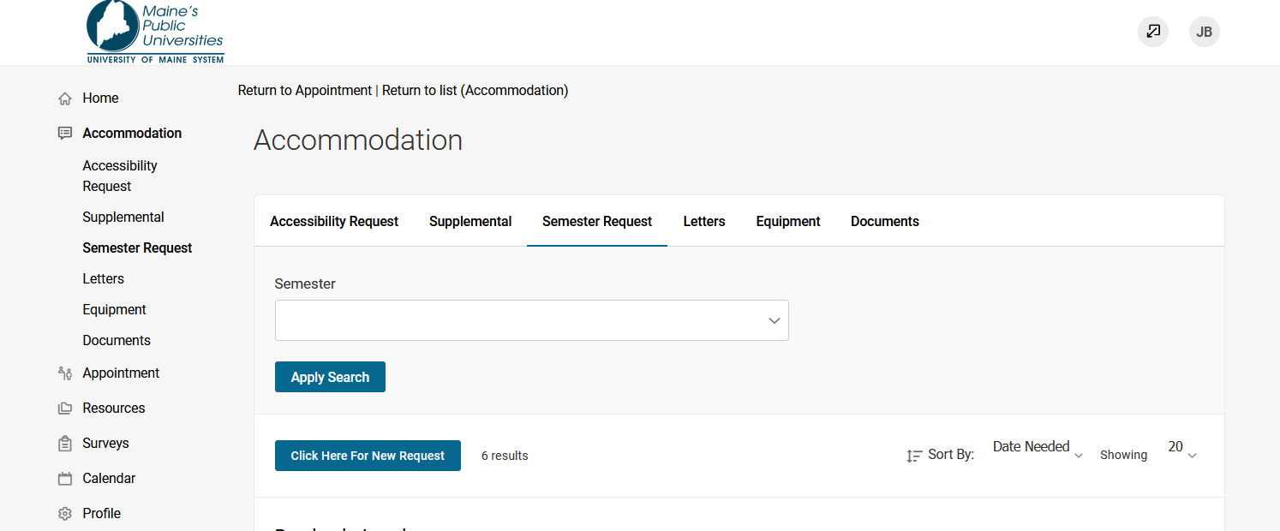

Continue onto the next page of this document

## **Begin Semester Request**

Next, select the semester from the drop down menu and click the “Begin Semester Request” button.

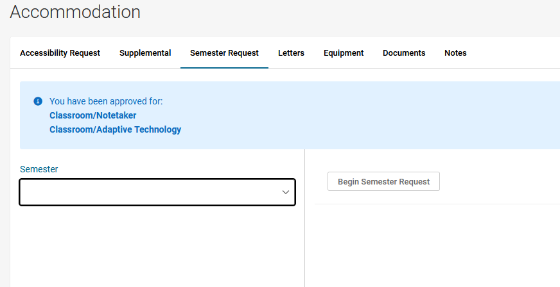

After clicking on the “Begin Semester Request” button, Accommodate will show a list of the student’s approved accommodations, which have already been attached to their semester courses.

Continue onto the next page of this document.

## **Review classes and select accommodations for each class**

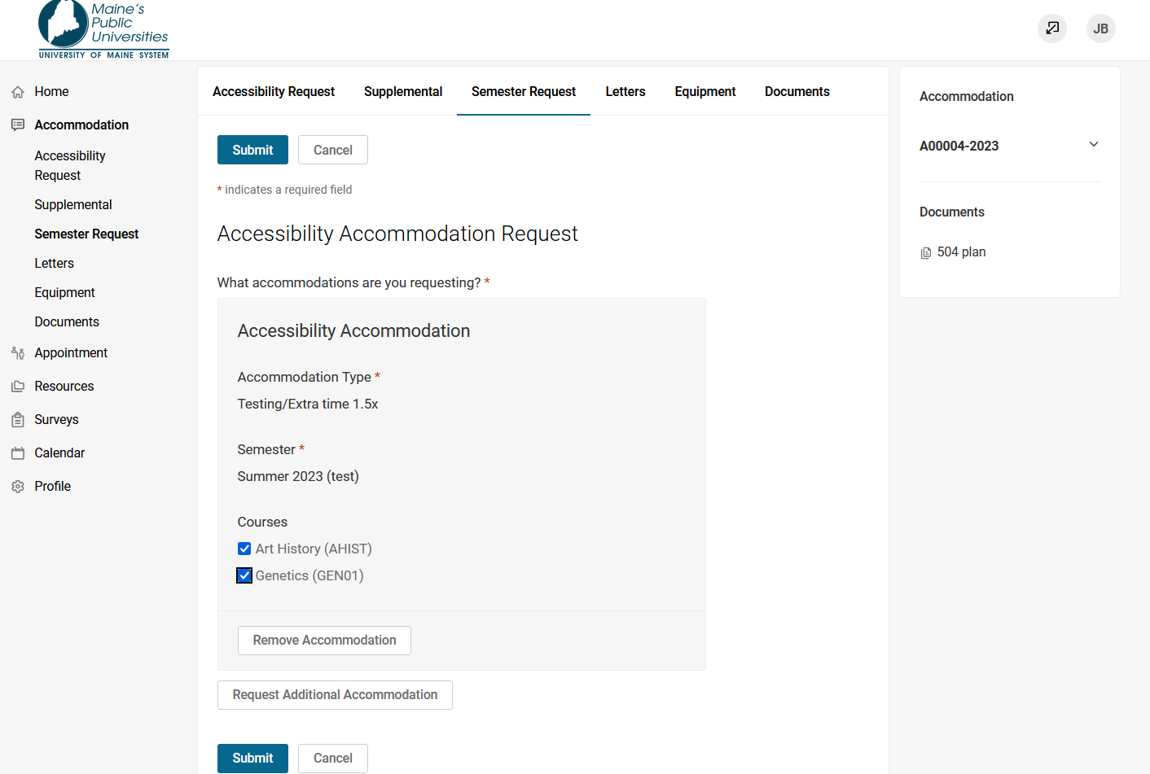

Students can review their accommodations and choose to “deselect” courses from a specific accommodation if it is not needed in that particular course. Otherwise all courses are automatically selected.

If students are not registered for courses at the time they have completed a Semester Request, no courses will show up in this function.

## **Click on the “submit” button.** image of the Semester Request page with a button labeled "submit"

Your semester request has now been submitted to your campus Accessibility Office for review. Once reviewed, an **accommodation letter will be provided to your professors via the Accommodate Platform. Students are no longer required to individually email their accommodation letters to professors.**

If students add a new course after submitting their semester request form they will need to submit an additional request to have a letter sent to the professor of the new course that was added to their schedule.

This ends the screenshot instructions about How to Request a New Semester Accommodation letter.

For instructions on how to request an appointment, click this link: [How to Request an Appointment](https://drive.google.com/u/0/open?id=1T4UpU3JQwfxgYLeP_MulACcOZ8Rl-YP_qKGxdPj_ARQ)

For instruction on how to request an additional accommodation, click this link:

[How to Request an Additional Accommodation](https://drive.google.com/u/0/open?id=164SzkpfbjQyU0UTRlUEY-DO6h8smNdsPTkDmAmkXATg)

Helpful Instructional Videos:

[Copy of Links to Student Instructional Videos](https://drive.google.com/u/0/open?id=1pS7rYHzrE33TUKMeFz6arYECFJsy_a5ciw3PULECGyI)