Requesting an Appointment:

To Schedule appointments:

# **Navigate to the “Appointments” sub tab on your Accommodate home screen.**

The “Appointments” tab located on the left side of the page will take you to the screen shown below.

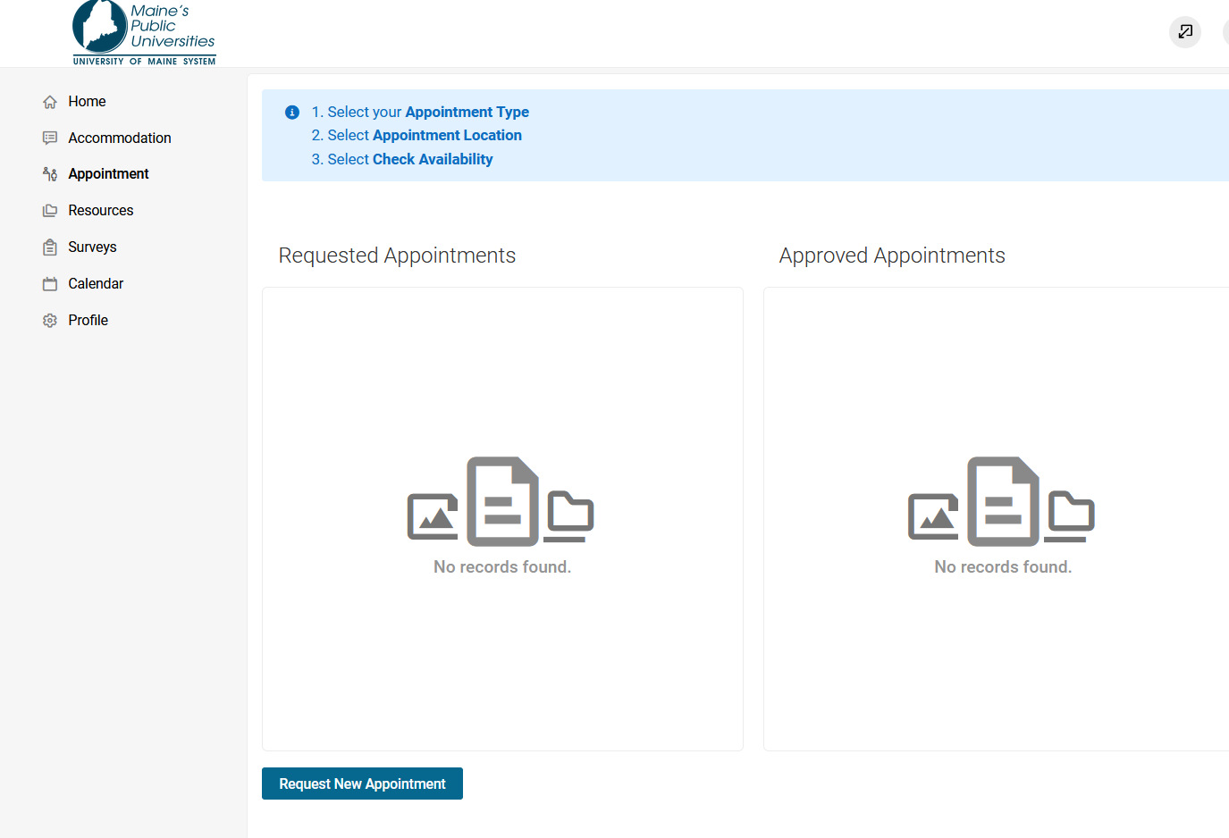

# **Click on the “Request New Appointment” button.**

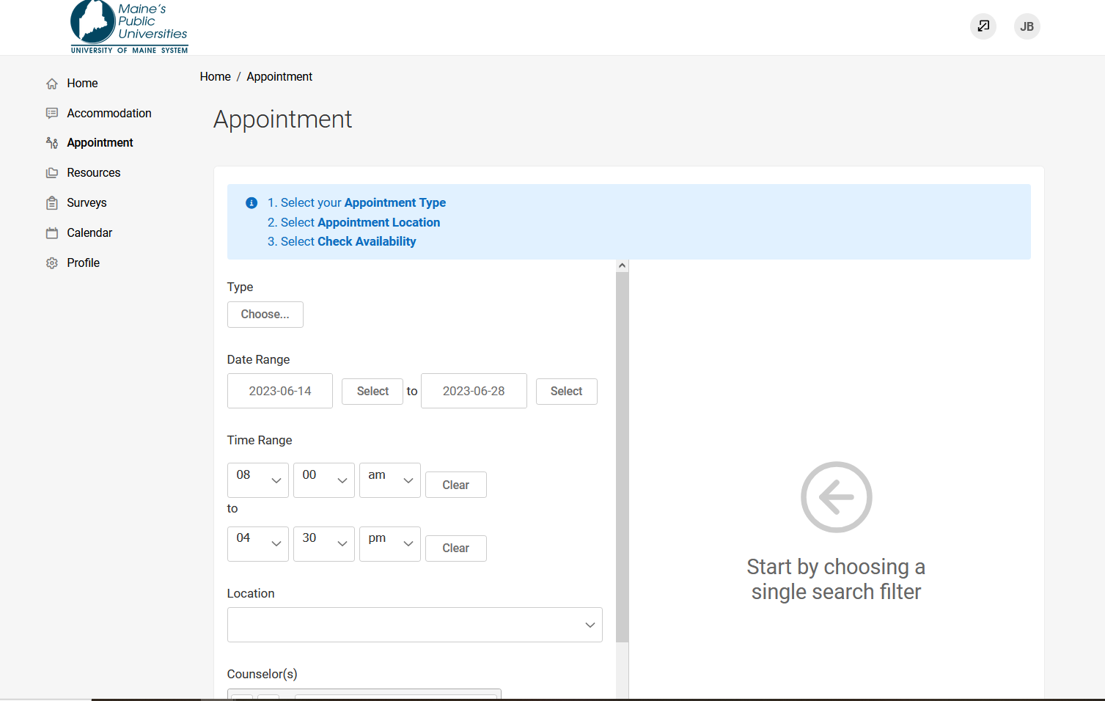

# **Choose your meeting type (General 50 or General 30)**

# **Select a date and time range.**

# **Select Campus location (your home campus)**

If available, select the name of the professional staff member you’ve worked with in the past.

# **Click on the “Check Availability” button.**

A list of available dates and time will be displayed on the right-hand side of the screen. From the list of available dates, pick one that works best for you and click on it.

# **Confirm your requested appointment date and time.**

Next a screen will pop up asking you to confirm your requested appointment date and time. You’ll have the option to add notes into the appointment request.

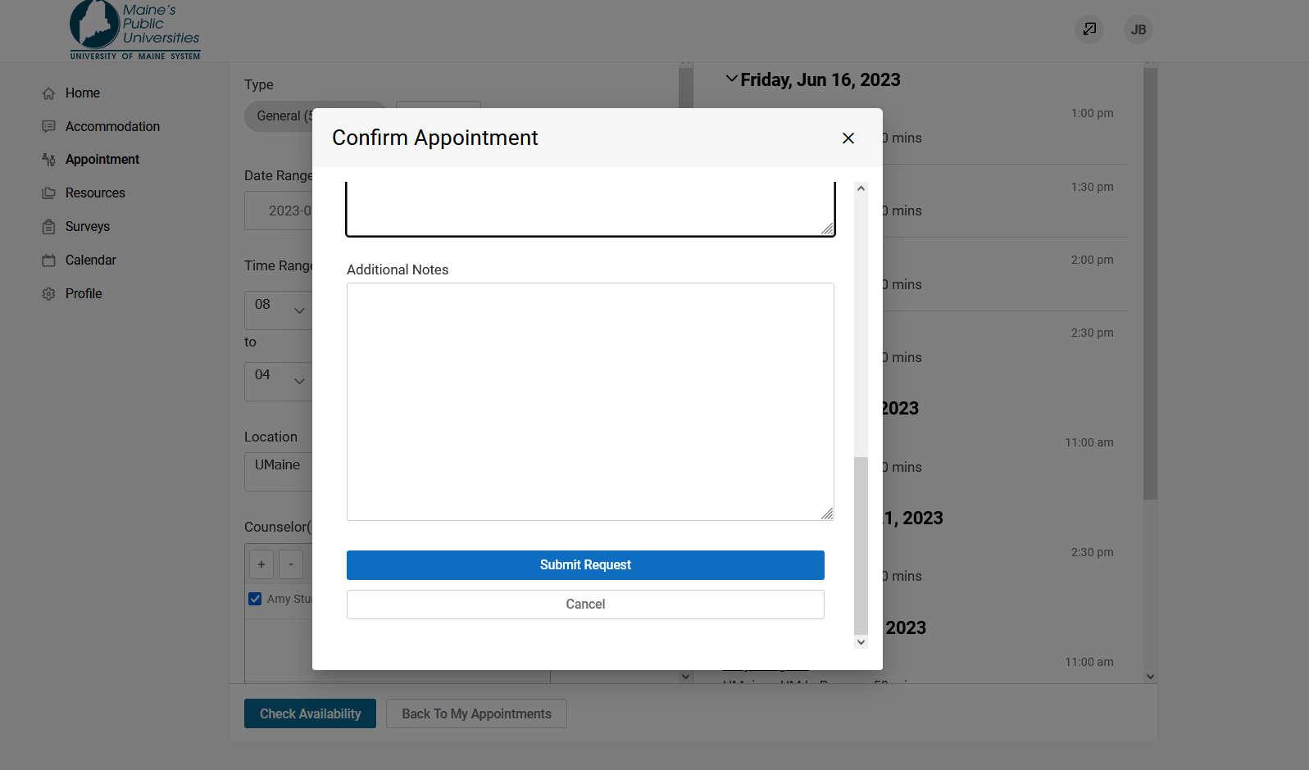

# **Click on the “Submit Request” button.**

Your request will be sent to your campus Accessibility Office.

Your campus Accessibility Office will review your requested appointment and notify you if the appointment is confirmed via email.

# **View confirmed appointments.**

You can also view confirmed appointments by clicking on the Appointments sub tab. All confirmed appointments will appear in the box on the right-hand side of the screen.



