**How to Request a Test Proctoring Appointment:**

# These instructions explain how students can request Test Room booking appointments (test proctoring) for their upcoming exams.

# Log into [Accommodate](https://umaine-accommodate.symplicity.com/)

Using your UMS single sign on (maine.edu email and password) log into Accommodate. If you are unsure about how to log on to Accommodate, please review our screenshot instructions on

[How to Access Accommodate through the MyCampus Portal](https://docs.google.com/document/d/1dtC8GELAgUu2yfAa3hrFt1PmIQmzJdCaZtkgXaQ4pr8/edit?usp=sharing).

**Click on the “Testing Room” button on the left side of the home screen.**

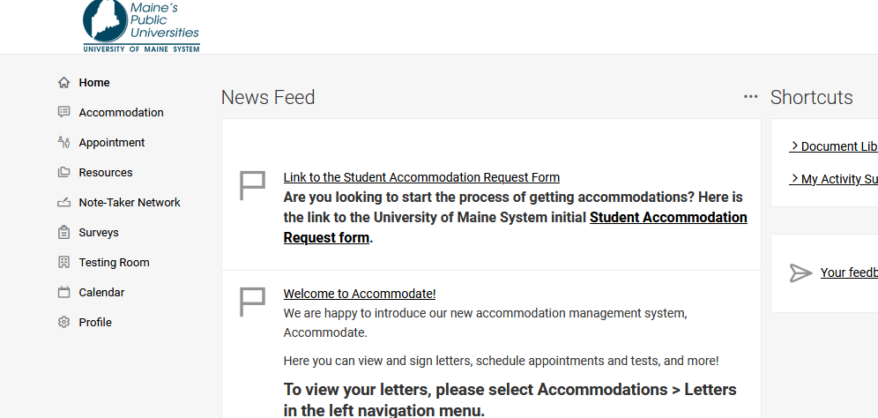

**To submit a new Test Room Booking Request, click on the “New Booking Request” button.**

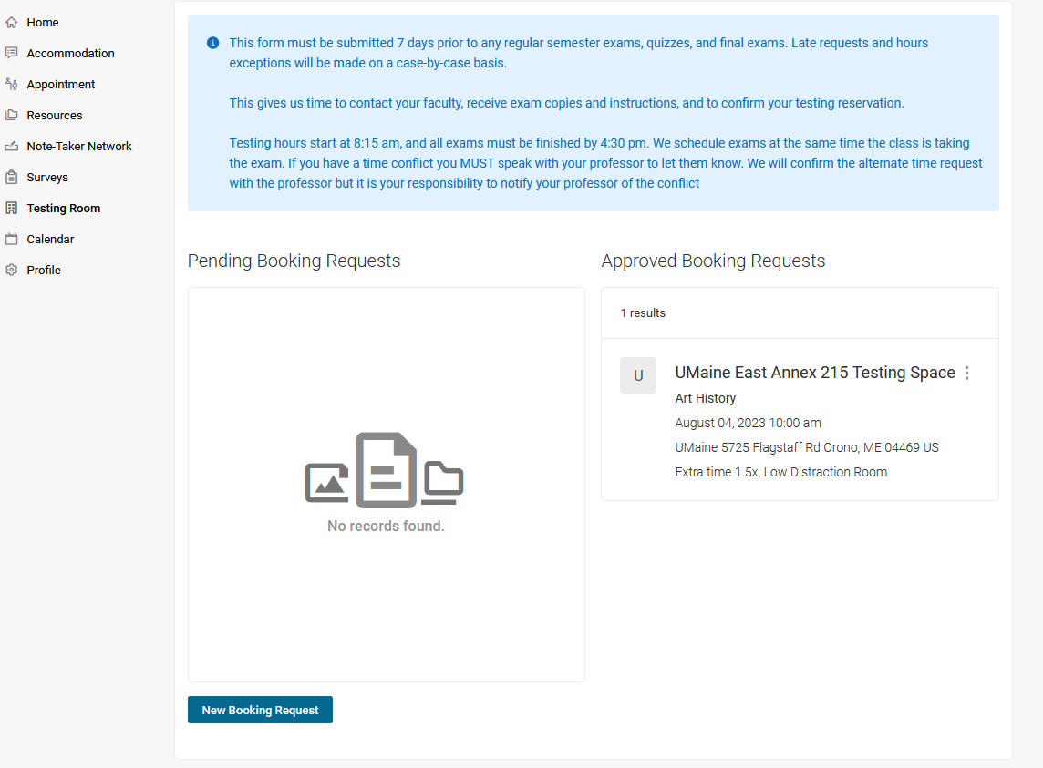

Select the correct course by clicking on the “Course” drop down bar.

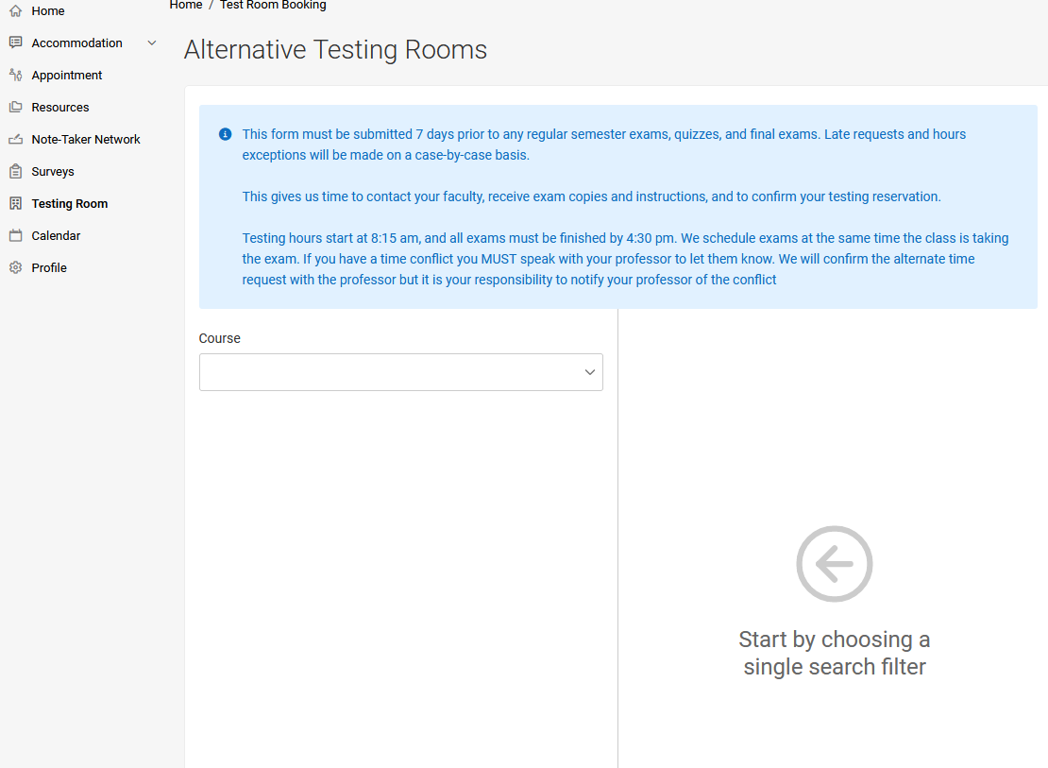

**Fill out the required information about the Exam type.**

This will include the date of the exam, time you need to take the exam, and other required information.

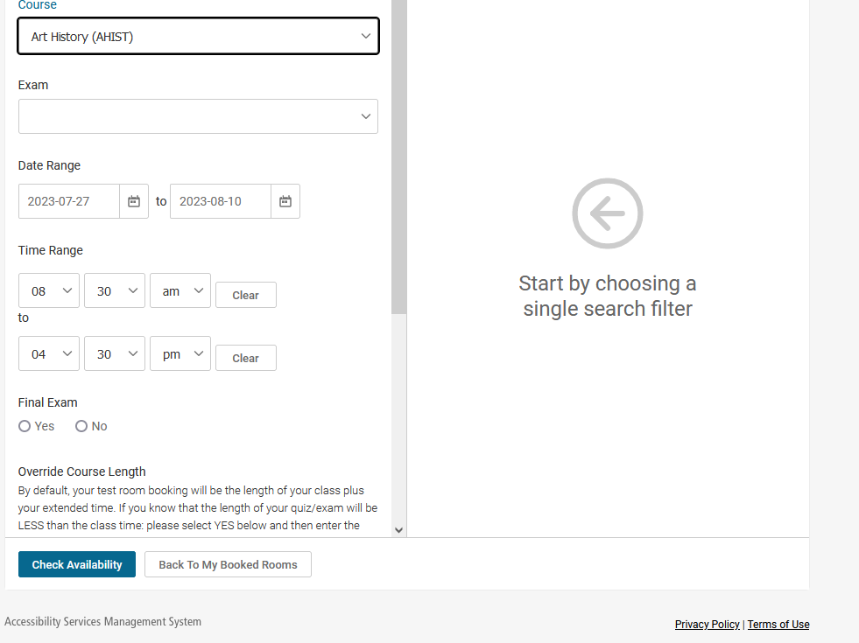

Please make sure to select “Campus”. For this purpose, “Campus” is defined as the location in which the course is being held and indicates the location where you need test proctoring services.

A list of your available accommodations should also be displayed on this screen

**Click on the “Check Availability” button.**

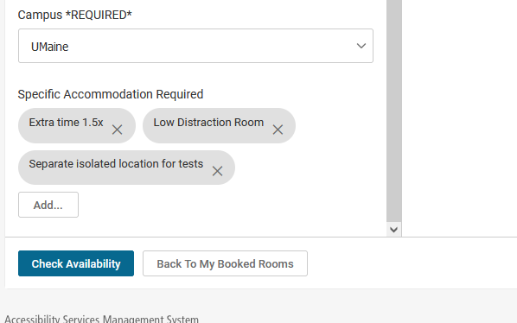

After clicking the “Check Availability” button, a list of available test appointment times will be displayed on the screen to the right of the page.

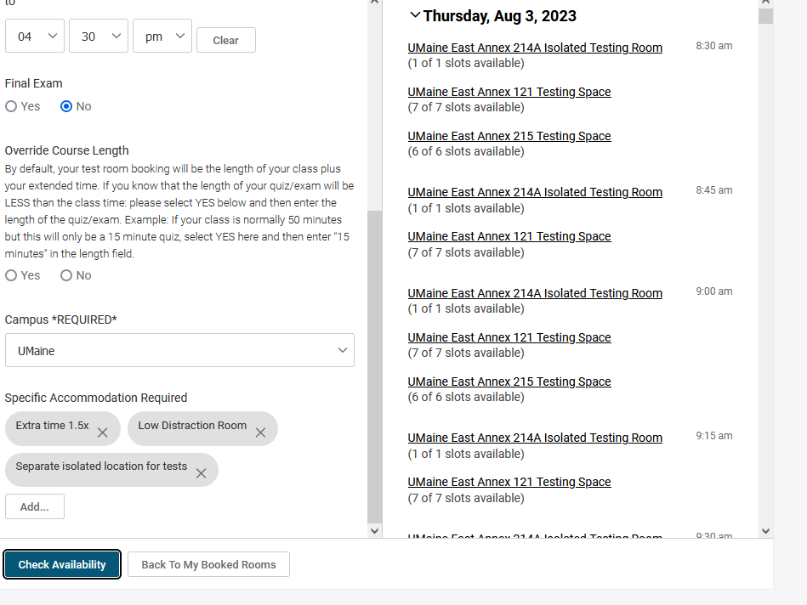

**Click on the desired date and time.**

Next, a screen will display with a “Confirm Exam Booking” title.

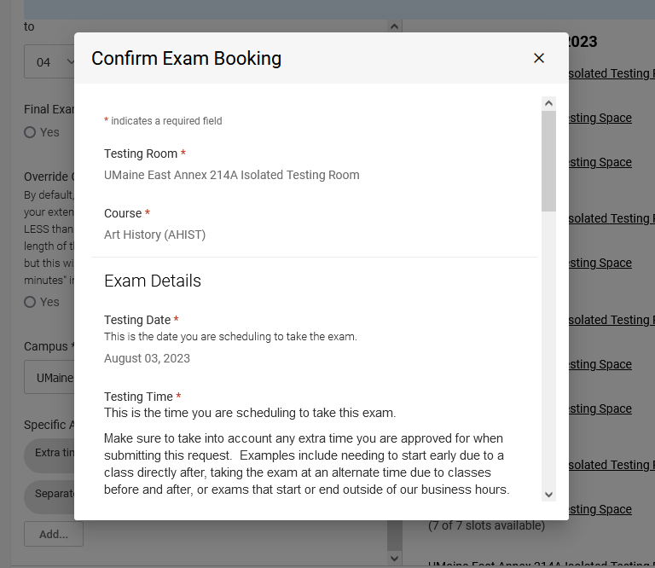

You will be required to answer additional questions on the “Confirm Exam Booking” page, including if you are requesting to take the exam at the same date and time as the rest of the class, the name of the exam, and if you have additional information to share.

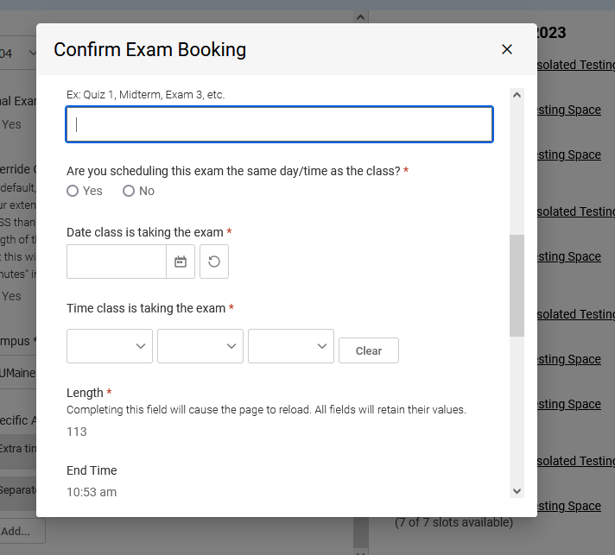

**After entering in the relevant information, click on “Submit Request.”**

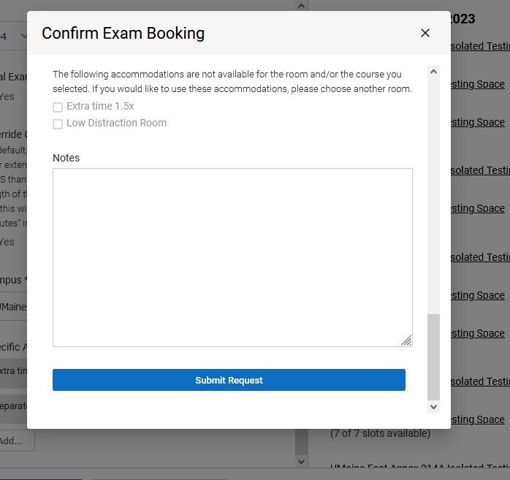

Your Campus Accessibility/Disability Services staff will review your request and approve or decline your Test Room booking appointment. Students will receive an automatic system message from Accommodate when the appointment has been scheduled or declined.