Welcome to Accommodate, the University of Maine System’s tool to help you with all of your accommodation needs.

Students who have not requested accommodations from their Accessibility/Disability office before in the past will need to complete a Student Accommodation Request form as the first step in the process. To fill out the form please go to https://umaine-accommodate.symplicity.com/public_accommodation/.

You may be asked to sign on with your UMaine Single Sign On (SSO) credentials. Once on the page it will display a form that you will need to fill out, labeled Student Accommodation Request Form.

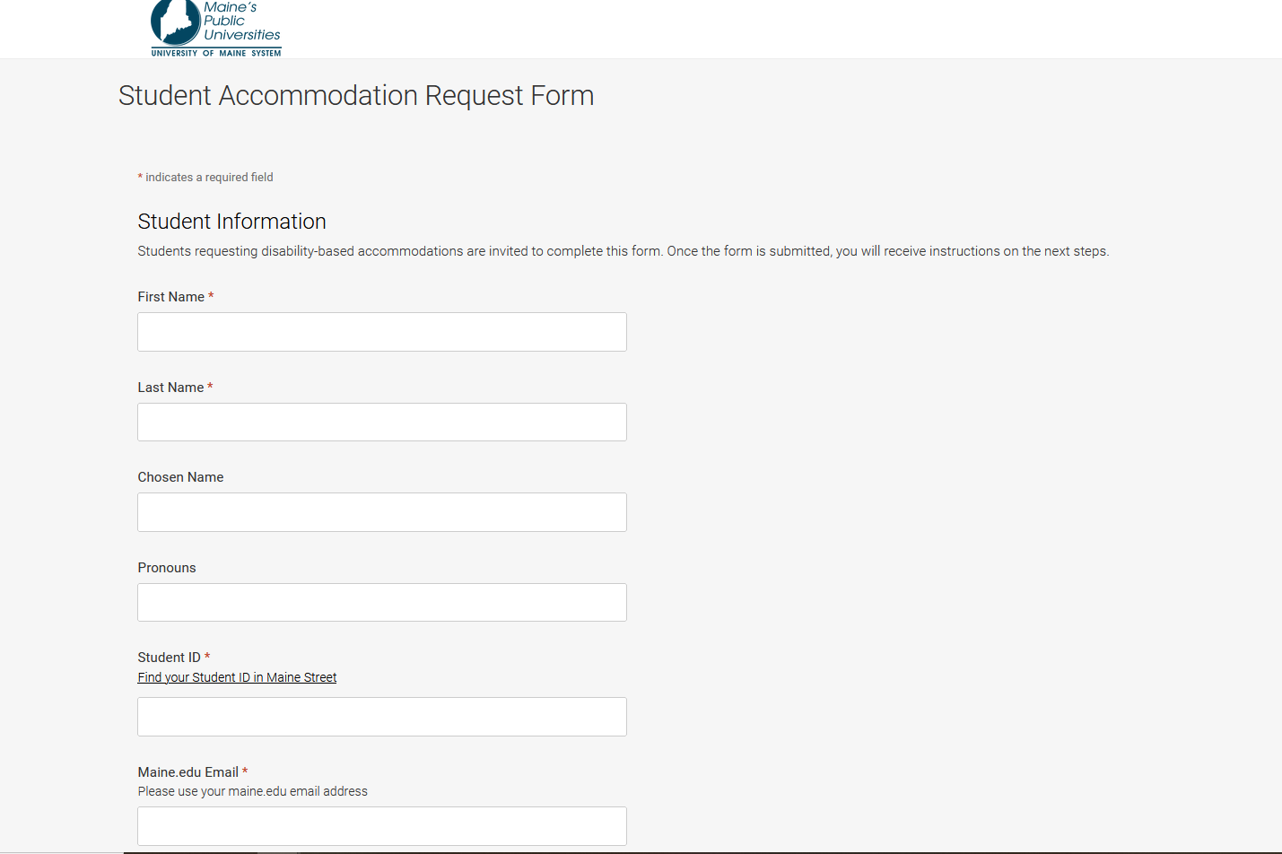

This form will ask students a series of questions about their diagnosis and symptoms.

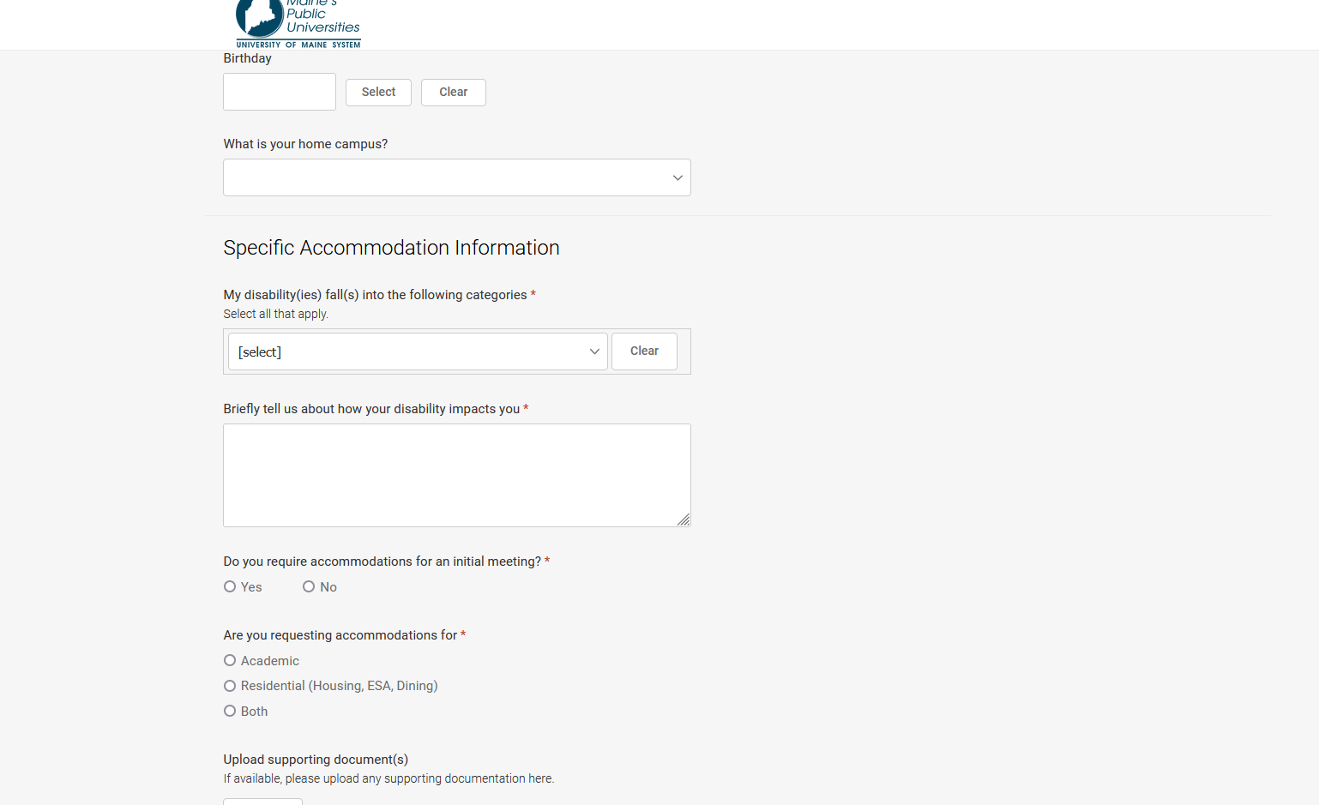

The form also gives students the opportunity to upload any documentation that they have about their diagnosis, symptoms, or previous accommodations they’ve utilized in the past. Fill out the form accordingly.

Continue onto the next page of this document
Next, please click on the box next to the “I’m not a robot” and then click on the “Submit” button.

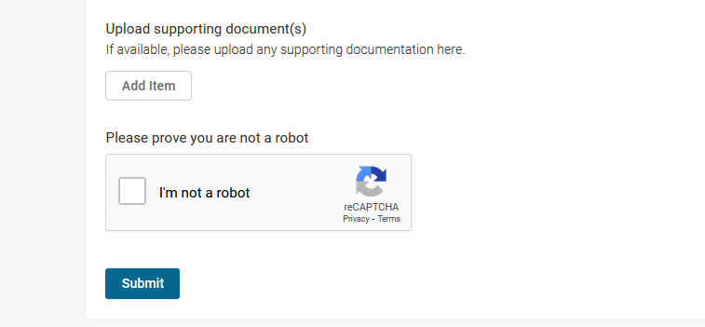

Once the Student Accommodation Request form is submitted, staff at your campus Accessibility/Disability office will be notified and you will receive instructions about next steps. Most likely, the next step will be instructing students to request an appointment from within the Accommodate platform.

For More Screenshot Instructions on how to use Accommodate, please clink on the links below:

How to Access Accommodate from the MyCampus Portal

How to Request an Appointment

How to Request a New Accommodation letter for the Semester

Helpful Instructional Videos:
Copy of Links to Student Instructional Videos

