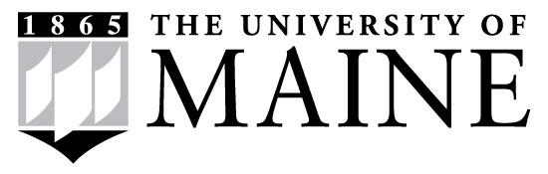
Student Employee
Dress Code Policy

As student employees, you are acting as representatives of this Office, as you come in contact with students, parents, faculty, staff, and administrators.

Staff and student workers are expected to dress in a manner that reflects a professional setting. Discretion and good judgment on the part of student employees in their style of dress and personal appearance are essential to the professional image and the safe operation of the university. Student workers are expected to dress in a professional manner appropriate to their working environment and to the type of work performed. Whatever your work setting, you must wear presentable clothing that is clean and not wrinkled. There may be additional clothing requirements depending on your specific job in regards to safety requirements.
Employees should avoid tight fitting, revealing clothing (midriffs, miniskirts, low cut necklines, etc.); skirts and dresses should be appropriate length. You are expected to dress neatly and in good taste. Each department will determine the student employee dress code based on differing student duties. Some areas may require more formal attire than others; please refer to your supervisor for more details.

As a student employee, you are expected to dress in a manner representative of the University.

I understand and agree to abide by the dress code as stated above.

____________________________________________
Employee Full Name (Printed)

____________________________________________ ___________
Employee Signature Date

