Student Employee
Break Waiver

When a student is scheduled to work for four hours or more, they are entitled to a break. The chart below details the types of breaks a student may take.
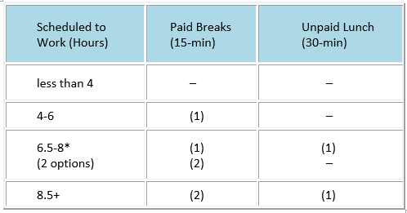
Paid breaks are 15 minutes long and are mandatory for any student employee working over 4 hours in one shift. Students working long periods of time on the computer (data entry or word processing, etc.) should take a break after every 2 hours.

*Students working 6.5–8 hours in one shift have the option to take an unpaid lunch (30 minutes). If the student and the supervisor agree, the student may take (2) paid 15-minute breaks if they opt to not take the 30-minute lunch break. If the student chooses the latter option, as an employer you must have the employee sign a break waiver form and keep it in the student’s employee file.
Students working over 8 hours must take the unpaid lunch break.
Breaks cannot be combined or “saved” to come in late or leave early.

BREAK WAIVER:
I understand, by State law, I must be given the opportunity to take at least 30 consecutive minutes of rest time after 6 consecutive hours of work. I waive the right to take a 30 minute break and instead take short breaks throughout the day/evening.

____________________________________________
Employee Full Name (Printed)

____________________________________________ ___________
Employee Signature Date

