Online Survey Research Guidance
A survey may be the best way to gather data from many participants in a short amount of time. With the use of computers and online software options there are many opportunities to disseminate surveys, but these platforms can also present challenges to the researchers when trying to protect the privacy of their participants. This guidance is to help assist researchers when writing an Institutional Review Board (IRB) application that involves the use of online surveys.

Tips for Writing an IRB Application Using Online Surveys
- If the survey is anonymous, please make sure that the platform you are using is not collecting Internet Protocol addresses (IP addresses). The UMaine IRB considers IP addresses to be an unlikely, but possible means of identifying participants. When IP addresses are being collected as part of a survey research protocol, the IRB considers these surveys to be confidential, not anonymous.
If IP addresses will be collected, but no other identifiable data will be collected, the investigator can add the following language to the Confidentiality section of the Narrative and Consent Form:
No personally identifiable information will be collected. However, network IP addresses will be processed during the survey and, while there is a very low chance that such information could be used to identify a participant, it is theoretically possible to do so.
- The researcher should clearly indicate in the application which platform is being used and who will have access to the account.
- If you are conducting an online survey, create the survey in the platform before submitting the application to the IRB. We suggest that the researcher include the link to the live survey and a copy of the online survey with the application. The link is so the IRB can confirm that the consent language is presented correctly in the online environment. At a minimum, a copy of the survey must be included with the application.
- Compensation: If the researcher will be providing compensation for an anonymous survey, the contact information to obtain the compensation must be separate from the collected data.
For example, in Qualtrics, at the end of the survey the participant can be sent to a separate survey (not connected to the survey response data) where they will enter their contact information to obtain the compensation.
- Recruitment: The application should include an explanation of how the recruitment will happen (web site posting, emailing survey link to targeted group, flyer, etc.) and all the advertisements and recruitment scripts should be included in the Appendix section of the application. You can view recruitment samples on the IRB website.
- Consent Form: The Consent Form should be the first page of the survey.
For exempt studies, the researcher should include the following statement in the Consent Form:
Participating in the survey indicates consent. Another option would be to have “I agree” or “I do not agree” button at the end of the Consent Form so the participant can indicate their choice of whether they consent to participate or not.
Researchers may want to also include the following statement in the Confidentiality section of the Consent Form:
Confidentiality will be maintained to the degree permitted by the technology used. Your participation in this online survey involves risks similar to a person’s everyday use of the Internet.
- Debriefing: If the study requires a debriefing, this should be presented after the last survey question. In the debriefing, participants should be provided with more information about the study and provided with contact information to the researchers and other relevant resources (these will depend on the study). The participant should also have the option to withdraw from the study after they have read the debriefing statement by simply being reminded that that they may choose not to submit their responses.

Examples of Common Survey Platforms

Qualtrics
- This is the preferred platform for survey research.
- Qualtrics automatically collects IP addresses. IP addresses are considered direct identifiers. If the researcher wants the survey to be anonymous the survey settings must be adjusted appropriately to anonymize responses.
  - To anonymize survey responses please do the following (and see Figure 1 below): On the Survey Tab, click on the Survey Options button. Click on Security, and make sure Anonymize Response is On.
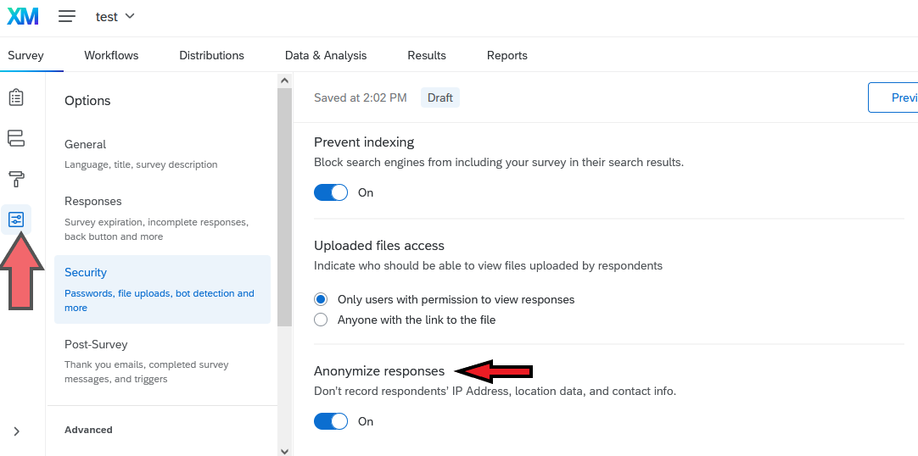
Figure 1: Screenshot of how to anonymize responses on a Qualtrics survey
- To avoid over-enrollment the researcher can set response limits in Qualtrics; this can be a useful tool to avoid non-compliance.
- Once the study is complete and data has been downloaded from Qualtrics it is best practice to delete the data from Qualtrics.
- This platform can be used for more than minimal risk studies.

Other Platforms
- REDCap: Preferred platform for survey research. This platform can be used for more than minimal risk studies.
- Survey Monkey: Platform should be used only for minimal risk studies.
- Mechanical Turk: Platform should be used only for minimal risk studies.
- Google Forms: Not recommended for human subjects research as it is not as secure as other available platforms.
It is up to the researcher to be familiar with the survey platform being used.
The investigator should be familiar with the types of information being collected by the survey tool (e.g., IP address, email address), the options the survey platform offers regarding what information will be collected (can some features be turned off) and the ways information will be stored.

References
- Loyola University: Online Survey Research
- Pacific University Oregon: Guidelines for Online Surveys and Social Media
- Reed College: FAQs: Considerations When Working With Online Survey Providers
- University of Toledo: Guidance for Online Tools for Research Activities, Data Collection and Storage (PDF)
- University of Wisconsin Madison: IRB Guidance: Qualtrics Best Practices (no longer available online)

