CITI Training Instructions
Office of Research Compliance (ORC), University of Maine
The Office of Research Compliance (ORC) delivers a variety of research training through the University of Maine System (UMS) subscription service to the Collaborative Institutional Training Initiative (CITI). These instructions guide you through the institution-specific CITI registration and enrollment processes. Further information about research compliance at the University of Maine (UMaine) and training requirements can be found on the ORC website.
Important note: You are only required to complete the training(s) for your specific area(s) of research compliance.
Contents
I. Establish a CITI Account as a New User 2
II. Log into CITI as an Existing User 3
a. Log in via UMaine Portal (Preferred Method) 3
b. Log in via CITI 3
III. Link ORCID iD (if applicable) 4
IV. Enroll in CITI Courses 4
a. New Users 4
b. Returning Users 5
V. Trainings 5
a. Animal Care 6
b. Biosafety 6
c. Conflict of Interest 7
d. Export Control 8
e. Human Subjects 8
f. Responsible Conduct of Research & Safe Research Environments 9
g. Submission 10
h. Final Reminder on Requirements 10
VI. Access CITI Records and Reports 10

Establish a CITI Account as a New User
  - Important note: if you have previously set up a CITI account, please do not create another. See Section II. Log into CITI as an Existing User of this document for guidance.
    - Note: if you already had an account set up with CITI from another institution, you can affiliate that existing account with UMaine without needing to create a new account. See how to add/change your affiliated institution on the CITI Support website.
  - Go to CITI Program website and click on the white “Register” button located in the upper right corner of the homepage (see Figure 1 below).
Figure 1: Screenshot of CITI Program Menu Bar – “Register” Button
  - Search for ‘University of Maine System’ in the section titled ‘Select your Organization Affiliation’ and click on it (see Figure 2 below).
Figure 2: Screenshot of Select Your Organization Affiliation
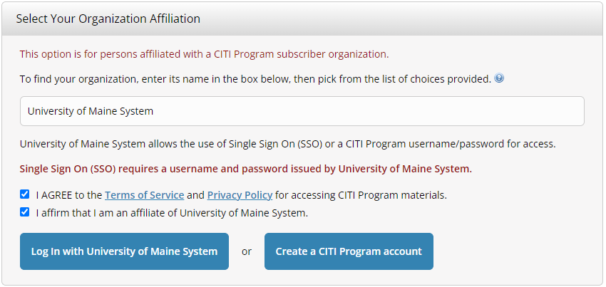
    - Click the check boxes to agree to the CITI Terms of Service and Privacy Policy, and to agree that you are an affiliate of the University of Maine System.
    - Select the appropriate option:
      - If you have a University of Maine System email address/account (@maine.edu), click “Log in with University of Maine System.”
        - Sign in to your UMaine account as you typically would to create a CITI account.
      - If you do not have a University of Maine System email address/account (@maine.edu), select “Create a CITI Program account.”
        - Complete the information on the following pages to create your account.

Log into CITI as an Existing User
To log into CITI once you have established your CITI account, you can use either the UMaine Portal or log in via CITI directly.

Log in via UMaine Portal (Preferred Method)
    - Go to the UMaine Portal and log in using your UMaine credentials.
    - Under LaunchPad, select the icon for CITI (blue rectangle with “CITI” in white letters; see Figure 3 below). You will automatically be logged into CITI.
Figure 3: Screenshot of UMaine LaunchPad – CITI Link
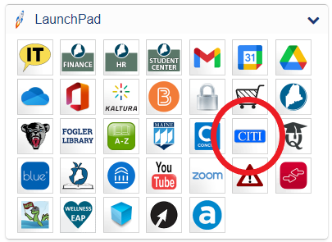

Log in via CITI
- Go to CITI Program website and click the blue “Log In” button located in the upper right corner of the homepage (see Figure 4 below).
Figure 4: Screenshot of CITI Program Menu Bar – “Log In” Button
- On the login page, click the center option labeled “Log In Through My Organization.”
- On the list of organizations that appears, click on “University of Maine System” and you will be logged in using your UMaine single sign-on (SSO).

Link ORCID iD (if applicable)
This section is optional. If you do not have an ORCiD iD, please disregard this section.
Some researchers may have an ORCID iD. According to CITI, an ORCID iD is:
“A permanent numeric identifier that individuals own and control, which provides a way to distinguish themselves uniquely from other researchers and scholars. ORCID iDs are often used in systems and platforms from grant applications to manuscript submissions, and are increasingly required by funders, publishers, data repositories, and other research workflows.”
Your ORCID iD can be directly linked to your CITI account. See Connecting your ORCID iD with CITI Program on the CITI Program Support website for instructions.

Enroll in CITI Courses

New Users
    - After you enroll, you will be brought to your “My Courses” page. Under “Institutional Courses,” click the button next to University of Maine System labeled “View Courses” (see Figure 5 below).
Figure 5: Screenshot of Institutional Courses page – "View Courses" Button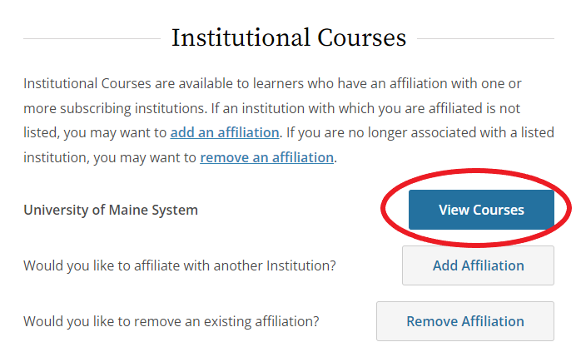

    - You will be brought to the “Select Curriculum” page. Select any desired course(s) from the list. See Section V. Required Trainings of this document for details on which specific trainings are required for each area of research.
    - Once you have made your selection(s), hit the “Submit” button at the bottom of the page (Note: you are able to sign up for additional courses later, after you have made this initial selection – see Section IV.b. Returning Users of this document for instructions).

Returning Users
- After logging into CITI as a returning user, you will be brought to the “My Courses” page. On this page, you will see a list of all courses you are currently enrolled in and have previously completed.
- To enroll in another course, scroll to the very bottom of the page to the section labeled “Learner Tools for University of Maine System.” Click the link for “Add a Course” (see Figure 6 below).
Figure 6: Screenshot of Learner Tools menu – “Add a Course” link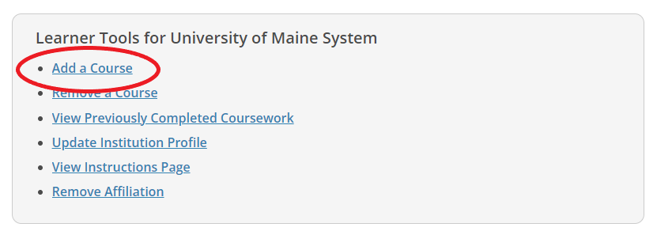
- You will be brought to the “Select Curriculum” page. Select any desired course(s) from the list. See Section V. Required Trainings of this document for details on which specific trainings are required for each area of research compliance.

Trainings
Please note: You are only required to take the training(s) for your specific area(s) of research compliance.
If you are unsure of which trainings may be required for your research, please explore the resources available on the ORC website and reach out to the ORC for additional guidance as needed.
Once you know which trainings are required for your research, find the relevant compliance area below and follow the instructions to sign up. See Section IV. Enroll in CITI Courses of this document for instructions on how to enroll as a new or existing CITI users.

Animal Care
    - Visit Animal Care on the ORC website for guidance on when and for whom this training is required.
    - To enroll, on Question 6, select the required course “Working with the IACUC” (Institutional Animal Care and Use Committee), as shown below. In addition to the required “Working with the IACUC” course, we strongly recommend you take any other listed modules that apply to your research. (See Figure 7 below).
Figure 7: Screenshot of Question 6 – Laboratory Animal Welfare course selection menu
(List continues – see the CITI Select Curriculum page for the full list of available modules.)

Biosafety
- Visit Biosafety on the ORC website for guidance on when and for whom this training is required.
- To enroll, on Question 7, select the following 4 courses (see Figure 8 below):
      - “Introduction to Biosafety”
      - “Basic Biosafety Training” (Note: after enrollment, on My Courses page, the title will appear as “Training for Investigators, Staff and Students Handling Biohazards.”)
      - “Select Agents, Biosecurity and Bioterrorism”
      - “NIH Recombinant DNA (rDNA Guidelines)”
Figure 8: Screenshot of Question 7 – Biosafety/Biosecurity course selection menu
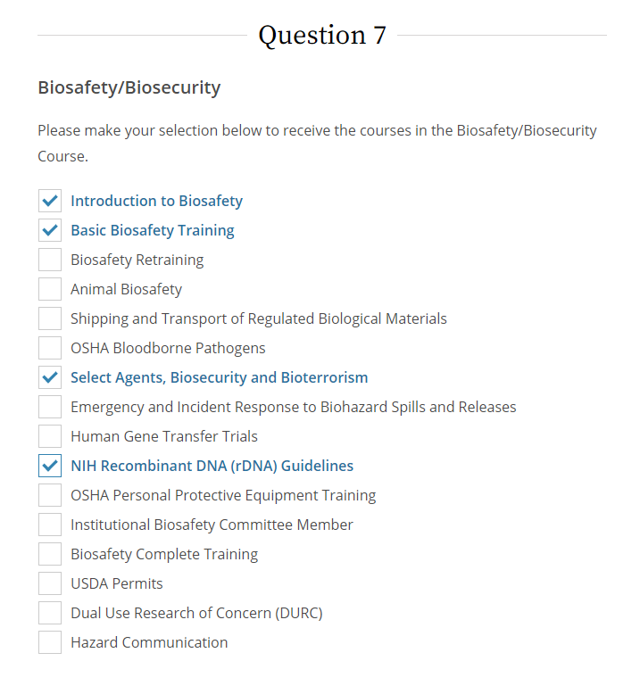

Conflict of Interest
- Visit Conflict of Interest on the ORC website for guidance on when and for whom this training is required.
- To enroll, on Question 5, select “Conflicts of Interest (All OTHER University of Maine System Campuses)” (see Figure 9 below).
Figure 9: Screenshot of Question 5 – Conflicts of Interest course selection menu
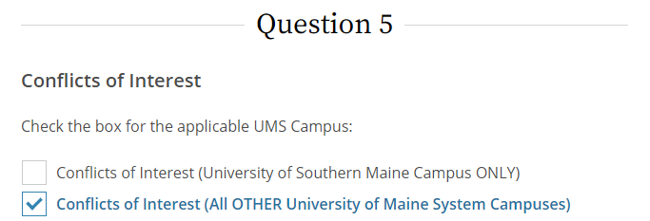

Export Control
- Visit Export Control on the ORC website for guidance on when and for whom this training is required.
- To enroll, on Question 8, select “CITI Export Controls” (see Figure 10 below). (Note: after enrollment, on the “My Courses” page, the title will appear as “CITI Export Controls Course.”)
Figure 10: Screenshot of Question 8 – CITI US Export Control Regulations course selection menu
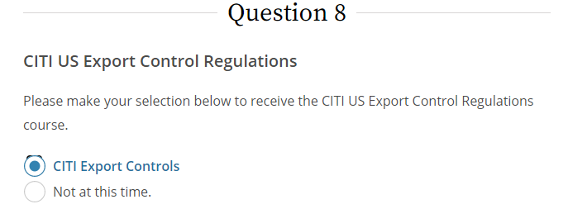

Human Subjects
- Visit Human Subjects on the ORC website for guidance on when and for whom this training is required.
- On Question 1, select one learner group based on your role and the research you will be conducting. You will be able to go back and add another learner group later, if needed. (See Figure 11 below).
- The most common selection is “Social & Behavioral Research Investigators,” shown below. (Note: after enrollment, on My Courses page, the title will appear as “Social & Behavioral Research - Basic/Refresher.”)
- The Biomedical Research Investigators course can be selected for researchers that are conducting mostly biomedical research.
Continues on next page.
Figure 11: Screenshot of Question 1 – Human Subjects Research course selection menu
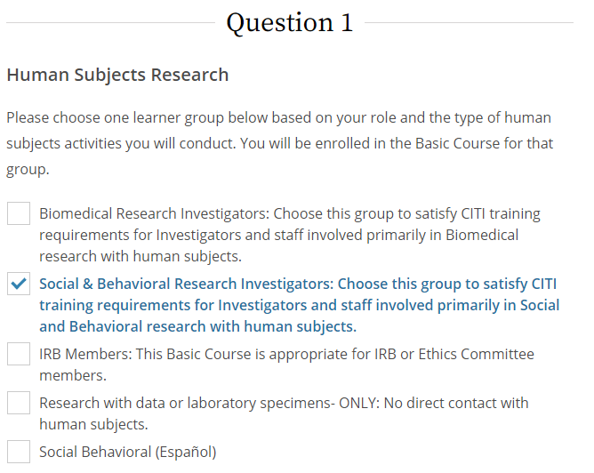

Responsible Conduct of Research & Safe Research Environments
- Visit Responsible Conduct of Research (RCR) on the ORC website for guidance on when and for whom this training is required. (Note: Not all RCR training requirements are able to be fulfilled by the RCR course on CITI.)
- On Question 4, select “General Responsible Conduct of Research Course” (see Figure 12 below). (Note: after enrollment, on My Courses page, the title will appear as “General RCR.”)
- Optional: You may also select “Safe Research Environments” as an optional training. This is not required for any researchers but may be a useful resource for researchers who must have a plan in place for safe & inclusive research for off-campus or off-site research.
Continues on next page.
Figure 12: Screenshot of Question 4 – Responsible Conduct of Research (RCR) course selection menu
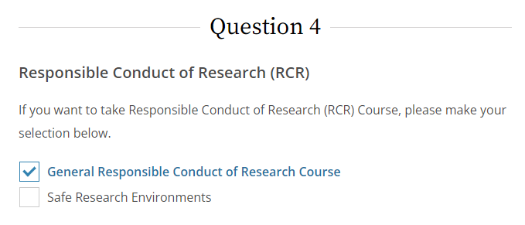

Submission
After all selections have been made, scroll to the bottom page and click the button “Submit.”

Final Reminder on Requirements
As a reminder, please note that you are only required to take the training(s) for your specific area(s) of research compliance. If you are unsure of which trainings may be required for your research, please explore the resources available on the ORC website and reach out to ORC for additional guidance as needed.

Access CITI Records and Reports
  - Users can access training records and Completion Reports through the “My Records” link in the menu bar at the top of the CITI website.
  - CITI will automatically alert ORC when you complete training, however there is a slight delay. ORC is also able to view in CITI when your training is complete. Please do not need to send copies of completion reports to ORC.
    - If you require immediate assistance (i.e., you've just completed Financial Conflicts of Interest training and need access to PARS [Proposal Approval Routing System]), please contact sponsored@maine.edu.
    - For all other CITI training inquiries, please contact umric@maine.edu.

