FERPA (Family Educational Rights and Privacy Act) Decision Tree
University of Maine Office of Research Compliance
Link to Plain Text Version of FERPA Decision Tree (Word)
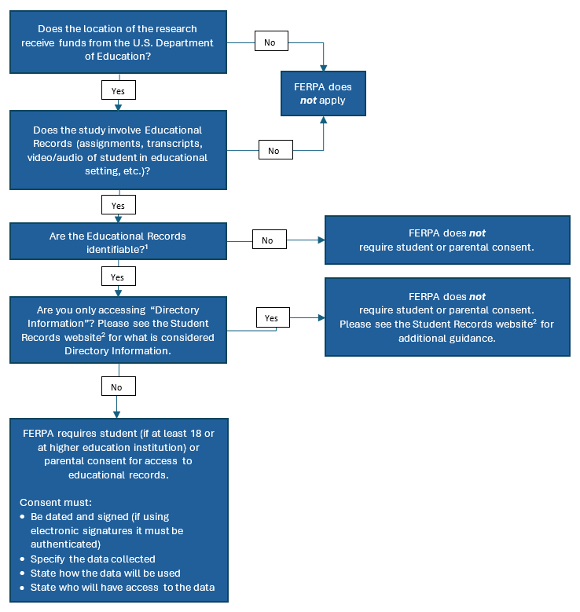
¹ Records from your own students would never be considered de-identified.
² Office of Student Records Website

