Export Control Decision Tree

Do my proposed research activities qualify as fundamental research?
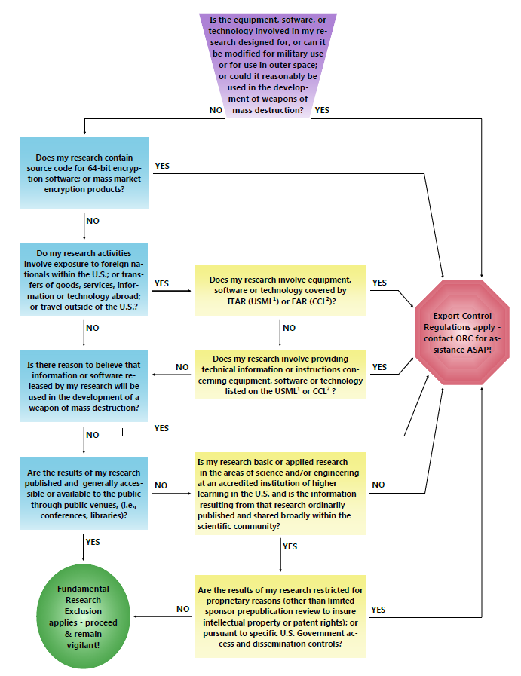
¹United States Munitions List (International Traffic in Arms Regulations (ITAR))
²Commerce Control List (Export Administration Regulations (EAR))

Plain Text Version of Export Control Decision Tree (Word)

