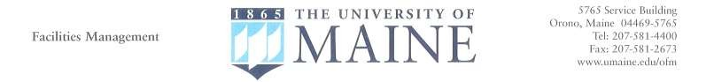

To: All University Motor pool Customers

From: Motor Pool Office

Date: July 1, 2017

Subject: Motor Pool Rates

Over the last few years the Motor Pool has faced continual increases in maintenance, operational, insurance and equipment costs yet have held rates steady since July 2009. The impact of this is affecting the ability to provide this important service. The Motor Pool understands that the University community is in very challenging economic times; however, the rate structure must be revised to meet these rising costs. Fortunately, these new rates continue to represent savings over alternative rental options while preserving the ability to provide a quality service and investment in new equipment.

Below is the new Motor Pool Rate Table effective August 1, 2017:

New Rates

Vehicle Types | Daily  Charge | Per Mile  Charge
Sedan | $36.00 | $0.13*
Sedan-Hybrid | $38.00 | $0.09*
Cargo Vans | $41.00 | $0.17*
Passenger Vans | $43.00 | $0.20*
2x4 Pickup Truck | $42.00 | $0.20*
4x4 Pickup Truck | $42.00 | $0.22*

The new rates continue to consist of two components. The Daily charge covers administrative costs such as salaries, cleaning, insurance, and investment in new equipment. *The Per Mile charge consists of a monthly fluctuating fuel charge which covers the cost for fuel and maintenance expenses.

Thank you for your understanding and we look forward to providing continued vehicle services to the University community.

