Transformational Geometry Teaching Notes

This is a set of materials built around a core of a three sets of activities where students work with the basics of transformational geometry, including visual and symbolic representations of translations, rotations, and reflections of edges, vertices, and figures. Optional additions or variations are described which allow an instructor to develop in more depth themes appropriate for a mathematics capstone course for teachers, a methods class, or a content class.

Handouts for students are in a separate PDF document: TransGeom-Worksheet.pdf

Here is a quick overview of the materials, with very approximate durations. Recommended use is to include all of the core activities (Section 1 ~ 45 minutes; Section 2 ~55 minutes; Section 3 ~50 minutes) and augment as desired with elaborations and extensions.

Overview of learning objectives 2

1.1. Translation and reflection task (core, 10-15 min) 3
1.2. Debrief/discuss the mathematics (core, 20 min) 4
1.3. Analyze student work (core, 15 min) 5
1.4. Elaboration (methods): Clinical Interview (homework plus 20 min in-class) 6

2.1. Congruence task (core, 10-15 min) 7
2.2. Debrief/discuss the mathematics (core, 20 min) 8
2.3. Examine and analyze student work (core, 15 min) 10
2.4. Describe student difficulties (core, 10 min) 10
2.5. Elaboration (methods): Tasks to investigate student thinking (15-20min) 11

3.1. Sets of transformations (core, 20 min) 12
3.2. Symmetry group on an equilateral triangle (core, 30 min) 13
3.3. Elaboration (mathematics): Apply ideas to a new shape (45 min) 14

Appendices 15

Transformational Geometry

Specific learning objectives for module:

Part 1:
1.A. Content knowledge related to basic ideas of transformational geometry
1.B. Pedagogical Content Knowledge (PCK) of student thinking about basic transformational geometry ideas
1.C. Features of geometry assessment items from Common Core State Standards in Mathematics-aligned tests

Part 2:
2.A. Content focus is ideas of congruence as they occur in transformational geometry
2.B. PCK related to student thinking about transformation constructions
2.C. The instructional practice of analyzing student work

Part 3:
3.A. Content focus related to lower division undergraduate-level mathematical ideas of sets and groups
3.B. More undergraduate content related to symmetries of a group and geometric interpretations of those properties

[Available in a future draft - Part 4:
4.A. Content focus on advanced (upper division level) ideas related to transformational geometry (in particular, connecting ideas of groups and symmetry to other topics in mathematics).]

Common Core State Standards in Mathematics (CCSSM) Connections: In addition to providing opportunities to revisit/learn basic concepts of transformational geometry, this module includes content specifically connected to the CCSSM standards for congruence (in terms of rigid motions in the plane):

CCSS.MATH.CONTENT.HSG.CO.B.6
Use geometric descriptions of rigid motions to transform figures and to predict the effect of a given rigid motion on a given figure; given two figures, use the definition of congruence in terms of rigid motions to decide if they are congruent.

CCSS.MATH.CONTENT.HSG.CO.B.7
Use the definition of congruence in terms of rigid motions to show that two triangles are congruent if and only if corresponding pairs of sides and corresponding pairs of angles are congruent.
CCSS.MATH.CONTENT.HSG.CO.B.8
Explain how the criteria for triangle congruence (ASA, SAS, and SSS) follow from the definition of congruence in terms of rigid motions.

Part 1
Part 1 is focused on content related to basic ideas of transformational geometry, PCK (knowledge of student thinking in particular) related to basic transformational geometry ideas, the instructional practice of utilizing PCK in lesson/activity planning, and features of the kinds of geometry assessment items encountered on standardized/state tests.
Section + approximate duration | Sequence of lesson sections  (i.e., “lesson plan”) | Content Commentary - on the ideas and teaching them to future teachers | Pedagogical Content Knowledge (commentary)
1.1 Work on task 1a + 1b | Participants have the opportunity to work on and discuss a relatively simple transformational geometry task. The task is taken from the set of available sample CCSSM assessment items. It is assumed that the content in the task involves ideas and/or skills that the participants may not be completely fluent with or that are completely new to the participants.  Part 1a asks participants to identify which transformations will generate a particular image.  Part 1b asks participants to carry out the transformations in the other answer choices and to describe how the resulting figures differ from the image figure that was provided.  Learning objectives 1.A and 1.C
Approximately  10-15 minutes | Participants work individually on Task 1a and 1b (based on an 8th grade assessment item).  The item is shown below and in Appendix A. It is also the first page in the handout for participants: TransGeom-Worksheet.pdf.  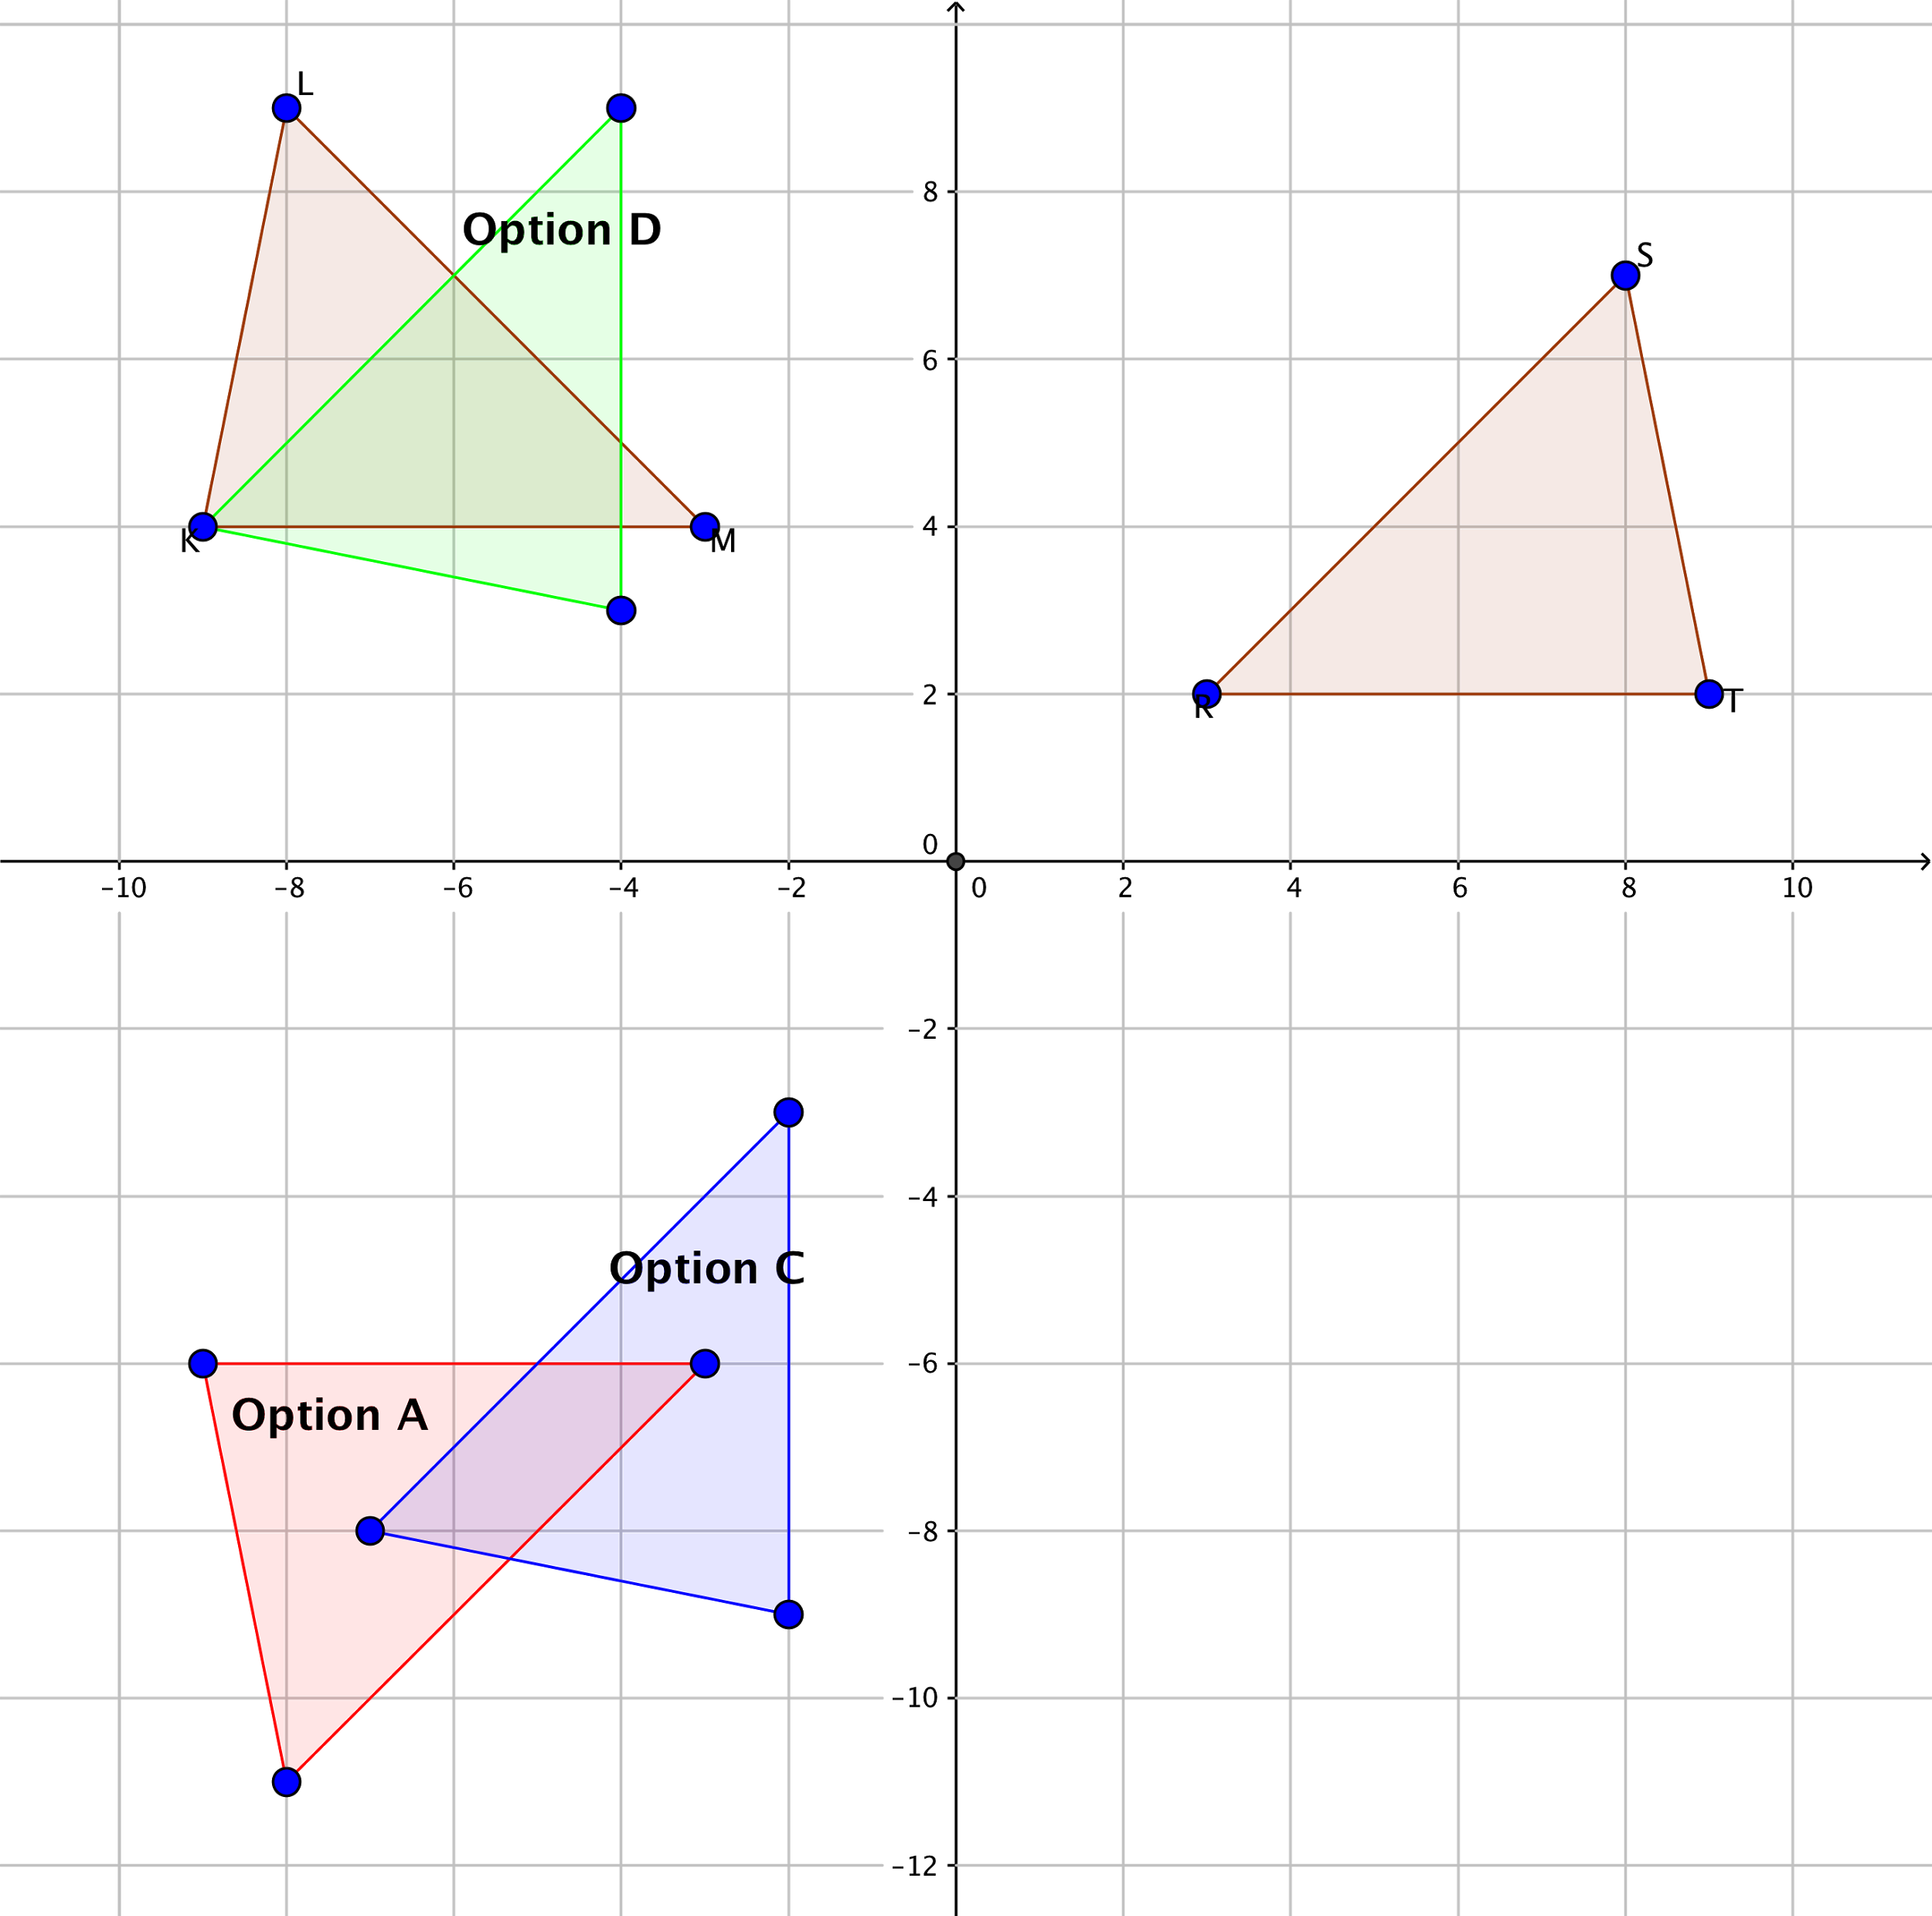  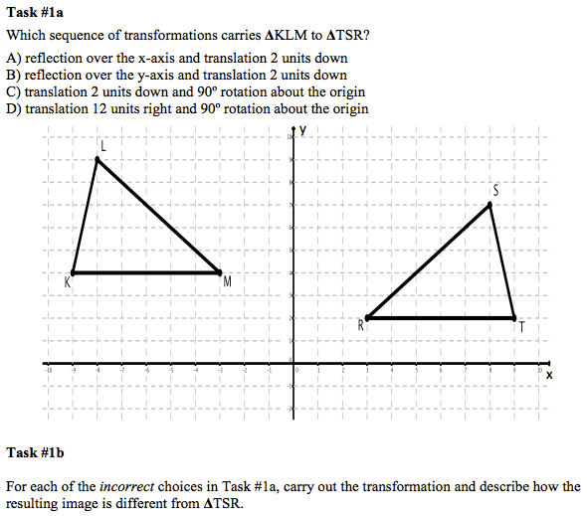  Participants discuss their solutions in pairs or small groups. | The answer is choice (B).  The results of carrying out the other answer choice transformations are shown below as well as in the Appendix. | Participants are likely to solve 1a by examining the answer choices and carrying out the transformations described in each one until they find one that works.  Participants may have difficulty with the specific definitions of reflection, translation, and rotation.  In particular, some participants may not attend to the specifics of where the line of reflection is located and rely instead on an imprecise sense of reflection where the reflection occurs across a line going through a vertex of the triangle.  Rotation is likely to be the most difficult transformation for participants to perform because of the complexity of envisioning a rotation centered at the origin. Some participants may rotate the figure around its center or around one of the vertices instead.  Successful participants may use a variety of techniques to rotate the figure correctly. These may include rotating side KM first, as it is easier to see that a horizontal line transforms to a vertical line when rotated 90° and using the concept of negative reciprocal of the slope.
1.2. Debrief about/discuss the mathematics | Participants have opportunities to become aware of the (possibly varied) ways that people think about key terms that appear in transformational geometry. Learning objectives 1.A and 1.B.
Approx. 20 minutes | Facilitate whole-class discussion about Parts 1a and 1b of the task.  Solicit approaches participants used to Part 1a of the task that were successful as well as ones they tried but then found were unproductive/incorrect.  Solicit (or provide) details about what each of the key transformational terms mean (reflection, translation and rotation) to ensure that participants have opportunities to learn (or reinforce) their understanding of these terms.  Make sure that “center of rotation” is discussed and the incorrect interpretations (rotating about the center of the figure or about one vertex) are discussed.  Solicit solutions (and strategies used) to carry out the incorrect answer choices (Part 1b). Either carry out those transformations on the board/overhead as participants describe them or have participants present.  For each transformation, ask participants to describe how the resulting image is different from the given image using appropriate transformational language. | [Additional description of how to teach participants to perform the rotation (with precision)? Is this needed or are the comments in left and right-most columns sufficient? Ask pilot users ] | Some participants may ask if it would be appropriate to use a protractor for this task.  Show the result of rotating original triangle 90° about either a vertex or its center. This may involve a discussion about identifying the center of a triangle.  For those who have difficulty performing the rotation, ask whether it is possible to tell what quadrant the image will be in, without actually performing the rotation. Have participants try to visualize the approximate location and orientation of the image as a precursor to formally carrying out the rotation.  Suggestion to instructor/facilitator: if participants have difficulty performing transformations, prior to showing a complete process with all steps, show the final image and see if participants can discover what process would bring the object to the image.
1.3. Analyze student work [Note: Interviews with students instead of written work are under development] | By examining written work from students, participants will have opportunities to develop PCK related to student thinking about transformational geometry ideas as well as understanding of key terms/ideas they need to carry out and interpret transformational geometry tasks.  Learning objective 1.B.
Approx. 15 minutes | Appendix C contains the set of student work samples and categorization.  NOTE: Do NOT distribute the categorization table to the participants. Make enough copies of the set of student work samples for each pair/group to have their own set.  Working in pairs or small groups, participants examine the set of sample student solutions.  Tell participants to assess the accuracy and completeness of the solutions and then also sort/categorize the strategies and difficulties they see in the written work.  Sample directions: “You are now going to examine sample student work. Sort the work into categories that represent different ways of thinking and/or difficulties. Once you and your group are in agreement about the categories, generate a list that describes them.” |  | 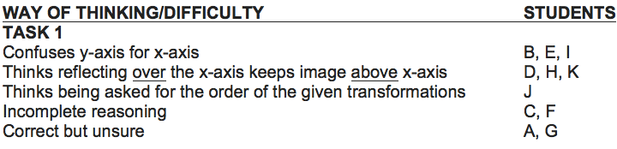  [larger version in Appendix]
1.4 Elaboration – Clinical Interview [Optional] Out-of-class assignment | [See file “Clinical_Interview_Assign_Capstone” for a detailed description of this assignment.]  Participants conduct an individual, one-on-one Clinical Interview using Task 1 or Task 2 (described in section 2.1) with a student (someone who may be familiar with the content but not someone who is apt to have complete mastery over the ideas and skills).  Participants create a reflection report that includes information about:  (a) whether (and in what ways) the students’ understanding of the common English language meanings of words such as “reflection,” “rotation,” etc. played in their understanding of and work on the task;  (b) descriptions of the ways of thinking (both productive and unproductive) the student displayed while working on the task;  (c) strategies and difficulties the student demonstrated while doing the actual drawing/constructing of the figure.  If this assignment is used, the teachers can report out about the difficulties they observed in their interview and add those to the list generated in Part 1.3 above or to Part 2.3 below.

Part 2
Part 2 is focused on content related to ideas of congruence as they occur in transformational geometry, PCK related to student thinking about transformation constructions, and, the instructional practice of analyzing student work from CCSSM geometry items.
Section + duration | Sequence of lesson sections | CCK (commentary) | PCK (commentary)
2.1. Work on the task | Working on this task provides participants with the opportunity to think about and discuss a transformational geometry construction task (which, for some, may be more challenging that the previous inspection task). The task is taken from the set of available sample CCSSM assessment items. It is assumed that the content in the task involves ideas and/or skills that the teachers may not be completely fluent with or that are completely new to the teachers. Learning objective 2.A
Approx. 10-15 minutes | Participants work individually on Task 2, an 8th grade assessment item  (see below and Appendix D).  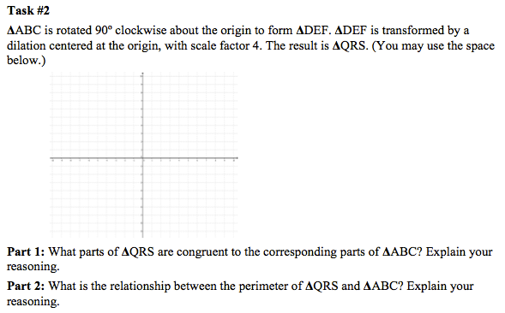  Working in pairs or small groups, participants discuss their own solutions to the task.  Challenge question: Ask participants to consider what happens to the area of the triangle when the transformations are performed. | The resulting image is shown below and in Appendix E.  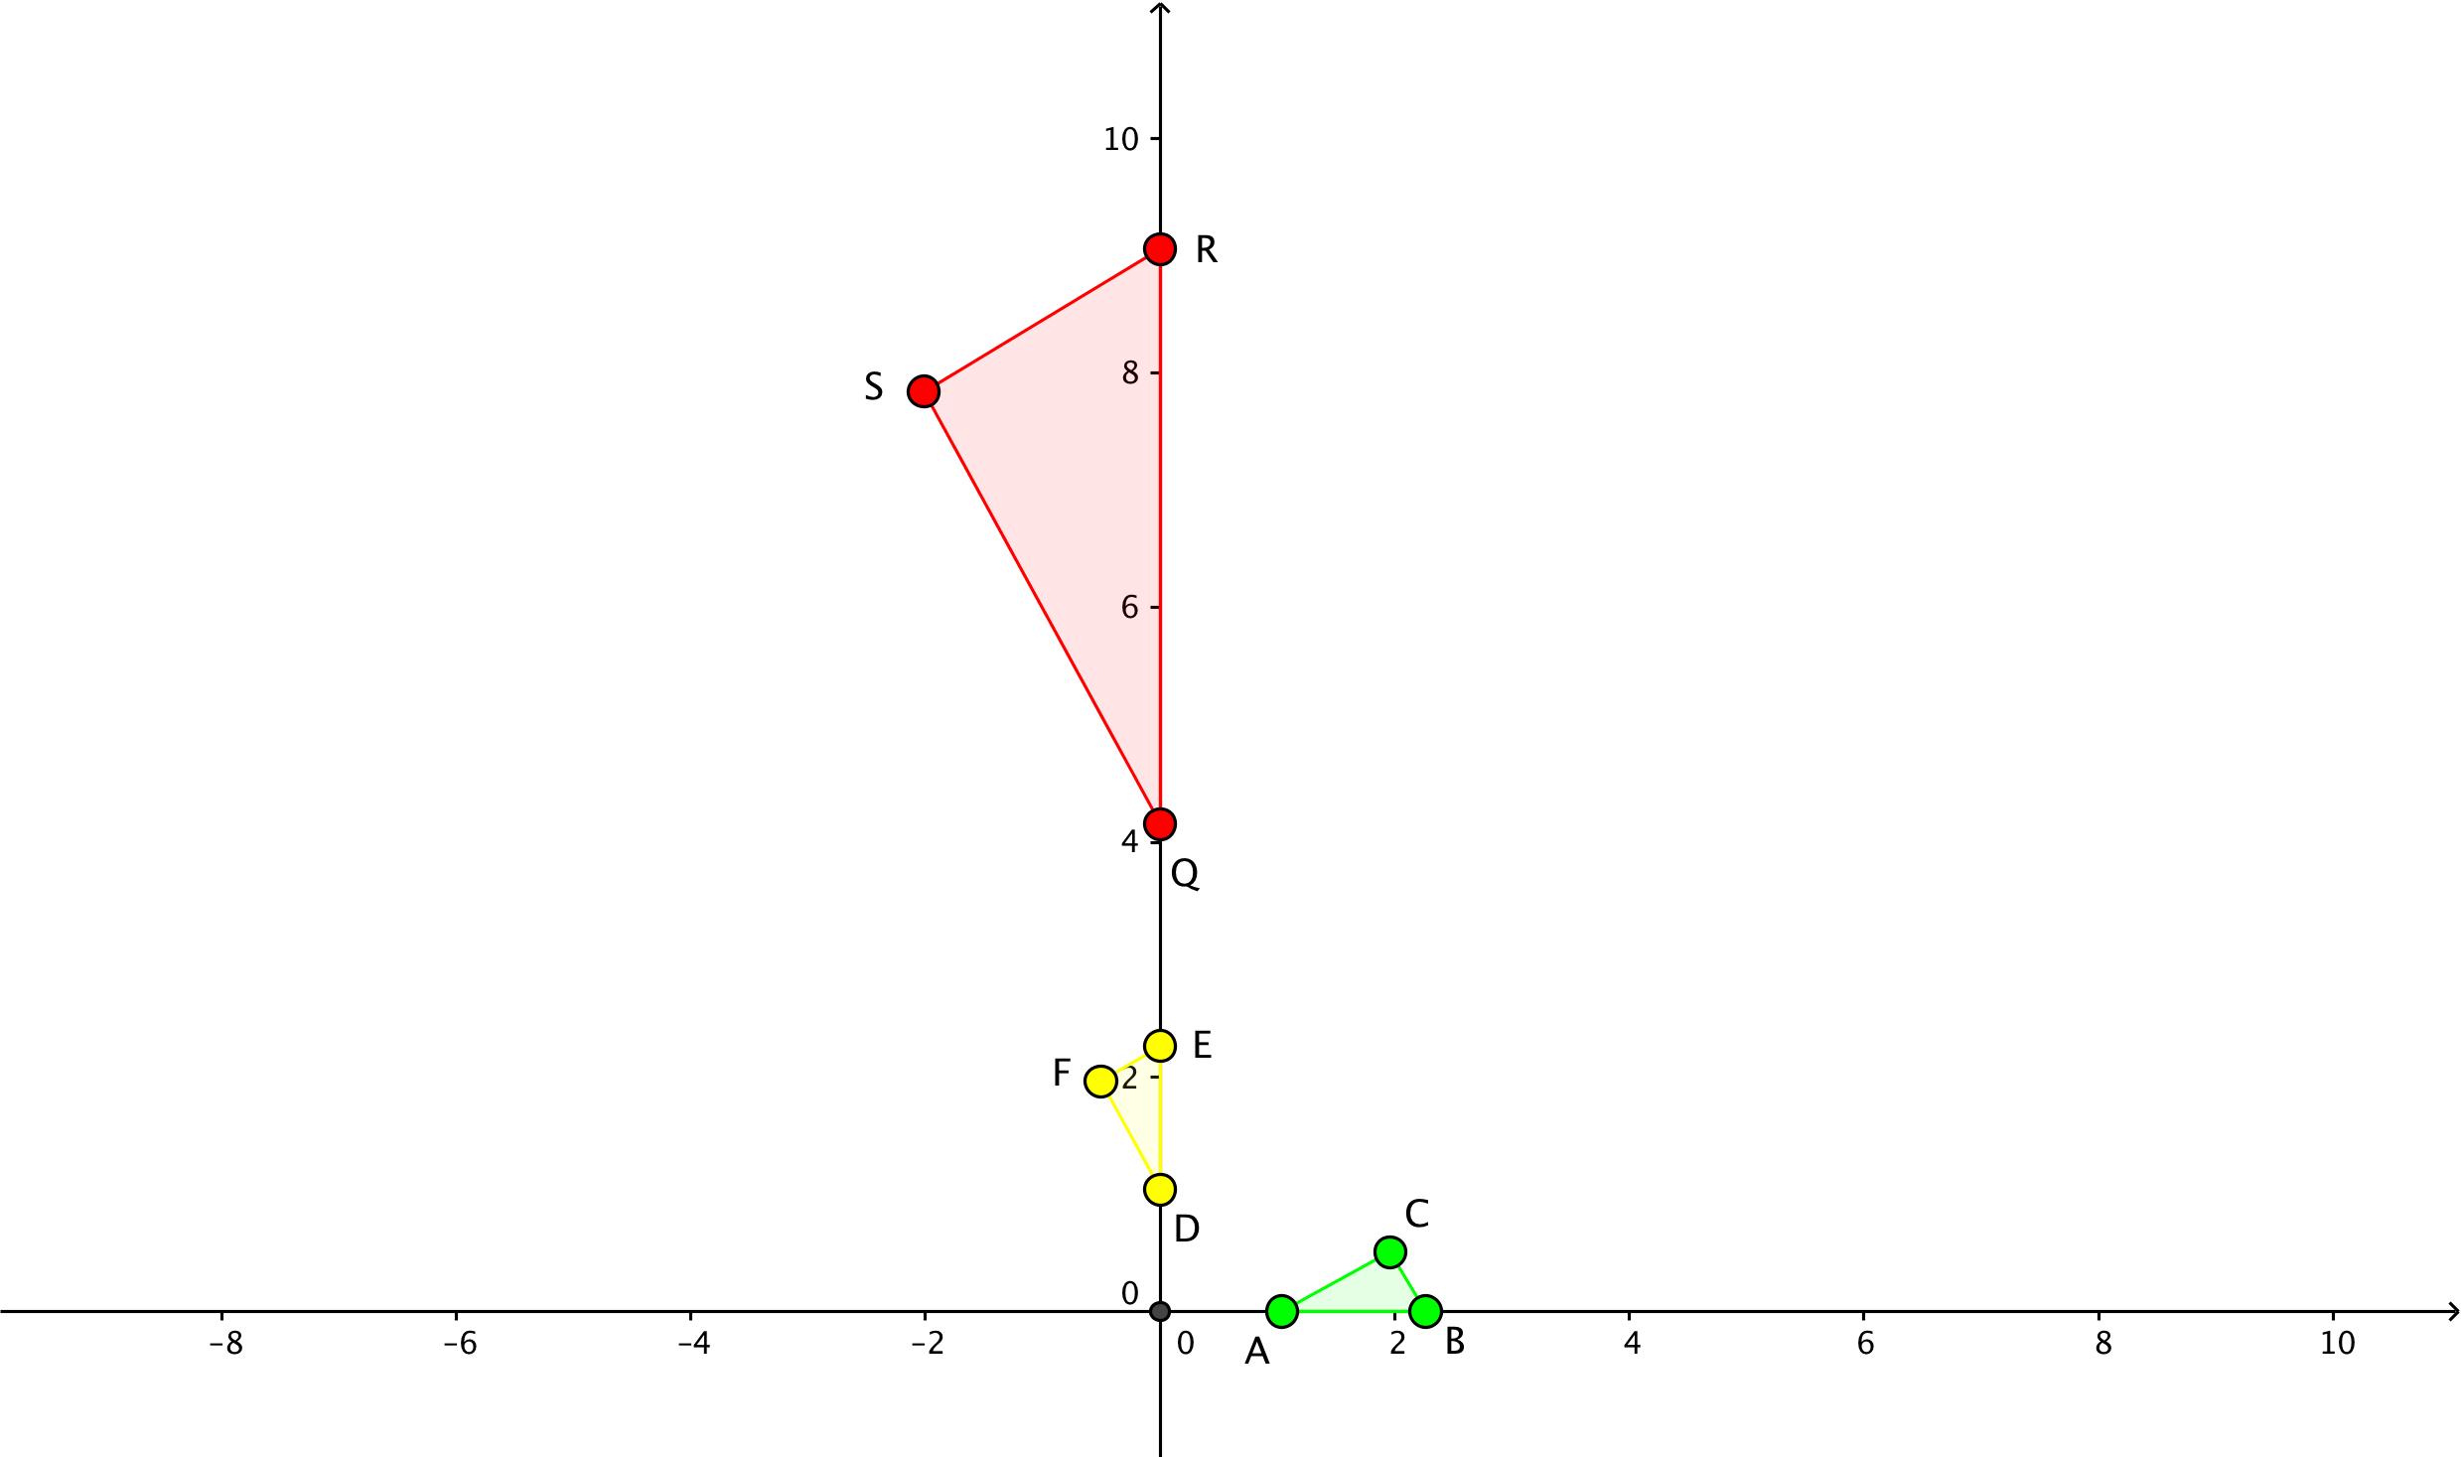  The angles are congruent.  The perimeter of the resulting triangle is four times that of the original triangle. | For the construction: Although a grid is provided, it is possible to answer both parts without actually constructing and transforming the triangle and its image.  Learners may not have a robust understanding of what rotate “about the origin” means. Common incorrect solutions include rotating the triangle about its center or rotating it about a vertex. Note that answering the questions about congruence and perimeter correctly is independent of accurate rotation. The rotation part of the task provides opportunities for participants to strengthen their understanding of rotation.  Dilations and how to perform them may be unfamiliar for learners. In particular, they may not have a precise understanding of what “centered at the origin” means. Some may dilate the triangle from the center of the figure or from a vertex. Again, this does not impact the answers to the questions posed in the task but creates opportunities for participants to refine their understanding of dilations.  Some participants may construct triangles in different regions of the grid. Although the answers to the questions do not depend on the original location, it may be worth exploring how the dilation works when the triangle has a vertex at the origin and when it does not.  In addition, some may think that “scale factor 4” means that the resulting triangle should be 1/4th the size of the original instead of 4 times the size.  For the perimeter question: Participants may state that the answer is four times the original perimeter but be unable to explain their reasoning. In particular, some may not have thought through specifically what occurs to a line segment under a dilation.
2.2 Debrief about/discuss the mathematics | During this discussion, participants will have opportunities to hear about the range of strategies people used to solve the task. In addition, the discussion should focus on ideas of congruence as they are applied to side length and angle measure. Facilitators should then introduce the idea of congruence of figures and participants should have opportunities to consider how congruence can be defined via rigid transformations of the plane. Learning objectives 2.A and 2.B
Approx. 20 minutes (excluding the challenge and extension activities) | Facilitate whole-class discussion about the first section of the task.  Solicit approaches participants used to generate the image of the original triangle (both ones that were successful as well as ones they tried but then found were unproductive/incorrect).  Discuss first part of the task (about congruence of parts). Ask participants to describe how they know that particular parts are congruent. Also ask which parts are NOT congruent and how they know.  Ask participants what has to be true to determine that two TRIANGLES are congruent and how congruence is established via transformations.  Then discuss the second section (the part about comparing perimeters), soliciting strategies teachers used. | [See content commentary for section 2.1]  [content information about extension activity will be provided in a later draft.] | [See PCK commentary for section 2.1]
Challenge | [Optional: Discuss challenge question about area and ways in which answer connects to issues of dimension.]
Extension | [Optional extension activity: Review the triangle postulates for congruence (i.e., ASA, SAS, and SSS). Then have participants work in pairs/groups to explain how the criteria for triangle congruence (ASA, SAS, and SSS) follow from the definition of congruence in terms of rigid motions.] [PCK information will be provided in a later draft.]
2.3. Examine and analyze student work | Participants will examine a set of sample student solutions to Task #2. In addition to assessing the accuracy, participants will sort solutions based on the strategies or difficulties they find in the work. Learning objectives 2.A and 2.B
Approx. 15 minutes | Appendix F contains the set of student work samples and categorization. Working in pairs or small groups, participants examine the set of sample student solutions.  NOTE: Do NOT distribute the categorization table to the participants. Make enough copies of the set of student work samples for each pair/group to have their own set.  Example directions: “You are now going to examine sample student work. Sort the work into categories that represent different ways of thinking and/or difficulties. Once you and your group are in agreement about the categories, generate a list that describes them.”  Tell participants to assess the accuracy and completeness of the solutions and then also sort/categorize the strategies and difficulties they see in the written work. |  | 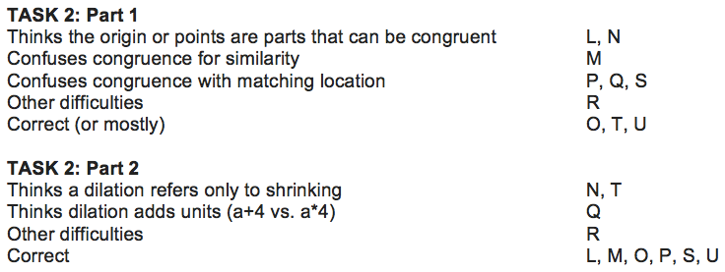  Participants may need guidance to grasp the distinction between separating work samples according to the degree of correctness, and describing the thinking that led to different types of solutions.
2.4 Generate list of student difficulties | This task explicitly probes the connection between content and pedagogy, as participants need to understand the geometry fully, and also the nature of a student’s mathematical understanding, in order to describe particular difficulties.  Learning objective 2.B
Approx. 10 minutes | Have whole class discussion to generate inventory of ways that students appear to be thinking about the tasks as well as specific difficulties that are apparent in the written work.  This list can represent difficulties that students had on either part of the task. |  | [See PCK commentary for section 2.3]
2.5 Elaboration: Generate task | In this activity, participants engage in the teaching-related work of finding/creating a task to diagnose student thinking or to support student learning. Learning objective 2.C
Approx. 15 minutes. (This could also be an out-of-class assignment/activity). | Participants (in their pairs or small groups) select one difficulty from the list generated in 2.4.  Participants now create (or find) a new task/activity that a teacher could use to further diagnose student thinking and/or to strengthen students’ understanding of the geometric ideas. |  | Sample: A task might be designed that probes the difference between a dilation centered at a vertex of the triangle, and a dilation centered outside the triangle. This would highlight, among other concepts, the idea that a dilation is about the distance from a fixed point, not just an enlargement or a shrinking.

Part 3
Part 3 is focused on content related to undergraduate-level mathematical ideas related to transformational geometry (in particular, the ideas of a group as a set of transformations, and the symmetry of a group).
Section + duration | Sequence of lesson sections | CCK (commentary) | PCK (commentary)
3.1 Revisit and/or learn criteria for a group | To begin the examination of connections between transformations and the mathematical structure of groups, discussion and activities provide teachers with opportunities to revisit and/or learn mathematical concept of a group, including the idea that we are working with a set of transformations, rather than a single transformation, and the defining characteristics of closure, associativity, identity, and inverses. Learning objective 3.A
Approx. 20 minutes | In pairs/groups, participants generate examples of sets that constitute a mathematical group.  Note: If participants have difficulty generating examples, perhaps with the following questions:  “Does the set of integers and the operation division constitute a group?’  “Does the set of integers and the operation addition constitute a group?’  After pairs/groups have generated some examples, ask them to create a definition of a group. | Requirements to be a group: closure, associativity, identity, and inverses.  Group properties:  closure: performance of an operation on members of the set produces a member of the same set.  associativity: performance of an operation produces the same result regardless of how valid pairs of parentheses are inserted.  Example: (ab)c = a(bc)  identity: Denoted as I. Performance of the identity leaves an element of a set unchanged  (e.g., IA= A)  inverse: for every element A of a set, there must be an inverse of A, denoted as A⁻¹ such that AA⁻¹=I  See Appendix G for formal mathematical statements of axioms. | Participants may have difficulty distinguishing between the identity element and the inverse. This can occur because both bring the object onto itself.  Participants may assert that commutativity is a necessary criterion for a set to be a group. One reason for this is the use of the language “product of transformations.” In this case, product is not referring to traditional multiplication.

3.2 Examine group as a set of transformations | Explore a set of transformations that constitute a symmetry group using an equilateral triangle (see Figure X) and develop systematic method for verifying that each condition is satisfied.  Learning objective 3.B
Approx. 30 minutes  (may vary depending on how familiar participants are with symmetry transformations, transformations as elements of a group, and products of transformations). | Working in pairs/groups: In pictures and/or in words, describe the symmetries of an equilateral triangle.  Alternative phrasing: What transformations can be performed on an equilateral triangle that bring the image onto itself (the original figure)?  After the pair/group work, pose this question to the whole class: Does the set of symmetry transformations of an equilateral triangle constitute a group? | 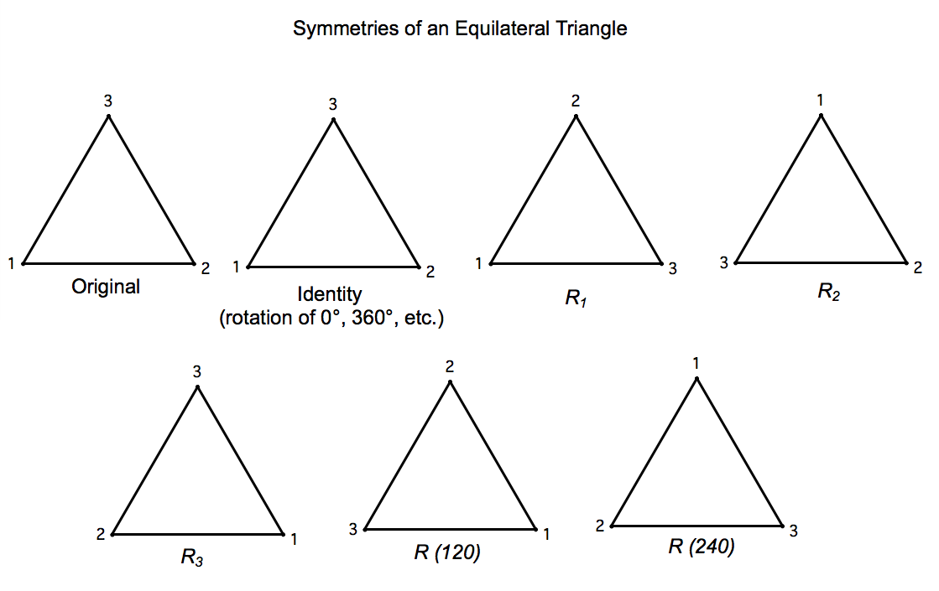  [See Appendix H for larger image]  Explanation of the above transformations:  Identity: Rotation through an angle of 0° + (n)(360°)  R₁: Reflection about the axis through vertex 1  R₂ : Reflection about the axis through vertex 2  R₃: Reflection about the axis through vertex 3  R(120): Rotation through an angle of 120° counterclockwise  R(240): Rotation through an angle of 240° counterclockwise |  | Though some may have seen groups (perhaps in abstract algebra), they may not have thought about groups in a geometric (symmetry) context.  Some may have difficulty with the idea that the elements are transformations and may instead be thinking that the group is made up of triangles.  Students may not grasp that we are talking about sets of transformations (in this case, sets of symmetries), rather than individual transformations. The goal is to determine if the set, taken as a whole, constitutes a group.  Students need to understand how to find the product of two transformations as a prerequisite to checking on criteria for group.
 | Participants learn how to verify each required condition. As a starting point, instructor can show an example of how to verify a single condition. In this case, that the product of R₁R₂ produces a result that is in the original set (closure). | 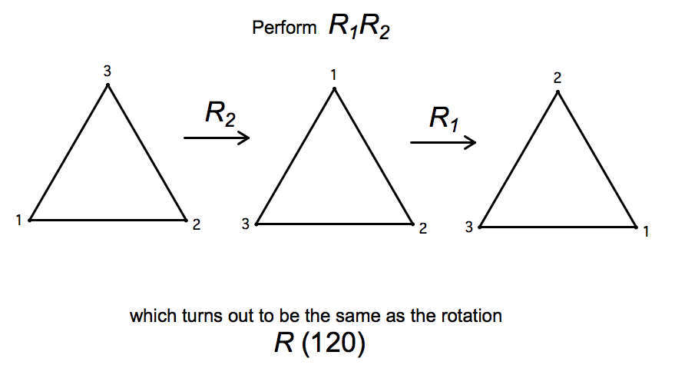  [See Appendix I for larger image.] |  | It may help to invoke the idea of “composition of functions” as a way of understanding both the process of generating a product of transformations and the order in which that process occurs (see figure in column to the left for an illustration of a product).
 | Instructor may suggest that an operation table is an effective way to demonstrate this, and show an example for the equilateral triangle. | 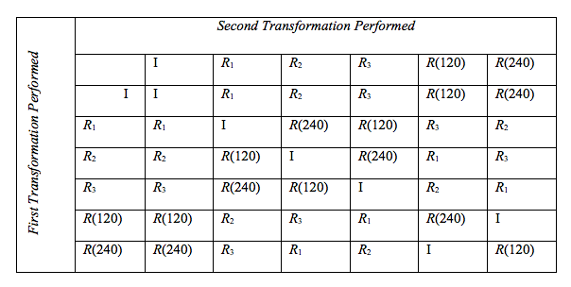  [See Appendix J for larger image.]
3.3 Apply ideas to new figure | Working in groups, participants then explore the symmetries of an isosceles triangle, create an operation table and determine whether the symmetries of a non-square rectangle form a group.
10 minutes | Participants practice how to verify each required condition. Instructor suggests performing RvRh. | 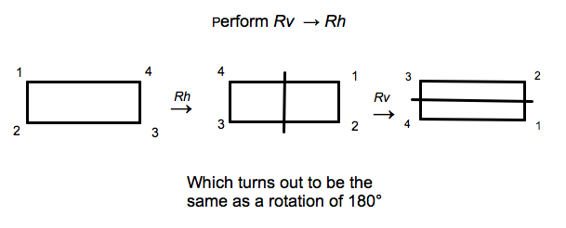  [See Appendix L for larger image.] | Participants may not realize that when given RvRh, the convention is to perform Rh first, then Rv on the image.
10 minutes | Participants build a diagram showing symmetries of a non-square rectangle | 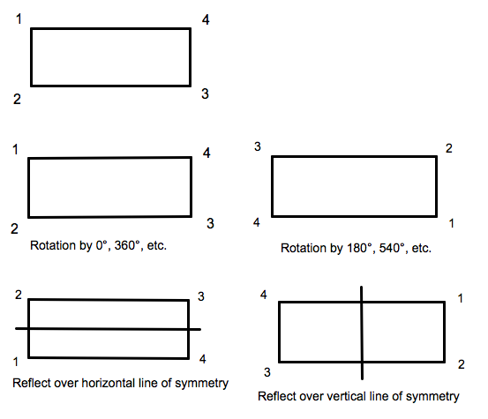  [See Appendix K for larger image.] | Participants may not always refer back to original figure, and placement of the vertex names, when defining each transformation.  This ideas should not be confused with the product of two transformations, when each image is used in the subsequent transformation.
25 minutes | Using the equilateral triangle as an example participants will create their own operation table to verify whether or not the symmetries of a non-square rectangle constitute a group. | Instructor first helps students figure out dimensions of operation table. students then fill in the table and draw a conclusion. | Participants may first build an operation table that is the same size as the table for the equilateral triangle.

APPENDICES

Appendix A.

Appendix B. Solution to Task 1b

Appendix C: Sample student solutions to Task 1 + categorization table

[See TransGeom-Worksheet.pdf for Task1 samples]

Appendix D: Task 2

Appendix E: Task 2 solution

Appendix F: Task 2 sample student solutions

[See TransGeom-Worksheet.pdf for Task2 samples]

Appendix G: Formal Axioms for Mathematical Group
In order for a set of transformations to be a group, certain conditions (axioms) hold.

Closure
· If f and g are in S, then fg and gf are in S

Associativity
· If f, g, and h are in S, the (fg)h = f(gh)

Identity
· There is a unique element in S satisfying If = fI = f for all f in S.

Inverses
· Given f in S, there exists a unique element f⁻¹ satisfying f⁻¹ = ff⁻¹ = I

Appendix H: Symmetries of an Equilateral Triangle
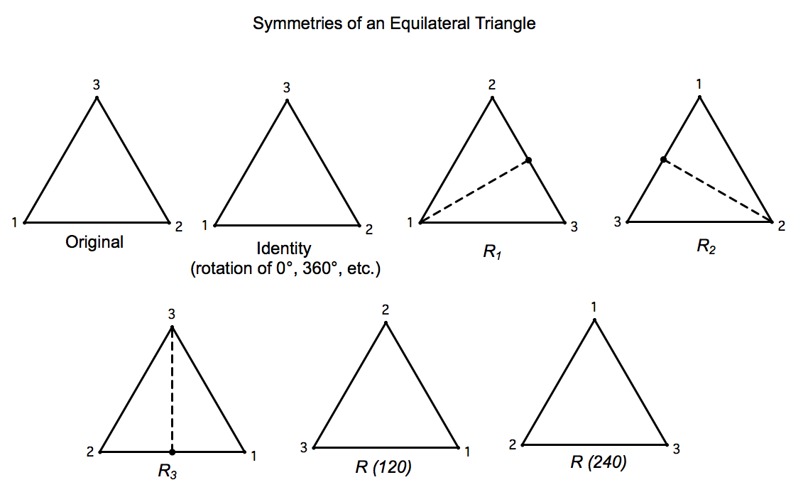

Appendix I: One example demonstrating closure

Appendix J: Operation table

Appendix K: Symmetries of rectangle

Appendix L: One example demonstrating closure with non-square rectangle

