Course reform, SMT 506
Outline of unit on Transformational Geometry:
- Transformational geometry defined through idea/concept of mapping
- Requires understanding the ideas of one to one and onto
- Link between this definition of mapping in transformational geometry and typical definition of function (a set of ordered pairs with no two different pairs having the same first element)

- Mathematical concept of a group
- Idea that we are working with a set of transformations, rather than a single transformation
- In order for a set of transformations to be a group, certain conditions must apply
  - Closure
  - Associativity
  - Identity
  - Inverses

- Examples of sets of transformations that constitute a group
  - Symmetries of an equilateral triangle
  - Learn how to verify each required condition

- Notation for describing symmetry groups
  - Permutation group symbols
  - Pictures/figures
  - Example: Work through the symmetries of equilateral triangle as shown below 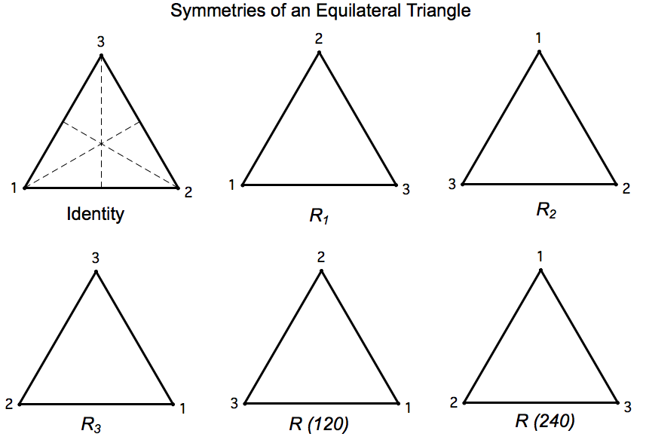
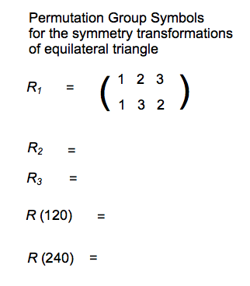
5. Multiply transformations (Example below—same pattern: show students, then have them produce a new one)
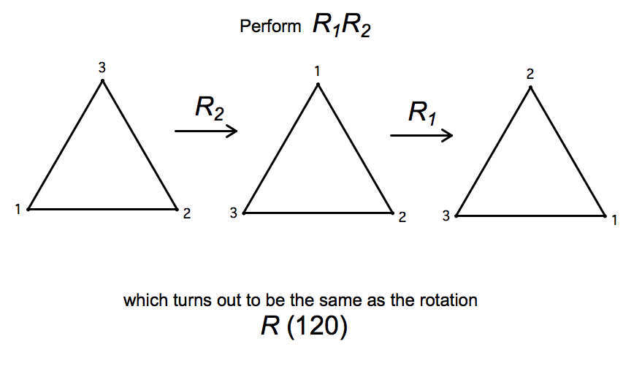
6. Euclidean motions of the plane
  - Translations
  - Rotations
  - Reflections

- Similarity transformations

