SMT 504 2015 Pre-survey, Part 2

Below is a sample of 4 student responses to Questions 7, 8, and 9 from the Part 1 open-response survey you just took. Score them in this way:
- Score the students’ responses to Questions 7 and 9, and give your rationale for the scores. You don’t need to score the claim, Question 8, but use their claim to inform your scoring of Question 9.
- Scoring scale: This is intentionally ambiguous at this point so you can decide what the expectation is.
  - 4 (Meets expectation – you feel the student is ready to move on),
  - 3 (Almost meets – pretty much correct, but could be improved),
  - 2 (Partially meets – response is more substantially lacking)
  - 1 (Does not meet expectation)
Imagine that you’d feel okay if a student left your class with a 3, very good if they were at a 4, but you would not want them to leave your class at a 2 or a 1.
- Provide rationale for assigning the scores
- Suggest instruction or feedback that might benefit the student
- Email to me copy of your scores, rationale and recommendations by class time on Sept. 1; I’ll aggregate scores for class discussion.

Here’s a copy of the question:
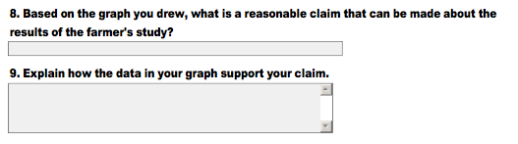
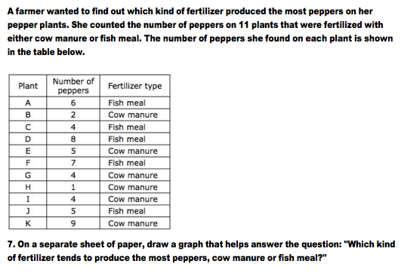
Student #1
SY22

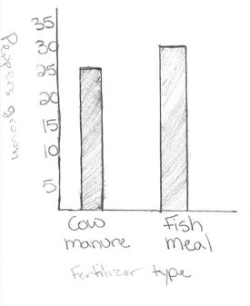
Q7, Student 1 Graph:

Q8, Student 1 Claim: More peppers are grown in fishmeal fertilizer

Q9. Explain how the data in your graph support your claim.

the fish meal bar is higher

_________________________________________________________

Student #1 Q7 score: Q9 score:

Rationale:

What instruction or feedback might benefit this student?

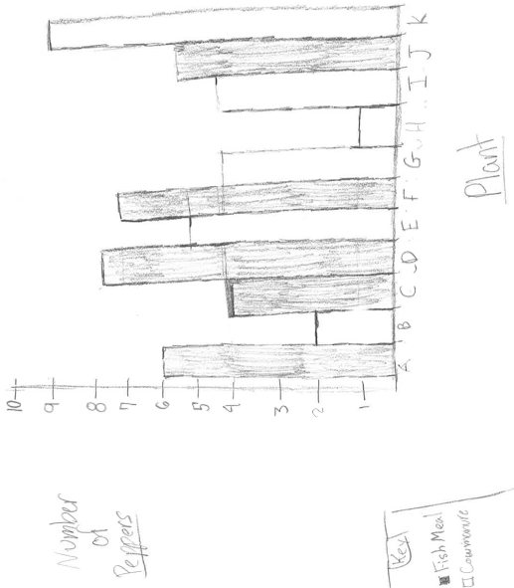
Student #2
YL20

Q7 Student 2
Graph:

Q8, Student 2 Claim: That fish meal has a better average number of peppers than cow manure.

Q9. Explain how the data in your graph support your claim.
Well, Fish meal was mostly always above 4, and cow manure had a couple down below 3, but I can't be certain because cow manure also had some above 5.

_________________________________________________________

Student #2 Q7 score: Q9 score:

Rationale:

What instruction or feedback might benefit this student?

Student #3
OU40

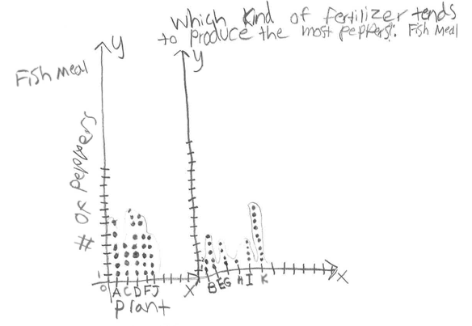

Q7 Student 3 Graph

Q8, Student 3 Claim: Peppers grow more when Fish Meal fertilizer is used.

Q9. Explain how the data in your graph support your claim.
The Fish Meal data has a range of four and is not as variable as the Cow Manure. The Cow Manure is much more variable, with an outlier at nine and on average less pepper growth than the Fish Meal.

________________________________________________________

Student #3 Q7 score: Q9 score:

Rationale:

What instruction or feedback might benefit this student?

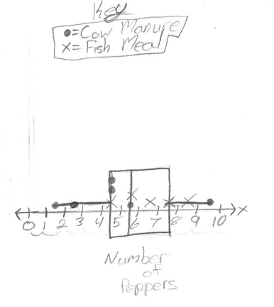
Student #4
NB27

Q7, Student 4
Graph

Q8, Student 4 Claim: The fish meal had a higher average.

Q9, Explain how the data in your graph support your claim.

I know this because even though there is one cow manure data point that is higher than everything else most of the cow manure data is fairly low.

_________________________________________________________

Student #4 Q7 score: Q9 score:

Rationale:

What instruction or feedback might benefit this student?

