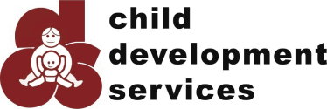
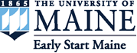
New England Early Intervention Conference 2017

June 14 & 15, 2017
8am – 4pm
Westin Hotel
Portland, Maine
https://umaine.edu/neeic/

The Maine Autism Institute for Education and Research (MAIER) and Child Development Services (CDS) of Maine are excited to announce our New England Early Intervention Conference June 14th & 15^{th, 2017} in Portland Maine! This year’s theme is “Supporting the Social-Emotional Development of Young Children” and we have exciting speakers from around the country who will be presenting timely information on EI Practice, Family & Practitioner Collaboration, Research, Professional Development, and Policy. It should be an exciting, first-of-this-kind event for Maine professionals, practitioners, and family members.

A conference of this size and breadth takes community sponsors to be a success. Join us in making this event successful by becoming a business or community sponsor. Several levels of giving are available (see next page) and all include recognition through a variety of options. So join us in planning this exciting event and receive public recognition as one of our sponsors!

To learn more about the New England Early Intervention Conference, visit our website: https://umaine.edu/neeic/

Questions? Contact Deborah Rooks-Ellis by phone (207-581-2352) or email NewEnglandEIConference@gmail.com

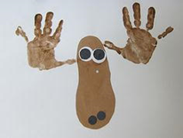

Sponsorships
New England Early Intervention Conference

______ Bronze $100 Name on bag

______ Silver $250 Name on bag
Logo on T-shirt

______ Gold $500 Name on bag
Logo on T-shirt
Logo on NEEIC website

______ Platinum $1000 Name on bag
Logo on T-shirt
Logo on NEEIC website
Logo on Event Banner

______ Diamond $2,500 Name on bag
Logo on T-shirt
Logo on NEEIC website
Logo on Event Banner
Plaque of Recognition
Media Recognition

Corporate Name______________________________________________________________

Mailing Address_______________________________________________________________

City__________________________________ State____________ Zip__________________

Phone Number_________________________ Email_________________________________

Please send sponsorship form and payment no later than May 15 to:
Deborah Rooks-Ellis
University of Maine
5766 Shibles Hall, Room 303
Orono, ME 04469-5766

