Ordering a Language Assessment Online

Registration Instructions
To register for your online assessment, please follow the directions below:
    - Go to: www.languagetesting.com to purchase your test and set up your account.
    - On the left side of your screen, select the language in which you will be testing and click the Get Certified button:

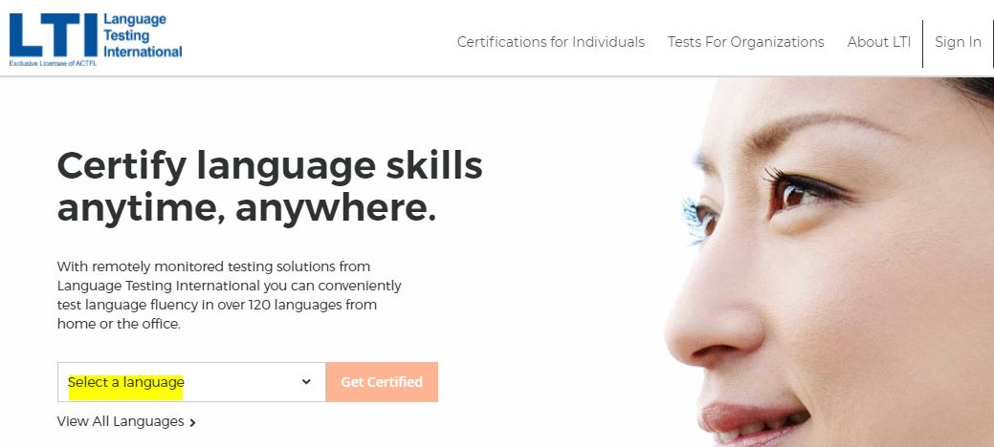

On the next screen, direct your attention to the right-hand column labeled Students/Teachers and choose the following option: Programs with ACTFL Requirements. Select Choose Test.

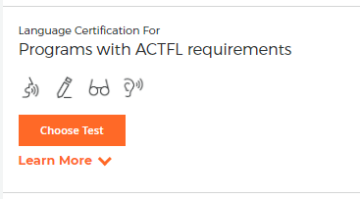

In the blank under “What school or institution are you looking for?” start typing the name of your institution. Your institution should pop up automatically (if it doesn’t, contact your institution’s administrator). Click Continue.

On the next page, select your test(s) – choose “Select Test” so that you see it turn blue, and click Continue to Schedule.

You will come to a proctoring page -- select Web-Based Proctoring (or your institution if you will be going to campus for testing).

Select your time zone and choose the date and time you’d like to take the test. You’ll be asked to log in if you have an existing LTI account or create one if you do not, and you’ll make your payment.

You’ll get to a page that allows you to review your order; you can order an additional test from this page as well before final checkout.

You’ll be emailed with instructions once you have ordered your test(s).

Select your Certificate Format and Delivery method.

Good luck!

For Customer Support: 800-486-8444, Option 1

