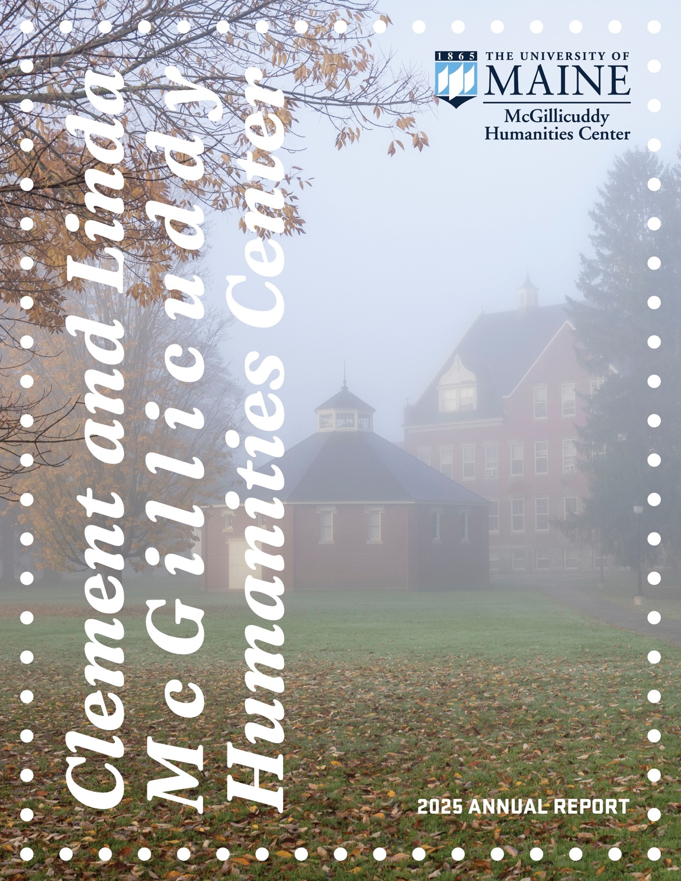

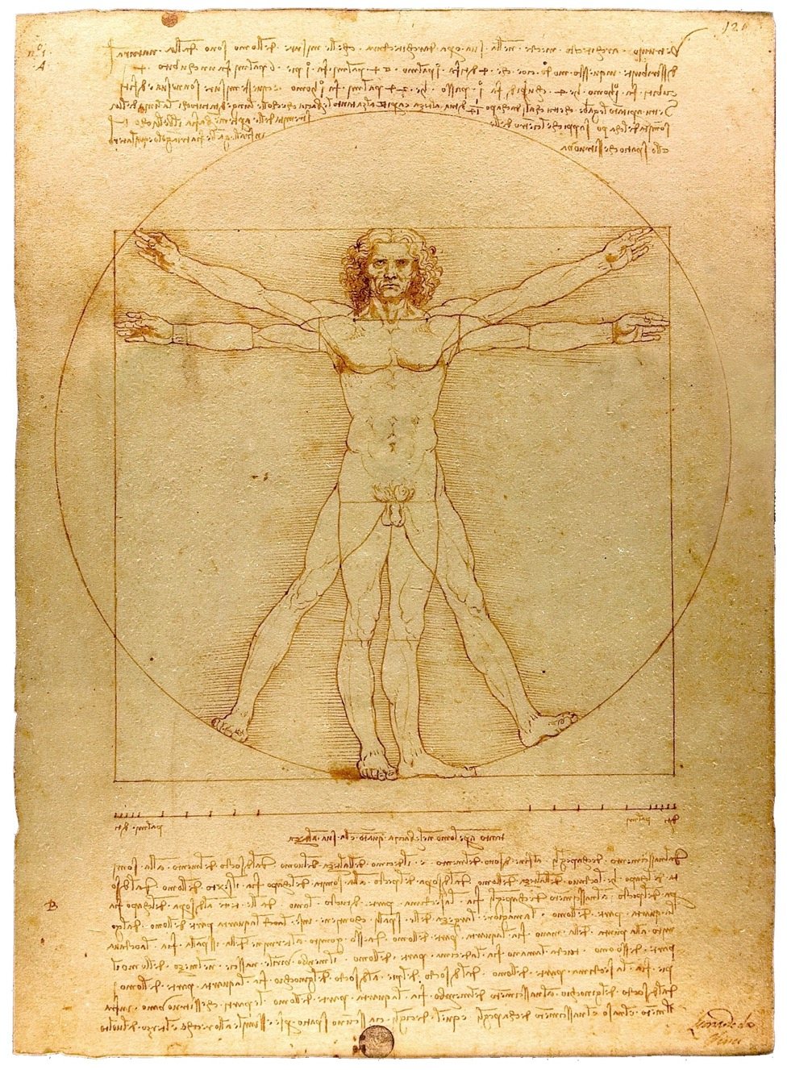
Above: “Vitruvian Man” by Leonardo da Vinci
Cover photo: “Campus early morning fog” by Ron Lisnet
CLEMENT AND LINDA MCGILLICUDDY HUMANITIES CENTER 2025 ANNUAL REPORT

T
he Clement and Linda McGillicuddy Humanities Center’s mission is to demonstrate the immediacy and applicability of humanities studies by advancing teaching, research, and public engagement in the humanities in Maine. It supports programs that foster intellectual curiosity, critical reflection, and creative innovation.

Central to the Center’s work is the belief that study of the humanities cultivates compassion across differences, develops empathy, and, in addition to providing a sound training in critical thinking, develops the emotional and intellectual agility needed to brilliantly navigate an increasingly interconnected and complex global landscape.

The Center serves as a locus for humanities research, interdisciplinary collaboration, and meaningful conversations among scholars, artists, students and the public through the support of lectures, symposia, panels, performances, and exhibitions, as well as individual and collaborative research by students and faculty.

As the humanities constitute not only a cluster of disciplines, but an entire stance toward lifelong learning, the Center also seeks to enrich the experience of humanities education both within and beyond the borders of the public university, from K–12 students to Maine’s thriving community of senior citizens.

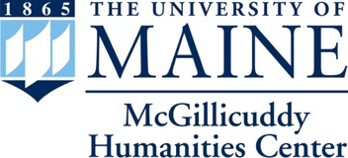

ADVANCING RESEARCH IN THE HUMANITIES WHILE CONNECTING
SCHOLARS TO ONE ANOTHER AND THE BROADER MAINE COMMUNITY
FROM THE DEAN

T
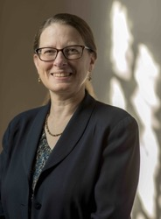
he McGillicuddy Humanities Center continues to fill a vital role on our campus, doing a remarkable job demonstrating the value of the humanities within academia and across human communities.

Having something like the MHC on our campus is a wonderful way to ensure that the humanities are central, and visible, here at the University of Maine. The Center provides fellowships and grants for faculty and students to support them in pursuing humanities research, and it enriches campus life by funding visiting speakers, performances, class workshops, and more. Reading this report, you’ll get a sense of just how significant the MHC’s contributions to our campus – and beyond – truly are.

UMaine is fortunate to have a center such as this one on our campus. That good fortune springs from the generous support it receives from those who also understand and celebrate the value of the humanities. The MHC is funded almost entirely by the philanthropic contributions of UMaine alumni and friends.

MHC Director Zach Ludington’s second year at the helm has shown him to be a thoughtful steward of the humanities here at UMaine. This year’s MHC Annual Symposium, titled “Hard Copy: The Material Culture of Reading and Writing,” has brought authors, artists, and scholars to campus to explore the uneven (yet unbroken) history of the written word, with more yet to come this spring.

As always, I am impressed by the efforts of the MHC to foreground the humanities in a manner that is both aspirational and accessible. Many thanks to all of you for joining me in supporting the Clement and Linda McGillicuddy Humanities Center.

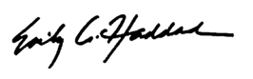

Emily Haddad
Dean
College of Liberal Arts and Sciences

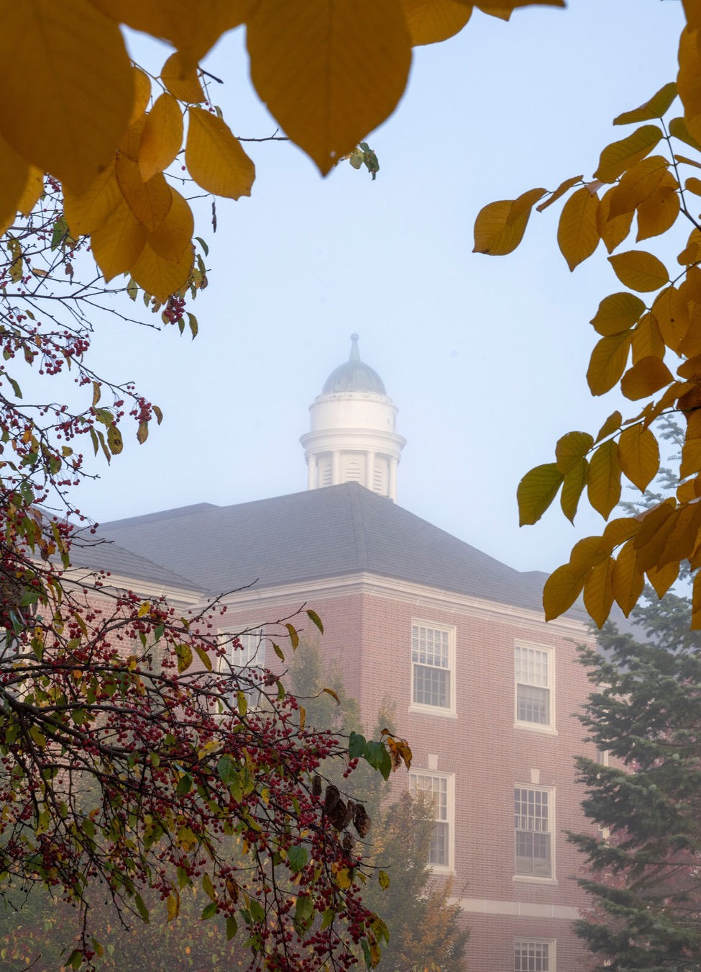

FROM THE DIRECTOR
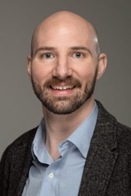

I
n preparing this report at the conclusion of my first year as Director of the McGillicuddy Humanities Center, I feel my remarks in this space must foreground my gratitude for the goodwill and generous contributions offered by an astounding breadth of patrons, students, faculty, staff, alumni, community members, and friends.

Scores of people intervened in ways both large and small to make fiscal year 2025 an exciting and productive time for MHC. The 2024-2025 Symposium, “From Talkies to TikTok: 100 Years of Audiovisual Storytelling,” brought visitors like Mariana Ivanova, Academic Director of the DEFA Film Library and Associate Professor of German Film and Media at the University of Massachusetts-Amherst, and Santiago Tijerina (’21, Honors), an emerging, award-winning filmmaker and alum, to campus for screenings, talks, and class visits throughout the year. A few of this past year’s Symposium events, including Dr. Ivanova’s visit, were supported by a grant from the German Embassy’s “Germany on Campus” program.

Outside of Symposium events, the Center was honored to accept the Director’s Award from the Collins Center for the Arts at its fall Gala celebration. Danny Williams, Executive Director of the CCA, presented the award to the Center in recognition of the history of collaboration between the CCA and the MHC.

The Center’s calendar was happily punctuated by celebrations of undergraduate Fellows’ work. Between fall 2024 and spring 2025, eight Fellows made public presentations of their independent research and creative projects and a further four Fellows were welcomed to the Center in spring 2025. One of the Center’s Fellows, Alex Morgan (spring 2024-fall 2025), had the honor of concluding her time at UMaine as salutatorian at Commencement in the spring.

Meanwhile, fifteen faculty applications received support from the Center over the past year, from Sabrina DeTurk’s (Honors) trip to Italy for research toward a new book to Susan Pinette’s (Modern Languages & Classics, Franco-American Programs) efforts at the Franco-American Centre to digitize and preserve important artifacts of Franco-American culture.

Fiscal year 2025 also saw the arrival of Alex Young as the McGillicuddy Humanities Center’s new Humanities Specialist. Occupying the position left by Brian Jansen in summer 2024, Alex comes to Orono from Pittsburgh, where they managed facilities and operations for Carnegie Mellon University’s School of Drama, Video and Media Design program. A multimedia artist with a rich and varied experience in arts organizations and university arts programs, Alex brings a broad range of arts and humanities skills and interests.

Just as we welcome Alex to the Center, we also say goodbye to Matt Mullen, a steadfast partner in the University of Maine Foundation who has left for a new opportunity. We also mark the departure of Philip Hamilton, ’85, from the McGillicuddy Humanities Center’s Board of Advisors. Philip’s wisdom has been an asset to the Center since its beginnings; I, along with the Center’s past directors, am grateful for his service to the Board. Coinciding with Philip’s exit, the Board enjoyed the chance to welcome new members as well: François Amar, Professor Emeritus of Chemistry and former Dean of the University of Maine’s Honors College; Sean Cox, ’15, ’20G, independent scholar; Managing Editor, Mount Desert Island Historical Society; Tam Huyhn, ’03, Executive Director, Holocaust and Human Rights Center of Maine; and Lisa Marin, UMM ’09, retired educator; President, John Marin Foundation.

One final development of the past year I’ll mention in closing has to do with the document before you. This annual report for FY 2025 is the first to exist as a digital-first artifact.

In closing, I’d like to express my thanks again to all those who have supported and undertaken the Center’s work over the last year. The Board of Advisors, faculty mentors to the Center’s Fellows, faculty, staff, and student collaborators, community members, visitors to UMaine, and patrons. Coupled with the support of the University of Maine Foundation and the College of Liberal Arts and Sciences, our generous patrons’ contributions make the support we offer students and faculty and the programming we present on campus possible. A final note of gratitude goes to Alex Young, Humanities Specialist, who is the author and designer of this report and the monthly newsletters you receive from the Center. Alex is also the lead coordinator for the Center’s undergraduate Fellows program and much else besides.

Thanks to you all for keeping abreast of the Center’s activities. I hope you enjoy reading about them here.



Zachary Rockwell Ludington
Director
McGillicuddy Humanities Center
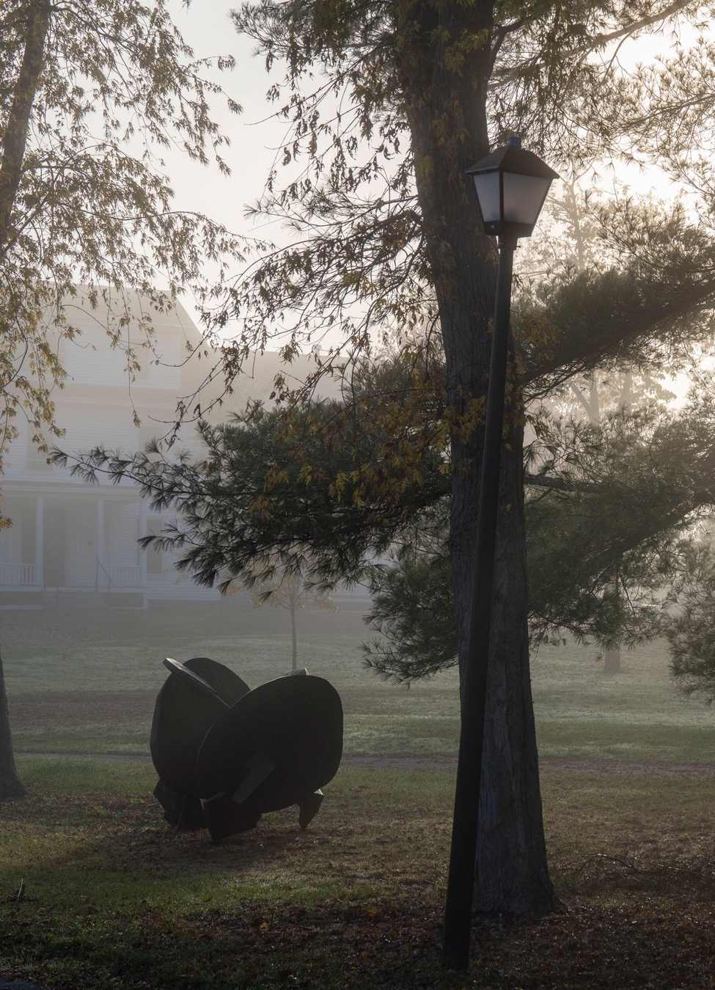

McGillicuddy Humanities Center and Collins Center Welcome Steven Page for Discussion, Performance

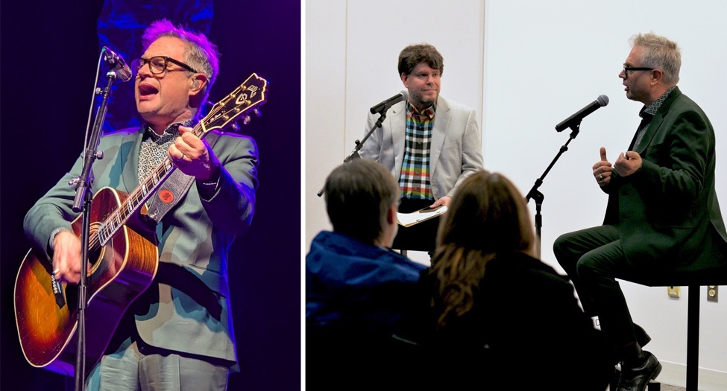

Canadian singer-songwriter, and former lead singer of Barenaked Ladies, Steven Page performing at the Collins Center for the Arts (left) and in discussion with Bates College Professor of Music Dale Chapman prior to the performance (right).

On Thursday, April 17, the Collins Center for the Arts and the Clement and Linda McGillicuddy Humanities Center welcomed seven-time Juno Award winning multi-platinum recording artist and Canadian Music Hall of Fame inductee (as lead singer of Barenaked Ladies) Steven Page for an evening performance and discussion.

Prior to the performance, Page met with Storytelling students at UMaine and gave a pre-performance discussion with Professor of Music at Bates College, Dale Chapman. In the pre-performance discussion, Page entertained the audience with his trademark wit and tales from his early career as a musician starting out in the Toronto suburb of Scarborough, Ontario in the late ‘80s and the ascent of his group the Barenaked Ladies in the early ‘90s.

In an episode of audiovisual media history befitting the MHC’s annual symposium theme; Page spun the true story of how he and his bandmates went from performing their song “Be My Yoko Ono” in 1991 at Citytv’s Speakers Corner to having the first independent label album to go certified platinum in Canada the following year. Speakers Corner was a legendary video booth at the corner of Queen and John Streets in Toronto where anyone could speak their mind for up to two minutes for one dollar to then be played back in segments on television. Soon after the stunt, the Barenaked Ladies would be frequently featured in segments on Citytv-owned stations and with an admixture of persistence, media and promotion savvy, chance, and a singular sensibility for song-crafting and entertaining Page and his cohort would quickly become a major force in Canadian music.

On stage, Page was joined by cellist Kevin Fox and guitarist Craig Northey (co-founder of the Vancouver-based rock band, Odds). The trio performed a two-hour set with was interspersed with bits of comedic wit and banter. The setlist ranged from Barenaked Ladies’ classics like “It’s All Been Done” from the 1998 album “Stunt” to Page’s solo work like “The Golden Age of Doubling Down” off of his latest album “Excelsior” from 2022.

In addition to the event with Steven Page and Dale Chapman, the McGillicuddy Humanities Center co-sponsored three further events at the Collins Center for the Arts: UMaine alumnus Morgan Cates’s A Day in the Life: A Beatles Experience in conversation with UMaine Professor of Music Anatole Wieck, the Yamato Drummers in conversation with UMaine Professor of Music Emeritus Stuart Marrs, and Paul Taylor Dance Company rehearsal director Cathy McCann in conversation with Bates College Assistant Professor in Dance Tristan Koepke.

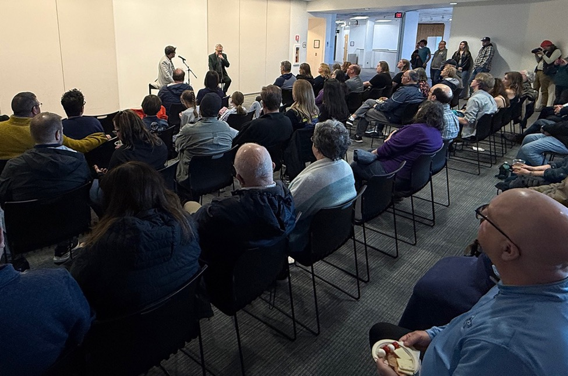

Steven Page speaking with Dale Chapman to a packed house prior to his performance at the Collins Center.

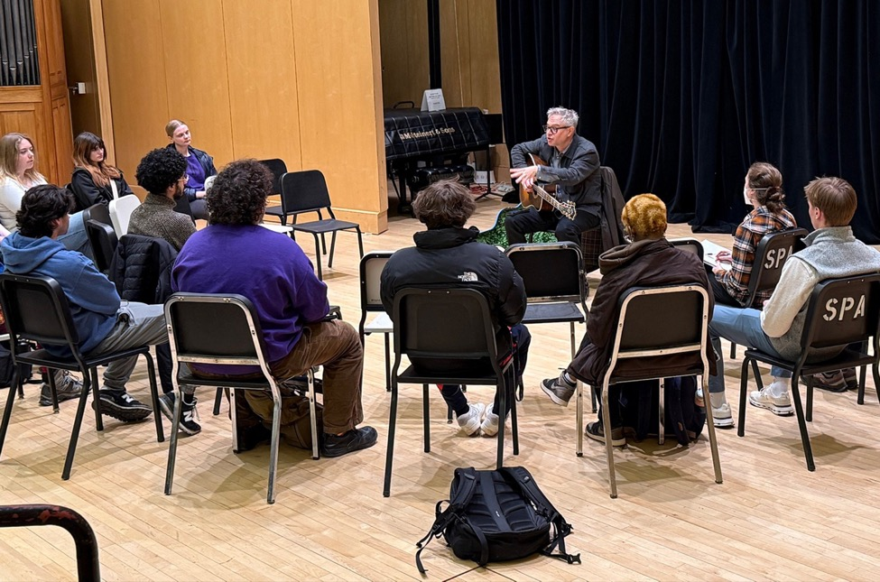

Steven Page visiting a Storytelling class to discuss his creative process at UMaine prior to his performance at the Collins Center.

FROM TALKIES TO TIK-TOK:

100 YEARS OF AUDIOVISUAL STORYTELLING
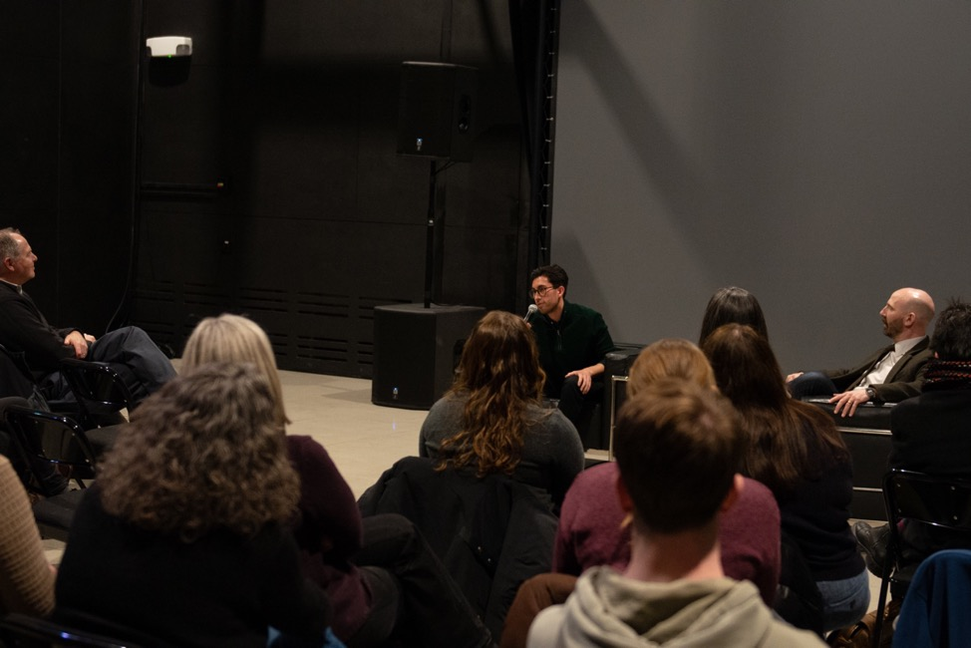

Filmmaker Santiago Tijerina in discussion with MHC Director Zach Ludington at the screening "Courts of Belonging" at the IMRC Center.

2024-2025 MHC ANNUAL SYMPOSIUM

The 2024-2025 McGillicuddy Humanities Center Symposium “From Talkies to Tik-Tok: 100 Years of Audiovisual Storytelling” brought media makers and scholars to the University of Maine to highlight the impact and evolution of audiovisual media one-hundred years after the first commercial screening of a sound-on-film motion picture took place in New York City in 1923. The symposium focused on the myriad ways in which combinations of audio and video can carry a narrative. Whether on a screen, on a stage, in an art installation, or as part of an enhanced lecture, the ways we share art and information have changed drastically in the last century and our symposium presenters both examine this history as scholars and partake in shaping it as media practitioners. The lineup of guest curators, filmmakers, and humanities scholars collectively contributed to a broad examination of how audio-visual culture has influenced and continues to shape the stories we tell and the art of storytelling itself.
In the Fall semester, the Center hosted three events with support from a “Germany on Campus” grant from the Embassy of the Federal Republic of Germany. The first event of the three consisted of a screening and discussion of Rolf Losansky’s 1989 film, Farewell Disco, led by Dr. Mariana Ivanova, Associate Professor of German Film and Media and Academic Director of the DEFA Film Library at UMass-Amherst. The film tells the story of a grieving young man who takes up a solitary practice of climate activism and amateur forestry just before German reunification. This event was additionally sponsored by the School of Forest Resources, the Climate Change Institute, and the Department of Modern Languages & Classics.
The second event presented the University of Maine's own Anne Knowles, McBride Professor of History, to share insights from her research on the history of the Holocaust. The event was well-attended and Professor Knowles’s rich visual presentation shared highlights from years of developing geohistorical datasets and data visualizations that reveal the scale and dynamics, spaces and places of the Holocaust in stunning new ways that illuminate geography as a visual way of knowing — and exploring — the past.

For the third and final event supported by Germany on Campus, the Center presented a screening of A New Peace of Münster, a documentary by Maria Kolossa that tells the story of how a Dutch comedian and a Professor of German teamed up to talk climate migration along the German-Dutch border. Following the screening, Class of 1965 Endowed Term Professor of German at the University of Pennsylvania, Simon Richter, who also served as co-producer and the “Professor of German” in the film, led a conversation about the film with the audience.

In the Spring semester, the Center welcomed three early career scholars of film, television, and popular culture in the Hispanic world: Assistant Professor of Spanish and Digital Humanities at University of Florida Joanne Britland, Assistant Professor of Spanish at University of Illinois at Urbana-Champaign Anna Torres-Cacoullos, and Assistant Professor of Film and New Media Studies at University of South Florida Olivia Cosentino. The event, organized by MHC Director Zach Ludington, “FAN FRENZY: A Century of Stardom and Fandom in Hispanic Cinema” traced histories of fans as active participants in culture from the early twentieth century to the present day. Taking to task the symposium’s theme of addressing one hundred years of the moving image, Torres-Cacoullos presented on early movie magazines of 1920s Spain, Cosentino provided a history of media representations of Mexican women, and Britland demonstrated the role of fan culture in cultural activism through zines and social media in the present day.
In late March, the Center, in partnership with the Department of Communication and Journalism’s Spring Colloquium, presented scholar of twentieth century media, race, and protest and Postdoctoral Fellow at Harvard University’s Charles Warren Center, Sage Goodwin. Goodwin’s presentation “Making the News: The Mid-Century Black Freedom Struggle and the Development of Network Television News” examined ideas held about the network era of television as a “golden age” of broadcast journalism. Goodwin unpacked the real race relations in journalism of this era and the belief that Americans could trust neutral reporters who told them the news the way it was when many did not. Goodwin illustrated that television as it entered US homes in the mid-twentieth century, swiftly becoming the nation’s primary source of news, was less a vessel for the transmission of impartial information and more a battleground for the fight for Black freedom and equality. As segregationists and civil rights activists alike fought to shape how the networks determined what constituted responsible coverage, who reported the news, and which narratives reporters told about race in America, Goodwin outlined the story of how the pioneers of television news responded, uncovering how racial politics forged the modern television newsroom.
The symposium wrapped with three presentations in as many weeks in March and April by Maine-based media makers who screened recent video projects, with accompanying discussion, at the IMRC Center’s Fernald Adaptive Presentation & Performance Environment. The first of the three, Caroline Losneck—a documentarian, radio/podcast producer, filmmaker and experimental installation artist—presented “Making Stories in Maine.” Losneck is known for seeking out off-the-radar venues for her documentary work — from buildings slated for demolition, public parks, and flooded city streets, to empty campgrounds and film festivals. Her works have been featured in venues and outlets from Maine Public Radio, NPR, BBC, and The New York Times to the Camden International Film Festival and Rooftop Films. During the event, Losneck discussed her multidisciplinary and multi-outlet approach to documentary mediamaking. The event included a screening of her short documentary Diving for Scallops, co-created with Christoph Gelfand for The New York Times. Filmed off the coast of Cushing, Maine, the documentary profiles a fisherman who practices the fading craft of diving for sea scallops on the ocean floor.
Our following event presented a screening of the documentary Courts of Belonging by UMaine class of 2023 alumnus Santiago Tijerina who graduated with a degree in International Affairs with Honors. For Courts of Belonging, Tijerina received the 2024 Emerging Maine Filmmaker Award. The documentary follows a group of immigrant refugee residents in Portland, Maine who find community through the sport of futsal as they take the court at Kennedy Park in the neighborhood of East Bayside, one of the most diverse neighborhoods in Maine. The film was screened to a packed audience that included Tijerina’s friends, family, and former faculty mentors and was following by a lively discussion.
For the final screening event of the symposium, former McGillicuddy Humanities Center Director and UMaine Professor emerita of English, Margo Lukens, was joined by co-directors Donna Loring and David Camlin for a screening of the animated film Mary and Molly.
The film follows Mary, a young African-American woman living in Bangor, Maine who finds a letter from her mother that tells of her Penobscot Indian heritage and the decision that her parents made many years ago to bring her up with only the knowledge of her African-American heritage. After opening the letter on her 21st Birthday, Mary goes to the Bangor Public Library and learns of Molly Molasses, her Penobscot Ancestor, and connects with her Penobscot ancestry for the first time. The film tackles Black and Brown issues of race, heritage, and the choosing of identity. The film features the creative work of indigenous creators and collaborators.

Presented with support from:
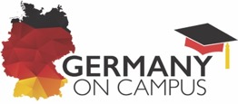

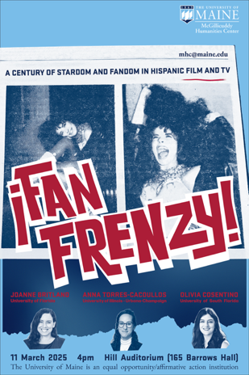

A selection of posters from events for the 2024-2025 McGillicuddy Humanities Center annual symposium.

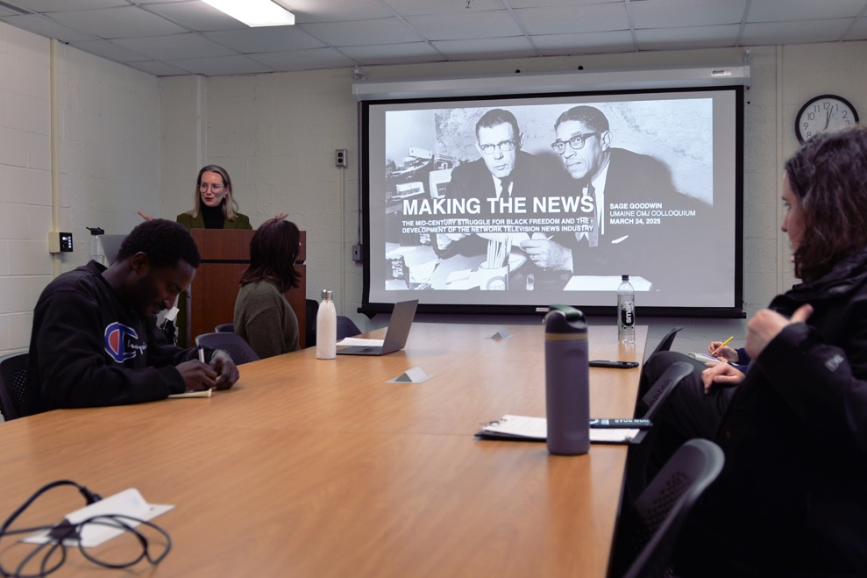

Sage Goodwin speaking on the development of network television news in a co-presentation between the MHC’s annual symposium and CMJ’s colloquium.

2025-2026 Symposium Theme Examines the Materiality of the Written Word

HARD COPY: THE MATERIAL CULTURE OF READING AND WRITING

The virtuoso Cuban poet and novelist José Lezama Lima lamented in a brief essay in 1954 the modern writer’s boredom with the stark and lifeless letterforms of his trade. It was the era of typewriters, inky daily newspapers, and carbon-copy forms; the written word had come to feel ordinary. But Lezama reminds us that, with their millenary history, at turns bright with heroism and intelligence and by equal turns shadowed by terror or fierce ignorance, the shapes and contours of our alphabet —not to mention myriad other forms of writing— harken back to the names of animals, fragments of forgotten faces, or the inscriptions on a lost colossus. Reading and writing resurrect these “corceles en la luz,” stallions in the light, miraculously reanimated and given solid form by our pens, our keyboards, our eyes, and our fingertips. The McGillicuddy Humanities Center’s 2025-2026 Symposium will delve into this uneven but continuous history, from the proto-writing of ancient commerce to modern graphic design and the autofill on our phones.

The 2025-2026 McGillicuddy Humanities Center Symposium will welcome scholars, writers, and artists to UMaine for talks, presentations, workshops and class visits throughout the academic year. These events will revolve around the theme, “Hard Copy: The Material Culture of Reading and Writing.” Considering the rich and long history of alphabetic systems, book arts, typography, and graphic design, and extending from the origins of written expression to our present digital landscape, the Symposium will find and trace connections between multiple fields of knowledge and artistic practice.

Contact mhc@maine.edu or MHC Director Zach Ludington at zachary.r.ludington@maine.edu for more information.

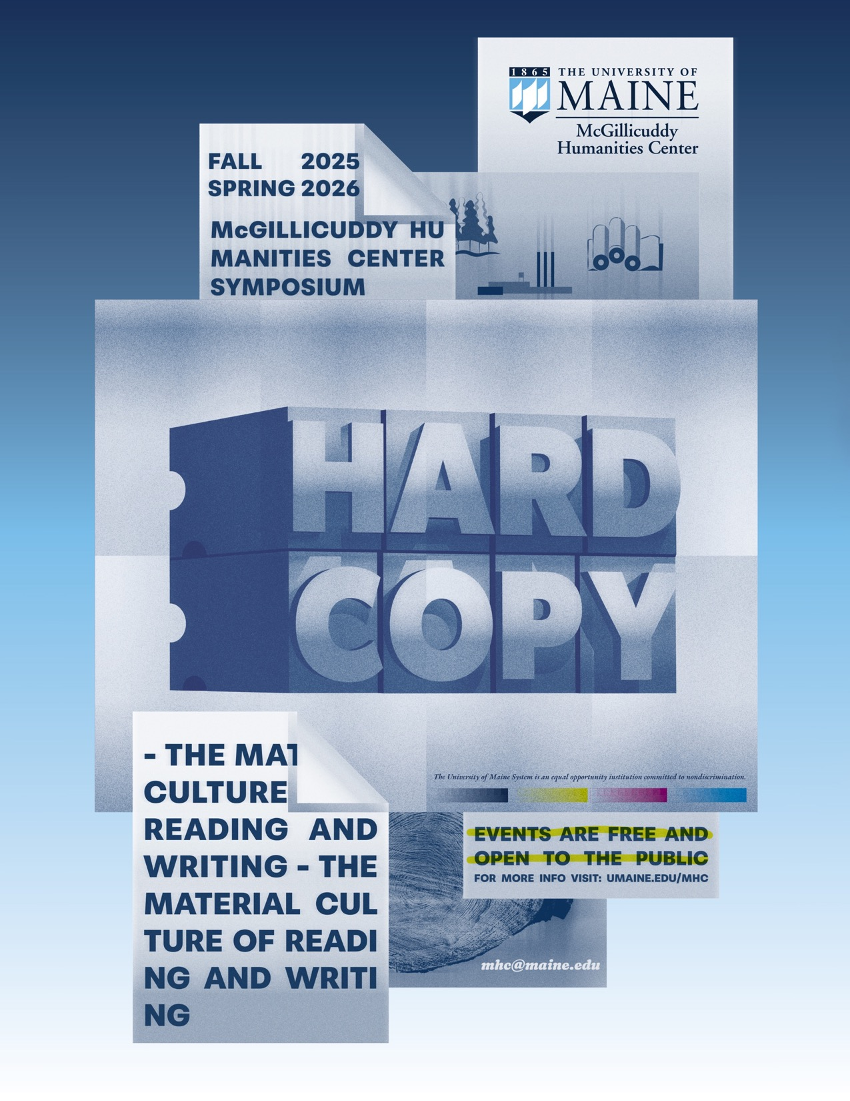
The Clement and Linda McGillicuddy Center Undergraduate Fellows

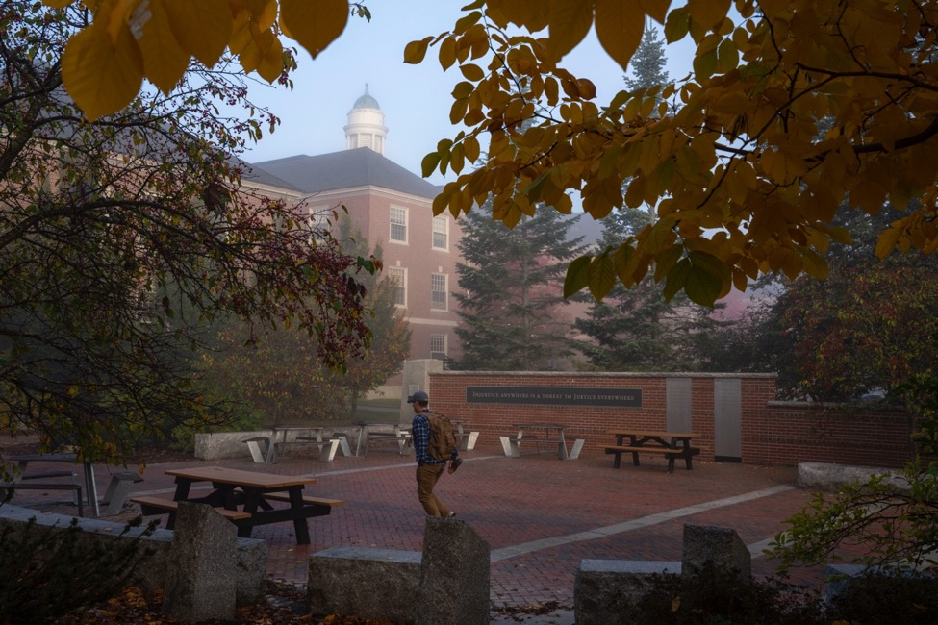

The Fellows program offers juniors and seniors the support to develop individual humanities research or creative projects, work collaboratively with their peers, participate in interdisciplinary humanities programs, and gain professional skills. Fellows attend, help plan, and promote the Center’s programs, which helps connect them and the Center to their peers, faculty, and the public. Fellows also act as student ambassadors for the Center’s mission, both on campus and in communities beyond.

Each student works with a faculty advisor, as well as with the MHC staff and other Fellows, to develop and prepare their research for public presentation. At the culmination of the fellowship, they are required to share their findings or creative works in an MHC showcase event. Most Fellows also create additional outputs for their projects, from poetry chapbooks or journal articles to gallery shows and workshops.

Currently the MHC funds eight total Fellows simultaneously, with new cohorts of four rotating in and out each semester. Fellows are awarded $8,000 over two consecutive semesters for their work as well as up to $1,000 for expenses associated with their work.

As of Spring 2025, 50 students have been selected to join the MHC Fellows program.
Fall 2024 through Spring 2025 MHC Student Fellows

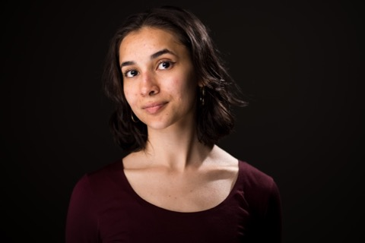
REHANNAH BAKSH, a University Studies major from Queens, New York, utilized their MHC Undergraduate Fellowship to create a choreographic work-in-progress titled “Dogpile: So, what does it mean?” presented in the Dance Studio in Class of 1944 Hall. Baksh’s work-in-progress examined movement interests and dancer dynamics and is based on Ranjana Khanna’s 2007 essay, Indignity. The project explored the intersection of dance and philosophy drawing on work from Anne Bogarts Siti company and Gaga movement vocabulary as well as post-structural and decolonial literary discourse. Baksh’s work formed an exercise in how and when language fails to articulate inexperience through the body and particularly concerned the process of dehumanization and how the body can attempt to speak for itself. Baksh presented a brief spoken introduction of the goals and aims of the work, followed by the performance, and talk back with the ensemble. As part of their fellowship, Baksh also facilitated a two-day movement training workshop with College of the Atlantic faculty member Jodi Baker. Baksh’s MHC Undergraduate Fellowship work was supervised by Assistant Professor of Theatre and English Rosalie Purvis.

OBIE CASPERSON, an Anthropology major and Honors College student from Fort Collins, Colorado, presented a screening of their video essay and MHC Undergraduate Fellowship project “Local Distinctiveness in Nicosia, Cyprus” in Barrows Hall’s Hill Auditorium. Casperson’s project set out to document local distinctiveness in the Mediterranean city of Nicosia and evaluate the impact of 21st-century contemporary urbanization and globalization. Additionally, Casperson presented their MHC Undergraduate Fellowship research for the panel “Invisible Lines, Tangible Impacts: The Anthropology of Borders” at the Maine Science Festival alongside Professor of Anthropology and Quaternary and Climate Studies Dan Sandweiss, moderated by Kate Dickerson of the Maine Discovery Museum. For their MHC Undergraduate Fellowship, Casperson worked with faculty mentor Gregory Zaro, Associate Professor of Anthropology and Climate Change.
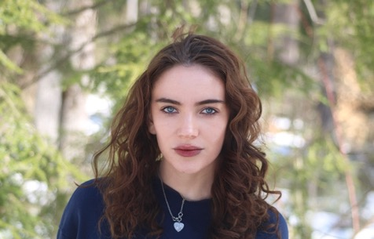

Fall 2024 through Spring 2025 MHC Student Fellows

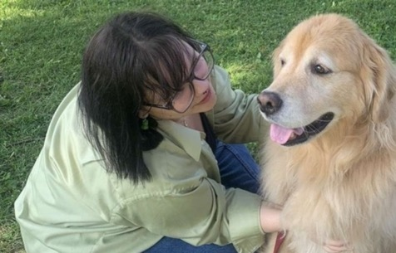
KYRA PEDERSON, a Philosophy major from Brainerd, Minnesota, was awarded an MHC Undergraduate Fellowship to work on their project “Packing the Wound: A Phenomenological Account of Grief Objects.” With this project, Pederson asks: what fills the space that loss creates, and why must that space be necessarily occupied? Through personal exploration, poetry writing, and formal philosophical exploration, and examples: Pederson seeks to establish a working definition of Grief Objects and develop their research argument that Grief Objects exist foundationally within our natural processes of grief and healing from grief. For this research, Pederson has been working with Professor of Philosophy Jessica Miller. Pederson’s presentation occurred in October of the Fall 2025 semester at the University of Maine in Orono and via Zoom.

NEIL ROCKEY, an International Affairs major from Chicago, Illinois, presented their MHC Undergraduate Fellowship research project “When Code Meets Combat: AI Ethics and Just War Theory.” Rockey’s research addresses the question: what happens when algorithms influence life-or-death decisions in wartime? As AI systems are increasingly used in defense, they challenge centuries-old just war principles in unprecedented ways and raise pressing questions. Who bears responsibility when an AI-assisted strike goes wrong? Can machines truly distinguish between combatants and civilians? Using AI ethics principles and an examination of the just war tradition from Augustine to Autonomous Weapons Systems, this research attempts to answer these questions and more. It grounds discussion in existing technologies and near-horizon developments rather than speculating about distant futures to offer a balanced assessment of how the bellum iustum must evolve to address these emerging capabilities. For this project, Rockey was advised by Dr. Manuel Wörsdörfer, Associate Professor in the School of Computing and Information Science and Maine Business School.
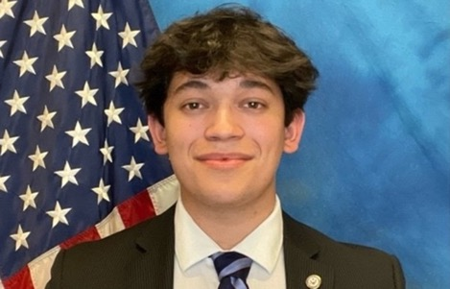

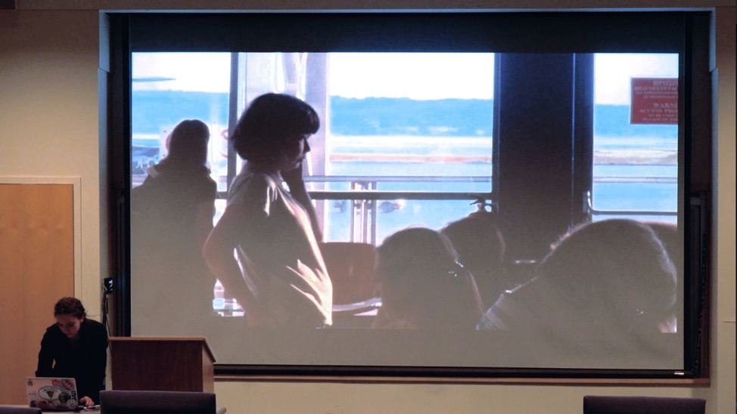

Obie Casperson presents their documentary video research project “Local Distinctiveness in Nicosia, Cyprus” at the Hill Auditorium in Barrows Hall.

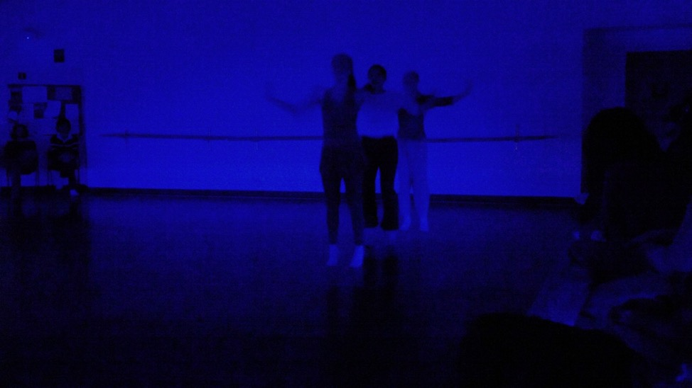

Rehannah Baksh presents their choreographic work “Dogpile: So, what does it mean?,” performed by dancers Anysia Doohovskoy, Elise Dunne, and Macy Harris at the Dance Studio in Class of 1944 Hall.

Spring 2025 through Fall 2025 MHC Student Fellows

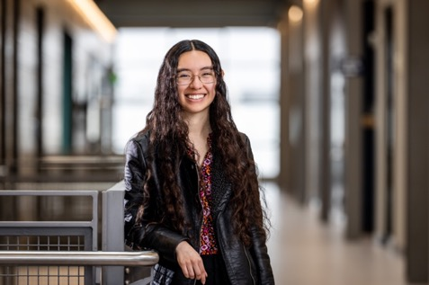
CHANTELLE FLORES, a student in the Honors College and dual English and Art History major from Oakland, Maine, was awarded an MHC Undergraduate Fellowship to work on their project, “The Traces of Other Ghosts: A Documental Poetic Approach to Hypervisualizing Medical Trauma.” With this project, Flores aims to raise awareness of medical trauma by creatively exploring the tensions between patient and medical field, between subject and document, and between the physical body and one’s lived experience. Flores is working with Dr. Hollie Adams, Associate Professor of English. Flores’s MHC Undergraduate Fellowship is supported by the David ’64, ’67G and Alison ’71 Wiggin Humanities Fellowship.

HEATH KENNEDY, a Music Education and Performance major from Cape Elizabeth, Maine, was awarded an MHC Undergraduate Fellowship to work on their project, “The Influence and Uniqueness of Barbara York’s Music.” Kennedy seeks to understand what makes Barbara York’s musical compositions for low brass unique, as well as understand her influence within the tuba and euphonium community. For this research, Kennedy is working with faculty advisor David Stern, Adjunct Professor of Low Brass. Kennedy’s MHC Undergraduate Fellowship is supported by The Sandra Merrill Peters and John G. Peters Humanities Scholarship Fund.

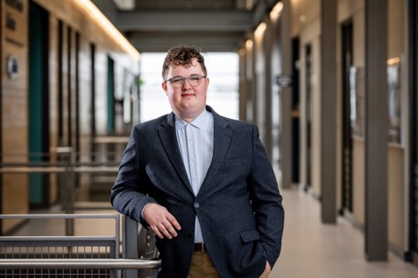

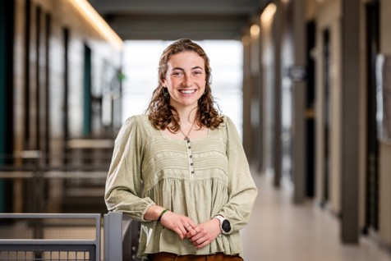

JORDAN RAMOS, a student in the Honors College and a Studio Art and Environmental Science double major from Bristol, Rhode Island, was awarded an MHC Undergraduate Fellowship to work on their project, “Maine Wild Blueberry Harvest Heritage: A Painting Series Exploring the Interconnected Relationship Between the Fields and Communities Practicing the Harvest Tradition of Hand-raking.” For this research, Ramos is advised by Dr. Lily Calderwood, UMaine Cooperative Extension Wild Blueberry Specialist and Assistant Professor of Horticulture. Ramos’s MHC Undergraduate Fellowship is supported by the Echoes of Maine Humanities Fund.

ELLIS SINCLAIR, an English and Women’s, Gender, and Sexuality Studies double major from Bangor, Maine, was awarded an MHC Undergraduate Fellowship to work on their project, “Girls’ Worlds.” For this, Sinclair will produce a collection of essays exploring three classic children’s stories: Alice in Wonderland, Peter Pan, and The Wonderful Wizard of Oz. Employing a Marxist-feminist framework influenced by prominent children’s literature scholars such as Jack Zipes and Maria Tatar, they aim to situate these stories in both their historical contexts and their contemporary sociological relevance. Sinclair is working with the English Department’s Dr. Hollie Adams as a faculty advisor on the project. Sinclair’s Fellowship is supported by the Liam Riordan Humanities Fellowship Fund.
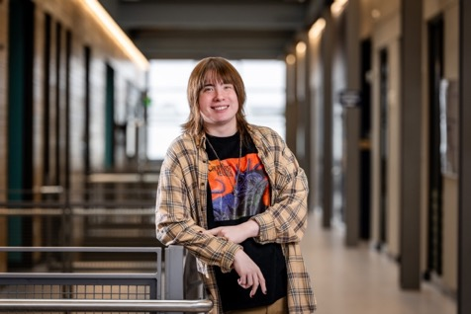

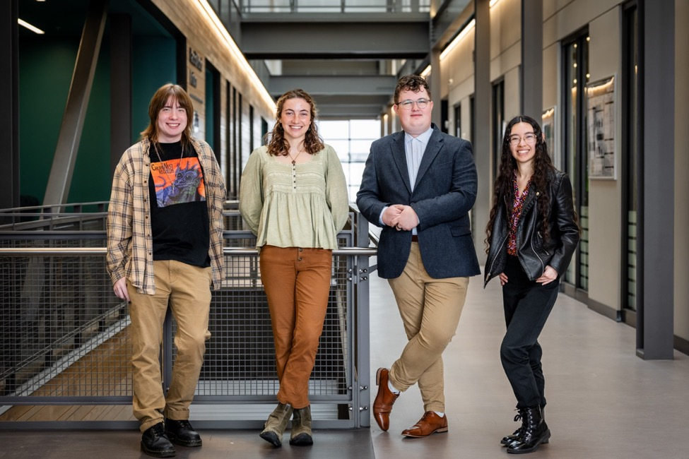

The Spring 2025-Fall 2025 McGillicuddy Humanities Center Fellows, from left to right: Ellis Sinclair, Jordan Ramos, Heath Kennedy, and Chantelle Flores.

Fall 2024 Faculty Grants

Constant Albertson (Art)
“Inter Caetera: Old sins cast a long shadow”

Completed in 2024, this piece was accepted into a major juried exhibition (March 5-May 31, 2025) at the Utah Museum for Contemporary Art in Salt Lake City. This exhibition was a major feature of the conference (March 26-29) of the National Council on Education in the Ceramic Arts (NCECA) and the opening of the exhibition was held during the conference. The funding supported Connie’s travel to install her piece and attend the opening/conference.

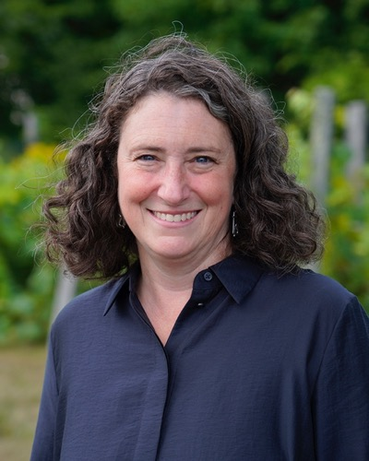
Sabrina De Turk

Sabrina DeTurk (Honors)
“Women in Early Modern Venetian Art: Fluid Identities”

This MHC Faculty Grant supported essential research travel to Venice, Italy for Dr. DeTurk’s book project, Women in Early Modern Venetian Art: Fluid Identities. The book is under contract with Routledge and Sabrina finished the final manuscript over summer 2025. The trip allowed her to view and photograph key artworks and architecture that are central to her analysis of how women were represented in 15th and 16th century Venetian painting. The timing, during spring break in March 2025, allowed Dr. DeTurk both to capture images of sites she have already identified as critical to her text and also to explore additional artworks and architecture that she could incorporate into the book.

Ryan Dippre (English)
“Exploring the Archives: Tracing UMaine’s History/ies of Writing Instruction”

The University of Maine has long been a site of cutting-edge engagement with rhetoric and composition. Thanks to the careful stewardship of the first-year writing program for almost a half century by Pat Burnes, that history has been saved as a massive archive that she gave to the program upon her retirement in 2017. In early Fall 2024, the program was awarded a small grant by the Boston Rhetoric and Writing Network to explore, organize, and begin to digitize these archives. This grant allowed for a graduate student (Tulane Simpson) and their supervisor (Ryan J. Dippre) to travel to the April 2025 Conference on College Composition and Communication in Baltimore, Maryland to discuss their recent work in the program archives at the National Archives of Rhetoric and Composition meeting.

Rob Glover (Political Science and Honors)
“Strengthening American Democracy Through Poll Worker Recruitment”

This proposal sought support for an ongoing research project examining American democracy, a collaboration between researchers at the University of Maine and Colby College, and an array of stakeholders and practitioners across the state. Specifically, Dr. Glover sought resources to enable two members of his student research team, Makenzie “Mak” Thompson and Julian Ober, to attend a two-day “conference within a conference” (CWAC) in January at the larger Southern Political Science Association (SPSA) annual conference. This CWAC convened scholars and practitioners from across the country, focusing on the ways that research can shape, inform, and improve democratic practice.

Stephen Miller (History)
“Feelings and Emotions in a colonial war: Victorian Soldiers in South Africa, 1899-1902”

This grant supported the presentation of two papers related to Stephen’s new book, The Military Papers of Field Marshal Sir George White 1885- 1900: Upper Burma, India, and South Africa to the Army Records Society in both London and Aberdeen in May-June 2025. In addition, funds support trips to London and New Zealand for Dr. Miller’s next book project.

Fall 2024 Faculty Grants

An Nguyen (Cooperative Extension)
“Voices of Change: Women, Work, and Labor Activism in Maine”

Tentatively titled “Voices of Change: Women, Work, and Labor Activism in Maine,” this ambitious oral history project aims to build a digital archive of audio and video interviews with women who can help advance our understanding of the labor movement and women’s working experience in Maine. They include labor leaders, union organizers, labor rights advocates, scholars of labor and gender, policy-makers, and working women from various industries and ethnic
backgrounds throughout the state. Dr. Nguyen will be leading this project with the support of the Bureau of Labor Education at the University of Maine, the Dr. Scontras Center for Community and Labor Education at the University of Southern Maine, the Maine AFL-CIO, and the Western and Eastern Maine Labor Councils.

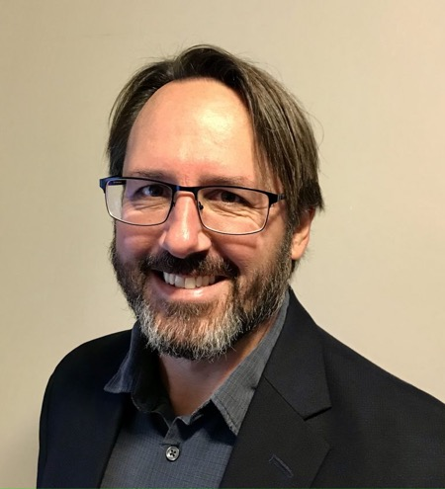
Gregory Zaro

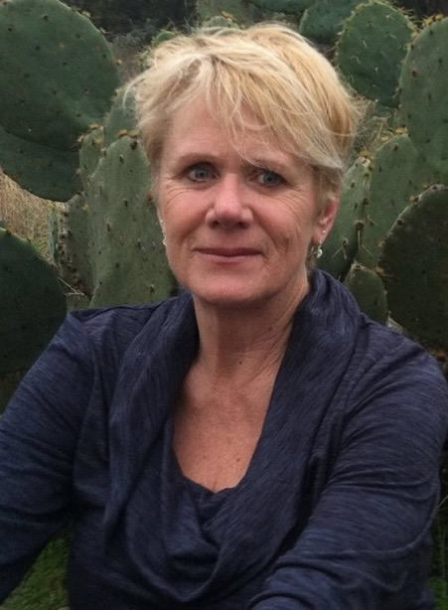
Susan Smith
Susan Smith (Intermedia)
“Shifting Ecosystems: disappearing landscapes”

This project aims to document both the rapidly changing landscapes of the American Southwest, specifically, the Rio Grande Valley, that are being dramatically altered by climate change, and migration at the geographic border; all sites of shifting ecosystems. Through site-based research a data visualization will be created of relationships between climate, migration and biodiversity.

Gregory Zaro (Anthropology)
“Documenting Legacies of ‘Green Heritage’ in a Mediterranean Urban Setting”

The proposed project seeks to document legacies of “green heritage” in Valencia, Spain, a 2,200-year-old city in the western Mediterranean. Using proven strategies from ongoing work in Zadar, Croatia, the project will utilize archaeological data, historic aerial imagery, cadastral maps, and contemporary city plans to identify, ground truth, describe, and photographically document legacies of past land use within the contemporary urban setting. The results will help to promote a landscape of local distinctiveness that is constantly threatened by urban development.

Spring 2025 Faculty Grants

Don Beith (Philosophy) and Susan Bredlau (Philosophy)
“International Merleau-Ponty Circle, 2025”

Don Beith and Susan Bredlau were awarded an MHC Faculty Grant to host the 49th annual meeting of the International Merleau-Ponty Circle at the University of Maine in September 2025. The International Merleau-Ponty Circle is a prestigious international society specializing in applying Maurice Merleau-Ponty’s philosophy to contemporary issues. Beith and Bredlau will use MHC funding to support the conference and its 2025 theme: “Health and Healing: Personal, Social and Environmental.”
Rebecca Dewan (Choral/General Music Education)
“Considering Matthew Shepherd”

Rebecca Dewan was awarded an MHC Faculty Grant to work with UMaine School of Performing Arts and the Maine Gay Men’s Chorus to present the Maine premiere of Craig Hella Johnson’s “Considering Matthew Shepard,” a choral work that addresses themes of love, loss, and social justice through the lens of the tragic murder of 21-year-old Matthew Shepard near Laramie, WY, in 1998.
Robby Finley (Philosophy)
“Philosophy of Logic and Games: Intersections and Applications”

Robby Finley was awarded an MHC Faculty Grant to support travel to present two related projects that examine how applications of logic to reasoning and the gamification of reasoning can provide a fruitful frame of analysis for classic philosophical problems. Finley will present “The Value Capture Argument for Logical Pluralism” at The First Paris-Chicago Joint Conference in the Philosophy of Logic and Mathematics and “Logic as Game: Wittgenstein, Suits, and the Concept of ‘Game’” at The 52nd Annual Meeting of the International Association for the Philosophy of Sport.
Sarah Harlan-Haughey (English)
“Areley Kings and Severn Valley Site Visit”

Sarah Harlan-Haughey was awarded an MHC Faculty Grant for travel to Areley Kings and the Severn Valley in England for work toward the completion of their second book project. Harlan-Haughey will ubicate their study in the specific landscape in which the poet Layamon would have been working.

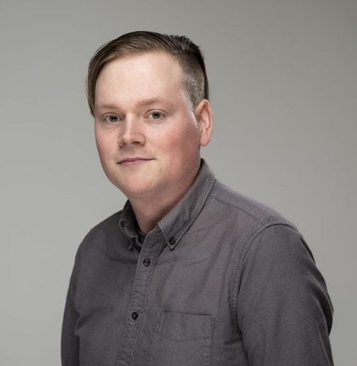
Robby Finley
Susan Pinette (Modern Languages and Director of Franco-American Center)
“Digitizing Peter Archambault's Beau-frog Drawings”

Susan Pinette was awarded an MHC Faculty Grant for the project Digitizing Peter Archambault’s “Beau-frog” drawings. This grant will complement an NEH Humanities References and Resources Grant received by UM Franco American Programs to digitize many of Peter Archambault’s iconic 1970s/1980s political cartoons including nearly 500 oversize drawings that require special attention. This grant will fund digitization of these oversize drawings by the USM Osher Map Library.
Judith Rosenbaum-Andre (Communication and Journalism)
“A deep dive into media engagement: Morality and neurodiversity”

Judith Rosenbaum-Andre was awarded an MHC Faculty Grant for the project “A deep dive into media engagement: Morality and neurodiversity.” The awarded MHC funding will assist with travel to the annual convention of the International Communication Association held in Denver, CO where Rosenbaum-Andre will advance two separate projects: one addressing how violations of morality impact people’s parasocial relationships with media influencers and another on how neurodiversity impacts people’s engagement with media narratives.

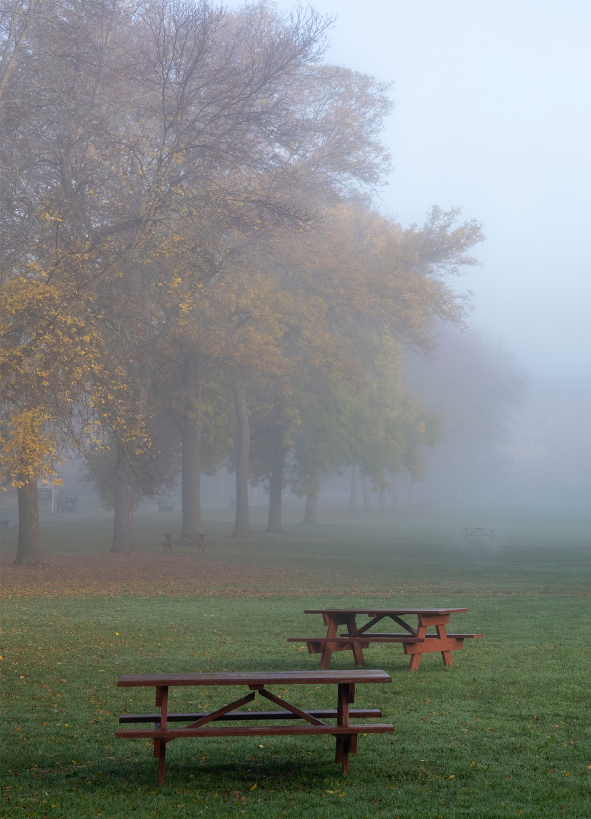

Intermedia Professor Susan Smith Documents Shifting Ecosystems in the American Southwest

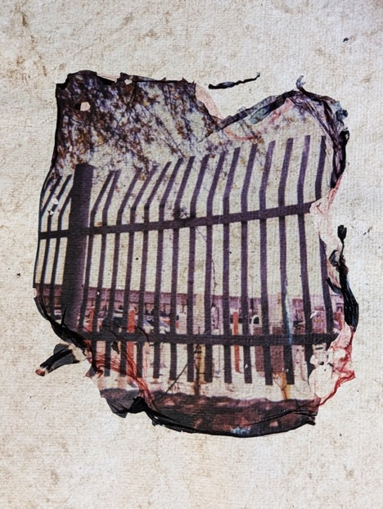

“Border Wall” by Susan Smith, from “Shifting Ecosystems: disappearing landscapes,” 2024.

Susan Smith, Associate Professor of Research and Graduate Coordinator of the Intermedia Program, utilized their MHC Faculty Grant to support explorations with alternative photographic processes and engaging directly with place as both subject and material in the project “Shifting Ecosystems: disappearing landscapes.”
With this project, Smith set out to visually document the rapidly shifting landscapes of the American Southwest, specifically the Texas/Mexico borderlands around El Paso/Juárez and the high desert. These sites are deeply impacted by climate change, border wall construction, and migration—both human and more-than-human. The ecosystems are undergoing profound disruption, manifesting in habitat fragmentation, biodiversity loss, and ongoing degradation. Research in these areas is further complicated by shifting policies, underscoring the entanglement of human activity with delicate ecological systems. The border wall alone threatens 89 endangered species and 108 species of migratory birds, while also exacerbating soil erosion, drought effects, and the damage caused by fracking.
As a means of documenting these landscapes, Smith employed the processes of Polaroid lift and lumen printing. Both processes resist the idea of permanence typically associated with art. Polaroid lift requires delicately detaching the image from its backing and floating it in water, where it becomes a fragile membrane, easily torn and rendered unusable. The lumen print process Smith uses does not rely on chemical fixatives, and produces images that inevitably fade over time and with exposure to light. Both processes memorialize loss while inhabiting a liminal space—what might be called a space “between borders”—and mirror the fragility of soils and ecosystems shaped by extractive and colonizing practices.
Regarding the project and the MHC Faculty Grant, Smith reflects:
As a faculty fellow, I have centered my artistic practice on confronting the consequences of these disruptions. It was important to me to feel the soil beneath me, to stand at the border wall, and to witness the transformations of these landscapes firsthand. Just as the borderlands are subjected to extraction and degradation, the traces my work produces are intentionally transient—an evanescent act rather than a fixed representation. Using water and soil gathered on-site, the artworks themselves embody the fragility of the environments they emerge from. I have sculpted vessels from soil, after visiting the sacred Hueco Tanks, a historic sacred site where cracks and hollows (“huecos” in Spanish) in igneous rock capture rainwater and channel it through the landscape. The vessels I created are a response to this place, and hold malas, or prayer beads, which are actually “seed bombs”; clay and soil with pollinator seeds from my own garden. This work does not seek to provide answers to immense challenges such as the climate crisis, mass human migration, or ecological collapse. Instead, it offers an ephemeral witnessing and a hybrid artistic response to these uncertainties. Alongside this fieldwork, these approaches extend into my teaching, where I guide MFA students in alternative photographic methods, sustainable art materials (pigments, dyes, fibers), and site-specific practices at the intersection of art and science.
Through the integration of on-site alternative photography, sculpture and reverence for place, Smith’s research creates a powerful visual record of vanishing ecosystems. By privileging presence over permanence, this body of work created with assistance from the MHC Faculty Grant, serves as a fleeting testimony to landscapes under profound transformation.

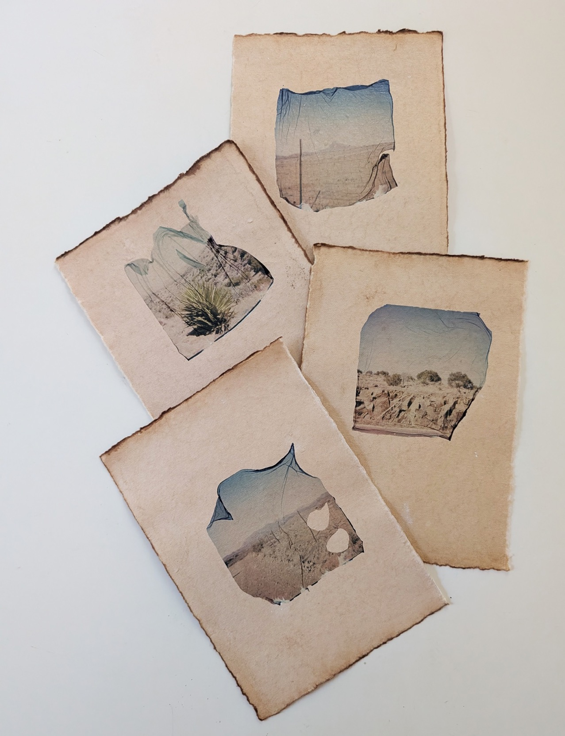

Hueco Tanks by Susan Smith, from:
Shifting Ecosystems: disappearing landscapes, 2024.

FUNDRAISING FOR MHC

OUR MISSION:

The Clement and Linda McGillicuddy Humanities Center (MHC) demonstrates the immediacy and applicability of humanities studies by advancing teaching, research and public engagement in the humanities in Maine.

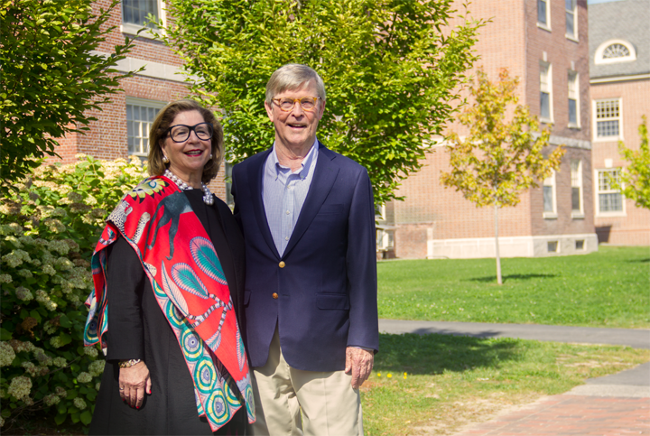

Clement and Linda McGillicuddy

Clement and Linda McGillicuddy support the Humanities Center through a fund they established in 2017 at the University of Maine Foundation. The McGillicuddys are committed to “giving back” to a state that means a great deal to their family.

Clem, a 1964 graduate of UMaine and a Houlton native, explains, “The University of Maine exposed me to many new situations … Many of my courses at UMaine, unrelated to my major, contributed to my curiosity and created a foundation for lifelong learning.” He is especially appreciative that the Center’s outreach extends well beyond classroom learning and opens new horizons for high school students and other Maine citizens.
MHC Gifts, Endowments and Funds

Donors have made gifts and pledges, and contributed their vision, time and expertise, as well as operating funds and sponsorships to support MHC activities.

Fundraising

The McGillicuddy Humanities Center Endowment Fund was created to support the MHC mission. Launched in 2010, the fund and Center were named for Clement and Linda McGillicuddy in 2017, and the Center continues to receive their generous support. Beyond the MHC Endowment Fund, additional donors have created, and continue to create, specific endowments affiliated with the McGillicuddy Humanities Center. Collectively, donations totaling $4,500,000 through May 2024.

Gifts of all sizes contribute to this permanent resource for the humanities at the University of Maine.

Endowments

Clement and Linda McGillicuddy Humanities Center Fund

The University of Maine Humanities Center was renamed in 2017 to recognize the enormous support of Clement McGillicuddy ’64 and his wife, Linda, of Hobe Sound, Florida and Northeast Harbor, Maine. The Clement and Linda McGillicuddy Humanities Center Fund advances teaching, research and public knowledge of the humanities. By developing and supporting programs that engage art, literature, history, philosophy, politics and diverse cultures, MHC aims to enrich the lives of all Maine citizens.

University of Maine Humanities Center Endowment Fund

Launched in 2010, the University of Maine Humanities Center Endowment Fund supports the Center’s mission. Earned income provides annual support for programs, research and community engagement. The fund is a general repository for gifts of any amount. Additional donors have created specific endowments affiliated with the humanities.

Affiliated Funds

Affiliated funds are established to support activities consistent with the mission of MHC and can be managed in collaboration with other UMaine units.
Richard Parks Anderson and Karin M. Anderson Music Composition Fund will provide financial assistance to the School of Performing Arts’ Music Division in support of the composition of musical works by UMaine students and faculty and performances by UMaine faculty and students of those works and other works by living composers.

Brennan Family Scholarship, established by Michael Brennan, Ph.D. ’19 in memory of his mother, Tara Brennan O’Meara, to benefit students with demonstrated financial need who are majoring in any humanities disciplines.

College of Liberal Arts and Sciences Scholarship Fund, established by Kathryn Olmstead to support meritorious students with a financial need in the arts and humanities.

Eaton Family New Writing Series Fund, established by John T. Eaton ’66 and Linda Talbot Eaton ’66 to support innovative and adventurous literary programming through the New Writing Series.

Echoes of Maine Humanities Fund, will support faculty and student engagement in research, events, lectures and collaborative activities that highlight the Echoes of Maine philosophy.

Jeannine Emond Lucey Franco-American Program Fund, established by Anne Lucey ’81 in tribute to her mother.

Global Exploration & Language Opportunities Fund, established by Charles Ryan ’84, provides support to students who wish to expand their global views through international travel to Central and South American countries.

Global Perspectives for Humanities Explorations Fund, established by Friends of the Salzburg Study Abroad Program in honor of Josef Roggenbauer, professor emeritus of German, the fund will provide support for faculty and students to benefit from opportunities that will expand their global views, ideas and experiences.

Susan and Philip Hamilton Humanities Fund, established by Susan Hamilton and Philip Hamilton ’85 to support humanities faculty and community engagement.

Sandy and Bobby Ives Fund, established by David Taylor ’74 and LeeEllen Friedland in recognition of the Ives’ contribution to folklife studies.

Adrien Lanthier Ringuette Franco-American Centre Library Fund, established by Celeste Ringuette in memory of her late husband.

Alan Miller Fund for Excellence in Communication and Journalism, established by Anne Lucey ’81 in memory of her late husband.

Patricia S. O’Brien Humanities Fellowship Fund, established by Matt Mullen ’08 in honor of his mother to support a Clement and Linda McGillicuddy Humanities Center Undergraduate fellow with a preference for a student who is majoring in History.

Opportunities in Journalism Fund, established by Brian A. Naylor ’78, ’04 H and Barbara J. Van Woerkom. The fund is intended to provide financial assistance to undergraduate students majoring in journalism.

The Sandra Merrill Peters and John G. Peters Humanities Scholarship Fund, established by Sandra Merrill Peters ’69 and John G. Peters ’69 to provide financial assistance to a deserving UMaine first-year undergraduate student majoring in a humanities field.

Liam Riordan Humanities Fellowship Fund, established by Tim Garrity ‘14G and Lynn Boulger, in honor of History Professor Liam Riordan, to celebrate his 25th year on the UMaine faculty. It supports a Clement and Linda McGillicuddy Humanities Center Undergraduate Fellow with a preference for a student who is majoring in History.

The Schmelzer-Livingston Center for Poetry and Poetics Fund, established by Henry Schmelzer ’65 and his wife, Cynthia Livingston, in recognition of the newly renamed Center for Poetry and Poetics at UMaine. The fund will support ongoing and new initiatives at the center.

Wickham Skinner “Making Things Better” Humanities Fund, will support an annual award to a faculty member whose recent scholarly accomplishment has contributed substantially to the humanities.

Claire Labrie Strickland ’75 Scholarship, established by friends and family in honor of Claire’s retirement, to provide scholarship funding to upperclassmen in the humanities who have demonstrated financial need, with a preference for those who are the first in their family to pursue a post-secondary education.

Dr. Robert M. and Jean W. Swan Humanities Scholarship Fund, established by the Swans to provide financial assistance to undergraduate students enrolled in health and related sciences who may wish to pursue additional studies in the humanities.

Wabanaki Student Support Fund, established by Barbara Bassler Keast ’63, to provide Native American students enrolled in the humanities disciplines short-term immediate financial assistance, to help ensure that they will have tools and resources needed to succeed in their pursuit of a degree.

Dr. Herbert E. Whiteley ’73 and Yvette Poirier Whiteley ’74 Fund, established by the Whiteleys to enrich the University community by providing support for visiting musicians and scholars in the humanities.

David ’64, ’67G and Alison ’71 Wiggin Humanities Fellowship, established by David Wiggin ’64, ‘67G in memory of his wife, Alison, to support a Clement and Linda McGillicuddy Humanities Center Undergraduate Fellow with a preference for a student who is majoring in English or Modern Languages from Southern Aroostook County.
Global Exploration and Language Opportunities Fund Award

The McGillicuddy Humanities Center and the University of Maine Office of International Programs (OIP) presented awards of $1500 from the Global Exploration and Language Opportunities Fund to Eli Rosen, Mackenzie Hanson, and Quincy Clifford for studies abroad in Costa Rica.

The Global Exploration and Language Opportunities Fund was established at the University of Maine Foundation in 2022 with a gift from Charles Ryan ’84. The Global Exploration Fund provides students opportunities to participate in activities which will expand their global views, ideas, and experiences through international travel with a preference for those wishing to travel to Central and South American countries.

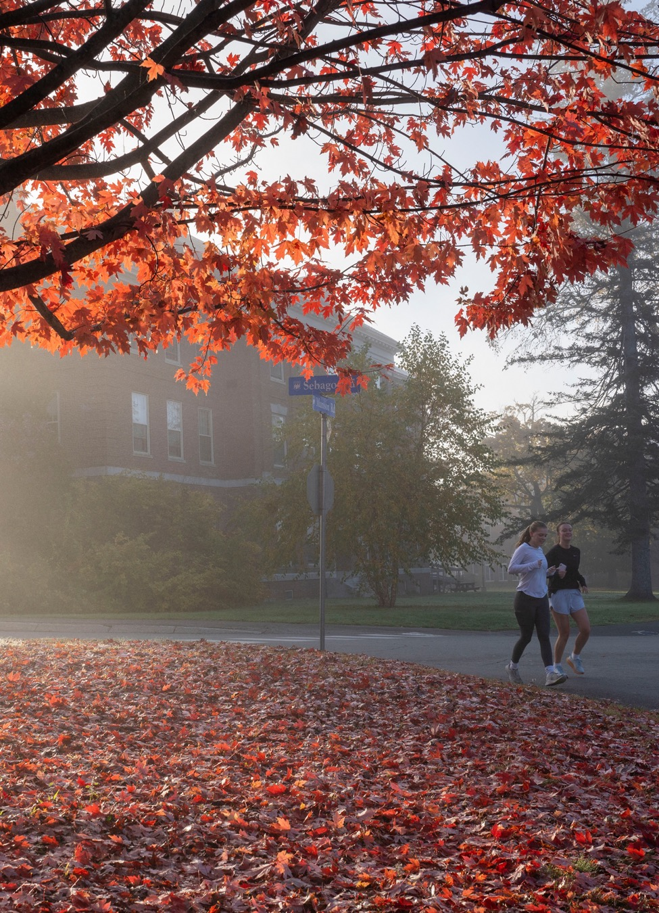

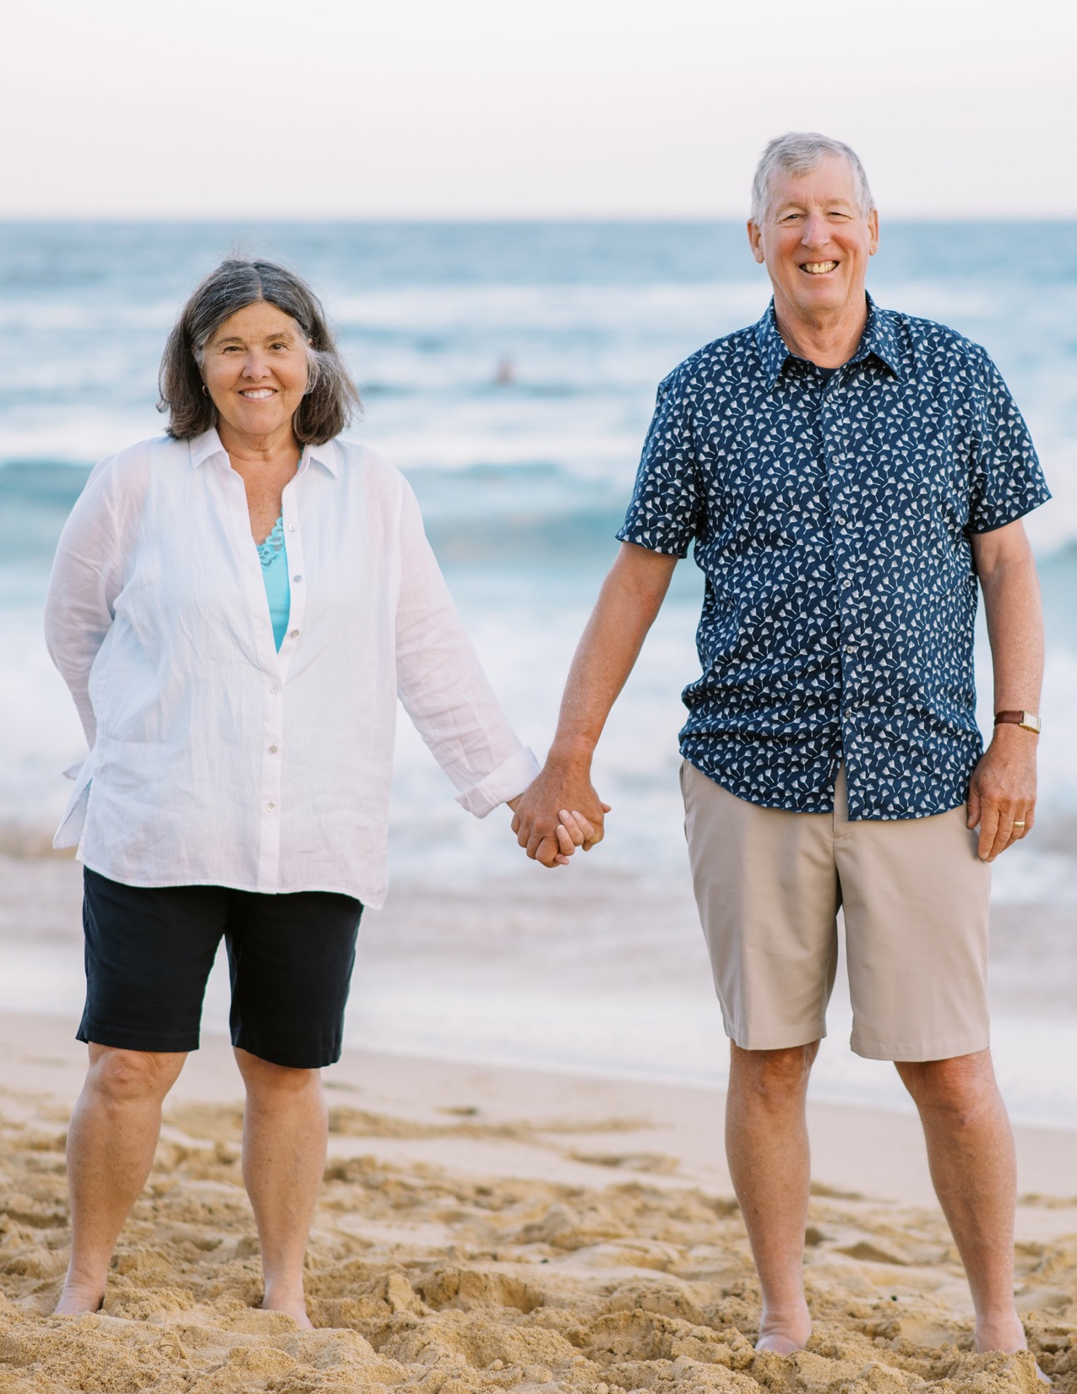

Alumni Herb and Yvette Whiteley Sponsor New Fund for Performing Arts at UMaine

In 2023, the McGillicuddy Humanities Center (MHC) welcomed Herb Whiteley to our Board of Advisors. Herb, a graduate of the University of Maine in Animal and Veterinary Science, along with his wife Yvette, a graduate of the University of Maine in History, together established the new permanently endowed Dr. Herbert E. Whiteley ’73 and Yvette Poirier Whiteley ’74 Fund to contribute to the MHC and support the arts and humanities at UMaine. The 2025/2026 academic year marks the first use of the Whiteleys’ new fund, which will provide annual distributions to enrich the University community by supporting visiting musicians and other visiting scholars in the humanities at UMaine. The Whiteley fund will enhance academic and cultural life on campus by bringing visiting scholars and musicians to UMaine for lectures, class visits, performances, workshops, and other public events.

Both Herb and Yvette have each been professionally involved in academic institutions since their days at the University of Maine in the late ‘60s and early ‘70s. Herb, a Professor Emeritus of the University of Illinois College of Veterinary Medicine, began his professorial career at the University of Illinois, subsequently taking a position at the University of Connecticut before ultimately returning to the University of Illinois as Dean of the College of Veterinary Science for 14 years. Yvette has worked for both the Office of the Dean of Arts and Sciences at the University of Connecticut and in Development for the College of Fine and Applied Arts at the University of Illinois. Together, the Whiteleys know the intricacies of university funding and they are clear in their hopes for the support they are lending to the McGillicuddy Humanities Center:

“We wanted to give money to something that is important and to us the arts and humanities are important. While the fund is specific, we wanted to give latitude and allow it to be general enough that the Center could put it to use regularly and take chances with its programming,” says Yvette.

The Whiteleys’ time at UMaine in many respects shaped the form of their giving and its emphasis on visiting scholars and musicians participating in direct engagement with students. Herb, who in addition to his career in Veterinary Medicine is an avid trumpeter and today performs as part of several bands and orchestras in Central Illinois, recalls his experience with music at UMaine with particular fondness. As a student, when he wasn’t working toward his goal of attending veterinary school, Herb could be found honing his craft on the trumpet in Lord Hall (then the home of the Music Department) and performing as a part of the university’s band, orchestra, opera workshop, and brass quintet. It was there that Herb relished visits from George Cavender, Director of Michigan University Bands, and members of the Tonight Show Band. Both left lasting impressions and in both instances the visiting guests directly engaged with the students: Cavender led rehearsals and the Tonight Show Band members performed live alongside student musicians.

Having met as students at UMaine, Herb and Yvette are a “bear pair” who claim: “the University of Maine holds a special place in our hearts.” Both point to their time at UMaine as crucial to their life trajectories. Speaking to the intent of their fund, Yvette notes:

“College is a really formative time of your life where you are safe to explore and have new experiences. When you’re a student, you have no idea whether an experience you have will be part of your life’s path or not; but, some will land and become a part of your trajectory. If we can in some small way help create the opportunities for moments like that to happen, that’s great.”
In Fall 2025, the Whiteley Fund will support visiting scholar Leah Batstone, a musicologist and founder of the Ukrainian Contemporary Music Festival in New York City, who is currently Assistant Professor of Music History at Montclair State University in New Jersey. Dr. Batstone’s visit will coincide with Ukrainian folk quartet DhakaBrakha’s performance at the Collins Center for the Arts on November 21st where she will lead a pre-performance discussion. Dr. Batstone will also meet with students in Michael Nokes’s History of Western Music class and lead a public guided listening session of contemporary Ukrainian folk music at the IMRC Center’s Ferland Adaptive Presentation and Performance Environment.
At the Center, we look forward to this and future events nourished by the Whiteleys’ support and hope that together we can create experiences that will impact the trajectories of students here at UMaine.

Patrons Circle

Patrons provide an annual gift of $1,000 in support of MHC initiatives.

Richard P. Anderson and Karin Anderson
Constance Hurley Babcock
Jessica Canatsey and David Canatsey
Ann Chase and Charles J. McGillicuddy
Sheila E. Comerford and Stephen W. Gove
Corey L. Davis
Steven Richard Evans, Ph.D. and Jennifer J. Moxley
Fidelity Foundation
Kevin Foss and Katie Lattari
Timothy Garrity and Lynn Boulger
Liane Shevis Giambalvo, RD, LCPC and Leonard Giambalvo
Alice Fonesca Haines
Philip Hamilton and Susan Hamilton
Jeffrey E. Hecker, Ph.D. and Judith L. Stickles
Jon T. Lightner
Clement E. McGillicuddy and Linda McGillicuddy
Jean E. McPeek
Blaine D. Moores
Matthew R. Mullen and Emily S. Mullen
Brian Naylor and Barbara Van Woerkom
Linda Weisskirchen Nula and Michael A. Nula
Kathryn Olmstead
John G. Peters and Sandra Merrill Peters
Celeste A. Ringuette
Charles H. Ryan
Henry L.P. Schmelzer and Cynthia E. Livingston
Terry Strickland and Claire Strickland
Dr. Robert M. Swan and Jean W. Swan
David Taylor and LeeEllen Friedland
Amb. John K. Veroneau and Carol Svoboda
James S. Ward IV and Susan C. Ward
Dr. Herbert E. Whiteley and Yvette Poirier Whiteley
David C. Wiggin
Board of Advisors

The Center’s Board of Advisors is a standing committee composed of University of Maine alumni and friends who advance the McGillicuddy Humanities Center’s mission. Leading by example as ambassadors, advisors, and supporters, the Board of Advisors acts as a conduit for information and opinion to and from the MHC, broadly sharing the programs and mission of the Center. In addition to contributing their time and expertise, all members of the BOA have made gifts or pledges to support MHC activities, or have included the MHC in their estate plans.

Chair

Tim Garrity ’14, Historian, Mount Desert Island Historical Society (retired)

Members

Nolan Altvater, ’20, University of Maine I.Ph.D. student and Special Projects Cultural Coordinator, Maine Coast Heritage Trust
Dr. François G. Amar, Professor Emeritus of Chemistry and former Dean of the University of Maine’s Honors College
Mary Copeland, ’11, Managing Director, Avance Partner Search
Dr. Sean Cox, ’15, ’20, independent scholar; Managing Editor, Mount Desert Island Historical Society
LeeEllen Friedland, President, Ethnologica
Jeffrey Hecker, ’86, ’14, Professor of Psychology, University of Maine
Tam Huynh, ’03, Executive Director, Holocaust and Human Rights Center of Maine
Carl Little, freelance writer, art critic and author
Lisa Marin, UMM ’09, retired educator; President, John Marin Foundation
Brian Naylor, ’79, Washington Correspondent, National Public Radio (NPR)
Sarah Penney, ’21, Senior Communications Associate, Sabin Vaccine Institute
Henry L.P. Schmelzer, ’65, former Chair, Maine Public Broadcasting (MPBN) Board of Trustees; former President and CEO, Maine Community Foundation
Dr. Robert Swan, ’68, dentist (retired) and Jean W. Swan, educator (retired)
Dr. David A. Taylor, ’74, External Relations and Program Development Officer for the Library of Congress
Herb Whiteley, ’73, Professor Emeritus, University of Illinois College of Veterinary Medicine

Ex-Officio

Emily Haddad, Dean, College of Liberal Arts and Sciences, University of Maine
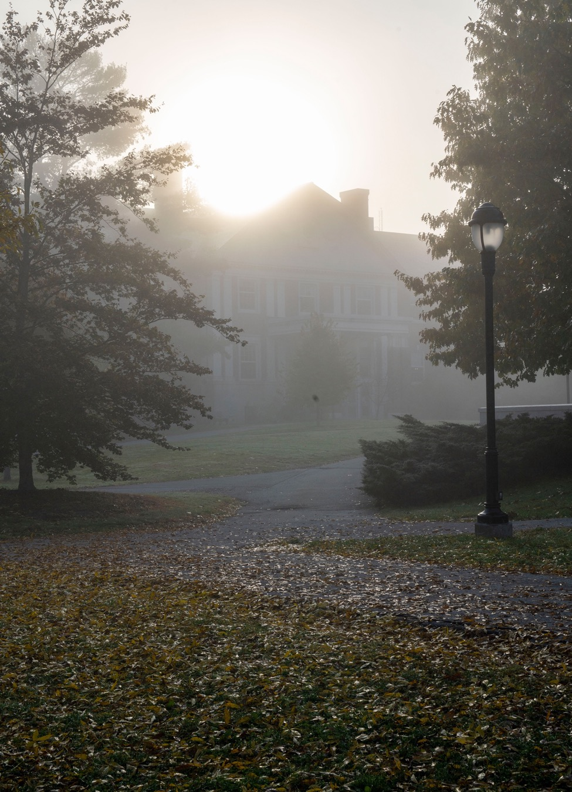

In complying with the letter and spirit of applicable laws and pursuing its own goals of diversity, the University of Maine System does not discriminate on the grounds of race, color, religion, sex, sexual orientation, transgender status, gender, gender identity or expression, ethnicity, national origin, citizenship status, familial status, ancestry, age, disability physical or mental, genetic information, or veterans or military status in employment, education, and all other programs and activities. The University provides reasonable accommodations to qualified individuals with disabilities upon request. The following person has been designated to handle inquiries regarding nondiscrimination policies: Director of Equal Opportunity, 5713 Chadbourne Hall, Room 412, University of Maine, Orono, ME 04469-5713, 207-581-1226, TTY 711 (Maine Relay System).

