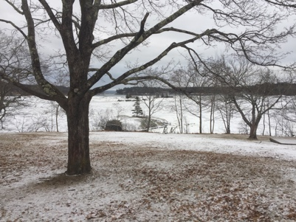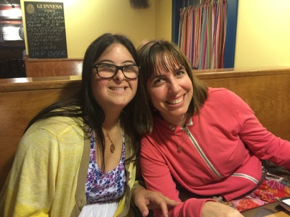

Nature Links is starting our Blue Hill Maine Program in February 2019

Our program is designed to help young adults continue their education after high school. We primarily address those with mild intellectual disabilities such as Autism. Our goal is to enhance independent life skills, job training, help to make new friends, learn about where we all live – contribute to our community - and have fun. Our curriculum seeks student input.
- We continue to meet at the Simmering Pot for (free) dinner, talking and games.
- When? Mondays from 4-6 pm at the Congregational Church, Blue Hill. All are welcome.

We are now announcing that our new Regular Daytime Program will begin meeting both Wednesday Feb 6 and Friday Feb 8th from 10 am - 2 pm (and subsequent weeks at those times). Bring your own lunch.
See our (draft) website at: https://sites.google.com/view/naturelinksmaine
Location: Bagaduce Music Lending Library Auditorium, 49 South St, Blue Hill
Costs? We welcome all interested students, irrespective of income. It’s free.
For more information about joining our program or contribute to help Nature Links build our teaching staff, contact coordinator Dr. Gregory Bush 305-926-5001
Background: Nature Links began in Miami Florida in 2007 with a successful set of programs focused on cooking, gardening, learning about environmental science, independent life skills, job training, healthy relationships, art, music videography (and more) – all leading to more fulfilling lives. That program has produced jobs for most of our graduates and continues with a focus on climate change and art. See our Miami website at http://naturelinks.net
Our program will focus on learning about the natural world around us in the beautiful Blue Hill Peninsula.
Brrrrrrh- Its now cold up here in Blue Hill but we are excited to start our new Nature Links Program.
We thank the Bagaduce Music Lending Library for providing us the space to start our program. Along with the Congregational Church, our Nature Links program lives on the generosity of local institutions and volunteers who make various presentations. Join us.

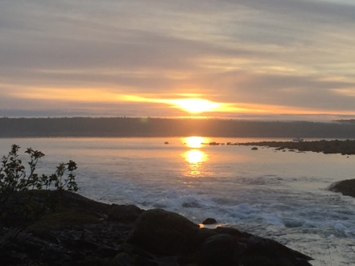
A growing group of parents has met over months to help begin this effort and to assist parents to learn more about state benefits and local programs.

