Autism Spectrum Disorder
Fact Sheet

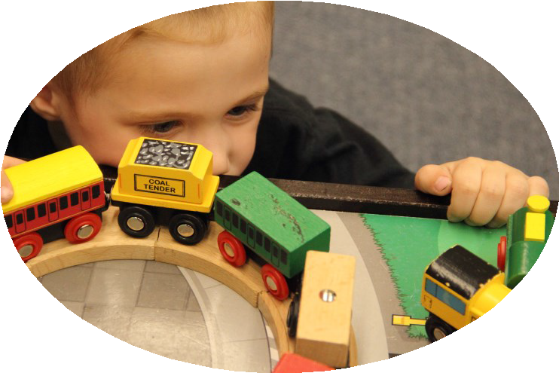What is autism spectrum disorder (ASD)?
Autism Spectrum Disorder (ASD) is a developmental disability stemming from problems in a child’s neurological system. It
impacts how a person communicates, behaves, and socializes with others. The impact on day-to-day living varies from person to person and can be mild to severe. Nearly half of all persons with autism have an average to above average intellectual abilities.
Autism is considered a lifelong condition.

How common is ASD?
According to the CDC (2018), autism affects one in 59 children, with boys being five times more likely to be identified than girls. Currently, researchers believe there is no single cause for ASDs, and both genetic and environmental factors may play a role. Typically, children are diagnosed in the first three years of life, however, some individuals may not be diagnosed until later in childhood or even in adulthood.

What are some signs of ASD?

Persons with autism may communicate, behave, learn, and interact with others in ways that are different than most people. The following are some things you may notice when interacting with someone with autism. Persons with autism may:

- Make limited eye contact
- Repeat or echo words or phrases
- Prefer not to be touched
- Have unusual reactions to smells, tastes, touch, or sounds
- Have difficulty with changes to routines or schedules
- Fixate on objects, colors, textures, or
sounds
- Be interested in others, but not know how to interact in typical ways
- Have difficulty understanding others’ emotions or nonverbal communications such as gestures and facial expressions
- Engage in repetitive behaviors such as rocking, twirling or hand-flapping

While some of these behaviors may seem unusual, they may actually be how individuals with autism manage their stress or anxiety, how they learn about their environment, or how they communicate fear, pain, happiness, or other messages. Consider what that message may be before responding, use concrete, concise language, and most of all, be patient and recognize we all have something to learn!

“A person with autism is not defined by their diagnosis; it is only a piece of who he or she is and can be.” ~Parent of a child with ASD~

What to do if you suspect your child may have ASD
The American Academy of Pediatrics now recommends ASD screenings as part of every child’s 18 and 24 month well-child visit. Early diagnosis and intervention is key to better outcomes for children with autism. If you are concerned about your child’s development at any age, talk with your pediatrician, family doctor, or nurse practitioner to obtain an ASD screening and further developmental assessments, if recommended.

What treatments are available for individuals with ASD?

Each person with autism is unique and therefore there is no “one- size-fits-all” intervention. Individuals should be assessed by licensed professionals to develop an individualized plan based on his or her needs and challenges. Therapies such as speech-language,
physical, and occupational therapy can help with communication, social engagement, sensory and motor issues, and activities of daily living. Early childhood and education professionals work with families to determine the most appropriate interventions for development, behavior, and learning. Interventions with scientific support for effectiveness are called “evidence-based practices.”

How can you help a person with autism feel more included and accepted?

Children and adults with autism spectrum disorders live, play, and work in our communities and often bring unique talents and perspectives. We can support their inclusion through our knowledge, patience, and understanding of their uniqueness and our willingness to include them in community activities and events. The Maine Autism Institute for Education and Research (MAIER) supports this effort through our Places and Spaces Project (https://umaine.edu/autisminstitute/maine-family-partnership/places-and
-sp a ce s/ ) and autism trainings for professionals, agencies, and community partners. Visit our website, or contact MAIER using our information below to learn more about these options.

Finally, in the words of a young adult living with ASD:
“Throughout my teenage years, I needed to gain self-confidence that would help me grow as an individual. I needed to try to do activities that would bring me out of my comfort zone. I fortunately had some amazing friends that encouraged me to try new things, even when I was not a big fan of doing so.”

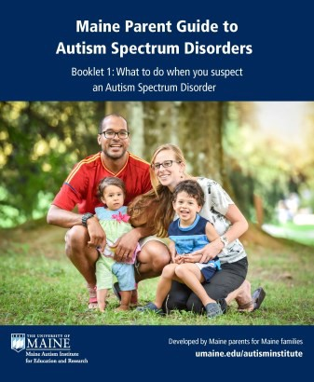For more information about Autism Spectrum Disorders

Contact:
Maine Autism Institute for Education and Research (MAIER) at the University of Maine:
Phone: 207-581-2352
Email: maineautisminstitute@maine.edu

Visit us on our website: https://umaine.edu/autisminstitute/
The Maine Parent Guide to Autism Spectrum Disorders is available free to families impacted by ASD.

Contact MAIER to have the four- volume set mailed to your home.

The Maine Department of Education provides significant funding to support MAIER.

The University of Maine is an EEO/AA employer, and does not discriminate on the grounds of race, color, religion, sex, sexual orientation, transgender status, gender expres- sion,national origin, citizenship status, age, disability, genetic information or veteran’s status in employment, education, and all other programs and activities. The following person has been designated to handle inquiries regarding non-discrimination policies: Sarah E. Harebo, Director of Equal Opportunity, 101 North Stevens Hall, University of Maine, Orono,ME 04469-5754, 207.581.1226, TTY 711 (Maine Relay System).

