Become a Friend of the
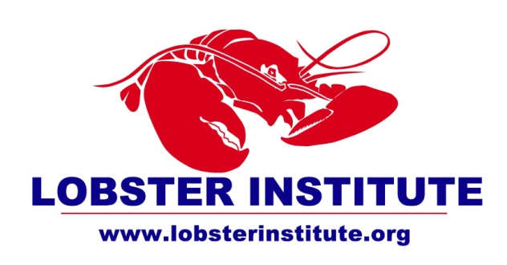

Yes, I would like to become a Friend of the Lobster Institute.

[ ] Enclosed is my gift of $_____ (checks payable to University of Maine – Lobster Institute)
[ ] Please charge my gift to my VISA/MC
Acct. # ________________________________________________________ Exp. Date _____________

Signature
The Lobster Institute’s needs are substantial to support this great industry that is an icon for Maine, New England and the Canadian Maritimes.
You can help by becoming a
Friend of the Lobster Institute.

Please complete this form and mail to:

Friends of the Lobster Institute
210 Rogers Hall, University of Maine
Orono, ME 04469 USA

Name(s): _____________________________
_____________________________________
Address: ______________________________
_____________________________________
_____________________________________
Phone: _______________________________
Job Title: _____________________________
Work Address: ________________________
_____________________________________
Work Phone: __________________________
[ ] My employer provides a Matching Gift – forms will be sent under separate cover.
Please send information on including the Lobster Institute in:
[ ] my will
[ ] my planned giving.

You can become a Friend of the Lobster Institute at any one of these giving levels:

INDIVIDUAL

$25-$49 Friend
$50-$99 Associate
$100-$499 Shoal Society
$500 - $999 Heritage Guild
$1000-$4,999 Highliner Club
$5,000 - $9,999 Edward A. Blackmore Federation

INDUSTRY

$100 - $4,99 Friend
$500 - $999 Associate
$1000 - $4,999 Supporter
$5,000 - $9,999 Partner

$10,000+ Benefactor

$10,000+ “Blue Lobster” League

