University of Maine
Information Technologies

Cisco 8945 Phone User Guide
& Office-Linx Voicemail

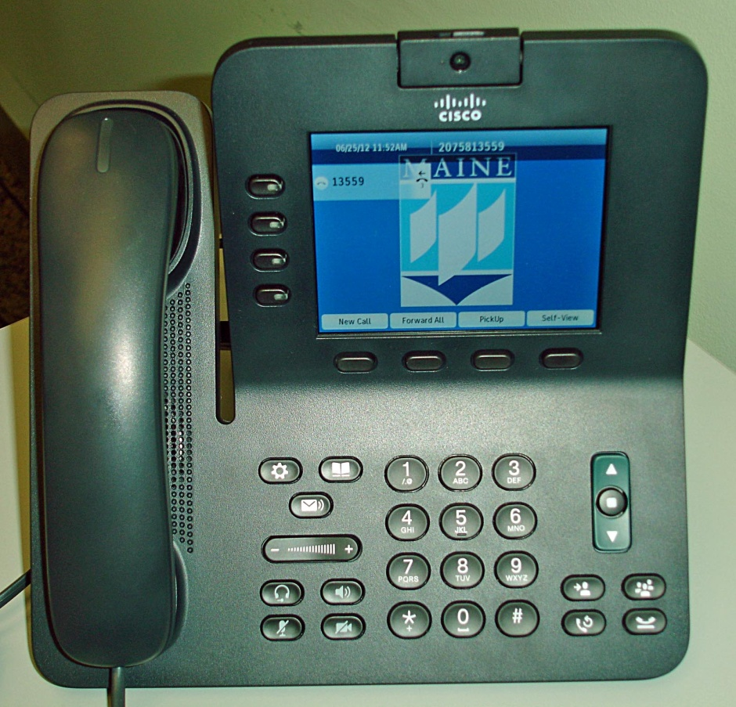

June 2012

Campus Dialing Instructions:
On-campus: 1-XXXX
Off-campus local: 8 + XXX-XXXX
Long distance in-state*: 8 + XXX-XXXX + authcode, THEN press #
Long distance out-state*: 8 + 1 + (area code) XXX-XXXX + authcode, THEN press #
International: 8011 + country code + city code + phone number + # + authcode, THEN press #
Toll Free: 8 + 1 + (8XX) XXX-XXXX
* If you are placing a toll call please remember to press the # key after entering your authorization code.

ATT Calling card calls: 8 + 1 + (800) 225-5288, then followed recorded instructions

Voicemail Access number: 581-3001
Express Messaging Access number: 581-3031

Phone/Button Diagram

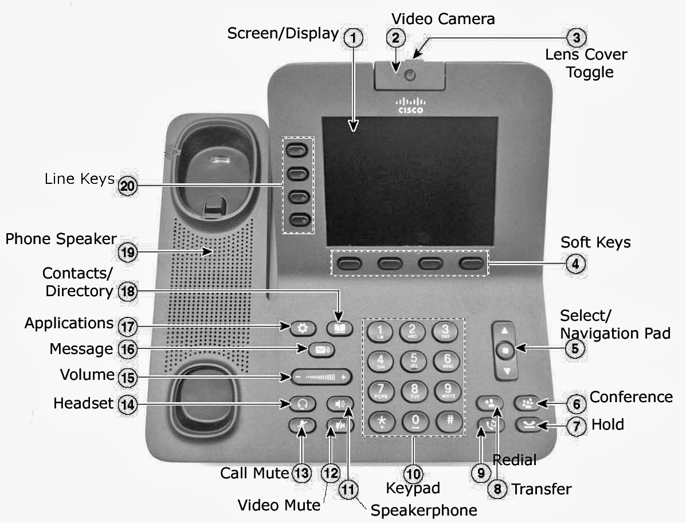
Placing & Answering Calls

Placing a call*:
● Lift and handset and dial, OR
● If you have multiple lines, press an unlit line button and dial, OR
● Press the New Call softkey located under the screen/display (phone will go on speakerphone) and dial.
* If you are placing a toll call please remember to press the # key after entering your authorization code.
To redial the last number you called:
● Press the Redial Button .

To hang up/end call, replace the handset OR:
● Press the End Call or Cancel Softkey (located under the screen/display).

Answering a call:
● Lift the handset.
● If you have multiple 581 lines, lift handset and press flashing red line button .

Placing a call on hold:
● Press the Hold button . The line button pulses green.
● To resume the call, press the pulsing green line button, OR
● Press the Resume Softkey (located under the screen display).

Putting a call on speakerphone:
● Press the Speakerphone button (it will light green). You can put the handset back on the cradle. To take call off speakerphone, lift the handset (the green light goes out).

Call Waiting:
● If you get a second call while the first call is active, the second line displays.
To automatically put the first call (green box) on hold and answer the second call, highlight the second call by pressing the down arrow on the select/navigation pad
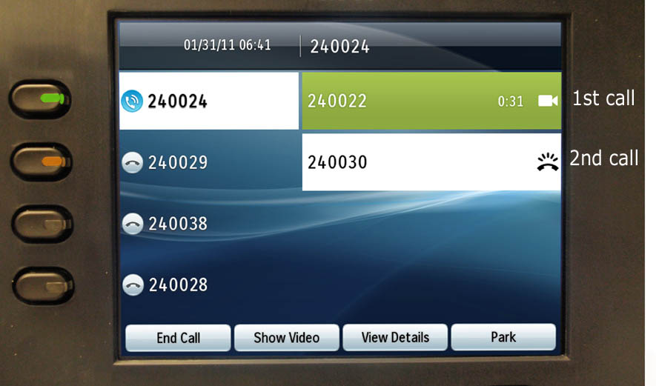
then press the round select button in the center. You can swap back and forth by highlighting the line/caller you want to speak to using the arrows, then press the center select button.

Mute Calls/Video
● You can press the Voice Mute button so callers can’t hear you (but you hear them). This button can be toggled on and off (when mute is on, button glows red).
● The Video Mute button works the same as the voice Mute button (you will see the caller, but they won’t see you).

Forward Calls
● Press the Forward All Softkey (located under the screen display).
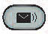
● You will hear 2 beeps. Enter the phone number you want your calls forwarded to. If you want your messages to forward directly to voicemail, press the Message Button .
● Look for the Forward All icon next to your line button.
● To Cancel call forwarding, press the Forward Off Softkey (located under the screen display).

Transfer Calls
● From a connected call, press the Transfer Button .
● Dial the transfer recipient.
● Press the Transfer Button again (you do not have to wait for them to answer). The transfer is complete.
NOTE 1: If you want to announce the call to the recipient before completing the transfer, wait for them to answer BEFORE pressing the Transfer button the 2nd time.

NOTE 2: If you decide you don’t want to complete the transfer AFTER you have dialed the recipient, press the End Call softkey (located under the screen display), THEN press your flashing line button OR press the Resume Softkey (located under the screen display) to speak to the caller again.

Initiating a Conference Call
● From a connected call, press the Conference Button (call will be put on hold and you will hear dial tone).
● Dial the next person; when they answer, press the Conference Button to add them to your conference.
● To add participants, press the Conference Button again and repeat these steps (you can conference a maximum of 8). The conference call ends when all participants hang up.

Call PickUp:
● If your phone is a member of a Call Pickup Group, you can answer someone else’s ringing phone. Just lift the handset & press the Pickup softkey.

Applications Button

Note: To navigate thru the features in the Applications Menu you will also use the Select/Navigation pad as well as the Softkeys located under the screen display.

You can access the following features from the Applications Menu:
● Call History
● Preferences
● Accessories
● Administrator settings (not available to end user).
● Phone Information

Call History: Allows you to review information about the last 150 calls on your phone. The oldest calls over the 150-call limit are dropped from the history. For each call record an icon to the left of the caller ID shows the call type:

Received
Placed
Missed

Preferences: Allows you to set personal preferences for the following items:
● Ringtone
● Wallpaper (Display screen)
● Brightness
● Camera Settings
● Bluetooth

Accessories: Allows you to connect an external headset or Bluetooth device to your phone.

Contacts/Directory

You have access to a Personal Directory & Corporate Directory on your phone. You can add
entries to your Personal Directory and search for UMaine employees using the corporate directory.
Note: To navigate thru the features in the Contacts/Directory Menu you will also use the Select/Navigation pad as well as the Softkeys located under the screen display.

Personal Directory
Once you are logged in to your Personal Directory, you can:
• Sign in and out • Add an entry
• Search for an entry • Dial a number
• Delete an entry • Edit an entry

Sign In to the Personal Directory:
1. Press the Contacts/Directory button.
2. Select Personal Directory. (Use the Navigation pad and Select button to scroll and select.)
3. Enter your MaineStreet User ID and PIN (default PIN is 1865) then press the Submit softkey.

Add to the Personal Directory Entry:
1. Select Personal Address Book; the Search for an entry screen displays.
2. Press the Submit softkey.
3. Press the New softkey (you may need to press the More softkey first).
4. Enter the First Name, Last Name & Nickname (required) information using the dial pad keys.
5. Press the Phones softkey and enter the phone numbers. (Include required dialing prefixes, such as 8 , 8 1 or 8 011.)
6. Press the Submit softkey to add the entry to your personal directory.

Search for an Entry in Personal Directory:
1. Press the Contacts/Directory button.
2. Sign in to Personal Directory.
3. Select Personal Address Book.
4. Select one, all, or none of these criteria to search for an entry: – Last Name – First Name – Nickname
5. Enter the search criteria information and then press the Submit softkey. The name displays.
Dial a Number from Personal Directory:
1. Press the Contacts/Directory button.
2. Sign in to Personal Directory.
3. Select Personal Address Book and search for an entry.
4. Select the person you want by highlighting and pressing the Select softkey. (Use the Navigation pad and Select button to scroll and select.)
5. Select the number to dial by highlighting and pressing the Dial softkey. (Use the Navigation pad and Select button to scroll and select.)
6. Press the Dial softkey.

Delete a Personal Directory Entry:
1. Press the Contacts/Directory button.
2. Open the Personal Directory.
3. Search and select the entry you wish to delete.
4. Press the Select softkey.
5. Press the Edit softkey.
6. Press the Delete softkey. (You may need to press the More softkey first.)
7. Press the OK softkey to confirm the deletion.

Edit a Personal Directory Entry:
1. Press the Contacts/Directory button.
2. Open the Personal Directory.
3. Select Personal Address Book and search for an entry.
4. Press the Select softkey.
5. Press the Edit softkey.
6. Modify the entry information.
7. Press the Phones softkey to modify a phone number.
8. Press the Update softkey.

Personal Fast Dials : allows you to store frequently called numbers to a fast dial list. You can then dial that number instead of going to your Personal Directory and entering search criteria.
Adding Fast Dial from the Personal Directory:
- Press the Contacts/Directory button.
- Scroll and highlight directory wanted
- Select by pressing the “Open” soft key on the bottom of the display screen.
- Choose Personal Address Book by pressing the Select softkey on the bottom of the display screen.
- Press the Submit softkey on the bottom of the display screen.
- Scroll and highlight the person you wish to add to the Fast Dial list.
- Press the Select softkey on the bottom of the display screen. 8.
- Press the FastDial softkey on the bottom of the display screen.
- Scroll and highlight the phone number you wish to add to the Fast Dial list.
- Press the Select softkey on the bottom of the display screen.
- Scroll and highlight the first available “Unassigned” slot on the Fast Dial list.
- Press the Select softkey on the bottom of the display screen.
The screen should read: Successfully Added – The personal address book phone entry has been added to the Fast Dial list.
To Use Fast Dial:
- Press the Contacts/Directory button.
- Scroll and highlight Personal Directory.
- Select by pressing the Open softkey on the bottom of the display screen.
- Choose Personal Address Book by pressing the Select softkey on the bottom of the display screen.
- Press the Submit softkey on the bottom of the display screen.
- Scroll and highlight the person you wish to call from the Fast Dial list.
- Press the Select softkey on the bottom of the display screen.
- Scroll and highlight the number you wish to call for the person selected.
- Press the Dial softkey on the bottom of the display screen to call the number.
Corporate Directory

The corporate directory contains corporate contacts that you can access on your phone. The information in this directory comes from Mainestreet/Peoplesoft records.

Search for and Dial a Contact
1. Press the Contacts/Directory button.
2. Select Corporate Directory. (Use the Navigation pad and Select button to scroll and select.)
3. Select one or all of these search criteria to search for a co-worker: – First Name – Last Name.
4. Enter the search criteria information, press the Submit softkey, and select a contact. Any call that requires the use of a long distance authorization code cannot be dial from the Corporate Directory.
5. To dial, perform any of these actions:
● Press the Dial softkey.
● Press the Select button.
● From the keypad, press the number that is displayed in the upper right-hand corner of the contact label.
● Press the Speakerphone button.
● Press the Headset button.
● Lift the handset.

Office-LinX Voice Mail Guide

Message Waiting Notification
You have voice mail messages when the red light on your handset is lit;
or when you see this red icon next to your line button.

Logging into Your Mailbox
Press the Message button. You will be prompted to enter your password. If this is the first time you have logged into your Office-Linx mailbox, the default password 1865. You will then be prompted to change your password. Passwords must be between 4 – 15 digits long.

Changing Your Password
Once you have logged into your voicemail box, press 8 (Mailbox Options) then press 4 (Set a New Password). The new password must be at least 4 digits, but no more than 15. Enter your new password followed by the # key, you will be asked to re-enter the password and # key again. You will hear a verbal confirmation that the password will be ready for use the next time you login. If you do not get a verbal confirmation the password has not been changed.

Recording a Greeting
Once you have logged into your voicemail box, press 8 (Mailbox Options), press 2 (Record Greeting). Then choose one of the following & follow the voice prompts:
1 to Record your Personal Greeting (same as External Greeting in the old voicemail system)
2 to Record your Name Greeting (same as Personal Verification in the old voicemail system)
4 to Record your Extended Absence Greeting (similar to Temporary Greeting in the old
voicemail system)
5 to Change your Location to Extended Absence (means you want your temp/absence
greeting activated)
6 to Change your Location to In Office (means you are back from your absence; i.e. in office,
and want your original Personal Greeting activated.
7 to Review Current Availability and Location

Important: After recording an Extended Absence Greeting, you must change your location to Extended Absence by pressing 5 (and follow the voice prompts) so that the recorded greeting is active. When returning from your absence remember to log back into your mailbox, go to (Mailbox Options, press 8); then (Record Greeting & select 6). This sets your status to “In Office”. Now your original Personal Greeting is active and the temp/extended absence greeting has been turned off. If you are unsure what location your voice mailbox set to press 7 to review current location.

Listen to Voicemail Messages
To listen to voice messages press the Message button (or call 13001 from your own phone) & follow the voice prompts. The order in which the messages play back is from most recent to oldest. After listening to a message you will be presented with the following options for that message:
Press 1 to reply sender only
Press 2 for the time and date
Press 3 to forward
Press 6 delete (CAUTION: YOU CANNOT RESTORE A MESSAGE AFTER DELETING IT)
Press 9 to skip to the next message

Office-LinX will keep an unread message for 90 days, a read message will be kept for 14 days before the system automatically deletes them.

Forward a Voicemail Message
To forward a message from your voicemail box: press 7 at any time during or just after listening to the message, press 3 (Forward Message), press 1 to add a comment or 2 to forward without adding a comment. You will be asked to enter the destination mailbox number or to dial by name press the * key.

If you choose to forward by using campus extension, enter the last 5 digits of the phone number followed by # (you can enter multiple recipients separating each with a # sign. Once you’ve entered the final 5 digit phone number, press the # sign again. You will then be prompted to press 1 to send your message.

If you choose to dial by name, press the * key then enter at least three letters of the persons first name or last name. You would enter letters by pressing the number key with the corresponding letters. For example: John Doe, first name would be keys, 5, 6, 4 and the last name would be keys, 3,6,3. Once you have entered the three letters Office-LinX will give you a list of possible recipients. After you have chosen the recipient follow the voice prompts to finalize the forwarding process.

Distribution Lists This feature enables you to compose and send a message to a large number of mailboxes at one time.

To Compose a Distribution List
While logged into your mailbox, press 8 (Mailbox Options), press 5 (More Mailbox options), then press 5 for (Distribution List Maintenance). Then choose from one of the following:
- To Add a List (follow voice prompts. After you have entered the mailbox numbers to your list, press # to end list.)
- Review List “
- Delete List “
- Modify List “

To Use the Distribution List
While logged into your mailbox, press 5 * & immediately enter the distribution list number (ie, list 1, list 2, etc), followed by the # key. (Example command sequence: 5 * 1 # ). If you wish to add any other single mailbox numbers for this message you would do so now by following the voice prompts. If there are no other numbers press the # key again. The voice prompt will have you record your message after the beep, when you have finished recording press the # key. Then press 79 to send the message.

To Check Office-LinX Voice Mailbox from Off Campus
Dial 581-3001.
You will be prompted to enter your mailbox number (last 5 digits of your phone number followed by #. Then enter your password followed by #. You should be logged in to your Office-LinX voice mailbox. Follow the voice prompts to navigate through the mailbox.
: When your phone is forwarded to another extension, callers will no longer be directed back to your voice mailbox. All calls will go directly to the forwarded location’s mailbox. This may be confusing to off-campus callers because they may not be aware your phone is forwarded & won’t hear your personal mailbox greeting.

