Online Material Transfer Agreement Request Submission
User Guide

University of Maine
Office of Innovation & Economic Development (OIED)

Welcome to UMaine’s agreement request process. We hope this online service will provide quick, convenient and easily accessible information regarding your project submissions and projects that are run through our Department of Industrial Cooperation (DIC).

To get started, visit our website at: https://umaine.edu/econdev/faculty-resources.
Click on “Request a New Agreement” on the right-hand Quick Links Menu.

You can also login directly through: http://umaine.wellspringsoftware.net

Log in with your maine.edu credentials.
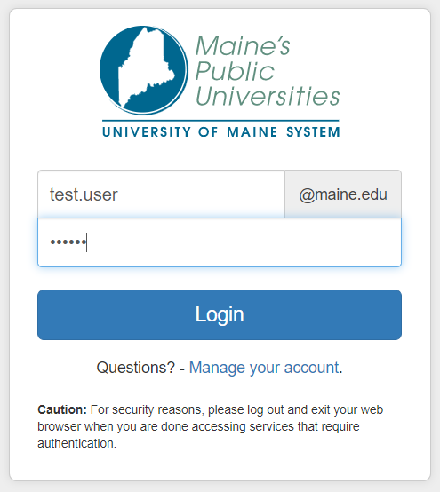
If you have issues with your single sign-on credentials, contact UMaine IT at help@maine.edu or (207) 581-2506.

On the Home Screen, click on MTA Request Form
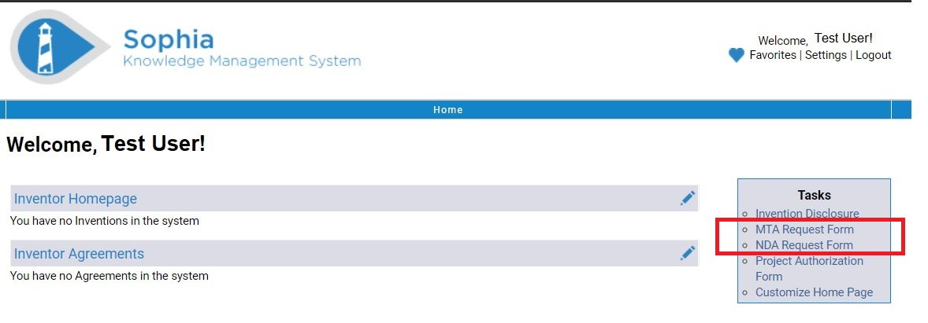
The MTA Request Form will open. Fill in the Organization’s contact information, complete the questions about purpose for exchange, and export control and click “Next”. If the company has sent you their agreement template for review, please attach it here.

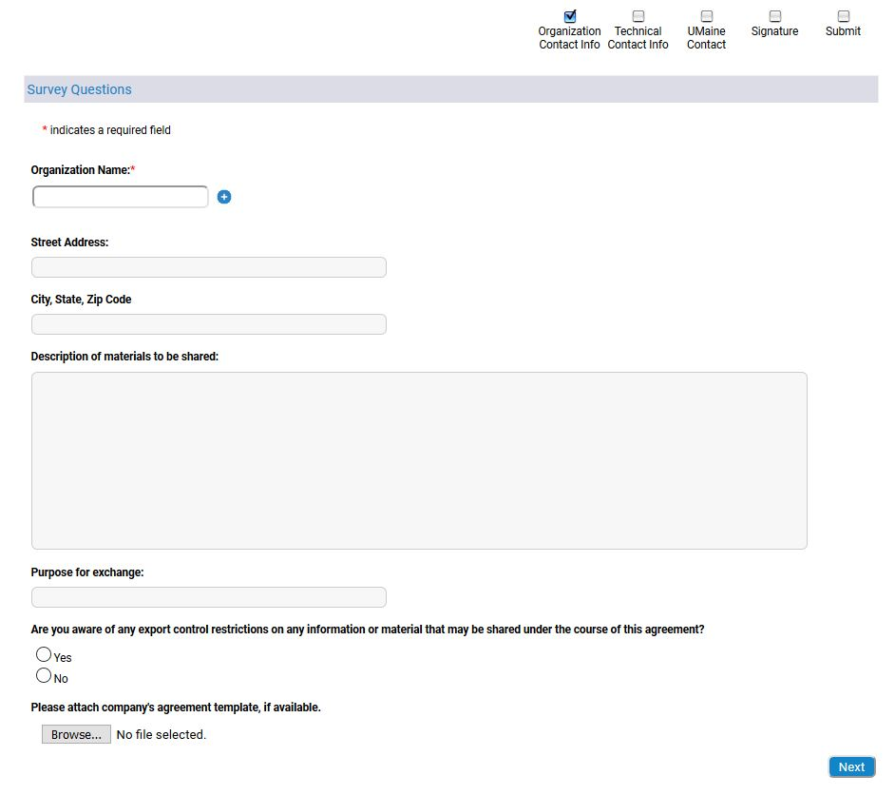
Technical Contact Info: Enter details about your contact at the Organization and click “Next”.
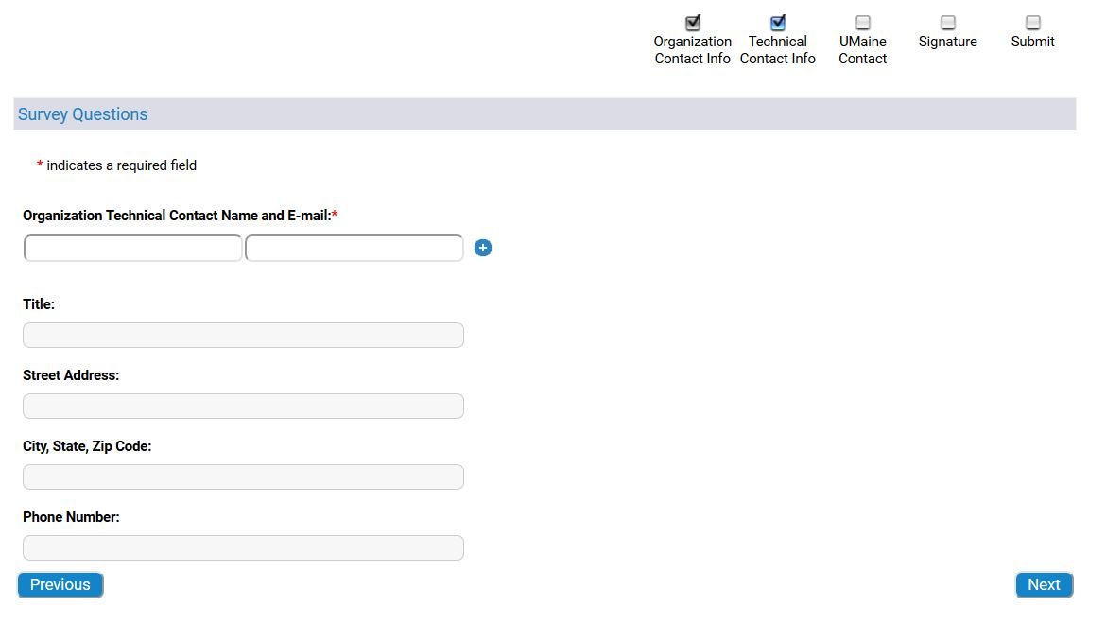

UMaine Contact: Enter information for the UMaine contact and click “Next”.
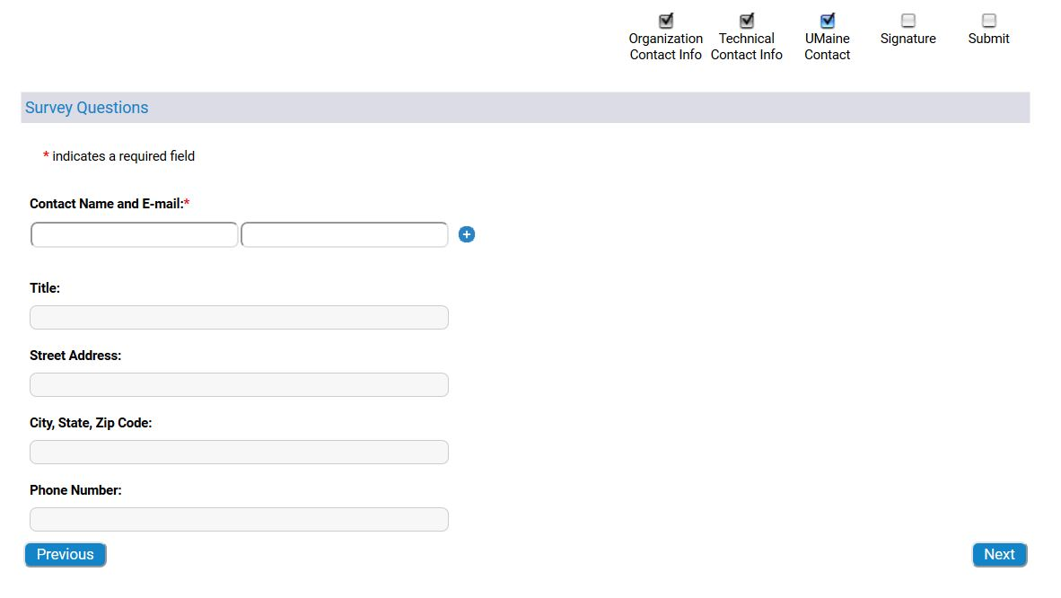

Signature: Enter details for the External Organization’s signatory, if possible. Click “Next”.
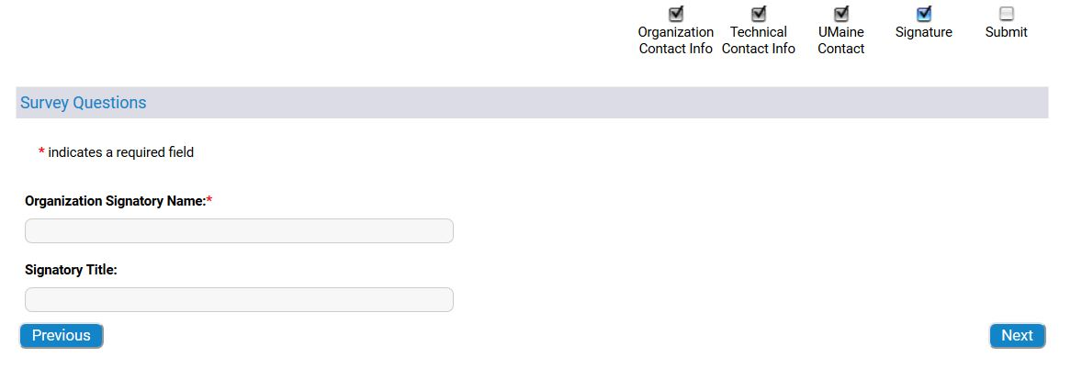
On the final submission screen, review your data and click “Submit”.
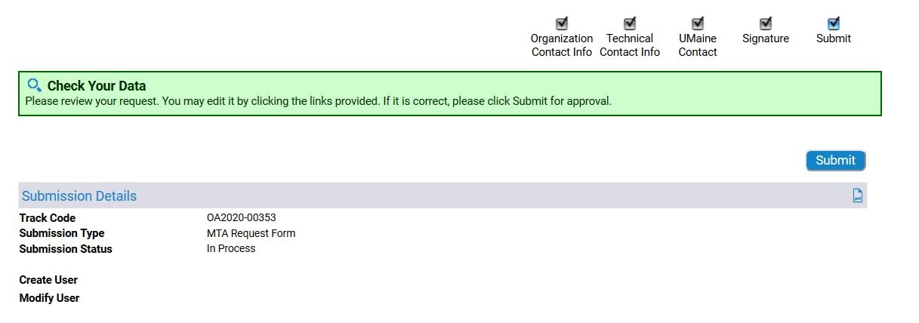

Once submitted, your Agreement Request Form will be received and reviewed by our Department of Industrial Cooperation staff. The client’s information will be routed to the Office of Research Compliance (ORC) for screening against a federal restricted party list. Upon approval from ORC, DIC staff will draft the project agreement and route it through DocuSign for review and signatures.

If you have any questions, please call our office at 581-2201 or email um.dic@maine.edu.

If this is your first time using Sophia, complete the following steps to set up your home screen to show your submitted records.

On the Home Screen, click Customize Home Page

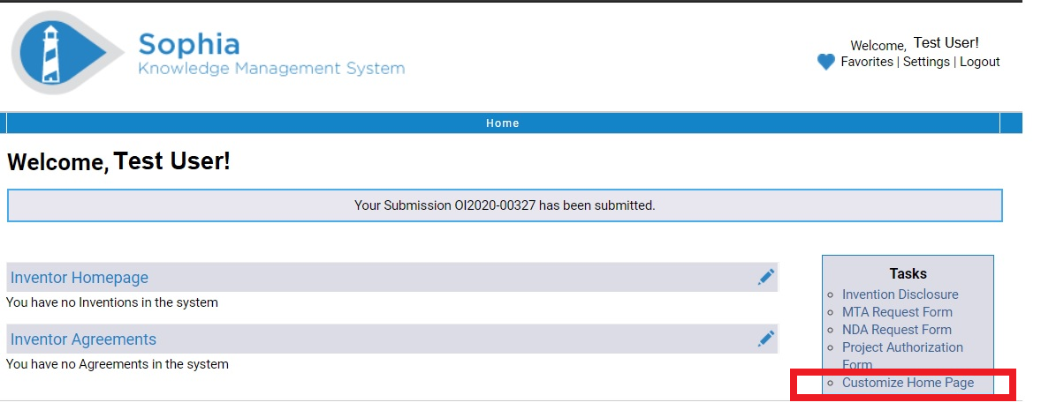

Add all of the available Widgets to your Home Page. You can adjust the order that they will appear on the screen by changing the order under Current Home Page Widgets. Click Finish when done.

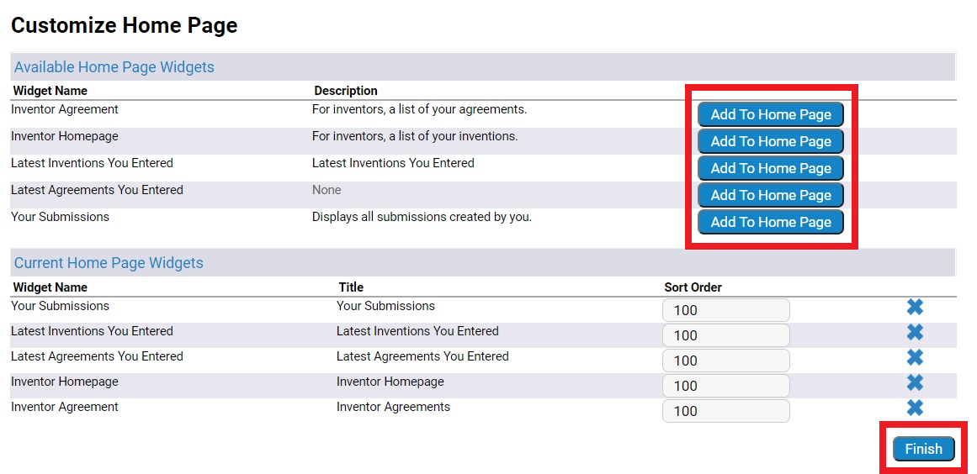

Once you return to your home screen, you will see the list of your active agreements and disclosures.

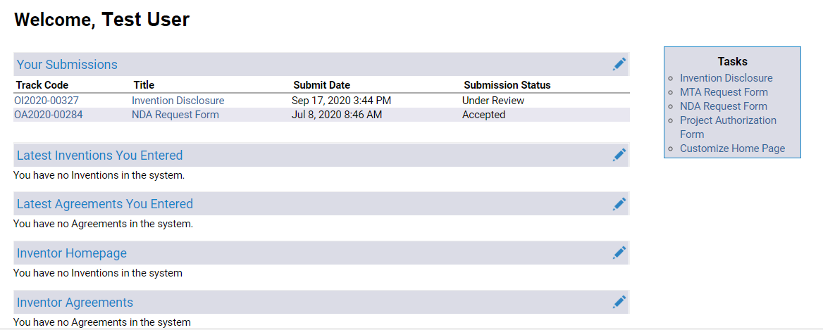

OIED is here to assist with any non-disclosure agreements, material transfer agreements, or industry sponsored agreements.

If you have any questions, please call our office at 581-2201 or email um.dic@maine.edu.

University of Maine
Office of Innovation & Economic Development
5717 Corbett Hall, Room 430
Orono, ME 04469
(207) 581-2201

