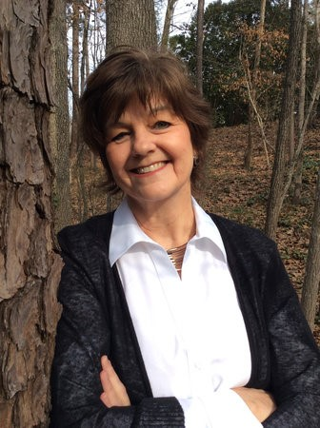‘’

Two Free Public Lectures on March 29

*Dr. Nancy MacLean*

*William H. Chafe Professor of History and Public Policy*

*Duke University*

**"The Origins of Today's Billionaire-Funded Radical Right and the Crisis of Democracy.”**

5:30 p.m. Thursday, March 29

Minsky Recital Hall

Reception and book signing to follow

**Annual Howard B. Schonberger**

**Peace & Social Justice Lecture**

“‘Freedom of Disintegration’: Milton Friedman, Free Market Activists, and the South's Desegregation Crisis”

Thursday, March 29 at 12:30 pm 141 Bennett Hall

Socialist and Marxist Studies Controversy Series

For additional information, please contact Professor Nathan Godfried

207.581.1842 or godfried@maine.edu

The University of Maine does not discriminate on the grounds of race, color, religion, sex, sexual orientation, including transgender status and gender expression, national origin, citizenship status, age, disability, genetic information, or veteran status in employment, education, and all other programs and activities. The following person has been designated to handle inquiries regarding nondiscrimination policies: Director, Office of Equal Opportunity, 101 North Stevens Hall, 581.1226, eoinfo@umit.maine.edu.

**History Department, Orono**

umaine.edu

e