17th Annual University of Maine/ University of New Brunswick International Graduate Student Conference

Time, Space, and Place

October 28th to 29th, 2016

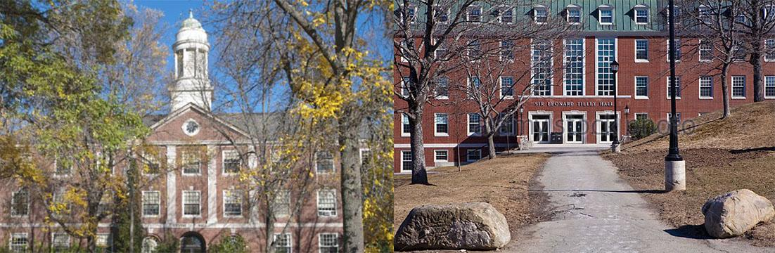

The history graduate students of the University of Maine and University of New Brunswick wish to announce the 17th Annual International Graduate Student Conference on October 28-29, 2016. This year the conference has attracted researchers from Florida to Nova Scotia.

Dr. Sasha Mullally will deliver the keynote address on October 28th, 2016. Her initial research explored the social and cultural histories of health and medicine in 19th and 20th century North America. She has begun a new research project that will explore the gendered professional and community roles of women physicians in rural and small town practices of Nova Scotia and Massachusetts from 1880 to 1930.She is also part of two collaborative research projects. She is Principal Investigator on a project, supported by an Insight Development Grant from the Social Sciences and Humanities Research Council (SSHRC) of Canada and co-investigator on a history of Medical Diasporas in Canada. With Dr. Wright, she is producing a book that examines the transnational history of physician migration in the second half of the twentieth century, looking 'outward' from Canada.

The keynote address will take place in the Bangor Room in Memorial Union on Friday, October 28th from 7 to 8:30pm. Appetizers will be served at 6:30pm. The conference will occur on Saturday, October 29th from 8am to 4pm.

For more information, please contact umaineunb@gmail.com.

