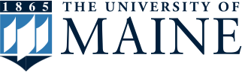
Native American Programs

Presents
Dr. Robin Kimmerer

The Personhood of Plants: Land, language and the rights of nature

This presentation will explore on our relationship to plants and how it is shaped by culture, worldview and experience. Together, we will explore scientific and indigenous conceptions of the nature of plants, from natural resources and respected teachers to consider how our perceptions of living beings are reflected in language and law.
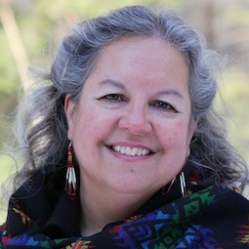
When: Monday, May 15, 2017
7:00pm – 8:30pm

Where: Buchanan Alumni House,
McIntire Room

About the Speaker: Dr. Kimmerer (Citizen Potawatomi) is a professor of Environmental Science and Forestry at SUNY College in Syracuse, NY

For more information:
Jennifer Bowen, 207.581.1417
jennifer.bowen@maine.edu

The University of Maine does not discriminate on the grounds of race, color, religion, sex, sexual orientation, including transgender status and gender expression, national origin, citizenship status, age, disability, genetic information, or veteran status in employment, education, and all other programs and activities. The following person has been designated to handle inquiries regarding nondiscrimination policies: Director, Office of Equal Opportunity, 101 North Stevens Hall, 207.581.1226, equal.opportunity@maine.edu.

