HTY 235

Heresy, Witchcraft, and Reform

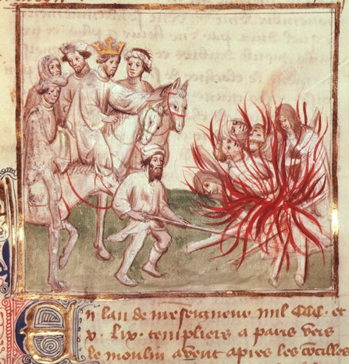 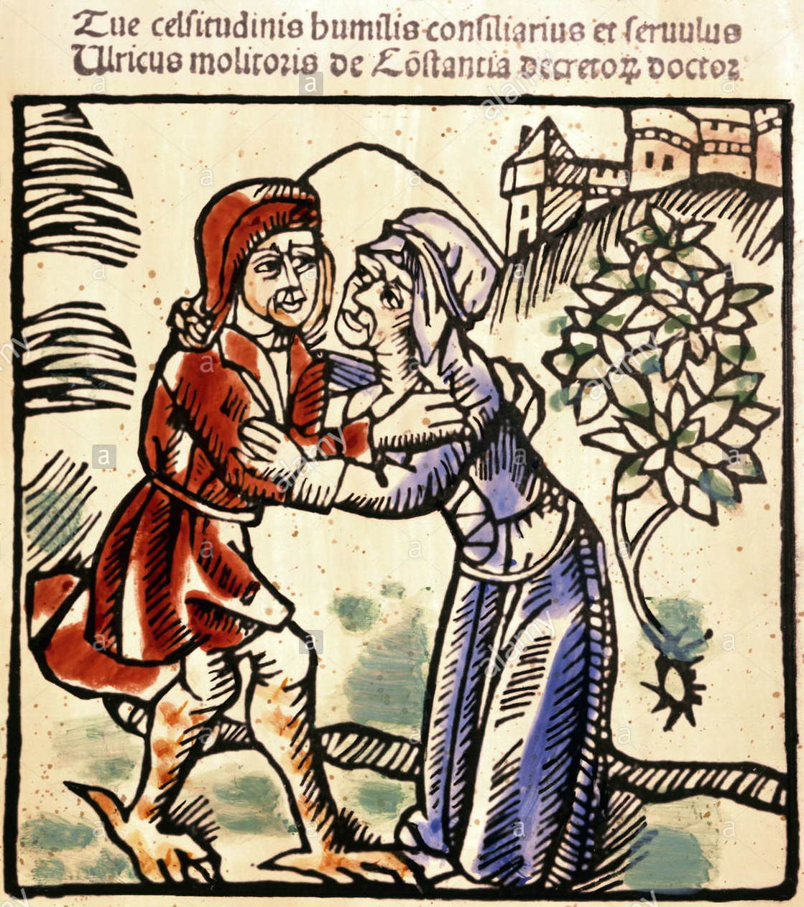

Description: This course will examine the repression of heresy and witchcraft in Europe from late antiquity through the seventeenth century. Focusing on issues surrounding gender, belief, and otherness, we will spend time reading and thinking about the meanings of religious dissent and orthodoxy in premodern contexts. Our investigation will center on the ways in which efforts to reform the Church were closely connected to campaigns against its imagined internal enemies. Prerequisites: none. 3 credits.

Instructor: Joel Anderson

T/TH, 3:30-4:45pm D. P. Corbett, 105

Fall 2021