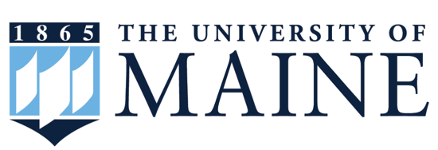
Inside this Issue:
Faculty spotlight, 1

Notes from the Chair, 2

New Faculty Spotlight, 2

Faculty Updates, 3-4

Graduate Spotlight, 4

Graduate Student Updates, 6

Undergraduate Spotlight, 7

Alumni Spotlight, 7

History Department Newsletter 2024
The University of Maine

Faculty Spotlight: Mark J. McLaughlin

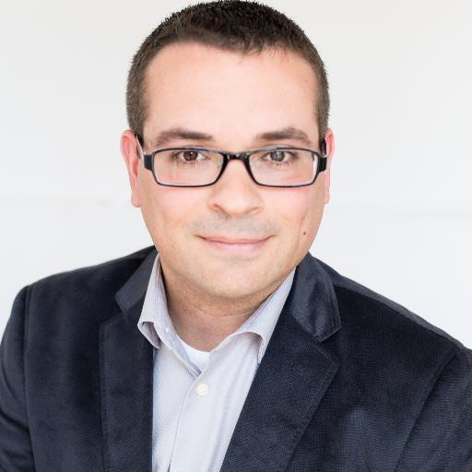
Mark McLaughlin started teaching at the University of Maine in January 2016. Born and raised in New Brunswick, Mark considers himself a “cross-border individual,” and Maine and New Brunswick share many environmental and cultural similarities; so coming to UMaine to teach seemed like a good fit.
Mark’s specialty is environmental and Canadian history and, during his recent sabbatical, he put the finishing touches on his first book project, entitled “Trees Are a Crop”: Crown Forests and Modernization in New Brunswick, 1940-1982. The book addresses the commodification and systematization of growing and harvesting trees in the mid to late 20th century. Mark anticipates that the University of British Columbia Press will publish it this coming winter.
Recently, Mark served as a judge for the Network in Canadian History and Environment’s book prize, got involved with the University of Maine’s Geddy W. Simpson Lecture Committee, and presented a paper on the militarization of the New Brunswick forestry sector after the Second World War at the Association for Canadian Studies in the United States in Washington, D.C. Just last month, he brought the Atlantic Canada Studies Conference (ACSC) to the University of Maine for its 50th anniversary. The ACSC is his favorite conference because it focuses on the Acadiensis School “project” of recentering Canadian history on the Atlantic Region. The conference was very successful and close to 120 people were in attendance.
Sadly, three of Mark’s academic mentors passed away in 2023: Elizabeth Mancke, Bill Parenteau, and Peter Kent. “It was like losing multiple parents,” Mark told me. They shaped who he became as an academic as well as a person. In tribute to them, Mark finished several of the projects he had been collaborating on with his former mentors, including a book chapter he was writing with Parenteau and an article with Mancke. Mark also published a more formal tribute to Parenteau in the April 2024 issue of the Journal of New Brunswick Studies, which is to become the concluding chapter of a book on Parenteau’s scholarship.

Notes from the Chair

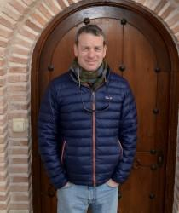
Just a quick hello from the road again this summer – this time from Australia where I am continuing to work on my next book project which investigates the feelings and emotions of British and British imperial troops during the South African War. Over 15,000 Australians went to war as part of the contingents raised by the colonial governments of New South Wales, Queensland, Tasmania, South Australia, and Victoria. Another 6000 or so made their way directly to South Africa and joined local regiments there. I am enjoying reading diaries and letters sent home which are now housed in several State Libraries as well in Canberra, the nation’s capital, at the Australian War Memorial. The AWM has one of the best military museums I have ever seen. This year, a PhD student, Joe Wrobleski is handling newsletter duties and I want to thank Joe and all those who participated. See you next year!

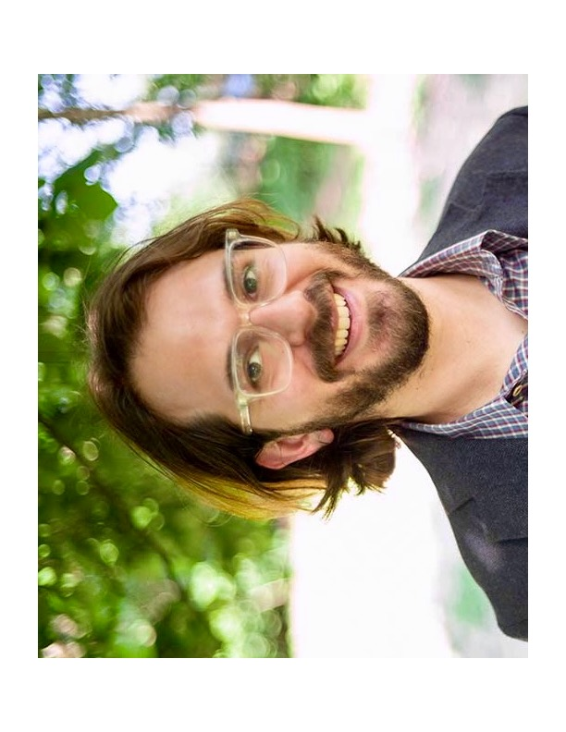
New Faculty Spotlight: Samuel Backer

Sam, from New Rochelle, New York, was hired this spring as an assistant history professor! His focus is on twentieth century America popular culture and the digital humanities. Sam’s interest in American popular culture’s history stems from work he did before graduate school. After graduating from Wesleyan in 2011 with a B.A. in history and music, Sam took some time off from academia, working as a producer on the nationally distributed public radio program “Afropop Worldwide.” This production, which focused on economic structures and their influence on culture, not only tapped into his passion for music, but also pressed him into new ways of thinking about pop culture; after three years of working on this program, he had developed a set of questions which drew him to enter the graduate program in history at Johns Hopkins University.
Although he initially focused on early American history, he soon realized that his historical interests led him to ask “twentieth century questions;” ultimately his focus, and his Ph.D. dissertation, “A Nation of Stages: The Political Economy of American Entertainment, 1870 to 1920,” shifted to studying the entertainment industry from the late nineteenth century. That study concentrates on the origins of the U.S. entertainment industry by examining the development of mass culture and how it has been shaped by economic forces. He successfully defended his dissertation in September 2022, and has expanded it to a book project, incorporating new work examining the 1930’s and the emergence of Hollywood and the movie industry.
He is excited to work with the “fascinating and supportive” faculty at UMaine. He also sees great potential here for interdisciplinary collaboration in computational history (using computers and data to answer historical questions) and the public digital humanities. For example, one of his current projects is an article employing dynamic topic modeling to analyze racialized language in nineteenth century sheet music. This interdisciplinary project aims to result in articles for journals in both the humanities and in the sciences.
Sam is also looking forward to teaching HTY 104, the second half of the survey course on United States history, and an upper-level class on the history of the American middle class – each of which will have a digital component. This will introduce undergraduates to new skills and help “bridge the gap between historical thought and the media landscape we use every day,” enabling students to “think of history within the context of their lives.”
For fun, Sam likes bicycling, gardening, and handball, “a New York sport.” An eclectic music lover, Sam is currently enjoying 1980s post-rap Latin dance music, some tracks from Neil Young’s live recording vault on Spotify, and new psychedelic rock by Wet Tuna.

Faculty Updates

Mary Freeman: Mary Freeman spent most of summer and fall 2023 revising her book manuscript, Abolitionists and the Politics of Correspondence. The manuscript is under contract with University of Pennsylvania Press, and as of this spring, has successfully gone through peer review. She looks forward to finishing final revisions on the manuscript over this summer (2024). Mary will also be presenting at the "Archives of Revolution" conference at the John Carter Brown Library (at Brown University) this summer. Her paper is titled "Slavery and the Archival Politics of 'Founding Documents.'" She also presented a paper at the Universities Studying Slavery Conference in Halifax, Nova Scotia, in October 2023. Mary gave a public presentation at Castine Historical Society last September, and she is gearing up for another public presentation at the Gouldsboro Historical Society this June. Finally, she had a productive year working with the new graduate editors of Maine History, Anne Bardaglio, Christine Liu, and Savannah Clark, working on content for two issues over the fall and spring semesters.

Anne Knowles: Anne Knowles's NEH-funded project, a public website called Placing the Holocaust, is nearing completion. The beta site will provide interactive mapping for scholars and students studying Holocaust camps and ghettos, as well as tools for finding thousands of places in 977 postwar interviews with Holocaust survivors. This project spawned several others led by Anne's students, like History and Education double major Katie Ritchie’s tactile map (measuring nearly 5.5 x 3.5 feet) for teaching sight-impaired students about the immensity of the Holocaust. Anne and her Ph.D. student, Maja Kruse, created a wall map of Holocaust sites for the refurbished permanent Holocaust exhibit at UN headquarters in New York City. Anne, Maja, and History Ph.D. student Christine Liu tested Placing the Holocaust at an international conference in Prague, Czech Republic and at the U.S. Holocaust Memorial Museum. In May, the trio traveled to Paris to present papers at Quantifying the Holocaust, the first conference on this theme. Anne's essay "How Can We Map the Holocaust?" will be published this spring in a volume of essays titled Space in Holocaust Research, published by the German press De Gruyter. Finally, Anne has been appointed UMaine Trustee Professor for 2024-2025. This provides release from teaching (in Spring) and research support.

Stephen M. Miller: Stephen M. Miller finished editing and transcribing The Military Papers of Field Marshal Sir George White 1885-1900: Upper Burma, India and South Africa for the Army
Records Society. It will be published this winter. This summer he traveled to Australia to track down some soldiers’ letters and diaries written during the South African War. This is part of a book project which will explore Victorian feelings and emotions during wartime.

Kara A. Peruccio: Kara published an article titled “Not a Girl, Not Yet a Woman: Suat Derviş, Nezihe Muhiddin, and Generational Conflict in Turkey, 1923-35,” in the Journal of the Ottoman and Turkish Studies Association in January 2024. Her article “‘Just as capable’: Pro Suffragio, the Egyptian Feminist Union, and the International Woman Suffrage Alliance Congress in Rome, 1923,” for California Italian Studies' special issue "Italy, the World, and the Eternal City: Rome in History, Memory, and Imagination" is forthcoming later this year.

Liam Riordan: Liam returned from his sabbatical to teach courses this year with significant new content. His first half of the US History course in Fall 2023 included cooking a pecan dessert from the prize-winning, All That She Carried (2021), which students in the class read. They made the dish in UMaine's experimental kitchen with undergrads, grad students, and family members, and then served the treat in class on the Monday of Thanksgiving week. In his spring course on the American Revolution, Liam used an elaborate role-playing game designed by the Reacting to the Past Consortium at Barnard College for the first time. It was set in New York City in the critical period from the start of the war in April 1775 to the Declaration of Independence in July 1776. As the classroom photo shows of the crowd mobbing Loyalist leader James Delancey, at least one student participated in costume! Overall, students found the game to engage their historical imagination and sense of contingency in new ways. Finally, Liam's research about those who opposed the American Revolution continues with his publication of “Recovering Loyalism: Opposition to the American Revolution as a Good Idea” in Wim Klooster, ed., The Cambridge History of the Age of Atlantic Revolutions, Volume One (Cambridge University Press, 2023). He presented at the book launch conference at the John Carter Brown Library in Providence in April 2024.

Graduate Student Spotlight: David Coombs

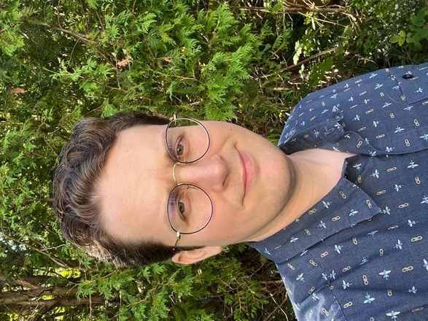
David, born and raised in Las Vegas, Nevada, is in his fourth year of his Ph.D. program. Originally interested in researching and writing about the history of technology and techno-rationality, he switched to labor history with a focus on systems and efficiency when his advisor, Prof. Howard Segal, passed away shortly after his arrival to the program. David has had a busy Spring semester: he defended his prospectus, tentatively entitled “The Uncommon Carrier: Coles Express, Trucking Regulation, and Transformation of the North American Northeast,” presented a paper similarly entitled “The Uncommon Carrier: Trucking Deregulation and the 1982 clash between the Teamsters and Bangor’s Coles Express” at the recent Atlantic Canada Studies Conference, and entered contract negotiations with the university as a member of the Graduate Students’ Union bargaining committee. To David, the importance of labor history on the present Graduate students’ union organization is profound, providing a historical context that underscores the significance of worker solidarity and collective bargaining in achieving a fair contract from the administration.
For the past three summers, David has been working as a research intern at the Cole Land Transportation Museum, exploring the rich archives of Coles Express trucking company housed there. This summer, David’s work continues as he embarks on translating data from the Coles Express archive into maps, visualizing the transformation of the Express’s New England and Atlantic Canada service network over time, and providing an empirical base for his dissertation.
David’s a classically trained pianist and, for fun, he plays piano for several local jazz and country bands.

Graduate Student Updates

Savannah Clark: Savannah is spending her summer conducting research for her dissertation. She was awarded a New England Regional Fellowship Consortium grant, which funds eight weeks of research in various archives throughout New England. As part of this fellowship, she will be doing research this summer in the Civil War letter collections of two archives in Vermont as well as at the Maine Historical Society. She is also working for the Lincoln County Historical Association, leading tours at their historic sites and cataloguing their collections. One of her articles will be published this fall in the journal, Home Front Studies.

Gregory Gaines: Gregory continues to work on his dissertation. He recently attended the Society for the Advancement of Scandinavian Study’s annual conference in Seattle.

Nolan Mertz: Nolan is working this summer as an intern at the Cole Land Transportation Museum in Bangor. There he is the project manager for the oral history department for the museum, working to create a database of over 50 veteran interviews. He finds this is a great way to employ his knowledge of history and dive further into his interest in military history. He is finding the Cole Museum to be a fantastic place to work, giving him much needed experience in the public history sphere and demonstrating how important and useful a B.A. in history can be in the private sector.

Joseph Wrobleski: Joseph defended his prospectus last Fall and is researching and writing chapters for his dissertation, tentatively titled “Wabanaki Legalities: Law, Property, and Indigenous Sovereignty: 1724-2021.” Awarded the Dunn Dissertation Research Grant, he will be traveling to the Provincial Archives in Fredericton and Halifax to conduct research this summer. Joseph also wrote and edited the 2024 History Department Newsletter.

Graduate Student Award Winners: This spring many graduate students were awarded department honors and scholarships, including Savanah Clark, David Coombs, Maja Kruse, and Joseph Wrobleski. This spring, Dylan O’Hara, Ph.D. Candidate, and Jennifer Munson, M.A. Candidate, walked at the graduation ceremony. Dylan’s dissertation is entitled, “‘To Choose Is To Be Free’: Black Urban Separatism in Boston, 1965-1992.”

Undergraduate Spotlight: Lincoln Tiner

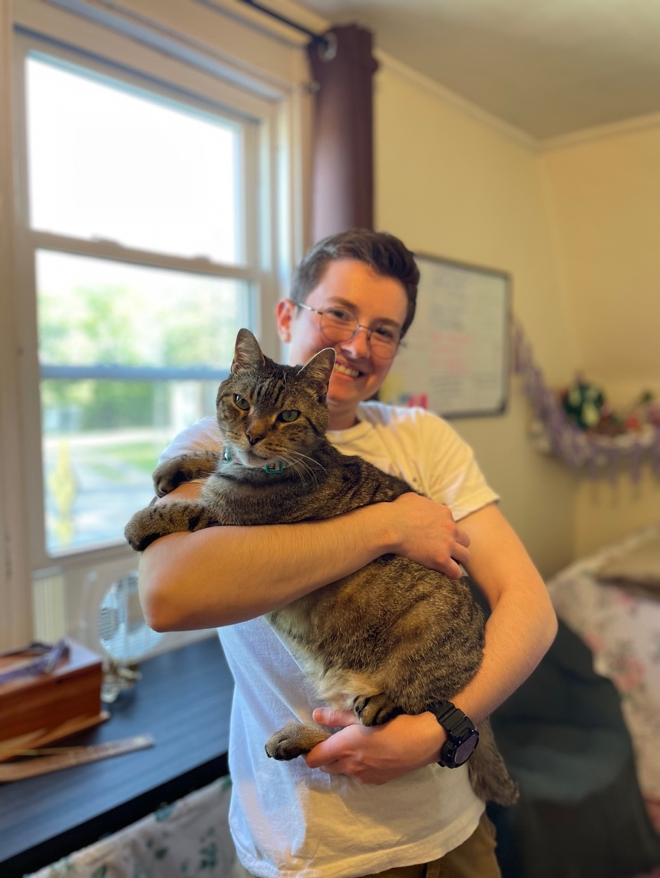
Hailing from Winslow, Maine, Lincoln arrived at the University of Maine’s History Department in 2022 by way of Annapolis. A 4+1 Student, he earned two years of college credits from both Advanced Placement classes and his time in the Navy and is on track to earn a B.A. in History, with a minor in Native Studies, and an M.A. in History in 3 years here. Initially inclined towards an engineering degree, Lincoln’s interest in history was piqued during a class at Annapolis, when learning about the McCarthy Era “Lavender Scare,” a period marked by widespread, anti-communist-fueled persecution of people who were believed to be queer. His eye-opening capstone project on Palestine with Professor Asif Nawaz directly connects to his interest in Indigenous rights—including those of the Wabanaki people here in Maine. This has further fueled his reading and research into the Maine Indian Land Settlement Act of 1980, including archival research while working at the William J. Cohen Collection here on campus. Though he attests to having many great history classes here at the university, his all-time favorite has been HTY 403: Early Middle Ages with Adjunct Professor John Greenlee. Self-described as “a huge nerd,” Lincoln enjoys reading and listening to political podcasts, but his true passion lies in spearheading an independent student-run nonprofit, Disability on Campus, which advocates for UMaine students with disabilities. Seriously injured in a Navy training accident, Lincoln quickly grasped the isolating nature of disability and its hindrance to educational access. His organization is growing into a large and effective advocacy group for disabled students. After earning his M.A., Lincoln hopes to earn another master’s degree in Library and Information Science.

Alumni Spotlight: Brittany Goetting

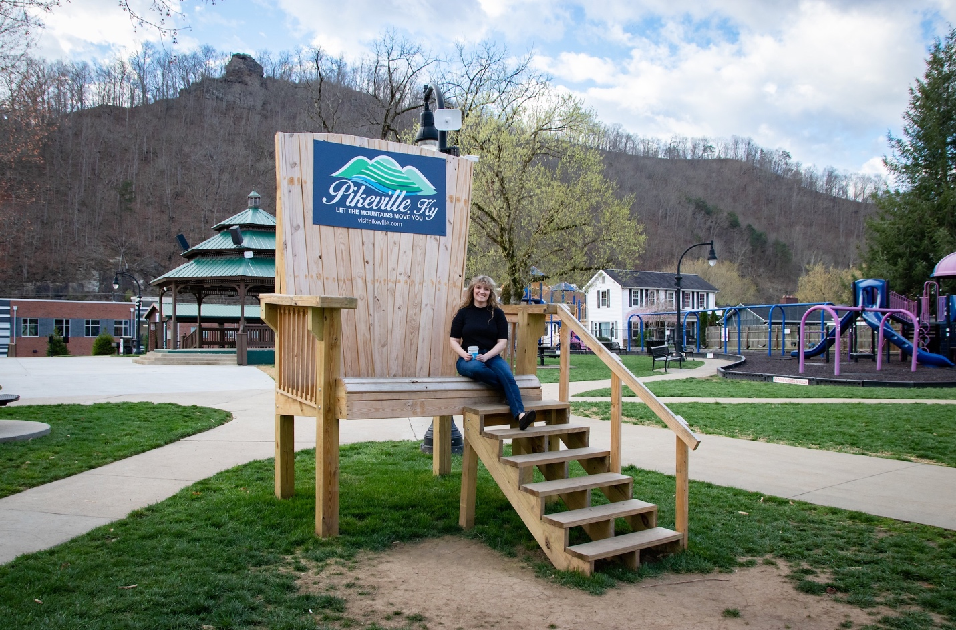
Brittany, whose specialty is religious history, came to Maine from Southern California, where she graduated from the University of California, San Diego in 2012. After completing her Masters in History at UMaine in 2015, she pursued her Ph.D. here “from the get-go!” Her dissertation, which she defended in April 2022, was entitled, “Bound by Print: The Baptist Borderlands of Maine and the Canadian Maritimes, 1770-1840.” It focused on Baptist print culture in Maine and the Canadian Maritimes in the late eighteenth and early nineteenth centuries and how that related to identity and religious community formation.
Since August 2022, Brittany has been teaching as Assistant Professor of History at the University of Pikeville in Pikeville, Kentucky. She works in what she describes as a small program with one other history professor, teaching four history classes each semester. The size of the program at the university requires her to “wear many hats” and take on several administrative duties, including the role of “Study Abroad Coordinator” which involves educational travel abroad with students. The last two years she took students from the university to Germany and England. Additionally, Brittany is also the faculty advisor for the university honors program and Phi Alpha Theta.
Aside from the considerable workload, a big transition for Brittany was adjusting to working and living in a small, tight-knit Appalachian community. “UPike” has about 1600 undergraduates and the students want to get to know their professors, some they will see five times a week. To Brittany, this is a rewarding part of working at UPike – building relationships with students, developing educational plans for them beyond one semester, and watching them develop and grow, which doesn’t happen as often at bigger universities.
Brittany is currently working on two articles on religious history. One proposed article examines the debate within the Baptist community in early nineteenth century Maine regarding involvement in the international missionary movement. She has also been approached by the Journal Bulletin of the Canadian Baptist Historical Society to research and write an article about the development of the New Brunswick Baptist community. Brittany plans to attend the International Conference on Baptist Studies organized by David Bebbington, who is considered a leading historian in the field of the history of the evangelical movement. Finally, she plans to turn to making her dissertation into a book proposal this winter.
Brittany is also becoming steeped in local history; she has teamed up with local historian Jeff Little to write an article on the impact of the Old Regular Baptists on eastern Kentucky history and culture. She also consulted on a historical coloring book published by the community to distribute in local schools celebrating Pikeville’s bi-centennial. In her spare time, Brittany enjoys hiking in the Kentucky mountains.

*** Congratulations to the May 2024 Graduates!***

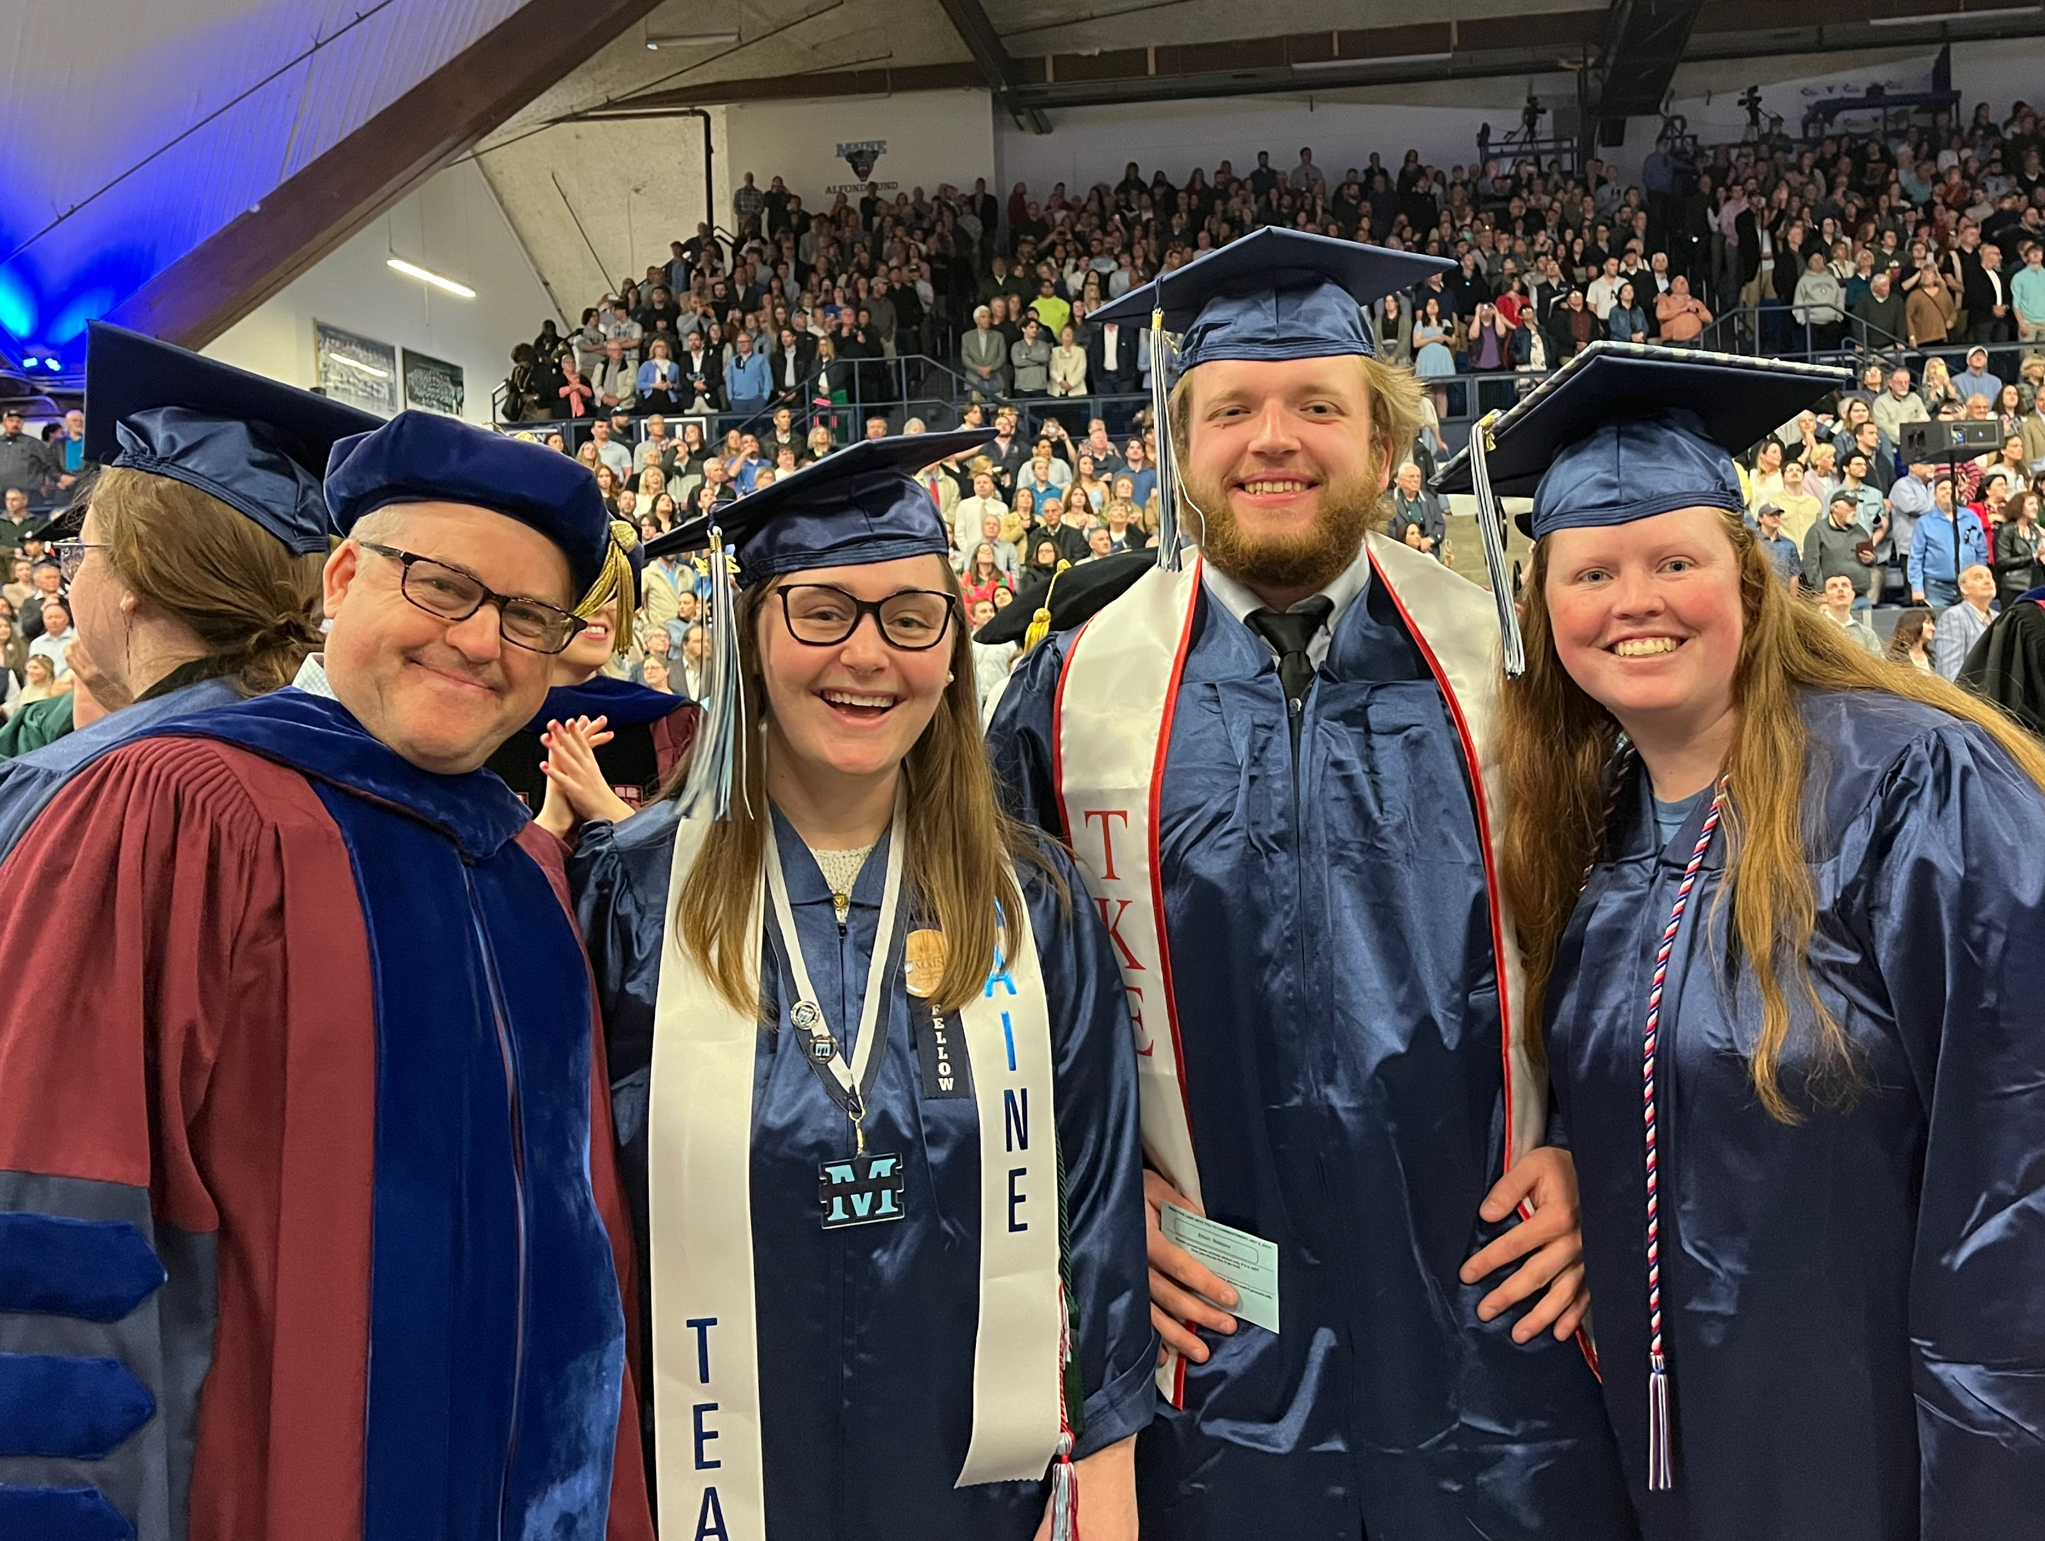
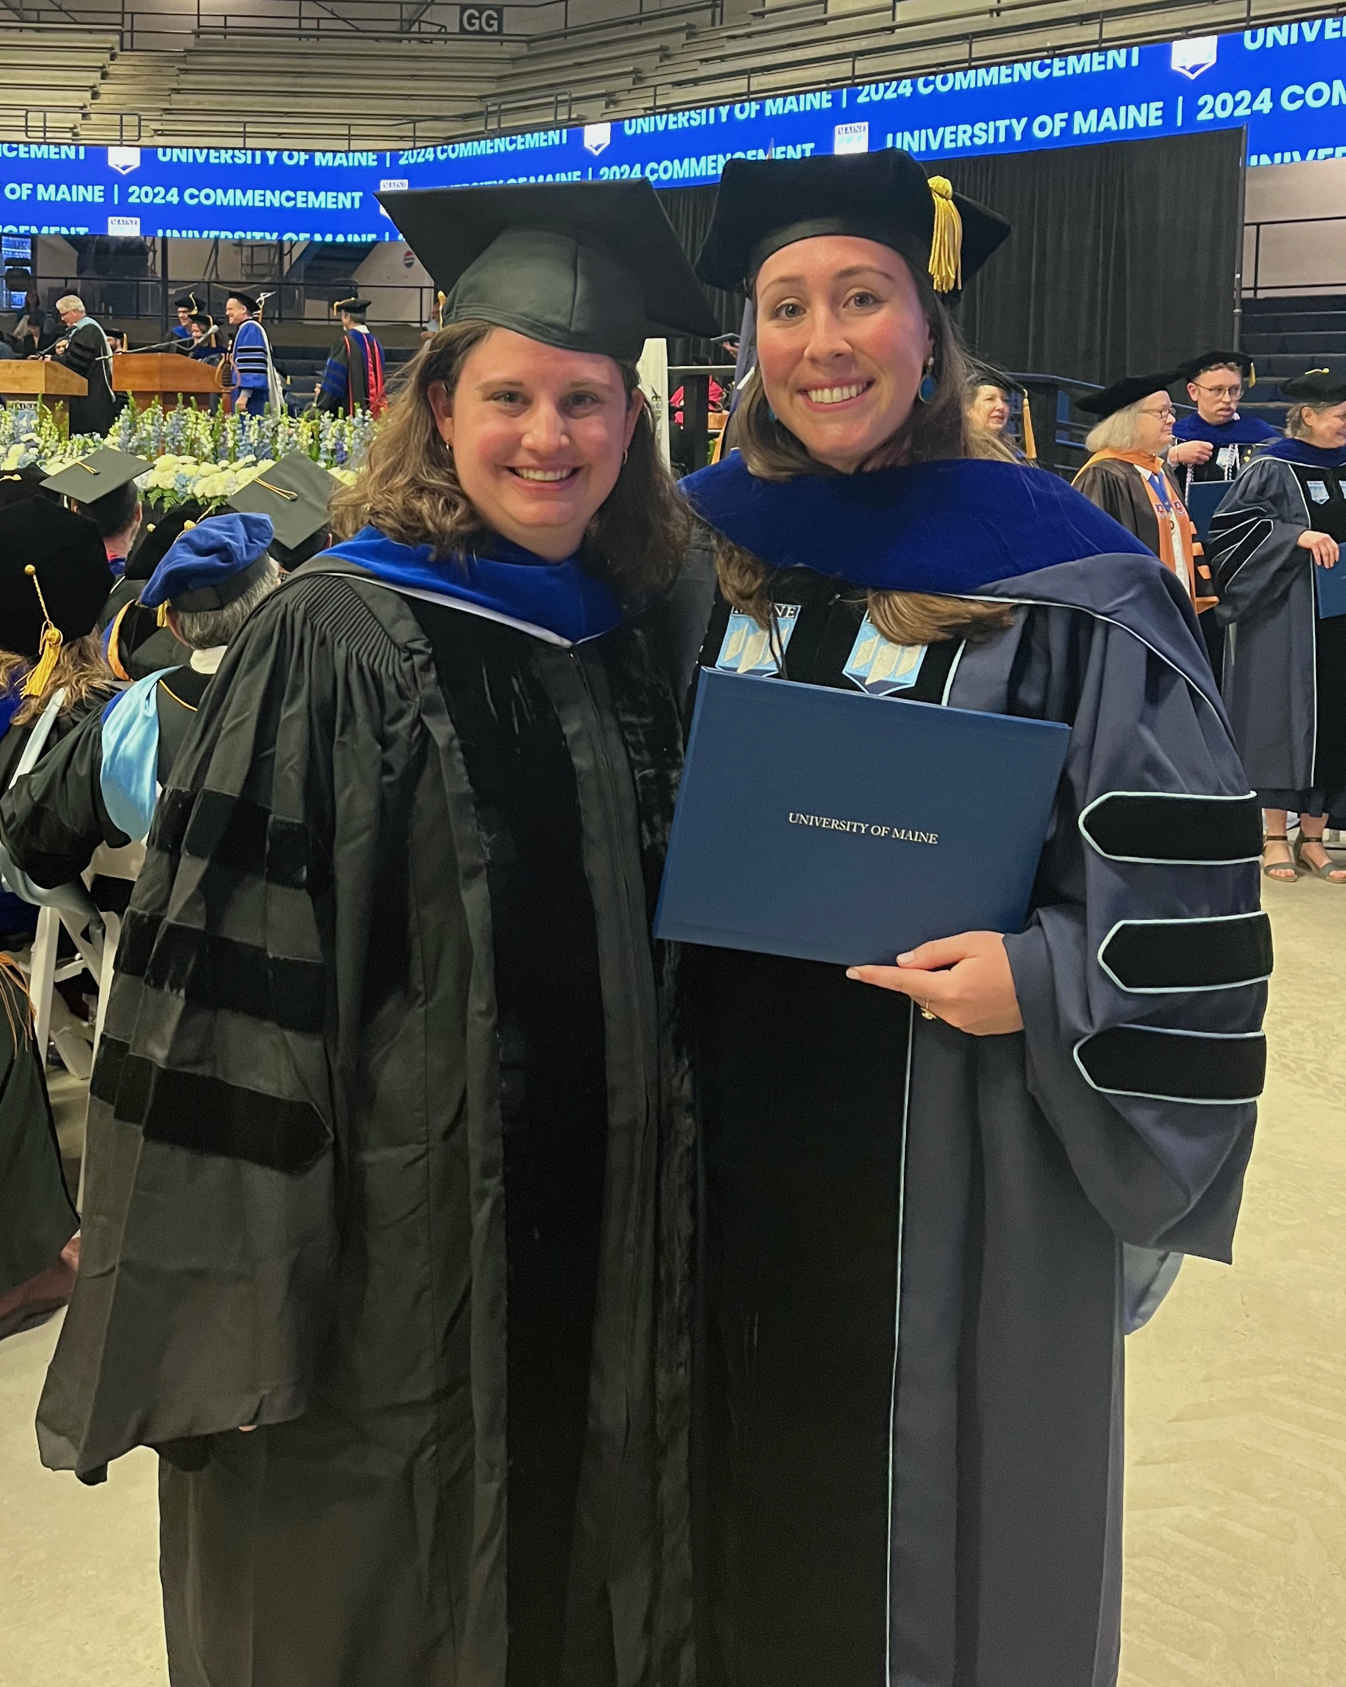

The University of Maine is an EEO/AA employer, and does not discriminate on the grounds of race, color, religion, sex, sexual orientation, transgender status, gender expression, national origin, citizenship status, age, disability, genetic information or veteran’s status in employment, education, and all other programs and activities. The following person has been designated to handle inquiries regarding non-discrimination policies: Director of Equal Opportunity, 101 North Stevens Hall, University of Maine, Orono, ME 04469-5754, 207.581.1226, TTY 711 (Maine Relay System).

History Department
5774 Stevens Hall
Orono, Maine
04469-5774

MAKE A GIFT TO SUPPORT THE UMAINE HISTORY DEPARTMENT

If you value the work being done by the UMaine History Department, consider making a contribution. http://umaine.edu/history/

You can also contact the History Department through the following:
Mailing Address: 5774 Stevens Hall, Orono, ME 04469-5774
Phone: 207.581.1907/1908 | Fax: 207-581-1817
E-mail: umhist@maine.edu
Website: http://umaine.edu/history/

