DOCTORAL DISSERTATION’S/MASTER’S THESIS TITLE CENTERED, BOLD, IN ALL CAPS, AND IN AN INVERTED PYRAMID FORMAT
By John Doe
B.A. Somename College, 2001

M.A. University of Someplace, 2004

A DISSERTATION/THESIS

Submitted in Partial Fulfillment of the Requirements for the Degree of
Doctor of Philosophy/Master of Science/Master of Fine Arts (in Chemical Engineering)

The Graduate School The University of Maine
May/August/December 2023

Advisory Committee:

Marilyn Monroe, Professor of Chemical Engineering, Advisor Cinderella Glass‐Slipper, Professor of Chemical Engineering Merlin Wizard, Associate Professor of Chemical Engineering Robin Hood, Assistant Professor of Wood Science and Technology Alice Wonderland, Associate Professor of Statistics

Copyright 2023 John Doe OR

© 2023 John Doe All Rights Reserved

*Copyright page is optional/not listed on TOC

UNIVERSITY OF MAINE GRADUATE SCHOOL LAND ACKNOWLEDGMENT

The University of Maine recognizes that it is located on Marsh Island in the homeland of Penobscot people, where issues of water and territorial rights, and encroachment upon sacred sites, are ongoing. Penobscot homeland is connected to the other Wabanaki Tribal Nations— the Passamaquoddy, Maliseet, and Micmac—through kinship, alliances, and diplomacy. The University also recognizes that the Penobscot Nation and the other Wabanaki Tribal Nations are distinct, sovereign, legal and political entities with their own powers of self-governance and self-determination.

DOCTORAL DISSERTATION’S/MASTER’S THESIS TITLE CENTERED, BOLD, IN ALL CAPS, AND IN AN INVERTED PYRAMID FORMAT
By John Doe

Thesis/Dissertation Advisor: Dr. Marilyn Monroe

An Abstract of the Thesis/Dissertation Presented in Partial Fulfillment of the Requirements for the
Degree of Doctor of Philosophy/Master of Science/Master of Fine Arts (in Chemical Engineering)
May/August/December 2023

The abstract should be a condensation of the substance of the student’s work, and not an introduction nor a text version of the Table of Contents. Within the space limit of 350 words (doctoral dissertations) or 500 words (Master’s theses), the writer should convey to the reader concisely and accurately the significance of the work, the boundaries of space and time that it encompasses, the method of inquiry, as well as the claim to generality (if any) made in the research. The abstract should be well balanced to reflect not only the eye‐catching or original elements of the thesis/dissertation, but the overall spirit and structure of the work. This balance is achieved if the abstract and the manuscript make sense without one another.

Depending on the type of research format that the thesis/dissertation has followed, the abstract may include information about some or all of the following elements: purpose, scope, method, results, recommendations, and conclusions. It should become clear from the abstract what the main idea of the research project is what is the central question that the author is trying to answer, why this question is important, what has been discovered, why this discovery is significant, and who could benefit from the findings. Summarizing the scope of the research should provide the reader with an idea about the author’s focus in the work and the motifs behind that focus. A brief description of the method should

explain what kinds of evidence have been provided and how the author has attempted to prove their validity. A succinct analysis of the results of the research should reveal the consequences of the discoveries that have been made, so that the recommendations or solutions offered by the author are given a relevant context. The summary of the conclusions of the research may specify whether the author claims any “cause and effect” relationships and/or whether the problem or central issue of the project has been resolved. An effective abstract uses well developed, coherent, concise and unified paragraphs with the elements of the research being discussed in logical order. Double caution must be used to make sure that there are no spelling or grammar mistakes. An abstract should not add any new information but should simply summarize the manuscript. A good abstract will also be intelligible to a wide audience.

Abstracts are recycled in electronic and abstracts journals, and they are an efficient way for scholars to keep up with the on‐going research in their fields. Therefore, the more clearly the abstract portrays the substance of the research project, the better chance there is that the author’s contribution to the field will be acknowledge.

DEDICATION (Optional)

Family and friends are awesome!

ACKNOWLEDGEMENTS (Optional)

I’d like to thank the Academy…

TABLE OF CONTENTS (FORMAT OPTION 1)

DEDICATION iii
ACKNOWLEDGEMENTS iv
LIST OF TABLES ix
LIST OF FIGURES x
LIST OF EQUATIONS xi
LIST OF ABBREVIATIONS xii
Chapter
- CHAPTER HEADING 1
First Level Heading 3
Second Level Heading 8
Third Level Heading 10
Fourth Level Heading 10
Fourth Level Heading 10
Third Level Heading 12
Second Level Heading 13
First Level Heading: If the title of this section does not fit on one line, it should be split into two or more lines so that at least five leader dots (. ) are left between
the text and the page number 21
Second Level Heading 29
- CHAPTER HEADING 70
First Level Heading 70
First Level Heading 86
First Level Heading 87
First Level Heading 88
REFERENCES 90
APPENDICES 94
Appendix A. Title 95
Appendix B. Title 101
Appendix C. Title 120
BIOGRAPHY OF THE AUTHOR. 123

TABLE OF CONTENTS (FORMAT OPTION 2)
DEDICATION iii
ACKNOWLEDGEMENTS iv
LIST OF TABLES ix
LIST OF FIGURES x
Chapter
- CHAPTER HEADING 1
  - First Level Heading 1
    - Second Level Heading. If the title of a heading is too long to fit on one line, it should be split into two or more lines so that at least 5 leader
dots (.....) are Left between the text and the page number 2
      - Third Level Heading 5
      - Third Level Heading 5
    - Second Level Heading 6
  - First Level Heading 7
    - Second Level Heading 12
    - Second Level Heading 39
- CHAPTER HEADING 46
  - First Level Heading 53
  - First Level Heading 59
BIBLIOGRAPHY 80
APPENDIX TITLE 72
BIOGRAPHY OF THE AUTHOR. 86

LIST OF TABLES (FORMAT OPTION 1)

Table 3.1. Title of the only table in Chapter 3 17

Table 4.1. Title of the first table in Chapter 4 25

Table 4.2. Title of the second table in Chapter 4 37

Table 5.1. Title of the first table in Chapter 5 55

Table 5.2. Title of the second table in Chapter 5 Titles which are too long to fit on one line without interfering with the column of page numbers on the right should be split into two or more lines so that at least 5 leader dots (. ) are left
between the text of the title and the page number 62

Table A.1. Title of the only table in Appendix A 82

Table C.1. Title of the first table in Appendix C 89

Table C.2. Title of the second table in Appendix C 90

LIST OF FIGURES (FORMAT OPTION 2)
Figure 1. Title of the First Figure in the Thesis 4
Figure 2. Title of the Second Figure in the Thesis 7
Figure 3. Title of the Third Figure in the Thesis 16
Figure 4. Title of the Fourth Figure in the Thesis 23
Figure 5. Title of the Fifth Figure in the Thesis 32
Figure 6. Title of the Sixth Figure in the Thesis 33
Figure 7. Title of the First Figure in the Appendix A 71
Figure 8. Title of the Second Figure in the Appendix A 72
Figure 9. Title of the First Figure in the Appendix B 78
**Number List of Tables and List of Figures using same format; either 1.1, 1.2, etc. OR 1, 2, 3, 4, etc.**

DISPLAY PAGE

ORGANIZING THE TEXT OF THE MANUSCRIPT BY THE HEADINGS OR DECIMAL SYSTEMS

The following samples illustrate ways for arranging the text of the manuscript. The first sample shows text organized by the “headings system” (CHAPTER 1) in which sections and subsections are distinguished by the style of their headings.

The second sample is organized by the “decimal system” (CHAPTER 2). In this arrangement, subdivisions are grouped by number. Students may choose to indent the headings of the subsection, or they may place all headings and subheadings to the far left as shown in the sample here.

A chapter starts on a new page.

Students should be careful to remain consistent in all chapters. The levels of subheadings should be reflected in the Table of Contents.

CHAPTER 1 CHAPTER TITLE
The chapter heading may be followed by some introductory text as shown here. Or, the first chapter subdivision may appear right away, as shown in the next sample. The style of the headings may vary from those shown here, yet every effort should be made to have the organizational scheme clear at a glance. Italics cannot be used for headings or subheadings. Bold styles, underlining, and/or different levels of indentation can be used.

First Level Heading

Text text text text text text text text text text text text text text text text text text text text text text text text text text text text text text text text text text text text text text text text text text text text text text text text.

Second Level Heading

Text text text text text text text text text text text text text text text text text text text text text text text text text text text text text text text text text text text text text text text text text text.
Third Level Heading. Text text text text text text text text text text text text text text text text text text

text text text text text text text text text text text text.

Fourth Level Heading. Text text text text text text text text text text text text text text text text

text text text text text text text text text text. Text text text text text text text text text text text text text text text text text text text text text text text text text text. Text text text text text text text text text text text text text text text text text text text text text text text text text text. Text text text text text text text text text text text text text text text text text text text text text text text text text text. Text text text text text text text text text text text text text text text text text text text text text text text text text text. Text

Table. 5.1 Sample of a split table. Detailed description of Table. 5.1, description does not appear on List of Tables.

Year | Location | Estimated  Number | Cost | Percent | Height | Length | Weight | Accepted/  Rejected | Date
1970 | City,State | # | $ | % | Feet/ inches | Inches | lbs./ ounces | A/R | #/#/#
1971 | City,State | # | $ | % | Feet/  inches | Inches | lbs./  ounces | A/R | #/#/#
1972 | City,State | # | $ | % | Feet/ inches | Inches | lbs./ ounces | A/R | #/#/#
1973 | City,State | # | $ | % | Feet/  inches | Inches | lbs./  ounces | A/R | #/#/#
1974 | City,State | # | $ | % | Feet/ inches | Inches | lbs./ ounces | A/R | #/#/#
1975 | City,State | # | $ | % | Feet/  inches | Inches | lbs./  ounces | A/R | #/#/#
1976 | City,State | # | $ | % | Feet/ inches | Inches | lbs./ ounces | A/R | #/#/#
1977 | City,State | # | $ | % | Feet/  inches | Inches | lbs./  ounces | A/R | #/#/#
1978 | City,State | # | $ | % | Feet/ inches | Inches | lbs./ ounces | A/R | #/#/#
1979 | City,State | # | $ | % | Feet/  inches | Inches | lbs./  ounces | A/R | #/#/#
1980 | City,State | # | $ | % | Feet/  inches | Inches | lbs./  ounces | A/R | #/#/#
1981 | City,State | # | $ | % | Feet/  inches | Inches | lbs./  ounces | A/R | #/#/#
1982 | City,State | # | $ | % | Feet/  inches | Inches | lbs./  ounces | A/R | #/#/#
1983 | City,State | # | $ | % | Feet/ inches | Inches | lbs./ ounces | A/R | #/#/#
1984 | City,State | # | $ | % | Feet/  inches | Inches | lbs./  ounces | A/R | #/#/#
1985 | City,State | # | $ | % | Feet/ inches | Inches | lbs./ ounces | A/R | #/#/#
1992 | City,State | # | $ | % | Feet/  inches | Inches | lbs./  ounces | A/R | #/#/#
1993 | City,State | # | $ | % | Feet/ inches | Inches | lbs./ ounces | A/R | #/#/#
1994 | City,State | # | $ | % | Feet/  inches | Inches | lbs./  ounces | A/R | #/#/#
1995 | City,State | # | $ | % | Feet/ inches | Inches | lbs./ ounces | A/R | #/#/#
1996 | City,State | # | $ | % | Feet/  inches | Inches | lbs./  ounces | A/R | #/#/#

Table 5.1 Continued.
1997 | City,State | # | $ | % | Feet/ inches | Inches | lbs./ ounces | A/R | #/#/#
1998 | City,State | # | $ | % | Feet/  inches | Inches | lbs./  ounces | A/R | #/#/#
1999 | City,State | # | $ | % | Feet/ inches | Inches | lbs./ ounces | A/R | #/#/#
2000 | City,State | # | $ | % | Feet/  inches | Inches | lbs./  ounces | A/R | #/#/#

Fourth Level Heading. Text text text text text text text text text text text text tex text text text text text

text text text text text text text text text text text text text text text text text t text text text text text text text text text text text text text.
Third Level Heading. Text text text text text text text text text text text text text text text text text text

text text text text text text text text text text text text text text text text text text text text text text text text text text text text text text text text text text text text text text text text.

Second Level Heading

Text text text text text text text text text text text text text text text text text text text text text text text text text text text text text text text text text text text text text text text.
First Level Heading

Text text text text text text text text text text text text text text text text text text text text text text text text text text text text text text text text text text text text text text text.

Second Level Heading

Text text text text text text text text text text text text text text text text te text text text text text text text text text text text text text text text text text text text text text text text text text text text text text text text text text text text text text text text text text text text text xt text text.

CHAPTER 2 CHAPTER TITLE

First Level Heading

Text text text text text text text text text text text text text text text text text text text text text text text text text text text text text text text text text text text text text text text.

Second Level Heading

Text text text text text text text text text text text text text text text text text text text text text text text text text text text text text text text text text text text text text text text.
      - Third Level Heading. Text text text text text text text text text text text text text text text text text text text text text text text text text text text text text text text.
      - Third Level Heading. Text text text text text text text text text text text text text text text text text text text text text text text text text text text text text text text.

Second Level Heading

Text text text text text text text text text text text text text text text text text text text text text text text text text text text text text text text text text text text text text text text.

First Level Heading

Text text text text text text text text text text text text text text text text text text text text text text text text text text text text text text text text text text text text text text text.

BIBLIOGRAPHY

The style of the bibliography will vary by discipline.

References should be listed single space within and double spaced in between.

APPENDIX A: THE TRUTH

This is the appendix, which goes between your Bibliography and the Biography of the Author. The information in an appendix is supplementary to the text. The body of the text should be able to stand alone if the Appendix is removed.
Table A.1 Title of Table. This is a table with numbers and needs to be listed on the LOT.

1 | 2 | 2
3 | 4 | 5
4 | 4 | 7

Figure A.1 Leroy the cat.
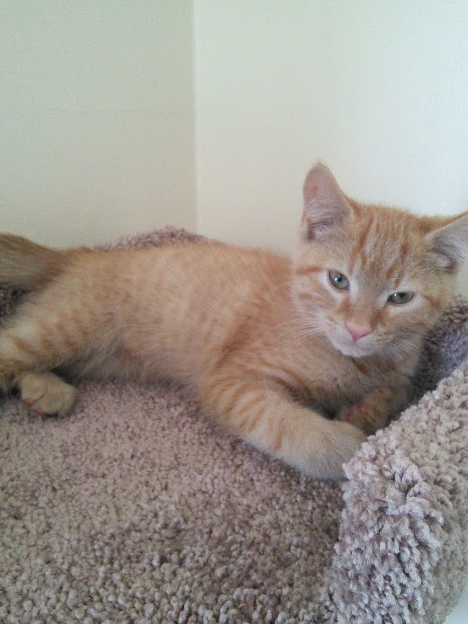

BIOGRAPHY OF THE AUTHOR

John Doe was born in Bradley, Maine on June 14, 1973. She was raised in Milford, Maine and graduated from Old Town High School in 1990. She attended the University of Notre Dame and graduated in 1994 with a Bachelor’s degree in Mathematics. She returned to Maine and entered the Civil Engineering graduate program at The University of Maine in the fall of 1995. After receiving her degree, John will be joining B & B Co., an international infra‐structure developer, to begin her career in
the field of bridge construction. John is a candidate for the Master of Science degree in Civil Engineering

from the University of Maine in May/August/December 2023.

