DOCTORAL DISSERTATION’S/MASTER’S THESIS TITLE CENTERED, BOLD, IN ALL CAPS, AND AN INVERTED PYRAMID FORMAT
By
Jane Doe
B.A. Fancy College, 2018
M.A. Fancier College, 2022

A DISSERTATION/THESIS
Submitted in Partial Fulfillment of the
Requirements for the Degree of
Doctor of Philosophy/Master of Science/Master of Fine Arts
(in Chemical Engineering)

The Graduate School
The University of Maine
May/August/December 2024

Advisory Committee:
Marilyn Monroe, Professor of Chemical Engineering, Advisor
Cindy Glass, Professor of Chemical Engineering
Walt Whitman, Associate Professor of Chemical Engineering
Frank Franklin, Assistant Professor of Wood Science and Technology
Harold Haroldson, Associate Professor of Statistics

(Copyright page optional/do not list on TOC)

Copyright 2024 Jane Doe

OR

© 2024 Jane Doe
All Rights Reserved

UNIVERSITY OF MAINE GRADUATE SCHOOL LAND ACKNOWLEDGMENT
The University of Maine recognizes that it is located on Marsh Island in the homeland of Penobscot people, where issues of water and territorial rights, and encroachment upon sacred sites, are ongoing. Penobscot homeland is connected to the other Wabanaki Tribal Nations— the Passamaquoddy, Maliseet, and Micmac—through kinship, alliances, and diplomacy. The University also recognizes that the Penobscot Nation and the other Wabanaki Tribal Nations are distinct, sovereign, legal and political entities with their own powers of self-governance and self determination.

DOCTORAL DISSERTATION’S/MASTER’S THESIS TITLE CENTERED, BOLD, IN ALL CAPS, AND AN INVERTED PYRAMID FORMAT
By Jane Doe
Thesis/Dissertation Advisor: Dr. Marilyn Monroe

An Abstract of the Thesis/Dissertation Presented
In Partial Fulfillment of the Requirements for the
Degree of Doctor of Philosophy/Master of Science/Master of Fine Arts
(in Chemical Engineering)
May/August/December 2024
The abstract should be a condensation of the substance of the student’s work, and not an introduction nor a text version of the Table of Contents. Within the space the writer should convey to the reader concisely and accurately the significance of the work, the boundaries of space and time that it encompasses, the method of inquiry, and the claim to generality (if any) made in the research. The abstract should be well-balanced to reflect not only the eye‐catching or original elements of the thesis/dissertation but the overall spirit and structure of the work. This balance is achieved if the abstract and the manuscript make sense without one another.
Depending on the type of research format that the thesis/dissertation has followed, the abstract may include information about some or all of the following elements: purpose, scope, method, results, recommendations, and conclusions. It should become clear from the abstract what the main idea of the research project is what is the central question that the author is trying to answer, why this question is important, what has been discovered, why this discovery is significant, and who could benefit from the findings. Summarizing the scope of the research should provide the reader with an idea about the author’s focus in the work and the motifs behind that focus. A brief description of the method should explain what kinds of evidence have been provided and how the author has attempted to prove their validity. A succinct analysis of the results of the research should reveal the consequences of the discoveries that have been made so that the recommendations or solutions offered by the author are given a relevant context. The summary of the conclusions of the research may specify whether the author claims any “cause and effect” relationships and/or whether the problem or central issue of the project has been resolved. An effective abstract uses well-developed, coherent, concise, and unified paragraphs with the elements of the research being discussed in logical order. Double caution must be used to make sure that there are no spelling or grammar mistakes. An abstract should not add any new information but should simply summarize the manuscript. A good abstract will also be intelligible to a wide audience.
Abstracts are recycled in electronic and abstract journals, and they are an efficient way for scholars to keep up with the ongoing research in their fields. Therefore, the more clearly the abstract portrays the substance of the research project, the better the chance that the author’s contribution to the field will be acknowledged.

DEDICATION (Optional)
To my family and friends. Thank you

ACKNOWLEDGEMENTS (Optional)
Thank you to my committee, friends, and family for the support and countless hours of reading my thesis.

TABLE OF CONTENTS
DEDICATION.............................................................................................................................................iv
ACKNOWLEDGMENTS...............................................................................................................................v
LIST OF TABLES..........................................................................................................................................x
LIST OF FIGURES.......................................................................................................................................xi
LIST OF EQUATIONS.................................................................................................................................xii
LIST OF ABBREVIATIONS.........................................................................................................................xiii
Chapter
1. CHAPTER TITLES ARE ALL CAPS.............................................................................................................1
First Level Heading.......................................................................................................................3
Second Level Heading.....................................................................................................5
Third Level Heading...........................................................................................8
Fourth Level Heading..........................................................................10
Third Level Heading.........................................................................................12
Second Level Heading...................................................................................................14
First Level Heading: If the title of this section does not fit on one line, it should be
split into two or more lines so that at least five leader dots(..... ) are left between
the text and the page number...................................................................................................15
2. CHAPTER TITLE OF CHAPTER TWO......................................................................................................20
First Level Heading.....................................................................................................................27
Second Level Heading...................................................................................................37
3. REFERENCES/BIBLIOGRAPHY..............................................................................................................70
4. APPENDICES........................................................................................................................................90
Appendix A. Title of Appendix A................................................................................................90
Appendix B. Title of Appendix B.................................................................................................93
Appendix C. Title of Appendix C.................................................................................................95
5. BIOGRAPHY OF THE AUTHOR............................................................................................................100

(Bio must be the absolute last page)

LIST OF TABLES
Table 3.1. Title of the only table in Chapter 3 17

Table 4.1. Title of the first table in Chapter 4 25

Table 4.2. Title of the second table in Chapter 4 37

Table 5.1. Title of the first table in Chapter 5 55

Table 5.2. Title of the second table in Chapter 5 Titles which are too long to fit on one line without interfering with the column of page numbers on the right should be split into two or more lines so that at least 5 leader dots (. ) are left
between the text of the title and the page number 62

Table A.1. Title of the only table in Appendix A 82

Table C.1. Title of the first table in Appendix C 89

Table C.2. Title of the second table in Appendix C 90

LIST OF FIGURES
Figure 1. Title of the First Figure in the Thesis 4
Figure 2. Title of the Second Figure in the Thesis 7
Figure 3. Title of the Third Figure in the Thesis 16
Figure 4. Title of the Fourth Figure in the Thesis 23
Figure 5. Title of the Fifth Figure in the Thesis 32
Figure 6. Title of the Sixth Figure in the Thesis 33
Figure 7. Title of the First Figure in the Appendix A 71
Figure 8. Title of the Second Figure in the Appendix A 72
Figure 9. Title of the First Figure in the Appendix B 78
**Number List of Tables and List of Figures using the same format; either 1.1, 1.2, etc. OR 1, 2, 3, 4, etc.**

CHAPTER 1
CHAPTER TITLE CENTERED, BOLD, ALL CAPS
The chapter heading may be followed by some introductory text as shown here. Or, the first chapter subdivision may appear right away, as shown in the next sample. The style of the headings may vary from those shown here, yet every effort should be made to have the organizational scheme clear at a glance. Italics cannot be used for headings or subheadings. Bold styles, underlining, and/or different levels of indentation can be used.
First Level Heading

Text text text text text text text text text text text text text text text text text text text text text text text text text text text text text text text text text text text text text text text text text text text text text text text text.
Second Level Heading

Text text text text text text text text text text text text text text text text text text text text text text text text text text text text text text text text text text text text text text text text text text.
Third Level Heading. Text text text text text text text text text text text text text text text text text text

text text text text text text text text text text text text.

Fourth Level Heading. Text text text text text text text text text text text text text text text text

text text text text text text text text text text. Text text text text text text text text text text text text text text text text text text text text text text text text text text. Text text text text text text text text text text text text text text text text text text text text text text text text text text. Text text text text text text text text text text text text text text text text text text text text text text text text text text. Text text text text text text text text text text text text text text text text text text text text text text text text text text. Text

Table. 5.1 Sample of a split table. Detailed description of Table. 5.1, description does not appear on List of Tables.

Year | Location | Estimated  Number | Cost | Percent | Height | Length | Weight | Accepted/  Rejected | Date
1970 | City,State | # | $ | % | Feet/ inches | Inches | lbs./ ounces | A/R | #/#/#
1971 | City,State | # | $ | % | Feet/  inches | Inches | lbs./  ounces | A/R | #/#/#
1972 | City,State | # | $ | % | Feet/ inches | Inches | lbs./ ounces | A/R | #/#/#
1973 | City,State | # | $ | % | Feet/  inches | Inches | lbs./  ounces | A/R | #/#/#
1974 | City,State | # | $ | % | Feet/ inches | Inches | lbs./ ounces | A/R | #/#/#
1975 | City,State | # | $ | % | Feet/  inches | Inches | lbs./  ounces | A/R | #/#/#
1976 | City,State | # | $ | % | Feet/ inches | Inches | lbs./ ounces | A/R | #/#/#
1977 | City,State | # | $ | % | Feet/  inches | Inches | lbs./  ounces | A/R | #/#/#
1978 | City,State | # | $ | % | Feet/ inches | Inches | lbs./ ounces | A/R | #/#/#
1979 | City,State | # | $ | % | Feet/  inches | Inches | lbs./  ounces | A/R | #/#/#
1980 | City,State | # | $ | % | Feet/  inches | Inches | lbs./  ounces | A/R | #/#/#
1981 | City,State | # | $ | % | Feet/  inches | Inches | lbs./  ounces | A/R | #/#/#
1982 | City,State | # | $ | % | Feet/  inches | Inches | lbs./  ounces | A/R | #/#/#
1983 | City,State | # | $ | % | Feet/ inches | Inches | lbs./ ounces | A/R | #/#/#
1984 | City,State | # | $ | % | Feet/  inches | Inches | lbs./  ounces | A/R | #/#/#
1985 | City,State | # | $ | % | Feet/ inches | Inches | lbs./ ounces | A/R | #/#/#
1992 | City,State | # | $ | % | Feet/  inches | Inches | lbs./  ounces | A/R | #/#/#
1993 | City,State | # | $ | % | Feet/ inches | Inches | lbs./ ounces | A/R | #/#/#
1994 | City,State | # | $ | % | Feet/  inches | Inches | lbs./  ounces | A/R | #/#/#
1995 | City,State | # | $ | % | Feet/ inches | Inches | lbs./ ounces | A/R | #/#/#
1996 | City,State | # | $ | % | Feet/  inches | Inches | lbs./  ounces | A/R | #/#/#

Table 5.1 Continued.
1997 | City,State | # | $ | % | Feet/ inches | Inches | lbs./ ounces | A/R | #/#/#
1998 | City,State | # | $ | % | Feet/  inches | Inches | lbs./  ounces | A/R | #/#/#
1999 | City,State | # | $ | % | Feet/ inches | Inches | lbs./ ounces | A/R | #/#/#
2000 | City,State | # | $ | % | Feet/  inches | Inches | lbs./  ounces | A/R | #/#/#

Fourth Level Heading. Text text text text text text text text text text text text tex text text text text text

text text text text text text text text text text text text text text text text text t text text text text text text text text text text text text text.
Third Level Heading. Text text text text text text text text text text text text text text text text text text

text text text text text text text text text text text text text text text text text text text text text text text text text text text text text text text text text text text text text text text text.
Second Level Heading
Text text text text text text text text text text text text text text text text text text text text text text text text text text text text text text text text text text text text text text text.
First Level Heading
Text text text text text text text text text text text text text text text text text text text text text text text text text text text text text text text text text text text text text text text.
Second Level Heading
Text text text text text text text text text text text text text text text text te text text text text text text text text text text text text text text text text text text text text text text text text text text text text text text text text text text text text text text text text text text text text xt text text.

CHAPTER 2
CHAPTER TITLE
2.1. First Level Heading
Text text text text text text text text text text text text text text text text text text text text text text text text text text text text text text text text text text text text text text text.
2.1.1. Second Level Heading
Text text text text text text text text text text text text text text text text text text text text text text text text text text text text text text text text text text text text text text text.
      - Third Level Heading. Text text text text text text text text text text text text text text text text text text text text text text text text text text text text text text text.
      - Third Level Heading. Text text text text text text text text text text text text text text text text text text text text text text text text text text text text text text text.
2.1.2. Second Level Heading
Text text text text text text text text text text text text text text text text text text text text text text text text text text text text text text text text text text text text text text text.
2.2. First Level Heading
Text text text text text text text text text text text text text text text text text text text text text text text text text text text text text text text text text text text text text text text.

BIBLIOGRAPHY

The style of the bibliography will vary by discipline.

References should be listed single-spaced within and double-spaced in between.

APPENDIX
This is the appendix, which goes between your Bibliography and the Biography of the Author. The information in the appendix is supplementary to the text. The body of the text should be able to stand alone if the Appendix is removed.
Table A.1 Title of Table. This is a table with numbers and needs to be listed on the LOT.

1 | 2 | 2
3 | 4 | 5
4 | 4 | 7

Figure A.1 Leroy the cat.
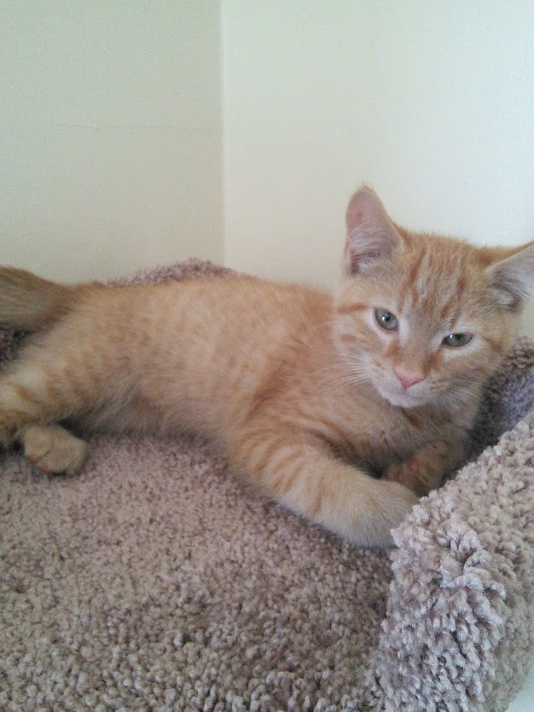

BIOGRAPHY OF THE AUTHOR

Jane Doe was born in Bradley, Maine on June 14, 1973. She was raised in Milford, Maine, and graduated from Old Town High School in 1990. She attended the University of Notre Dame and graduated in 1994 with a Bachelor’s degree in Mathematics. She returned to Maine and entered the Civil Engineering graduate program at The University of Maine in the fall of 1995. After receiving her degree, John will be joining B & B Co., an international infrastructure developer, to begin her career in the field of bridge construction. Jane is a candidate for the Master of Science degree in Civil Engineering from the University of Maine in May/August/December 2023.

