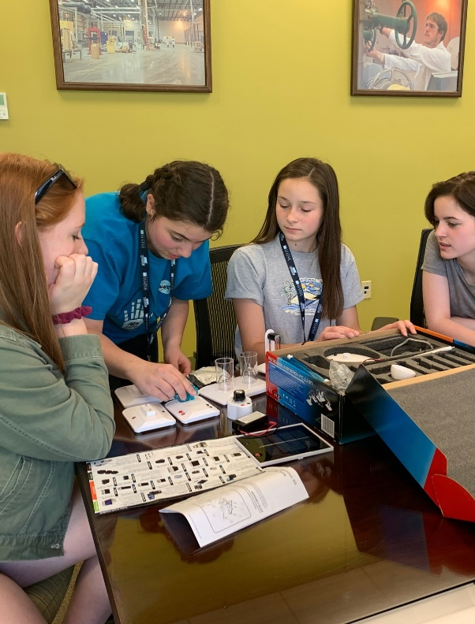
UMAINE INSTITUTE FOR
SELF
Sustainable Energy Leaders of the Future

June 27-30, 2021
Residential institute with
FULL SCHOLARSHIP for high school girls

[SELF] was incredibly formative, informational, eye-opening, and so, so fun for me! I cannot begin to describe how grateful I am that I got to be a part of it.
- Abigail Durgin, 2018

I learned what it means to be an engineer and got a glimpse of the exciting innovation that could improve our way of life.
The SELF camp showed me that I could accomplish whatever I set my mind to [and it] kickstarted the support and resources I needed to thrive in engineering.
- Grace Farrington, 2015

My own daughter Sarah attended the 2017 SELF program. This was after her sophomore year in high school. Her time on campus was so inspiring that she combined her junior and senior years and began with the computer engineering department...she is determined to be a professor, much like the ones that she got to
Connecting young women to STEM careers through research, mentoring and community service in forest bioproducts & biomedicine.

The SELF Institute is a cost-free, 3.5-day residential program for rural high school students. SELF focuses on the responsible use of forest ecosystems as a building block for sustainable and renewable energy. Students will explore cutting-edge research relevant to rural Maine communities by participating in demonstrations, hands-on projects, and field trips.

To qualify for the institute applicants must:
Be a high school student, preferably a sophomore
Have an interest in science and technology
Submit a report card
Submit an essay detailing interest in participation in SELF Submit at least one letter of recommendation

For more information, contact Sheila Pendse sheila.pendse@maine.edu or visit umaine.edu/gem/

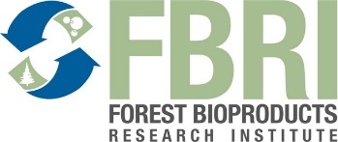
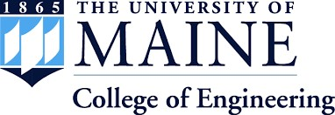

Funded by the National Institute of Food and Agriculture (NIFA), USDA — Women and Minorities (WAM) in STEM Fields Program award number 2020-38503-31951

meet during her time during SELF.

- Mary Glatter, parent, 2017
The University of Maine [name of campus] is an EEO/AA employer and does not discriminate on the grounds of race, color, religion, sex, sexual orientation, transgender status, gender expression, national origin, citizenship status, age, disability, genetic information or veteran’s status in employment, education, and all other programs and activities. The following person has been designated to handle inquiries regarding non-discrimination policies: Director of Equal Opportunity, 101 North Stevens Hall, University of Maine, Orono, ME 04469-5754, 207.581.1226, TTY 711 (Maine Relay System).

