http://garysalton.blogspot.com/2016/05/gender-bias-in-engineering-root-cause.html

Organizational Engineering
Evidence-based research into human behavior in group contexts

Monday, May 09, 2016

Gender Bias in Engineering: Root Cause Analysis
By: Gary J. Salton, Ph.D.
Chief: Research and Development
Professional Communications, Inc.
INTRODUCTION
Click to see video
Earlier studies (see footnote #1 for references and summaries) have shown that engineering is unique. It shares tools with other STEM disciplines but applies them in a unique way. Risk aversion was identified as the root-cause of information processing strategies used (see footnote #2 for citation). Effectively, failure carries more consequence for engineering than it does in other STEM professions.This stance creates a strong culture (see footnote #3 for citation). Things that frustrate this culture engender negative responses. This research investigates whether systematic gender differences create such a condition.
ENGINEERING BASED RESEARCH TOOL
Bias can arise from many sources. Unreasoned ignorance such as found when racial or cultural bias is passed on in families or confined social groups is one. However, behavioral patterns which threaten a desirable outcome can sometimes be assigned to an identifiable group. A bias can then be applied to that group as a means to suppress the offending pattern (see footnote #4 for evidenced-based citation on the existence of bias). This research seeks to determine if this condition exists in engineering.
The tool used in this research is “I Opt” information processing. It is based on the well-accepted input-process-output model of engineering. Information determines what can be thought. What you accept as input matters. You cannot consider what you do not notice. Your intended output sets the social effect of the input. An action output produces objective outcomes that can be assessed. Thought output leaves no trace and can only be assessed by inference.
Process links input and output. It determines how the input and output variables are expressed. For example, structured input (i.e., following some kind of predefined scheme) combined with action output tends to produce predictable outputs of uniform quality. This consistency is produced by the process (structured action) and not what the person “feels” about the subject. The same logic applies to other input/output combinations.
The “I Opt” model produces behavior. Behavior has no inherent meaning. For example, a person might be seen as rigid and inflexible. Alternatively, that same person exhibiting exactly the same behavior might be seen as careful, diligent and dependable (see footnote #5 for reference to a more complete explanation). Inferential analyses that rely on the interpretation (qualitative, second order data) run this type of risk of systematic error.
“I Opt” technology minimizes misinterpretation by focusing on the process that underlies behavior—input-process-output (see footnote #6 for validity citations). In addition it quantifies those components. This limits distortions based on the misjudging of relevance. Relevance might include such things as importance, visibility or degree of conviction.
THE SAMPLE
Table 1 shows the gender distribution of the sample used. The size and distribution appears sufficient to draw meaningful conclusions. The inclusion of organizational level recognizes the differential power residing in organizational rank (see footnote #7 for detail on the composition of the categories used).
Table 1
SAMPLE SIZE AND DISTRIBUTION
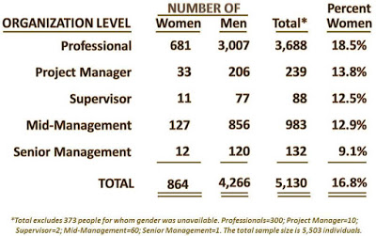
FACILITATING BIAS
"First impressions" matter. They can create expectations which can then guide future behavior. A place to begin the search for patterns is in these initial postures.
“I Opt” strategic styles are behavioral sequences (see footnote #8 for detail on the “I Opt” framework). They define behavior most likely to be used when confronting an unfamiliar issue. For example, the author’s dominant style is Reactive Stimulator (RS). When confronting a new issue my first inclination is to search for any input that is relevant (unpatterned input), attempt to apply it (process) in a way that most expeditiously resolves the issue (action output). This is not the only strategy I can use. It is just the one I most prefer (this research evidences the fact that I can access other more thoughtful styles).
Biases are created by differences. Table 2 shows the percent difference of the number of women versus men subscribing to each style as dominant. For example 16% more women than men engineers will choose my RS style as their initial response (see the first row of Table 2). Similarly, 29% fewer of these women than men will elect the RI pattern of exploring for new, untested methods.
The small numbers of women in some of the categories distort the percentages. However, the direction of differences is relevant and unprejudiced. The black entries signal the proportion of women exceeding men. The red entries signal women with less of an inclination than men.

Table 2
PERCENT DIFFERENCE IN
DOMINANT STYLE BETWEEN GENDERS
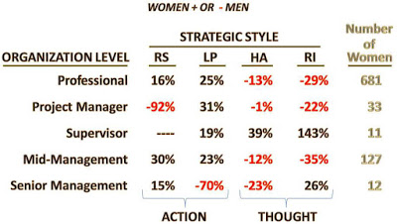
A pattern is clearly evident. Women tend to put more emphasis than men on the RS and LP styles (see number of black entries in these columns). They put less weight on the HA and RI styles (see number of red entries in these columns). The issue is whether this has consequence.
Styles can be categorized by output. The RS and LP styles favored by women are action oriented. The HA and RI are thought focused. Both action and thought are needed to get things done. However, the choice of one posture can limit the other. For example, action precludes the need for thought. You do not have to think about something already done. Thought (e.g., assessment, planning, etc.) introduces delays and uncertainties that can frustrate an action.
The thought/action divergence in initial positions is probably not enough to create a bias. But it is enough to alert people that “something is going on.” There are more men in engineering than women. That means that the average man will get a lot of confirmation that his way (see red numbers in Table2) is the “right” way. That implies that the average woman must be “wrong” (see black numbers in Table2). This difference can set a negative direction if not the destination.
CONFIRMING BIAS
Style strength measures the degree of commitment to a style. The greater the strength, the more tenaciously a person will cling to an approach in the face of opposition. The more they cling, the greater is the likely behavioral impact. The greater the impact, the greater is the motivation for a bias formation.
Table 3 shows the style strength differences between men and women engineers. The average woman is 9.6% more committed to the LP style than is the average man (see Weighted Avg./Total row). This means that the average women will stick to an initial LP position with about 10% more vigor than will the average man. An “inflexible” or “stubborn” attribute is easily applied.
On the other side the average man will hold to the idea oriented RI with about 10.9% more vigor than will the average woman. One possible inference among the dominant male population could be that women run out of ideas sooner than do men. In other words, men are more creative.
Table 3
PERCENT DIFFERENCE
WOMEN +/- MEN IN STYLE STRENGTH
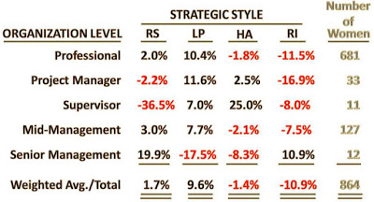
The more important bias generating issue is the 20 percentage point divergence between the mutually exclusive posture of the LP (9.6%) and RI (-10.9%). The average male engineer sees an opportunity for major gains using creative options. The average woman engineer sees the certainty, efficiency and effectiveness of applying existing methods.These are mutually exclusive options.
Table 4 shows that this is not a local phenomenon. The same LP and RI divergence appears in virtually all engineering work areas and among people with all types of academic engineering degrees. The structural differences will be visible in ordinary interaction. They may or may not generate the inferences used here. But there can be little doubt that they will have some kind of negative effect. However, there are mitigating factors that will tend to mask recognition of any biases.
Table 4
PROFESSIONAL LEVEL STYLE STRENGTH
GENDER DIFFERENCES
BY INITIAL ACADEMIC DEGREE AND WORK AREA
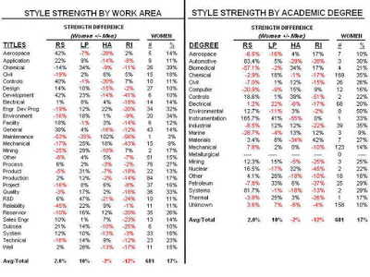
MASKING FACTORS
Engineering is the most thoughtful of the professions (see footnote #9 for citation). Graphic 1 shows that both men and women favor the use of the analytic HA style. The HA style is highly rational, reflective and measured. Both genders also put the spontaneous RS style at the bottom of their preferences. This commonality (see hardhat symbols in Graphic 1) tempers the expression of pattern-based bias.
Graphic 1
AVERAGE STYLE STRENGTH BY GENDER
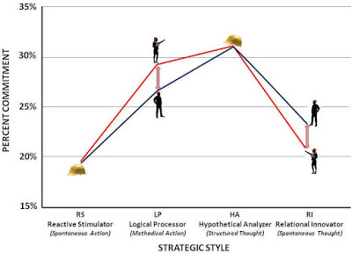
Graphic 1 tells us that any pattern generated bias will exist at a secondary level (see arrows). Secondary styles are used where the dominant style does not apply. Thus the structural divergence is likely to appear as something of an undertow in the flow of engineering transactions. Divergences repeatedly appear but not at a frequency that would make them standout as a part of the organizational structure. On an instance by instance basis they can be discounted. This discounting will tend to mask their function as a source of bias.
But the low participation of women is obvious and it has not escaped attention. The sample contains data on 106 participants in Engineering Advanced Leadership Programs. These programs typically involve rapid rotational assignments. Participants quickly gain wide knowledge of a number of engineering areas. More importantly, they get working exposure to a large number of executives who can be instrumental in facilitating future promotions. Positions on the program are coveted and not lightly dispensed.
Table 5
GENDER AND STYLE STRENGTH DIFFERENCES IN
ENGINEERING ADVANCED LEADER PROGRAMS
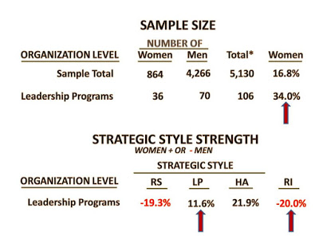
Table 5 shows that women make up 34.0% of program participants versus 16.8% in the overall sample. This is evidence that an effort is being made to include more women in the profession. The fact that the women being selected repeat the misalignment seen in other areas (more LP, less RI) is not noticed. Organizational science is not an engineering strong suit.
ROOT CAUSE SUMMARY
The secondary style divergence of men (RI) and women (LP) is an underlying cause of pattern based bias in engineering. Once established it can be magnified by the operation of unreasoned ignorance. With a population of 80% men, biases can be readily passed around and magnified. They offer a convenient explanation of occasional problems encountered when working with women engineers. With so few women engineers, there is no counterbalance. It is fertile ground.
Secondary level patterns do not clearly signal a bias. The widely shared highly rational HA style can also mask any bias that exists. Bias is irrational by definition. Suggestions that it is embedded in the engineering structure are likely be avoided, dismissed, discounted or ignored. When bias presents itself in unavoidable form, a logical “reason” for any disparities will be created (“reasons” are the forte of the highly rational HA strategy). This masking allows bias to persist.
There are undoubtedly other sources of gender bias. However, the structural divergence identified here is at least one of those causes. It has a behavioral consistency that insures its persistence over time.
REMEDIAL STRATEGIES
Style strength measures the degree of commitment to a style. The greater the strength, the more tenaciously a person will cling to an approach in the face of opposition. The more they cling, the greater is the likely behavioral impact. The greater the impact, the greater is the motivation for a bias formation.
The divergence in male-female secondary styles could be caused by nature, nurture or selection. Any conclusion would be speculation. It is also of little consequence. Averages are based on distributions. The relatively small divergence (~10%) suggests that within the female distribution there will be many individual women who match or surpass their male counterparts.
The STEM focus of attracting more women into engineering is on target. More women will be available to de-fang bias as it surfaces. Also, among the women attracted there will be those who are visibly exceptional. Their example will weaken the pattern-based rationale underlying the bias. The “just add women” strategy will work. Bias will be mitigated but not resolved.
Attracting more women with stronger idea-oriented RI inclinations could re-balance the structure. These people are attracted by the opportunity to discover new, unexpected relationships. They are motivated by things that have the potential of yielding major gains. Programs that stress this potential within engineering will erode the structural basis of bias.
It will take years to substantially increase female representation. A basic engineering degree takes four years. More years will be need for these women to accumulate the credentials to be accepted as full peers. A complementary strategy can facilitate the process. It will also improve the lot of the women already in the field. As a bonus it can improve the effectiveness of the engineering process itself. Everybody can win.
This complementary strategy involves redefining the “meaning” of the structural divergence. Currently the structural divergence creates a low-grade but irreconcilable conflict. This gives rise to negative emotions which in turn encourage bias. The complementary strategy must involve demonstrating as well as preaching. HA engineers do not take things on faith.
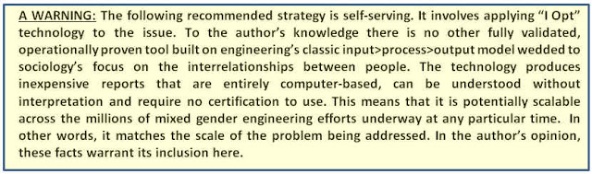
The core of the issue is an irreconcilable structural divergence problem. What is needed to reconcile the two mutually exclusive approaches is a common basis. The subject of the engineering effort is a natural common focal point. Everyone involved shares the desire for success. A tool that demonstrates a rational method to guide the application of the divergent approaches is likely to be well-received by all involved.
The “I Opt” TeamAnalysis™ is such a proven tool. The technology recognizes the relative strength of each style and the overlaps between the specific individuals in the group. Using this information the report is able to generate detailed recommendations. Conflicts born of structural divergences are automatically recognized and addressed by providing detailed alternative options. The group applies the knowledge with the common denominator of the specific engineering effort in which all are engaged (see Footnote #10 for detail on TeamAnalysis). It is a safe, effective and proven tool.
Attracting women and adjusting the profiles can diminish gender-based bias in engineering. However, to be truly effective the women attracted have to be retained. Graphic 2 shows that about 70% of men engineers are retained versus 60% of the women engineers—a 15% incremental loss among women. It is unknown if the incremental women leaving engineering are those with stronger idea-oriented RI preferences. However, any incremental loss of will act to frustrate strategies to reduce bias. Earlier studies have offered suggestions on how this might be addressed by making engineering more “woman friendly” (see Footnote #11 for options detail).
Graphic 2
RETENTION RATES IN ENGINEERING BY GENDER

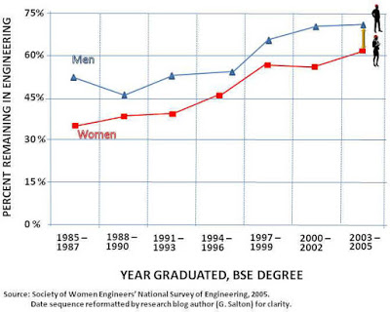
CONCLUSION
Bias can be based on many environmental, social and personal factors. This research does not pretend to have addressed all or even most. However it has identified, quantified and offered fact-based options for addressing at least some of them. It is hoped that this effort will help reduce the discrimination now being experienced. To the extent that it is successful it will improve the lot of women engineers. But even more importantly, it will improve engineering itself.
FOOTNOTES AND BIBLIOGRAPHY
1. A series of recent studies have focused on examining the
engineering discipline. These studies include both textual
and video formats.
The Engineering Personality. Salton, Gary J., 2014. This study demonstrates that the engineering “personality” traits are an entirely predictable outgrowth of the job being done. It goes on to show how these traits arise, quantifies the unique character of engineering and explores the implications of the findings.
Text Research Blog: http://garysalton.blogspot.com/2014/04/the-engineering-personality.html
Video (15 minutes): https://www.youtube.com/watch?v=jM1yf_7RIfY&feature=youtu.be

Women in Engineering. Salton, Gary J., 2015. This study quantitatively demonstrates that the gender bias in engineering has nothing to do with the intellectual demands of the profession by contrasting it with science where women are better represented. The study traces the core of the engineering/science difference to different consequences of failure in the two areas. This difference demands that the tools common between science and engineering be applied differently. The difference in tool application generates the social differences that impact women’s participation.
Text Research Blog: http://garysalton.blogspot.com/2015/01/women-in-engineering.html
Video (17minutes): https://www.youtube.com/watch?v=G0FNHeNsQEw
Engineering Insights. Salton, Gary J., 2015. Information processing commonalities generated by the structure of the engineering mission are measured. The study shows how this naturally results in an extremely strong culture. This culture has advantages and exposures. One such exposure is a systematic gender bias. The corollary positive counterpart is the efficient and effective discharge of engineering responsibilities.
Text Research Blog: http://garysalton.blogspot.com/2015/07/engineering-insights.html
Video (13 minutes): https://www.youtube.com/watch?v=40cZB_ngGSQ
Women in Engineering Leadership: Salton, Gary J., 2015. This study shows that the “I Opt” profile of women promoted from the professional pool match the profile of men similarly promoted. Equity in the opportunity for promotion is evidenced. The gender problem arises from the character of the professional pool. The number of women whose profile matches that of managerial jobs is relatively low. A naïve judgement based on the numerical shortfall is that women are being “discriminated against.” Actually correcting the condition requires that engineering attract and retain women with the requisite managerial profile. Various methods of accomplishing this are offered.
Text Research Blog: http://garysalton.blogspot.com/2015/09/women-in-engineering-leadership.html
Video (14 minutes): https://www.youtube.com/watch?v=xJw_M99TMDQ
2. The Women in Engineering video from 7:35 minutes to 9:30 minutes explains the core difference between science and engineering.
Video (17minutes): https://www.youtube.com/watch?v=G0FNHeNsQEw

3. The Engineering Insights video from 3:55 minutes to 5:50 minutes explains the factors and processes governing the creation of the engineering culture.
Video (13 minutes): https://www.youtube.com/watch?v=40cZB_ngGSQ

4. The Women in Engineering video from 25 seconds to 1:30 minutes outlines the evidence for systematic bias in engineering.
Video (17minutes): https://www.youtube.com/watch?v=G0FNHeNsQEw

5. The video Introduction to the EIM Report explains how the interpretation of behavior (i.e., patterns of action) can vary with the perspective. This process applies to the researcher as well as the research subject. The relevant part of the video begins at about 4 min 30 seconds and extends to about 6 min into the video (1½ min total). You can view this video on YouTube at: https://www.youtube.com/watch?v=HauMxXivyyM 6
6. "I Opt" VALIDATION: "I Opt" technology has been extensively validated both in terms of theory and operation. The major publications on the subject include:
A doctoral dissertation titled A Study of Intuition in Decision-Making using Organizational Engineering Methodology was approved by Nova Southeastern University in 2000. The dissertation used “I Opt” as both a subject and research instrument.The dissertation was subject to review by an independent doctoral research committee headed by a Ph.D. focused on research methods and found to meet all academically accepted standards of validity. The complete dissertation is available free of charge at http://www.oeinstitute.org/articles/ashley-fields.html
The dissertation is also available in book form as: Fields, Ashley (2001). The Effects of Intuition in Decision-Making, ISBN-13: 978-3639368185, Germany: VDM Verlag Dr. Müller (August 18, 2011). Available from Amazon.com.
“I Opt” Style Reliability Stress Test: The sample of 171 surveys applied a classic test-retest design covering a period of 18 years to test the reliability of the “I Opt” instrument on styles (i.e., short term decision responses). The results far exceed the reliability of traditional instruments (i.e., MBTI, DiSC, Firo-B, 16PF). The research is available of the Google research blog in textual form at: http://garysalton.blogspot.com/2011/03/i-opt-style-reliability-stress-test.html. A 10-minute video of the study is available on YouTube at:https://www.youtube.com/watch?v=Vs6eoIsqVkc
“I Opt” Pattern Reliability Stress Test: The same data as used for style reliability was applied to patterns (i.e., long-term decision sequences). The change between test-retest was found to be negligible. The research is available of the Google research blog in textual form at: http://garysalton.blogspot.com/2011/03/i-opt-pattern-reliability-stress-test.html. A 15-minute video of the study is available on YouTube at:https://www.youtube.com/watch?v=0SLg28BhNHU
Operationally: “I Opt” has been validated through continued worldwide use at all levels from hourly workforces to Board of Director levels of Fortune 50 organizations in the profit, non-profit and government sectors. An outdated (last updates 15 years ago) listing of the organizations involved can be found at http://www.iopt.com/corporate-information.html. Many of the clients cited have continued to use the technology for decades and many more pages of new clients could be added if the list were to be updated to today.
7. Category Definitions of Sample Data:The sample is categorized by
organizational level so the reader can discern whether differences are
local to a particular level or distributed throughout engineering.
The Professional category consists of professional, non-supervisory, degree
holding engineers actually working in engineering roles.
Project Manager is event (i.e., a specific task that has a defined end point) driven
activity. Its importance can vary from responsibility for the construction of a multi-billion
dollar production facility to the CAD/CAM design of knobs for a new instrument. The
role functions as both a terminal specialty role and as a route to higher management
levels. The roles’ managerial responsibilities are typically confined so as to give
greater focus to objective project. For example, Project Managers typically have
“dotted line” relationships to those assigned to the project.
Supervisor is a first level function whose focus is on the maintenance of an ongoing
process rather than an event. Supervisors typically carry the full range of managerial
functions.
Mid-management consists of managers, directors, general managers and other
similar titles that typically do not carry corporate officer status. As with Project
Managers, the range of responsibilities within this category is broad. For example,
the budgets controlled by these titles can range from tens of millions to only thousands
of dollars.
Senior Management consists of Vice President level engineering executives usually
with officer level status within their corporate entity. It also includes Chief Engineers
who may or may not hold that status

8. A general orientation to the “I Opt” paradigm can be found by viewing
the 8 minute YouTube video "I Opt" Strategic Styles and Patterns
at: https://www.youtube.com/watch?v=KVOyznCCWB8
An explanation of the dynamics of the input-process-output model
can be found in the YouTube video Team Tension—Causes
and Management from 1:30 minutes to 2:10 minutes.
http://www.youtube.com/watch?v=xQ_5b4BUUB0&feature=youtu.be.

9. Thoughtfulness is typically associated with the analytical Hypothetical
Analyzer (HA) style. The HA strategy involves system level
comparative evaluations of multiple options. This thought orientation
mandates that all considerations involved in an issue be treated
objectively. Irrational biases are an anathema to these calculations.
It can be expected that any anomaly will be seen as having some
form of rational basis. The thought processes of engineers can be
seen in the behavioral cascade section video of The Engineering
Personality YouTube video starting at 3 minutes and ending at
about 6 minutes in the presentation.
https://www.youtube.com/watch?v=jM1yf_7RIfY&feature=youtu.be.
10. The video IOPT TEAMANALYSIS ORIENTATION video provides
a walk-through of the TeamAnalysis report as well as information
on how it is constructed with the data provided. Video (9minutes):.
https://www.youtube.com/watch?v=tTBlAygPN3g
11. The Women in Engineering video from 13:15 minutes to
16:15 minutes outlines some of the options for improving
engineering’s attractiveness to women. Video (17minutes):.
https://www.youtube.com/watch?v=G0FNHeNsQEw
Labels: bias, Engineering, gender, men, OD, retention, Sociology, STEM, strategic pattern, strategic style, style, women
posted by Gary Salton, Ph.D. at 10:55 AM
<< Home

About Me
Gary Salton, Ph.D.
Ann Arbor, Michigan, United States
Ph.D. Sociology, MA Economics, MBA, B.S.
View my complete profile

Previous Posts
- Engineering Professors: Gender Gatekeepers
- Women in Engineering Leadership
- Engineering Insights
- Women in Engineering
- 3-DIMENSIONAL ORGANIZATIONAL CHARTS
- The Engineering Personality
- Human Resources Thought Diversity
- Team Tension: Causes and Management
- Organizational Rank and Strategic Styles
- Secrets of the Administrative Assistant

