

**January 11, 2013**

Prepared by Dick Thompson, CIO (dick.thompson@maine.edu • 973-3224)

**Administrative Review: Information Technology Services**



**Our vision is simply this:**

*To deliver seamless, high-quality and effective information technology infrastructure and services that matter to students, faculty and administrative users.*

**Section I - Executive Summary**

The Administrative Review of Information Technology (IT) began in July of 2012, a directive of the Board and Chancellor to use internal resources to perform a self-evaluation of IT systems and processes, with the product being a set of recommendations to enhance system quality, improve efficiency, and realize savings while maintaining or improving IT service.

Input teams gathered information, and recommendations were developed by an IT Administrative Review team. Detailed data is scarce but aggregated data depicts:

* 225 FTE – IT personnel in both central IT departments and within non-IT departments
* $ 24.2 million – IT Costs through central IT departments
* $ 7.5 Million – Estimated IT spend within non-IT departments
* 55% of expenditures are salary and benefits costs of employees

This report contrasts two alternatives to the current state. The first is a series of recommendations drawn from the IT review team. While some recommendations are innovative, the report did not meet the expectations as articulated by the original Charter. The second alternative builds on the first but is designed to achieve optimal performance and savings going forward. The choices are:

* Alternative 1: incremental improvements which are limited in efficiencies and savings potential but do not require major institutional change, or;
* Alternative 2: transformational redesign of IT service delivery that establishes a framework which provides accountability, high engagement and oversight from campus leadership. The design incorporates commitment to efficiencies, savings, and a greater focus on academic programs and activities.

Alternative 2, a redesign of IT service delivery, is the recommendation of the CIO. This redesign requires a new approach to governance in order to achieve the savings identified and establishes that the CIO has authority to manage all UMS IT resources, make commitments and decisions, and be responsible for meeting outcomes in service and performance.

The detailed recommendations with estimated savings follow:

1. Implement alternative leadership and governance structure – *FY 16 structural savings $410K*
2. Establish policies and practices to provide management oversight and inform leaders, administrators, tech staff and innovators – *No direct savings estimated*
3. Actively pursue cloud or “software as a service” sourcing of enterprise systems; Pursue advantages of best practice implementation and uniformity, support and training – *FY 16 structural savings $50K*
4. Investigate and implement a new funding strategy to record and recover costs of shared and centralized services – *No direct savings estimated*
5. Consolidate management and delivery of campus and system support and help desk services; Centralize or outsource end user provisioning, management and maintenance functions related to directly assigned devices – *FY 16 structural savings $1,040K*
6. Consolidate Data Center locations, management and operations – *FY 16 structural savings $160K*
7. Unify communications systems under one management structure provided by a single campus entity – *FY 16 structural savings $155K*
8. Restructure delivery of end user technology – *FY 16 structural savings $88K*
9. Systematically identify, review and organize IT services into a shared services model with campus IT management – *FY 16 structural savings $1,355K*

Total savings are calculated as net of any direct expense to accomplish technology conversion, retraining and consulting costs. The savings do not account for any HR costs related to staff reductions.

* FY 2014 - $ 174,000
* FY 2015 - $1,984,000
* FY 2016 - $3,258,000

A directive to proceed from the Chancellor begins the process. A proposed resolution or policy for Board action:

**The Board of Trustees endorses the Chancellor’s multi-year action plan to *redesign IT service delivery* and authorizes him to immediately begin implementation and provide regular progress reports at Board meetings.**

**Section II - Background and Charter**

**Introduction**

This report represents the culmination of seven months of information gathering and study of information technology services delivery across the University of Maine System (UMS), a project initiated to perform the administrative review of Information Technology (IT) as directed by the Board of Trustees and Chancellor James Page.

The report contrasts two alternatives to the current state. The first is a series of recommendations drawn from several IT input teams who reviewed various individual components of IT service and the management of IT functions across UMS. While some recommendations are innovative, they do not lead to an adequate aggregate level of efficiencies and savings. The second alternative builds upon initial recommendations presented in the first alternative, but is designed to achieve optimal performance and savings going forward. The choice presented here is thus between:

1. Alternative 1: incremental improvements which are limited in efficiencies and savings potential but do not require major institutional change, or;
2. Alternative 2: transformational change that establishes an accountable person within a framework that provides high engagement and oversight from campus leadership, as well as a commitment to efficiencies, savings, and a greater focus on academic programs and activities.

There are risks and rewards for both alternatives that will be highlighted throughout this report. Upon approval, a subsequent process will engage the Presidents and other key stakeholders to complete the detailed design and implementation plan, including oversight, reporting and audit metrics.

**Background and Charter**

In January 2012, UMS Trustees published a comprehensive new set of goals and actions to move the University System forward in the areas of program and workforce development, cost control, and student success.The Board of Trustees directed System and University leadership to implement the goals quickly, creating savings for reinvestment and improvement to important services. The administrative review of IT falls under one of those directives: III.f Reallocate Savings from Administration and Infrastructure to Teaching, Research, and Public Service.

Chancellor Page immediately prioritized the review of IT to provide a pilot review project that would demonstrate our ability to perform a self-evaluation of systems and processes, and to use internal resources to design improvements to enhance system quality, improve efficiency, and realize savings. He directed the System CIO to develop a work plan to conduct the review. The plan and expectations were presented to the Board in May and the work began in early June of 2012.

The initial charter directed a team of IT professionals, led by the CIO, to undertake a deep analysis of information technology across all of UMS. Individual IT Directors would be asked to lead specific evaluation components, obtaining data, costs, and options related to service delivery and recommendations. This work would engage CFO’s, Faculty, Students and Administrators wherever appropriate.

The recommendations were to be assembled by a steering/input team, reported to the Chancellor and, once approved by the System Board, implemented as quickly as possible. Actual cost savings/avoidance would be calculated as part of this report, as would a review of benchmarks for ongoing IT performance.

Anticipated outcomes included:

* Flexibility and innovation operationalized at the campus level but managed to common standards
* Transparent IT research and development processes for new tools/applications
* Resource redundancy only where necessary
* Cost savings/efficiencies while maintaining or improving service

**Team Members**

* Richard Thompson, System CIO
* Fred Brittain, IT Director, UMF, project consultant
* Stephen Houser, IT Director, USM, project consultant
* Leslie Kelly, IT Director, UMFK, project consultant
* Jeff Letourneau, Executive Director, Network Maine, project consultant
* Chancellor James Page, sponsor

Four input teams were created, each with up to six additional members. The leaders were: Lauren Dubois, UMA; Mike Cyr, SWS; Peter Gunn, UM; and William Wells, USM. A full listing of team members is included in Appendix A.

The four input teams were tasked with analysis and development of recommendations. The subjects evaluated were:

* End User Technologies
* End User Support/Help Desk
* Unified Communications (Voice, Video, Data)
* IT Standards and Procurement

The teams worked with key stakeholders, primarily from campus IT organizations. Each had an individual charter, identifying their charge, expectations and their deadlines. The expectations were:

* Development of a Review Scope document
  + This document will comment on charter’s scope and provide a more detailed task plan. Team members can seek guidance from other team chairs, or the CIO
* Collect and assemble information as determined in the scope
  + Interview/engage contributors and others to obtain and verify information collected
* Evaluate the information collected
  + Provide data to support analysis
  + Identify opportunities for action where appropriate
* Prepare a report of findings addressing the three basic improvement criteria
  + Service quality
  + Efficiency/effectiveness
  + Cost savings

Input teams gathered information and recommendations were developed by the Steering team. These were presented in early December as a draft report to the Chancellor and the Office of Organizational Effectiveness. Chancellor Page acknowledged the effort the group put into this work, but determined the report did not meet the expectations as articulated by the original Charter. He cited a lack of analysis and resultant design of what could be considered an optimal, forward-looking, client-centered IT resource for UMS. Moreover, the listed categories of investigation, anticipated level of efficiencies, and the estimated savings were insufficient to meet the intent of the review.

The Chancellor reissued a revised charter with more concise expectations. This charter directed the CIO to take direct responsibility for successful completion of the analysis and design stages of the administrative review and to develop recommendations to achieve optimal governance, management and operations to best serve students, faculty and administrative clients. The initial Review Team members were to act as project consultants as needed. The recommendations were to include efficiencies resulting in savings of at least 10% of current operating budgets. A final report was to be completed and ready for analysis by the Presidents and key stakeholders by January 9, 2013.

**Section III – Findings**

**Benchmarks and Standards**

The teams discovered early on that most IT-relevant data were either not readily available, or did not exist in a manner that would allow ready analysis (e.g., cost evaluation by service). For example, campus and the system office IT groups each use different metrics and budgeting techniques. This lack of uniformity also extends into how IT is funded. Ultimately, there was limited data that could be used and then only for general comparisons.

Benchmarks were equally difficult to identify. UMS is not alone in its challenges to capture IT data. Many higher education institutions across the country have similar difficulties and without good data to rely upon, the published information is often unpersuasive. The Education Advisory Board, a research and consulting organization focused on higher education, provided direct information including identification of a general movement towards more consolidation and shared services: "Centralized IT service units are preferred among profiled institutions and systems. Previous EAB research and a growing literature base suggest that moving to a centralized system can increase overall efficiency."[1]

**Description of the Current State**

Detailed data has been difficult to assemble and is inconsistent. Nevertheless key reported data, aggregated across the system identifies:

* 225 FTE - IT personnel in both central IT departments and within non-IT departments
* $ 24.2 million – IT Costs through central IT departments
* $ 7.5 Million – *Estimated* IT spend within non-IT departments
* 55% of expenditures are salary and benefits costs of employees

IT requires highly specialized skills to provide high quality, efficient services, and to be agile and responsive to the rapidly changing needs of teaching and learning. While the University of Maine System is ahead of its peers in several centralized and shared delivery models (e.g., financial/HR/student systems, the wide area data network, campus portal and some other services), there remain other duplicate and overlapping UMS services.

There are thirteen (13) senior managers responsible for the delivery of information technology services, including one each at of the seven campuses. Two campuses split the role of IT management with Library Services, sharing a single person across these integrated services. Each campus IT leader is autonomous with respect both to other IT leaders and the System CIO. The one exception is that each leader participates in the IT Leadership Council to share information and consider enterprise-wide issues, but is not bound by its decisions. All campuses deploy technology tools, operate user support services, and play a role in most technology matters at the campus. It is typically their individual decision or recommendation that determines the campus’s willingness to use shared services of any type other than the major systems already centralized. The three smaller campuses often use more shared services to gain efficiency and obtain services where they otherwise would not achieve critical mass.

There are duplications of teams, staff skills, and training throughout the System. The IT staffs are mostly technology generalists who have developed a working knowledge about many technologies. They are deployed across multiple tasks at their campuses, preventing technical specialization and the building of highly-refined expertise. The inability to move quickly or innovate is largely the result of a high number of staff delivering duplicate instances of services. In many cases, these duplicative services across campuses are without sufficient functional differentiation to justify the overhead of multiple implementations. Reducing duplication will allow UMS to re-deploy critical staff to focus on high level skills as: “*Deep expertise is required to facilitate cutting edge technologies and high quality service levels*”.[2]

The system wide services that the Information Technology Services organization (ITS) provides has five (5) of the thirteen senior managers focused on a variety of enterprise level services, including user support services and operating centers. The System CIO is one of those managers. Ongoing efforts continue to break down the silos between functional groups, including a partial reorganization earlier this year that initiated a new approach to software support and established a project management office.

A wide group of constituents (including IT, campus, and system office leaders as well as end users) agree we are not properly staffed throughout the UMS in academic and instructional technology support. In order to free staff to focus on academic technologies, basic services such as email, basic computer use, help desk services, desktop support, and infrastructure support should be appropriately rightsized and operated in a unified manner rather than replicated across institutions and departments within institutions.

**Alternatives Explored**

The initial recommendations (Alternative 1) of the Steering team chose an *incremental improvement approach*. Two categories of action items were identified:

1. Continued study of individual service components, further assembly of data to support or refute particular strategies, and
2. Exploring new areas for efficiency and savings.

Eighteen (18) recommendations were offered for consideration under this approach, ten (10) of which called for additional study or review of various components of IT delivery.

Priority services were identified for further review going forward, but there was no predicted direct savings, nor any significant redesign or transformation from current delivery models.

The CIO estimated savings from four of the recommendations, to grow to $214,000 annually with some possibility of further savings (as yet undetermined).

The Chancellor and Presidents requested a more directed and quantifiable plan, and directed the CIO to prepare an optimal set of recommendations to support the initial, overall goal.

The resulting recommendations (Alternative 2) are the framework for a *redesign of IT service delivery*, focusing on the best approach to delivery of service while remaining flexible and responsive. The recommendations build upon the work of the early teams, but propose aggressive action, modernization and most specifically accountability to deliver both the efficiency and savings anticipated, and a new focus on academic technology.

Three major components are:

1. Leadership and Governance,
2. Consolidation of Infrastructure Delivery, and
3. Academic and Administrative Technologies.

The planned outcome is a seamless information technology delivery system which is responsive to the needs of leadership, faculty, students and administrators.

The CIO’s alternative includes a strategy, commitment, and performance guarantee, including the development of service level agreements for all services and a guarantee to support campus level alternative delivery methods if service levels are not met.

Nine (9) recommendations are presented under the redesign, with estimated structural savings anticipated from seven of those totaling $3.25 million annually by FY16.

**Comparison of Alternatives**

*Alternative 1: Incremental improvement approach*:

To accomplish the recommendations in the *incremental improvement approach*, there is a need to establish a coordinator and some form of oversight to monitor progress and provide direction. The steering team recommended the following governance/sponsorship changes:

* Establish an executive level IT service management group consisting of academic executives from each campus to set priorities, to manage strategic direction and monitor quality and performance for IT system-wide.
* Form constituent-based advisory opportunities for consumers of IT services. These should include formally assembled groups of students, faculty, and administrative staff to have the ability for their needs to be heard and to provide priority and voice to their ideas and input.
* Campus-based IT leadership will be functionally responsible to the CIO, but continue a formal and direct relationship to campus administration. This will facilitate alignment of IT function while preserving campus relationships.
* Establish a mechanism to capture any savings determined at the campus or system level.

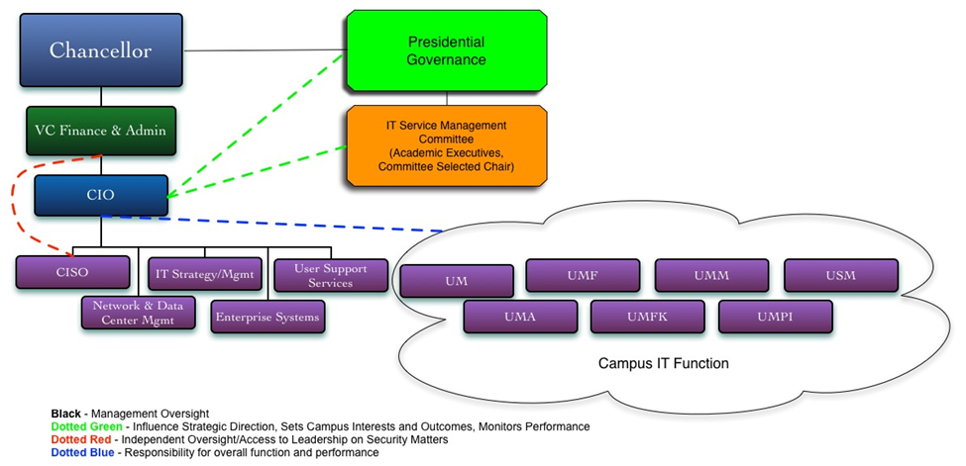

SWOT analysis of this option, highlighting unique characteristics of the incremental approach:

* Strengths
  + Continued review and study will create more comprehensive data and detailed recommendations
  + Least disruption to existing staff and systems
  + Campuses have direct leadership and management
* Weaknesses
  + No direct imperative to change
  + Silo solutions continue to propagate
  + Limited savings over extended period
  + Overall system leadership direction/accountability remains unclear
  + No scaling to realize efficiencies and savings
* Opportunities
  + Develop and train staff for expanded roles
  + Outsource where possible
  + Engage more students as work study staff and interns
  + Modernization of skills and systems
* Threats
  + Required budget cuts will be tactical at campus level, not strategic at the functional level – thus will primarily be absorbed through hiring freezes and service curtailment
  + Limited availability of IT Directors to perform the recommended activities
  + Innovation limited to scarce available resources
  + Staff attrition will be more significant across numerous campuses

*Alternative 2: Redesign of IT service delivery approach*:

The *redesign of IT service delivery* calls for bold steps in the leadership and governance process.

A new approach to governance is necessary to achieve the savings identified by these recommendations in this alternative. A necessary component is the establishment of an accountable person to lead the IT organization as a whole, a true University of Maine System CIO. This leader must have authority to manage all IT related resources, to make commitments, decisions, and, most importantly, to be responsible for meeting defined outcomes in service, performance and expectations of the administrative review.

Some recommendations about governance in the previous strategy are adopted here, including:

* Creating a council of academic and other leaders to guide and monitor the delivery of IT services, the IT Service Management Committee. This constituency is not currently well represented.
* Continued involvement of the Shared Services Advisory Committee, and
* Establishing a CIO cabinet group, IT leaders and staff which can focus on current and future operational needs. This level of support does not exist today.

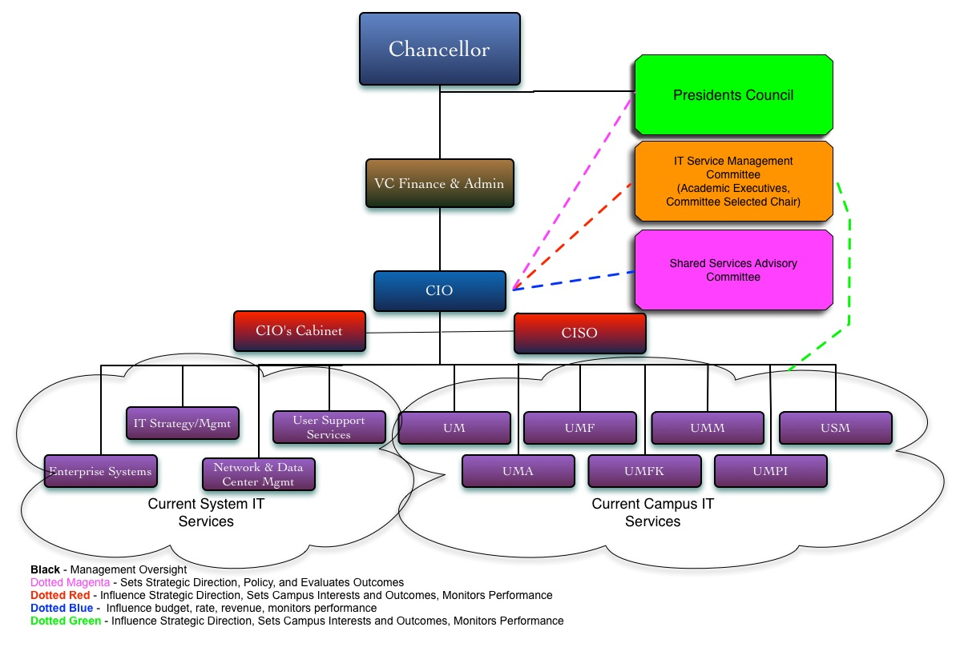

The proposed governance model is a critical component to the success of the *redesign* approach. The groups and individuals with new or altered roles are summarized as follows:

* Presidents’ Council – Sets strategic direction and expectations for UMS IT and oversees policy development and evaluation of performance.
* CIO – Management oversight over IT across UMS, responsible and accountable for meeting outcomes and performance metrics.
* CIO’s Cabinet – A select group of IT leaders to monitor operations; provide advice and research to support current and future initiatives.
* IT Service Management Committee (new) – A group of academic executives to define and monitor performance of IT across the learning environment.
* Shared Services Advisory Council – Primarily Chief Financial Officers responsible for monitoring budget, rate development and administrative system performance.

Implementation planning and execution will include further clarification of roles, responsibilities and oversight by responsible parties. A comprehensive audit plan for on-going assessment and evaluation of performance will be developed, designed to assess agreed upon outcomes and comparison against national higher education benchmarks.

To facilitate and augment skills, some temporary external consulting expertise in cost allocation, rate development, and new technologies will likely be required for successful implementation and could be funded from savings in year one and two. Specialized support from Human Resources and Organizational Effectiveness resources will be necessary to develop a best practice solution to sharing staff resources across the organization. Elimination of boundaries is critical.

SWOT analysis of this option, highlighting unique characteristics of the redesign approach:

* Strengths
  + Leadership and governance process sets strategy and monitors progress
  + Can achieve efficiencies and economies of scale, savings grow annually
  + Accountability in place to achieve results
  + Streamlined support and training systems
  + Sharing of expertise across UMS, silos removed
  + Transparent and predictable policies and procedures
* Weaknesses
  + Disruption to existing staff and systems
  + Level of effort to implement exceeds current capacity
* Opportunities
  + Contain costs of new technologies [these top 2 are key]
  + Create scalable solutions
  + Develop and train staff for expanded roles
  + Modernization of skills and systems
  + Outsource where possible
  + Engage more students as work study staff and interns
  + Innovation and flexibility encouraged
  + IT becomes an investment opportunity versus cost center
* Threats
  + Possible lack of support at campus or system leadership level
  + Loss of campus autonomy over IT services
  + Challenges related to staff reassignment
  + Inability to capture savings
  + Distribution of savings undetermined

**Challenges and Risk Mitigation**

The greatest IT challenges faced by UMS are the limitations of geography and the lingering concern over historical performance on the delivery of IT by current participants. There is a lack of trust amongst the various IT organizations and a deep memory of days where something or someone performed poorly or expectations were not met. This must be mitigated by commitment from leaders to support change, a willingness to share across the System, fair distribution of costs, continuous communication, assessment and evaluation of performance achieved against agreed upon outcomes and national higher education benchmarks.

Another significant challenge is the change impact on people. Over 55% of the total cost of IT services today is IT staff. Changes or elimination of jobs is therefore inevitable. This challenge can be mitigated with careful planning, communication and flexibility. Limited numbers of vacant positions are already being held to provide opportunities for displaced staff. More importantly, retraining our staff to support new initiatives will provide opportunities that do not exist today. The planned implementation of these recommendations over two years will allow normal attrition to ease the impact associated with these changes.

**Section IV - Recommendation**

**Proposed Strategy and Recommendations**

The transformation of University of Maine System Information Technology services to a modern, mission focused, high performing service delivery will require foundational change to the way we operate. Governance, policy, organizational and operational realignment are required to achieve those goals while UMS eliminates redundancy, reduces cost and achieves success. Alternative 2: the *redesign of information technology service delivery* will achieve these goals and is the proposal put forward here as the optimal strategy.

The Education Advisory Board report “Reinventing IT Services” notes “*Ensuring IT resources are being effectively managed is critical to colleges and universities because so much of what lies at the center of their mission is dependent and enhanced by technology*.”[3]

This is not a new concept. In 2009, “New Challenges New Directions” directed several actions including movement to a hybrid IT governance model, implementation of Gmail and other open source tools, development of a common portal tool for campuses, and other strategies. While somewhat successful, many components were not completed or have failed to yield anticipated results. This occurred mainly because implementation was a campus-by-campus decision and there was no accountability for failing to meet the directives. A change in governance, development of communication, accountability and oversight is paramount to success this time.

The *redesign’s* recommendations fit within three basic categories:

1. Leadership/Governance,
2. Consolidation of Infrastructure, and
3. Academic and Administrative Technologies.

The recommendations under these categories provide transformation to a streamlined and efficient system of service delivery and asset management. Each is highlighted below with estimated cost savings attached to each and anticipated staff reductions:

Leadership and Governance

* Recommendation 1 – FY16 estimated structural savings $410k, staff reduction 3
  + Implement alternative leadership and governance structure
    - Establish governance and organizational models to create accountability and responsibility for IT within a single structure
    - Establish an IT Standards and Procurement group to support commonality and best practice contracting of IT products and services
* Recommendation 2 – No direct savings estimated
  + Establish policies and practices to provide management oversight and inform leaders, administrators, tech staff and innovators
  + Develop a communications strategy
* Recommendation 3 – FY16 estimated structural savings $50k, staff reduction 0
  + Actively pursue cloud or “software as a service” sourcing of enterprise systems
  + Pursue advantages of best practice implementation and uniformity, support and training
* Recommendation 4 – No direct savings estimated
  + Investigate and implement a new funding strategy to record and recover costs of shared and centralized services
    - Establish true rate based assessments for all shared services

Consolidation of Infrastructure

* Recommendation 5 – FY16 estimated structural savings $1,040K, staff reduction 14
  + Consolidate management and delivery of campus and system support and help desk services
    - Select a campus and IT Director to manage this service
  + Centralize or outsource end user provisioning, management and maintenance functions related to directly assigned devices
* Recommendation 6 – FY16 estimated structural savings $160K, staff reduction 1
  + Consolidate Data Center locations, management and operations
    - Virtualize servers where practical
    - Reduce locations and staff
    - Consider outsourcing of some functions
    - Share data center infrastructure and costs with outside customers
* Recommendation 7 – FY16 estimated structural savings $155K, staff reduction 1
  + Unify communications systems under one management structure by a single campus entity
    - Voice, wide area, local area, and wireless networks managed as a single shared service
    - Expand network sharing as revenue generator/cost sharing initiative(s)

Academic and Administrative Technologies

* Recommendation 8 – FY16 estimated structural savings $88K, staff reduction 2
  + Restructure delivery of end user technology
    - Reduce computer lab units by 10% per year
    - Pilot then expand virtual desktop delivery
    - Consolidate and consider outsourcing of end user technology management
    - Implement mobility solutions where efficient and cost effective
* Recommendation 9 – FY16 estimated structural savings $1,355K, staff reduction 9
  + Systematically identify, review and organize IT services into a shared services model with campus IT management
    - Administrative Technologies
    - Academic Technologies
    - Expanded and additional academic focused services

**Rationale in selecting redesign strategy and the necessary conditions for success**

The optimal system for delivery of IT must have *ALL* of the following attributes:

* + Increased focus on academic technology
  + Locate Services close to students and faculty
  + Flexibility
  + Innovation
  + Quality
  + Accountability
  + Affordability

The *incremental improvement approach* does not meet these requirements, especially related to accountability and affordability. It is time for bold steps and accountable leadership. Presidents and campus leaders deserve direct support for and from IT. The Board, Chancellor and top administrators must be able to impact IT strategy and create accountability for high performance and capacity.

This is possible with the transformation directed within the *redesign of IT service delivery*. This can be accomplished within the three year plan and there is commitment to make it happen. Problems will be solved, savings accomplished, services improved and there will be an increased focus on Academic Technology. The timing and circumstances are ripe for this type of change.

Success in the *redesign* is predicated on support from the Presidents and their willingness to participate in the development of governance, oversight of this initiative, and to actively support the strategies discussed and ultimately implemented. The Chancellor must remain a solid champion of this effort and the Board must maintain its support through policy development and its Technology Committee oversight.

Most importantly, the IT community across UMS must be supported in thinking out of the box, looking at options and offering their support and willingness to design their future, improve services for the collective good, and solve problems by communication and engagement.

**Expected Savings and ROI**

The savings have been estimated based on an aggressive detailed design and implementation schedule, beginning activity in February of 2013. Total savings are calculated as net of any direct expense to accomplish technology conversion, retraining and consulting costs (particularly year one where estimated expense is $135K). The savings do **not** account for any HR costs related to staff reductions.

* FY 2014 - $ 174,000
* FY 2015 - $1,984,000
* FY 2016 - $3,258,000

The changes anticipated to achieve these savings include estimated staff reductions. The implementation strategy will be to use reassignment, retraining and other strategies to limit the impact on individuals where possible. Proper HR policy and protocols are available and understood to achieve necessary staff configuration.

It is important to note that savings can be achieved across all of the UMS, but that capturing those dollars for reinvestment may be challenging in some cases. IT infrastructure and services are funded by a myriad of strategies. Departmental IT and certain computer laboratories (research computing for example) are sometimes funded through direct grants or contracts and any saved funding would likely be returned to the grantor or be used for direct services provided to honor the grant.

Other sources of funds will be identified, such as allocation, surcharges, fees, revenue for services delivered. Savings will be calculated and reported to allow for those fees to be accumulated and used to further the expectations of the Board’s goals. In addition to these savings, the savings reports will include calculation of avoided costs by reducing future liabilities when shared services or other strategies are employed.

**Implementation Plan**

Upon approval to proceed, an implementation plan will be developed and presented to the Chancellor and Presidents Council with prioritization to achieve the savings within the fiscal years identified by March 1, 2013. Delineation/clarification of roles and responsibilities and development of a communications strategy and plan will begin immediately and the governance component will be established and operational by end of March. An estimated timeline against major recommendations is presented in a basic GANTT below to highlight the current prioritization strategy.

**MAJOR RECOMMENDATIONS PRIORITIZATION STRATEGY**



**Section V – The Request of the Chancellor and Board of Trustees**

A directive to proceed from the Chancellor begins the implementation process. The recommendation of the CIO is that the Board be presented with a resolution or policy as follows:

The Board of Trustees endorses the Chancellor’s multi-year action plan to *redesign IT service delivery* and authorizes him to immediately begin implementation and provide regular progress reports at Board meetings.

***Appendix 1***

***Initial Charter, May 2012 (pulled from presentation to Board of Trustees)***

Information Technology Across UMS

Evaluating and improving the effectiveness, efficiency and affordability of IT

**General Administrative Review Project**

**Presented to:**

**UMS Board of Trustees**

**Administrative Review Steering Committee**

**James Page, Chancellor**

**Rebecca Wyke, Vice Chancellor**

Approach to Administrative Review

IT Review Includes

* Analyze management structure and senior staff model
  + Recommend/Implement best practice structure
* Evaluate/act upon redundant services
  + Customer Support Services
  + Advanced Computing Strategy with UMaine
  + Telecommunications/network/wireless management
  + Individual campus datacenters
  + Procurement/Acquisition processes
  + Video Conferencing
  + Learning Management/Classroom Tech Tools
  + Web Services
  + Application acquisition, development, operations
  + Device/Computer lab provisioning (BYOD)
* Evaluate systems/applications/assigned resources
  + Enterprise system strategy
* Develop an initiative management process for R/D of new products/services
* Create a single operating budget
  + Inventory staff and infrastructure
  + Review and streamline funding model
* Establish/implement policies and standards for architecture, hardware, software

High Level Outcomes

* Flexibility and innovation at the campus level but managed to common standards
  + Measurement – customer satisfaction
* Transparent IT research and development process for new tools/applications
  + Modern web site with initiatives identified, measured
* Redundancy only where necessary
  + Measurement – any service or product appearing redundant will be documented and reviewed on regular basis
* Cost savings/efficiencies
  + Measurement – baseline costs will be identified, savings calculated. Metrics on standard services compared to other entities.

***Appendix 2 - Administrative Review / IT Review Team Charter, revised 18 December 2012.***

1. General Statement of Purpose. This Charter sets out the revised roles and responsibilities of the Review Team (the IT Review Team) leading the Administrative Review – Information Technology Project.
2. Composition. The IT Review Team is:

* Richard Thompson, System CIO
* Fred Brittain, IT Director, UMF, project consultant
* Stephen Houser, IT Director, USM, project consultant
* Leslie Kelly, IT Director, UMFK, project consultant
* Jeff Letourneau, Executive Director, Network Maine, project consultant.
* Chancellor James Page, sponsor

1. Responsibility and Authority. The CIO, assisted by the project consultants as needed, has responsibility for successful completion of the Analysis and Design stages of the Administrative Review for Information Technology within the terms outlined in this document, meeting all outcomes, budgets and schedules. The CIO must have prior approval from the Administrative Review Steering Committee or the Chancellor before changing project outcomes, scope, budgets, timelines, or processes, or before making any other policy or operational changes requiring Chancellor or Board approval.
2. Outcomes. The CIO will deliver recommendations for optimal governance, management, including budgetary management, and operational IT system to meet its functional responsibilities on a system-wide basis and to position the IT resource to best serve its student, faculty, and administrative clients on a forward-looking basis. In addition, the CIO will deliver recommendations that accomplish this task while realizing efficiencies and resulting savings of at least 10% of its current operating budget with additional savings to be realized in future costs of operation.

* Project Deliverables follow the established 4 Stage change process (Plan Analysis, Plan Design, Implementation, Audit). The CIO, aided by the IT Review Team, is responsible for a Plan Analysis and Plan Design (Stages 1 and 2) that identifies benchmarks and standards for assessing IT structures and services, assesses current structures and services on every campus and System facility, and presents plans and strategies to achieve project outcomes. Deliverables include: a recitation of benchmarks and standards, a review of current status, and a plan for the optimal structure for the efficient and cost-effective delivery of IT services. Stage 3 involves the implementation plan which includes: a budget, ROI and risk analysis; identification of resources; commensurate with Design recommendations; a comprehensive communications plan; a schedule of audit milestones, and all implementation activities. Stage 4 follows the schedule of audit milestones.
* Project Analysis and Design will encompass all information technology resources and services at all campuses, SWS, and other System facilities.

1. Resources. All System employees engaged in this project will perform their work as part of their normal duties with no compensation stipends attached. The IT Review Team will be staff supported by the System’s Office for Organizational Effectiveness.

***Appendix 3 – Alternative 2, Redesign of IT Service Delivery***

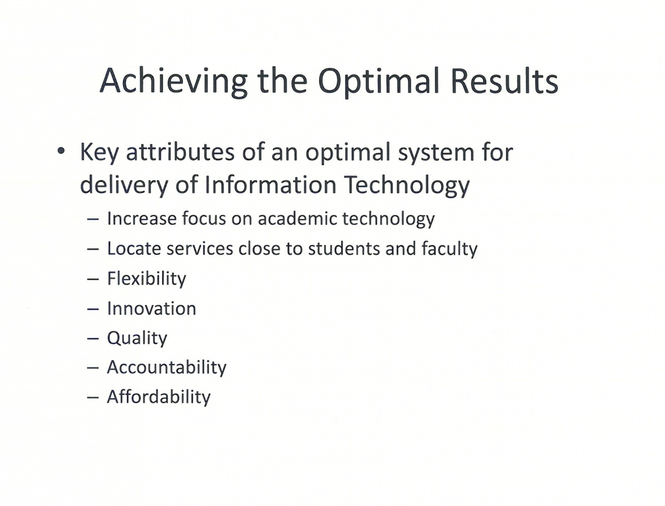

***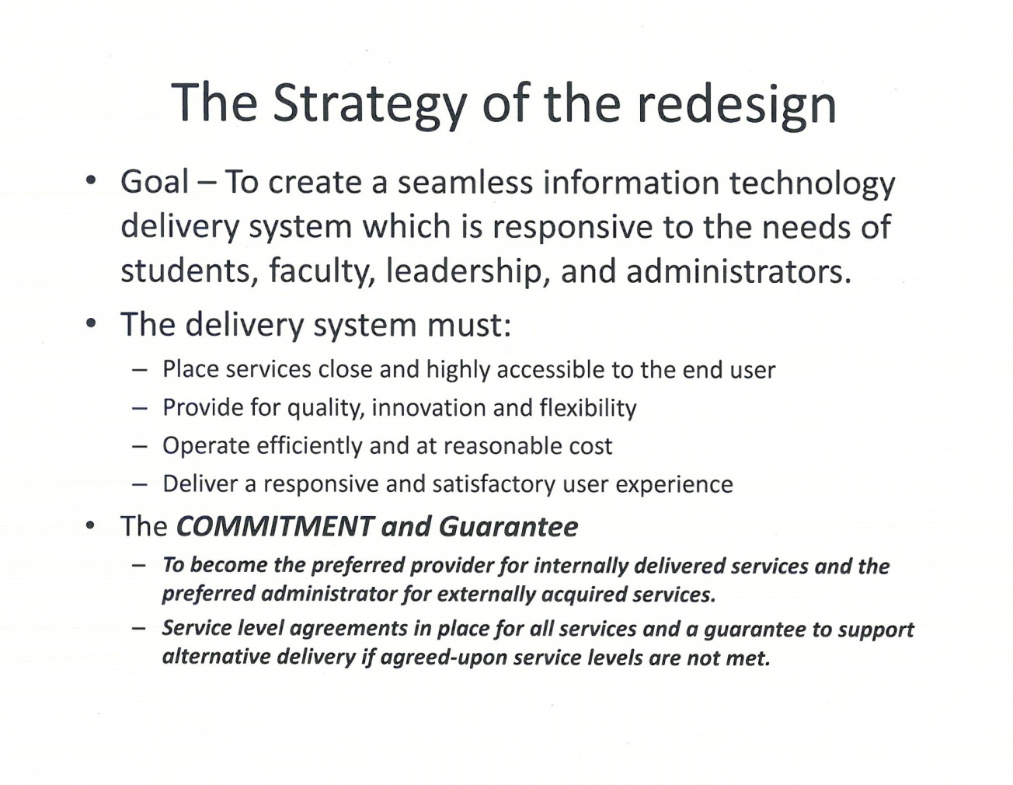  
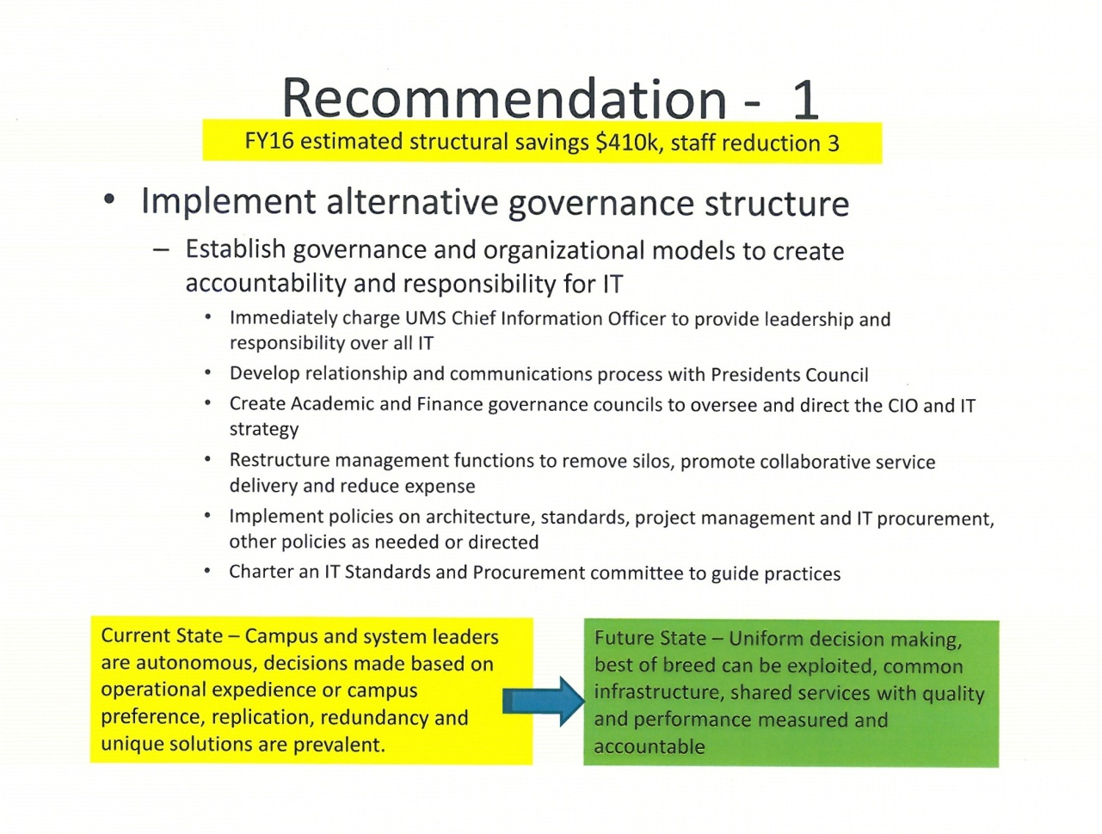***

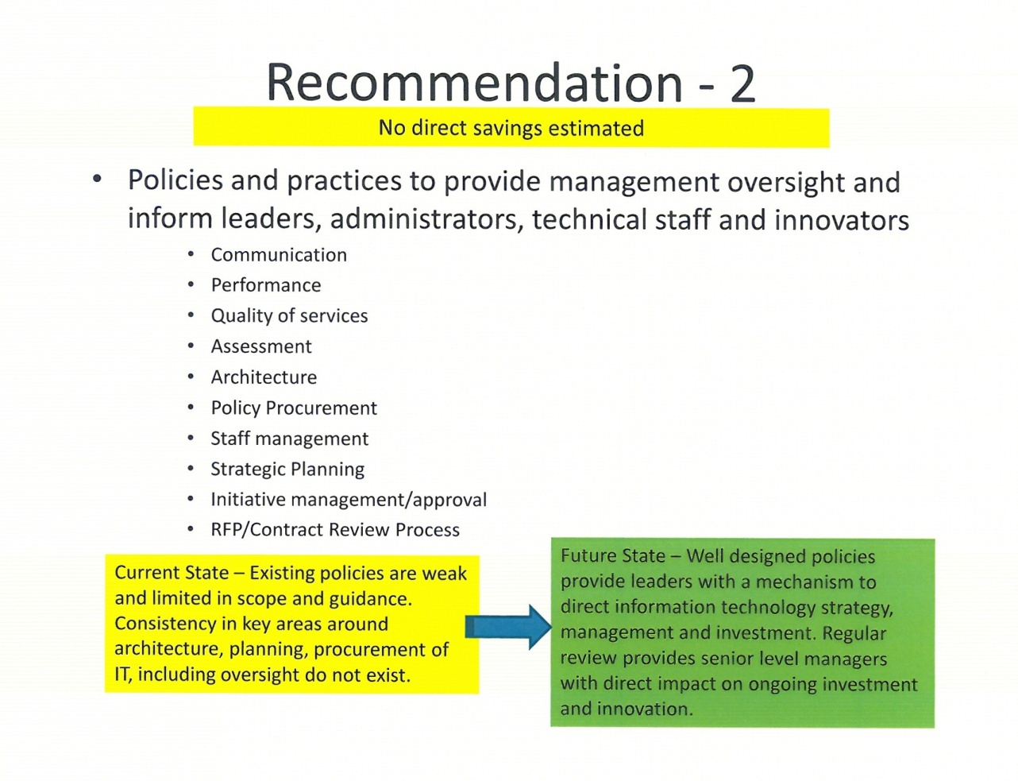

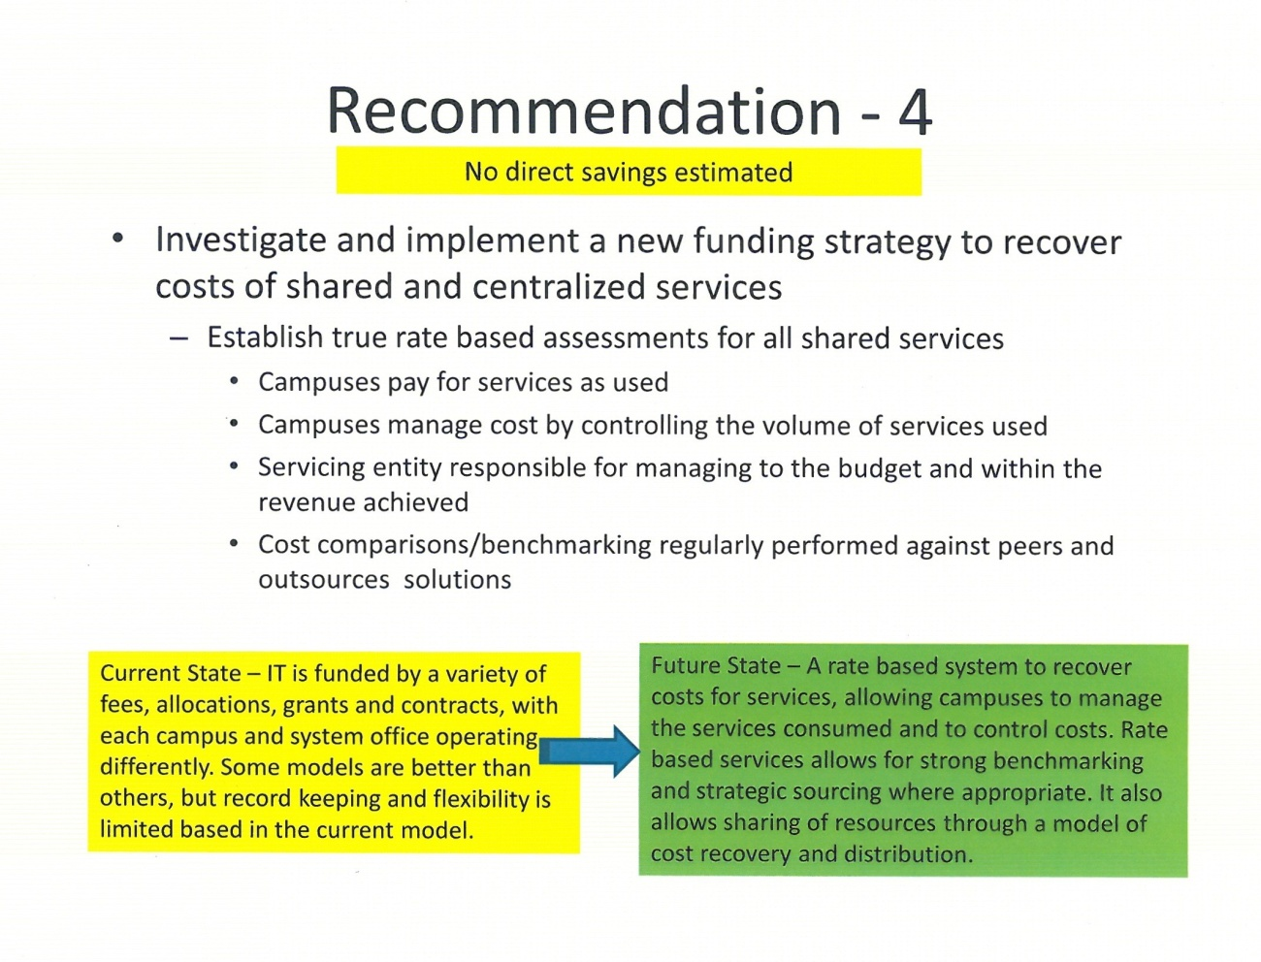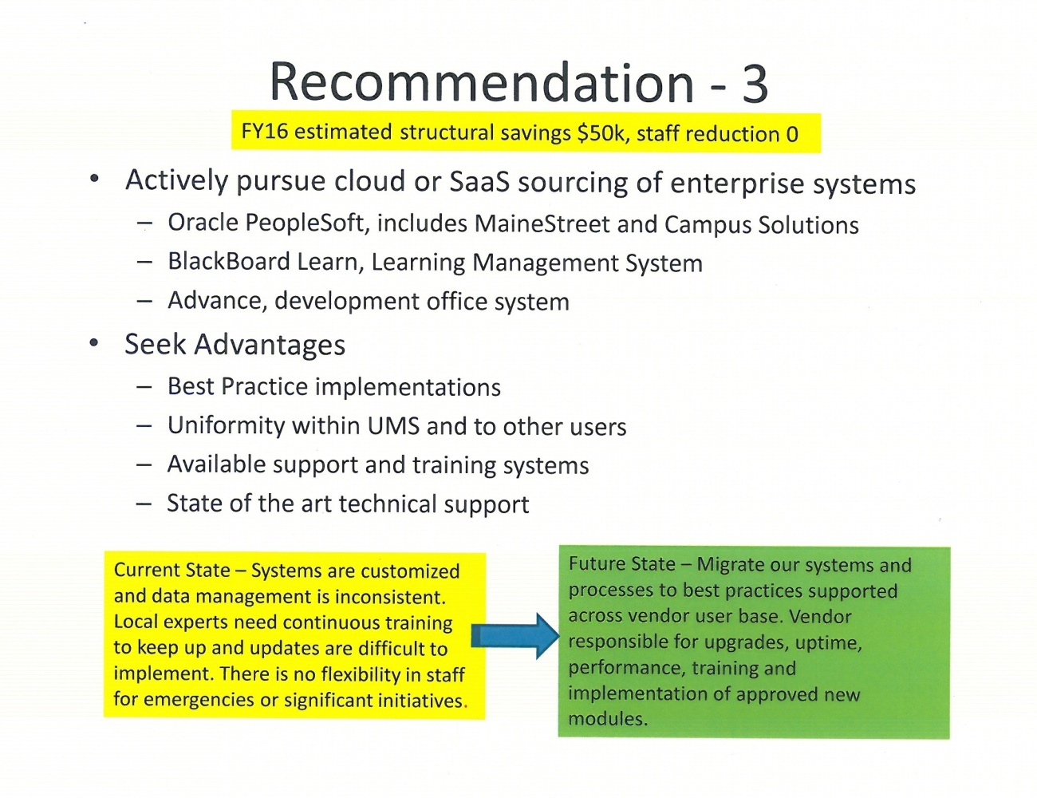

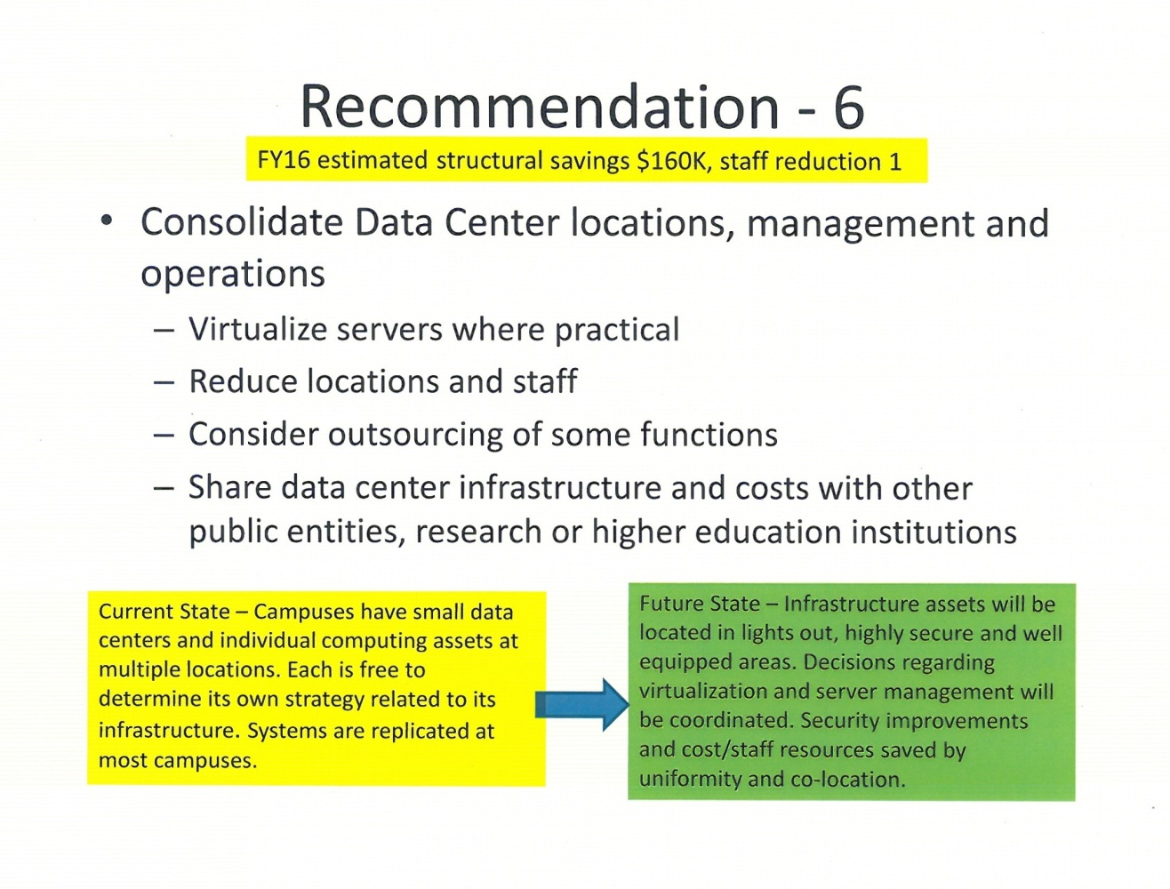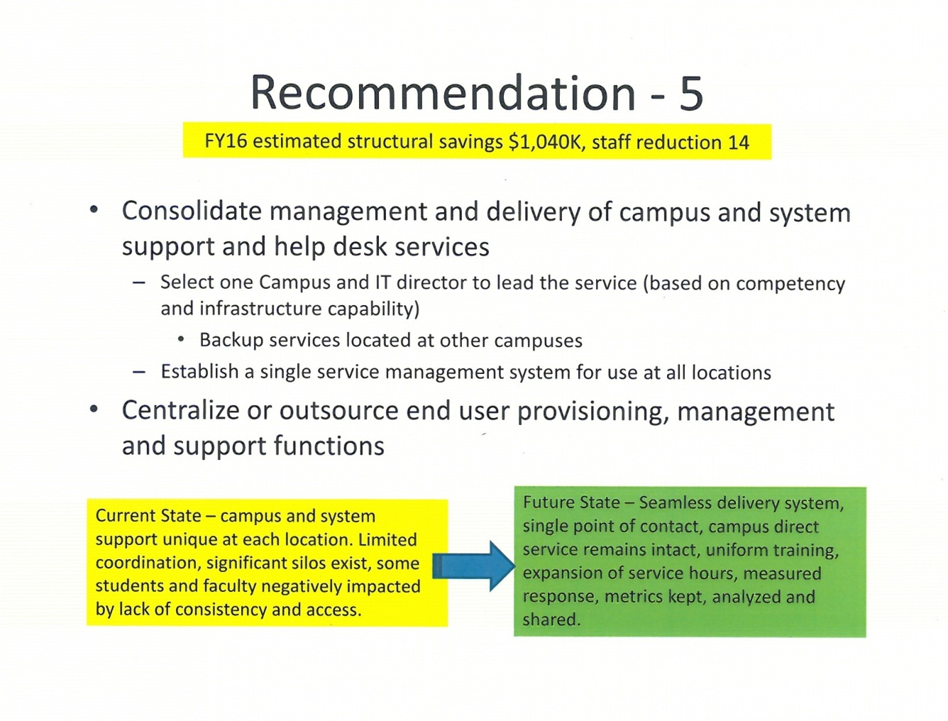

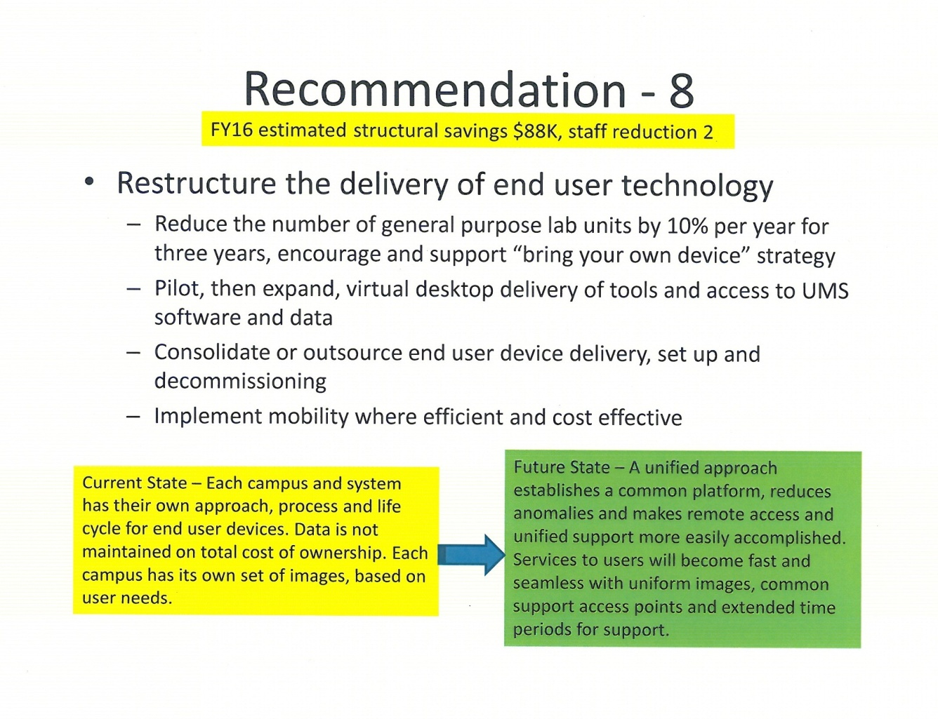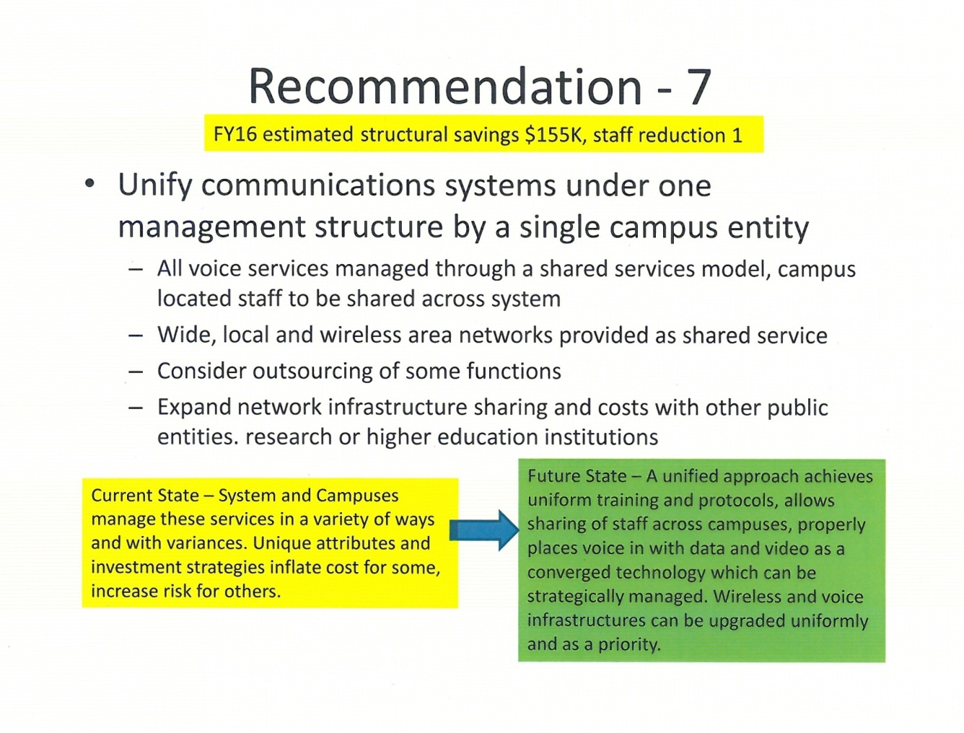

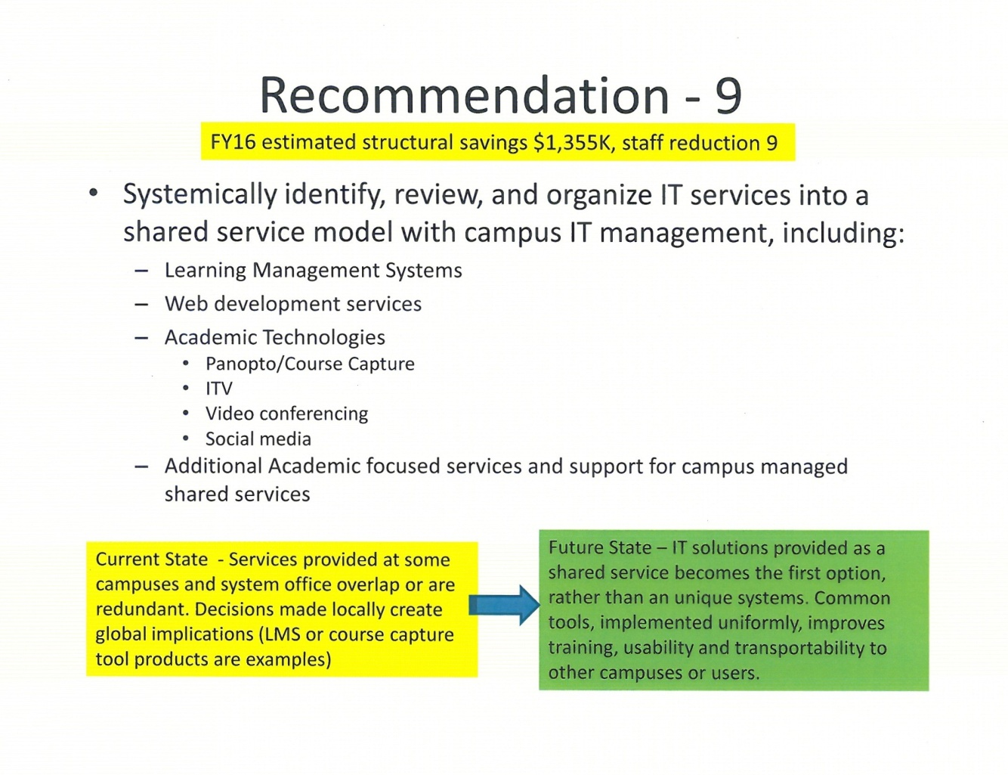

***Appendix 4***

|  |  |  |
| --- | --- | --- |
| **IT Admin Review** |  |  |
| Dick Thompson | CIO | UMS |
| Jeff Letourneau | Executive Director, NetworkMaine | UMS |
| Fred Brittain | Executive Director for Information Technology Services | UMF |
| Stephen Houser | Executive Director for Computer Services | USM |
| Leslie Kelly | Director of Information Services | UMFK |
| Cindy Mitchell | Assoc. CIO, Policy, Projects and Leadership | UMS |
| Cathy Caron | Administrative Specialist | UMS |
|  |  |  |
| **IT Leadership Council** |  |  |
| Lauren Dubois | Director of Computer Services | UMA |
| John Gregory | Executive Director of Information Technologies | UM |
| Fred Brittain | Executive Director for Information Technology Services | UMF |
| Leslie Kelly | Director of Information Services | UMFK |
| Mike Matis | Director of Information Technology | UMM |
| Dick Thompson | CIO | UMS |
| Cindy Mitchell | Assoc. CIO, Policy, Projects and Leadership | UMS |
| Michael Sonntag | Provost and Academic Vice President | UMPI |
| Joanne Wallingford | Director of Information Services | UMPI |
| John Grover | Director of Enterprise Computing and Application Services | UMS |
| Jeff Letourneau | Executive Director, NetworkMaine | UMS |
| Mike Cyr | Director of Academic Technology and End-user Support | UMS |
| John Forker | CISO | UMS |
| Bill Wells | CIO | USM |
| Stephen Houser | Executive Director for Computer Services | USM |
|  |  |  |
| **IT Standards and Procurement Team** | |  |
| Bill Wells | CIO | USM |
| Kevin Carr | Director of Strategic Procurement | UMS |
| Derek Husson | General Manager, Computer Connection | UMS |
| Ellen Schneiter | CFO | UMA |
| Cindy Mitchell | Assoc. CIO, Policy, Projects and Leadership | UMS |
| Joanne Wallingford | Director of Information Services | UMPI |
|  |  |  |
| **Unified Communications Team** | |  |
| Peter Gunn | Telecommunications Manager | UM |
| Nancy Austin | Director of Telecommunications and Campus Card Services | USM |
| Garret Peirce | Network Architect | UMS |
| Aaron Gagnon | Assistant Director for Information Technology Services | UMF |
|  |  |  |
| **Video Conferencing** |  |  |
| John Gregory | Executive Director of Information Technologies | UM |
| Angela Cook | Manager of Audiovisual and Media Services | USM |
| Mike Cyr | Director of Academic Technology and End-user Support | UMS |
| Jeff Letourneau | Executive Director, NetworkMaine | UMS |
| Aaron Bernstein | Assistant Director of Media Services | UMFK |
|  |  |  |
| **Device, Computer Lab Provisioning and BYOD** | |  |
| Lauren Dubois | Director of Computer Services | UMA |
| John Gregory | Executive Director of Information Technologies | UM |
| Stephen Houser | Executive Director for Computer Services | USM |
| Aaron Gagnon | Assistant Director for Information Technology Services | UMF |
| Mike Matis | Director of Information Technology | UMM |
| Carol Sobczak | Assistant Director of Student Computer Services | USM |
| Sam Gaudet | Systems Security Analyst | UMS |
| John Grover | Director of Enterprise Computing and Application Services | UMS |
|  |  |  |
| **Customer Support Services** | |  |
| Mike Cyr | Director of Academic Technology and End-user Support | UMS |
| John Gregory | Executive Director of Information Technologies | UM |
| Lauren Dubois | Director of Computer Services | UMA |
| Mary Beth Davidson | Assistant Director of University Computing Support | USM |
| Joanne Wallingford | Director of Information Services | UMPI |
| Ryan Conlogue | IT Support Service Coordinator | UM |
|  |  |  |
| **Budget** |  |  |
| Dick Thompson | CIO | UMS |
| Fred Brittain | Executive Director for Information Technology Services | UMF |
|  |  |  |
| **Policy/Practices** |  |  |
| Dick Thompson | CIO | UMS |
| Cindy Mitchell | Assoc. CIO, Policy, Projects and Leadership | UMS |

***Appendix 5 – Alternatives Comparison Chart***

|  |  |  |  |
| --- | --- | --- | --- |
| **Topic** | **Current State** | **Future State - Incremental Improvement** | **Future State - Transformational Redesign** |
| Focus | Campus level operations to maintain services. Maintain autonomy to meet known and perceived needs. Use System Wide Services systems as required | Mix of campus level and system level IT systems to support current operations. Some alternative delivery to be considered | Focus on the student and those that serve the student.  Efficiency and effectiveness by leveraging "System" expertise and resources |
| Design | Well meaning employees doing their best in a system that evolved, rather than being intentionally designed | Well meaning employees doing their best in a slightly improved system that is still short of intentional design | System designed for optimal success of employees and service to users |
| Alignment | Primary to campus, fairly autonomous as a "system" | Primary to campus, but with functional oversight by CIO | Primary to UMS, with local campus service delivery imperative |
| Stance | Primarily reactive  Cost center  Tactical/operational  Risk adverse | Primarily reactive, with focus group influence on future state  Cost center  Tactical/operational | Proactive  Value center (prized investment)  Strategic  Innovative |
| Value proposition | Cost center | Cost center with improvements | A continued strategic investment with solid reputation for delivery of client-focused results. Efficient, effective and highly responsive. |
| Decision-making | Fragmented and autonomous decision-making, roles outside of campus IT fairly unclear, silos within SWS and at campus level | Some form of "team" or "steering group" to oversee initiative formulation, resourcing and recommendations. | Clear and efficient decision making involving critical stakeholders through "governance council" oversight. Accountability assigned. |
| Quality function | Significant amounts of rework, redundant services, and inefficiencies | Teams initiate improvement efforts around specific opportunities. Campuses retain right to opt out or not support. | Rework, redundant services, and inefficiencies are continuously diminished through collaborative problem-solving aimed at best practices |
| Prerequisites | None | Presidential support for initiatives | Governance redesign |
| Strategy | At campus level, if it exists | At campus level | Agreed-upon written strategy responsive to campuses' critical needs and vetted by an IT "governance council". |
| Accountability | Low | Perhaps better | High |
| Content expertise | Diffused, narrow bench on most campuses, most employees are generalists and trained in-house. | Diffused, narrow bench at some campuses, some specialization opportunities may evolve. Staff training expanded. | Higher degree of specialization - utilized across campuses. Skill sets kept up to date. Opportunity for employees to grow and add more value - increasing own value to the system. |
| Communication | Presidents and campus leadership are linked in with local and tactical IT information. Strategic options are local only and infrequently explored | Shared opportunities are communicated, performance metrics generally anecdotal. | Presidents and campus leadership retain local information and tactical information channels. Strategic initiatives at UMS and campus actively considered and integrated into planning and implementation actions |
| Technology | Fairly autonomous selection on a campus basis | Campus consideration of standardized solutions, freedom to select based on internal criteria | Selection by team of content experts across the system, with local adjustments |
| Best practices | Some at campus level - mostly not shared | Potential to share through initiative teams | Shared and embraced as a strategic initiative, continuously monitored and implemented |
| Cost | Highest cost due to redundant systems, rework, lack of scale, repeating the learning curve, etc. | Potential for lower cost | Lowest cost for highest value |
| Level of collaboration | Limited beyond campuses | Collaboration on initiatives | Teaming across the system based on competency |

Works Cited

Angelos, Peter, Brad Cohen, Jason Davis, and Brittany Lloyd. "Shared Leadership: From IT Silos to IT Alliance." *EDUCAUSE Homepage/Annual Conference 2012*. N.p., 2012. Web. 04 Dec. 2012. <http://www.educause.edu/annual-conference/2012/shared-leadership-it-silos-it-alliance>.

Brink, Toni, and Joe LeMaster. *Business Affairs Forum, Custom Research Brief*. Nov. 2012. Information Technology Governance within University Systems. Education Advisory Board, Washington, DC.

"Core Data Service." *EDUCAUSE Homepage*. N.p., n.d. Web. 04 Dec. 2012. <http://www.educause.edu/research-and-publications/research/core-data-service>.

Ferrenberg, Alan, John Goshman, and Chris Shudes. "A Tale of Two Engagements: Different Paths to IT Transformation." *EDUCAUSE Homepage/Annual Conference 2012*. N.p., 7 Nov. 2012. Web. 04 Dec. 2012. <http://www.educause.edu/annual-conference/2012/tale-two-engagements-different-paths-it-transformation>.

"Huron IT Report, Administrative Review & Restructuring (ARR)." *University of Illinois*. N.p., 2 Feb. 2011. Web. 04 Dec. 2012. <http://www.uillinois.edu/arr/implementation/index.cfm>.

"IT Governance at Case Western Reserve University." *IT Governance at Case Western Reserve University*. N.p., n.d. Web. 04 Dec. 2012. <https://sites.google.com/a/case.edu/itgovcwru/>.

Jackson, Gregory A. "IT-Based Transformation in Higher Education: Possibilities and Prospects." *EDUCAUSE Homepage*. N.p., 13 Mar. 2012. Web. 04 Dec. 2012. <http://www.educause.edu/library/resources/it-based-transformation-higher-education-possibilities-and-prospects>.

"Laying The Foundation of Operational Excellence." *CWRU ITS: Operational Excellence*. Case Western Reserve University, 29 June 2010. Web. 04 Dec. 2012. <http://www.case.edu/its/opex/>.

"NextGen Michigan." *NextGen Michigan*. N.p., n.d. Web. 04 Dec. 2012. <http://www.nextgen.umich.edu/>.

*University Business Executive Roundtable*. 2011. Reinventing IT Services: A Five-Year Road Map for the Function. Education Advisory Board, Washington, DC. http://www.eab.com/Research-and-Insights/Business-Affairs-Forum/Studies/2011/Reinventing-IT-Services

1. ., Toni, and Joe LeMaster. *Business Affairs Forum, Custom Research Brief*. Nov. 2012. Information Technology Governance within University Systems. Education Advisory Board, Washington, DC.
2. *Reinventing IT Services*. 21
3. Ibid.,4.