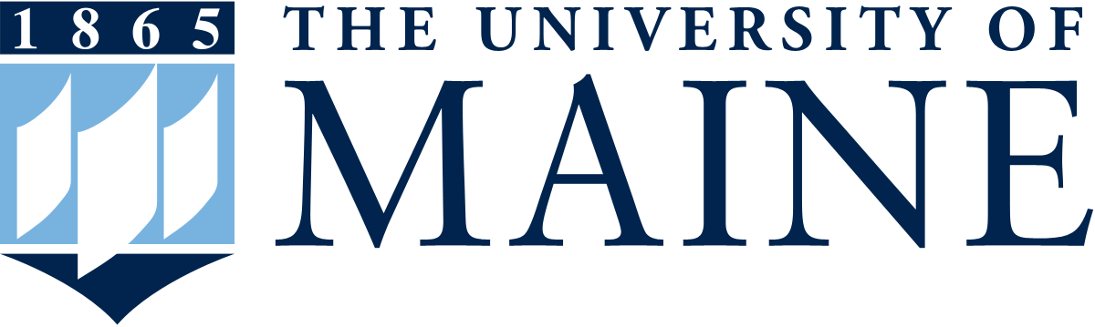
Maine EPSCoR FY24-29 NSF EPSCoR RII Track-1
Proposal Development Process
Phase I – Research Concept Papers

To prepare for the next round of NSF EPSCoR RII Track-1 funding, Maine EPSCoR is executing a formal proposal development process.

For Phase 1, researchers from Maine are invited to submit a concept paper that describes a current research problem/need for the state that might be applicable for the next Maine NSF EPSCoR RII Track-1 project.

The Track-1 grant is required to address a comprehensive, integrated, transdisciplinary, statewide focus that creates a substantial academic research infrastructure and includes strong intellectual engagement of diverse participants from institutions of higher education across the submitting EPSCoR jurisdiction, as well as productive partnerships between the jurisdiction's academic institutions and organizations in its governmental, nonprofit, and commercial or industrial sectors.

INSTRUCTIONS:
Please fill in the template below, using standard NSF font size requirements and margins. The allowable maximum is three pages. If you require additional space, you may delete unused lines in the Senior Personnel section, blank lines, or instructions in the document.

Sections:
- Indicate the general focus area of the research that you are proposing.
- Indicate the contact person for this concept.
- Indicate potential key personnel who could be part of the effort to address this research concept. (only include individuals who have granted permission to be listed)
- Intellectual Merit – provide a brief description in each of the sections, relating to the research focus that you have identified as a current problem/need in Maine.
- Broader Impacts – provide a brief description in each of the sections describing the likely impacts and outcomes that can be achieved.

Due by: | January 7, 2022
Submit to: | shane.moeykens@maine.edu (as pdf or Word doc)

By submitting this concept paper, you are giving Maine EPSCoR permission to post this document on a public website to encourage statewide discussions and collaborative engagements prior to the next phase of the RII Track-1 project development process.

For more information see: https://umaine.edu/epscor/track-1-rii-development-process/
https://www.nsf.gov/pubs/2021/nsf21586/nsf21586.htm

Maine EPSCoR FY24-29 NSF EPSCoR RII Track-1
Proposal Development Process Phase I – Research Concept Papers

- Proposed Research Focus:
- Primary Contact Person:
Name: | Institution: | Title: | Dept. | E-mail: | Phone:
- Suggested/Potential Key Senior Personnel:
Name: | Institution: | Title: | Dept. | E-mail: | Phone:
- Intellectual Merit:
- Need: a brief statement of the research problem/need to be addressed, and why it is urgent for Maine to address this problem/need now (how it is currently limiting the state’s capacity/research competitiveness).

- Research Goal & Objectives: describe the overall project goal to address this problem/need, and the related research objectives.

- Research Actions: describe a few specific key research actions that could be implemented to meet the objectives. Withhold any information deemed sensitive, given this form will be shared with the community.

- Priority: indicate how this research would address national priorities (FY2022 budget request to Congress, White House 2021 R&D priorities memo) and state priorities (Maine Economic Development Strategy 2020-2029, 2017 Maine Innovation Economy Action Plan).

- Broader Impacts:
- In-state collaborations: describe potential for collaborations within Maine (considering diverse participants from institutions of higher education, PUIs and community colleges, as well as productive partnerships between Maine’s academic institutions and governmental, non-profit, and commercial or industrial sectors).

- Regional/national collaborations: describe potential for collaborations among regional and national EPSCoR jurisdiction-based organizations, and/or partnerships with nationally recognized centers of R&D activity, such as federal and industrial R&D laboratories, NSF-sponsored research centers, and academic institutions with nationally recognized research capabilities.

- Economic development: describe potential for economic development in Maine.

- Workforce Development: describe potential for statewide workforce development in this research area (e.g., support for faculty and student teams that include women, minorities underrepresented in STEM, and persons with disabilities that will result in a strong, quantifiable impact on the STEM workforce; may also consider support for students who are in the first generation of the family to attend college, or those from economically disadvantaged or rural populations).

- Infrastructure: describe potential to provide infrastructure (e.g., physical and/or cyber) that grows the state’s academic research and education capacity.

