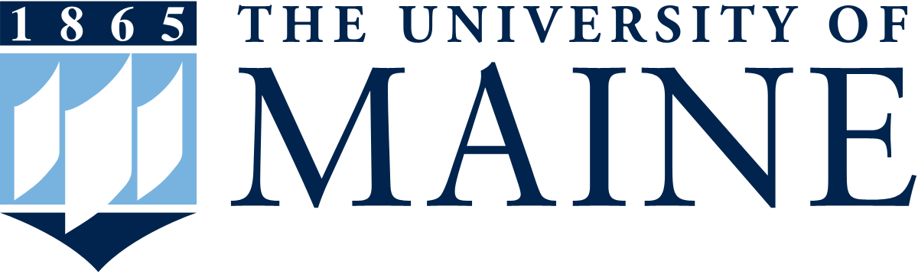

Maine EPSCoR FY19-24 NSF EPSCoR RII Track-1
Proposal Development Process

Phase I – Research Concept Papers

To prepare for the next round of NSF EPSCoR RII Track-1 funding, Maine EPSCoR is executing a formal proposal development process.

For Phase I, researchers from Maine are invited to submit a concept paper that describes a current research problem/need for the state that might be applicable for the next Maine NSF EPSCoR RII Track-1 project.

Note that the Track-1 grant is required to address a comprehensive, integrated, trans-disciplinary, statewide focus that creates a substantial academic research infrastructure and involves participants from colleges and universities throughout the state. It is not designed for individual, single institution, or small group faculty research.

INSTRUCTIONS:
Please fill in the template below, using standard NSF font size requirements. The allowable maximum is two pages. If you require additional space, you may delete unused lines in the Senior Personnel section, or blank lines in the document - please do not delete any other lines or instructions.

Sections:
- Indicate the general focus area of the research that you are proposing (i.e., aquaculture, alternative energy, etc.).
- Indicate the contact person for this concept.
- Indicate potential key personnel who could be part of the effort to address this research concept.
- Intellectual Merit – please provide a brief description in each of the sections, relating it to the research focus that you have identified as a current problem/need for Maine.
- Broader Impacts – please provide a brief description in each of the sections.

Due by: | February 15, 2017
Submit to: | shane.moeykens@maine.edu (as pdf or Word doc)

By submitting this concept paper, Maine researchers are giving permission to post this document on the Maine EPSCoR website in order to encourage statewide discussions and potential collaborative engagement prior to the next phase of the RII Track-1 project development process.

Personnel from each submitted concept paper are encouraged to look over the other submitted concept papers for potential synergy, and to contact others as applicable.

For more information see: https://umaine.edu/epscor/track-1-rii-development-process/
https://www.nsf.gov/pubs/2016/nsf16557/nsf16557.htm

Maine EPSCoR FY19-24 NSF EPSCoR RII Track-1
Proposal Development Process Phase I – Research Concept Papers

- Proposed Research Focus: |  | Marine Biotechnology
- Primary Contact Person:
Name: | Institution: | Title: | Dept. | E-mail: | Phone:
José A. Fernández Robledo | Bigelow Laboratory | Senior Research Scientist |  | Jfernandez-robledo@bigelow.org | 207 315 2567 Ext 315
- Suggested/Potential Key Senior Personnel:
Name: | Institution: | Title: | Dept. | E-mail: | Phone:
Judy Stone | Colby College | Chair and Professor of Biology | Biology | jstone@colby.edu | 207 859 5736
Elizabeth E. Ehrenfeld | SMCC | Adjunct Professor of Science | Biotechnology | EEhrenfeld@smccme.edu | 207 756 2046
G. Peter van Walsum | UMaine | Associate Professor | Chemical and Biological Engineering | pvanwalsum@umche.maine.edu | 207 581 2323
Mark L. LeClair | Nanospire Inc. | CEO | Nanotechnologies | mleclair@nanospireinc.com | 207 929 6226
David Ermerson | Bigelow Laboratory | Senior Research Scientist |  | demerson@bigelow.org | 207 315 2567 Ext 303
- Intellectual Merit: (the research focus)
- Need: a brief statement of the research problem/need to be addressed, and why it is urgent for Maine to address this problem/need now (how it is currently limiting the state’s capacity/research competitiveness).
Marine biotechnology provides a unique opportunity not only for harvesting the genetic treasures hidden in marine organisms but also to translate discoveries into business opportunities. Most biotechnology hubs in the Northeast do focus on biomedicine, here we propose to develop and to train the workforce in state-of-the-art biotechnologies with an emphasis on marine organisms/systems. Maine offers a diverse biotechnology sector and benefits from its proximity to the Boston-Cambridge hub. This proximity offers the advantages of the latest technologies under development with a lifestyle that large hubs intrinsically lack. Maine is also home to a number of high-quality Liberal Art Colleges. Another advantage of biotechnology hubs is that they do not necessarily require large infrastructure, as most of the high sophisticated new technologies are performed in small lab spaces. Finally, the nature of the project might also be of interest for other Maine research institutions including MDIBL, UMaine, Maine Bioscience, Jackson Lab. among others.
- Research Goal & Objectives: describe the overall project goal to address this problem/need, and 1-3 key research objectives.
Create the Maine Marine Biotechnology Center (MMBC) for incorporating, developing, and making available the latest genetic/molecular technologies to species of interest to Maine, but also national and worldwide. The center would be the reference for training undergraduate, graduate, and scientist needing to incorporate/explore biotechnology approaches to evolve/answer their hypothesis. The MMBC would serve as a guide/support for hypothesis driven science but also Maine’s ingenuity that requires state of the art molecular techniques. The MMBC would promote the advantages of bringing biotechnology to Maine and contribute to spin hypothesis driven basic science into biotech incubators.
Focus area 1: High Throughput Sequencing (HTS), bioinformatics, databases. Provide a core for nesting the latest HTS and making publically available for mining and for bio-prospecting.
Focus area 2: Development of genetic model systems on microorganism (algae, protozoa, viruses) and macroorganisms (e.g. oysters, macroalgae).
Focus area 3: Create a graduate program in marine biotechnology.
Focus area 4: Training the new generations in the latest genomic and post-genomic technologies and at the same time educating the general public on the potential of applied biotechnology to meet Maine’s scientific challenges while preserving our coastal environment.
- Research Actions: describe a few specific key research actions that could be implemented to meet the objectives. Feel free to withhold any information deemed sensitive, given this information will be shared with the community.
- Developing genetic systems for species of interest (e.g. American oyster and lobster) for guiding selective breeding of commercial aquatic species of interest and to be ready for
- Developing new intervention strategies to prevent/ameliorate the effect of pathogens/conditions (e.g. HABs and Vibrio with virus therapy, oyster strains “immune” to environmental hazards and pathogens, microbiomes by design).
- Incorporate hands-on biotechnology training programs from sequencing and bioinformatics to genetic engineer for undergraduate and graduate education, community colleges, and liberal arts colleges.
- Participation of high-school students and undergraduates on iGEM, an international program for developing critical thinking and problem solving using genetic engineering.
- Priority: indicate how this research would address NSF and state priorities in advancing the frontiers of knowledge and understanding (within a field and/or across different fields).
MMBC will focus on using research-based and hands-on training for academic teaching, training of the workforce, and learning by creating a statewide biotechnology hub of scientists, faculty, graduate and undergraduate students. Special emphasis will be in biology, bioinformatics, genetics, selective breeding, genetic bioprospecting, education/ethics of genetic engineering.
- Broader Impacts: (related to the research focus)
- Impacts: potential to benefit society and contribute to the achievement of specific, desired societal outcomes.
- Apply genomics and genomic tools to prevent and solve the challenges of growing aquaculture (e.g. sea lice in salmon, ).
- Exposing students to the possibilities of genomics and genetic engineering and how to create new business opportunities derived from basic science.
- Provide the scientific and cultural environment to retain the scientific workforce and avoid talent migration outside of the state.
- Inspiring students to pursue careers in biotechnology.
- Educating the general public on the potential of biotechnology.
- Impacts: potential economic development as a result of this research.
- Provide incubators and attract start-ups to Maine by providing a trained workforce.
- Generating Intellectual Property (IP) by establishing procedures and commercializing products.
- Provide a trained talent pool to attract companies to Maine.
- Attending national and international conferences for introducing the MMBC.
- Impacts: potential for statewide workforce development in this research area (faculty, postdocs, graduate and undergraduate students, and the professional workforce).
- Training students and preparing a professional workforce.
- Promoting biotechnology start-ups.
- Attracting, securing and retaining existing scientists to Maine.
- Impacts: potential to provide infrastructure that grows the state’s academic research and education capacity.
MMBC would put Maine in the map as national and international reference for species of both commercial and basic science. MMBC would provide access to the latest technologies to new marine model organisms to students and scientist, and serve as advocate for how Biotechnology can serve society.

