Engaged Black Bear Digital Badging Program Manual

How do I create my Credly account?

Account registration:
1. Go to the Engaged Black Bear website: https://umaine.edu/engagedblackbear/

2. Click ‘CREDLY SIGN-IN’ found in the top left of the page. The following text will appear:
‘To access your badges, please create an account using your @maine.edu email address.’
3. Under the “Sign In” button, click “Sign up now.”

4. Fill in your @maine.edu email address, name, and password. Check the box, ‘I agree to the Terms of Service and Privacy Policy’ and click ‘Sign Up.’

5. An email from Credly will be sent to the email address you provided. Open the email and click the link provided which navigates you to the Credly home page, at https://umaine.credly.com.

6. Click ‘Sign In’ found in the upper right corner of the screen and use the email address and password you provided to sign in to your Credly profile. You are now ready to customize your profile!

How do I claim my badge(s)?
1. After you have met the criteria as indicated to receive your badge, the EBB badge authorizer will issue you the badge and an e-mail will be sent to you asking you to claim the badge.
2. In the e-mail, click the blue highlighted, “Save & Share” which will bring you to the UMaine Credly website to sign-in to your account.
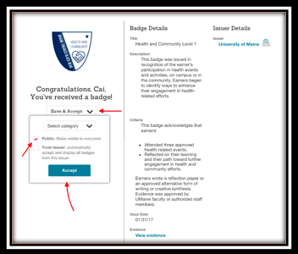
3. Click ‘Save & Accept’.
Congratulations, you received your badge!

How do I customize my Credly profile?
Go to “Account Settings” (top right menu) to update your profile information.

Elements of a customized Credly Profile:
- Profile photo in Avatar area.
First change your Profile Picture by clicking “Change Avatar” underneath the blank picture with a professional-like photo.
- The “About Me” section is a short description (up to 158 words) about yourself. Keep it professional. Employers and others will be reading it. You can include the following information:
-Year you will graduate from college.
-Your Major(s) and minor(s).
-Leadership roles; clubs, programs etc.
-Honors/Awards received.
If desired: Possible career goals and interests.
- Your location: University of Maine, Orono, ME
- If you have a personal (professionally related) blog or website or an online e-portfolio include the link to this under the “Official Website or Blog.”.

Example of “About Me” bio:
My passion is writing which is why I chose a double major in Journalism and English with a minor in Professional Writing. Additional skills I have sharpened through my college career include HTML coding, leadership, and foreign relations. While studying abroad at the University of Barcelona, I exercised my communication skills through strengthening my fluency in Spanish and developing an understanding and deep respect for people and communities with diverse cultural histories. I hope that travel will be a part of my future endeavors.

**Any time you edit a field within the “Account Settings” page you will have to scroll and click “Save Changes.”

Sharing Your Badge on LinkedIn
- Go to credly.com/my-credit
- After logging onto your Credly account, hover your cursor over the badge you would like to share. Click the “share icon” (on the right of the trash can icon).
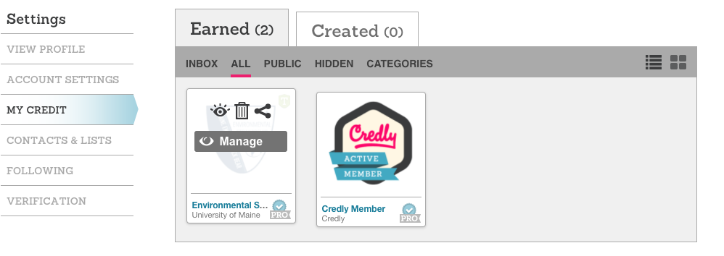

- Click the LinkedIn icon in the pop-up window, followed by the “Add to Profile” icon.

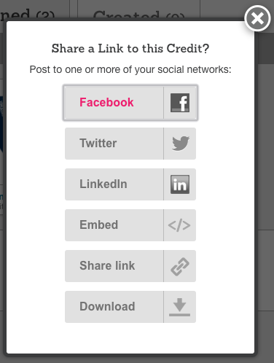
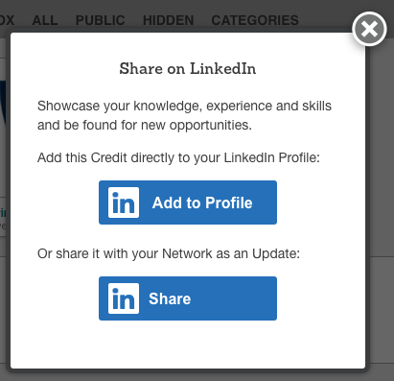
4. If your LinkedIn page does not open automatically, click the “Add to Profile” icon on the following pop-up menu next to the instructional text.

5. On LinkedIn, a pop-up menu will appear asking you to fill out Certification Name, Certification Authority, License Number, Certification URL and Dates. You can use the “Copy” buttons from the pop-up menu in Step 4 to copy this information over quickly instead of re-typing it. This will add the information to your clipboard for you paste.

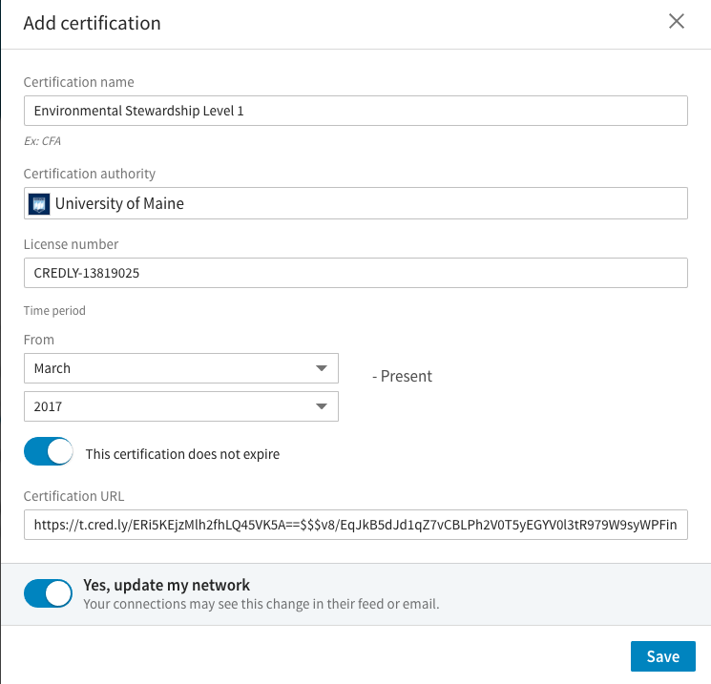
6. After all the information is copied over to the LinkedIn form, make sure to check “This certification does not expire” under the “time period” section. Choose whether or not you want to update your LinkedIn connections on earning your badge, and hit “Save.” Your badge is now available on your LinkedIn profile!

How to Link Your Social Media Accounts

- Sign into Credly account through https://umaine.credly.com
- Click the arrow next to your name in the top right corner
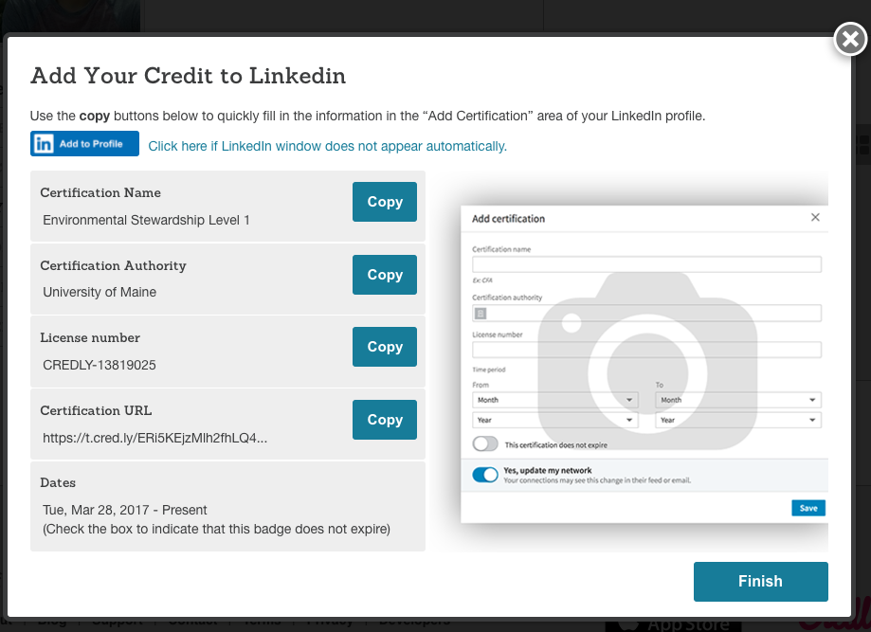
- Click Account Settings
- On the right hand side of the page you will see an option for ‘Linked Social Accounts’
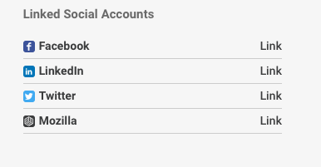
- Click ‘Link’ next to any account you want and it will automatically share your badges when they are earned on Credly!
- The EBB Initiative strongly suggests that you link your LinkedIn account to help you gain a competitive edge with future employers!
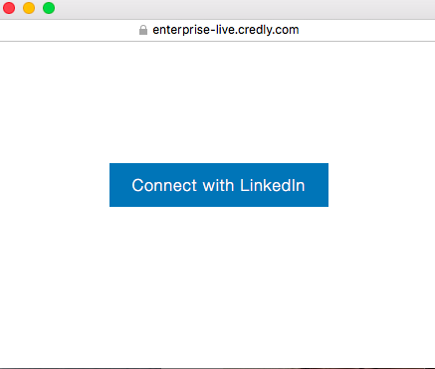

Sharing to Facebook and Twitter
- Go to credly.com/my-credit
- After logging onto your Credly account, hover your curoser over the badge you would like to share. Click the “share” icon (on the right of the trash can icon).
- To share on Facebook, click the “Facebook” icon. To share on Twitter, click the “Twitter” icon.

Pop-ups will appear prompting you to post to your respective social media site.

Twitter
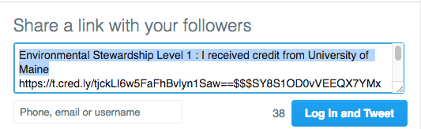

Facebook

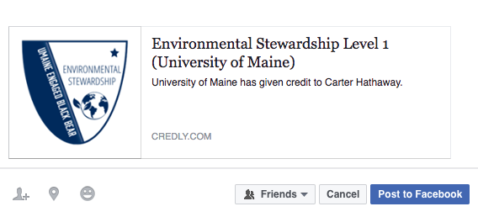

Adding Your Badge to Your Email Signature Line (Gmail)
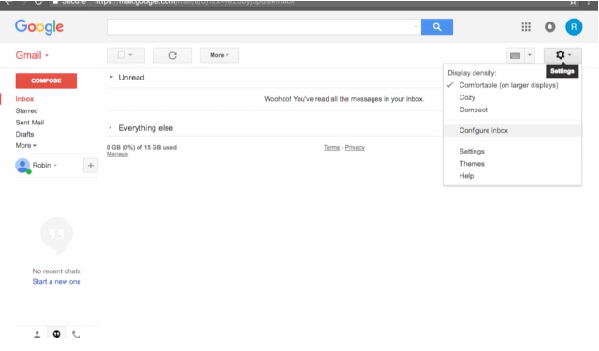
- Click the gear icon on the upper right corner of your Gmail inbox. Scroll down to settings.

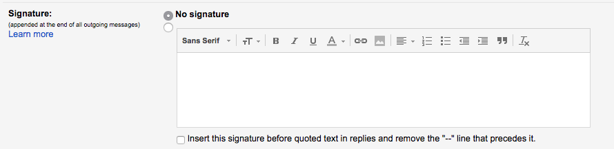
- Locate the signature box. This will be edited later.

- Go to credly.com/my-credit
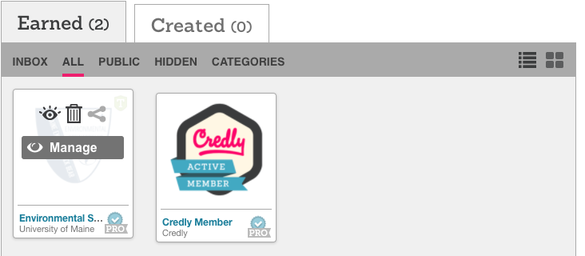
- Hover over the badge you want to add to your signature line. Click the “share” icon to the right of the trash can icon.

- Click “Download.” This will download the image of your badge. You do not need to save in Open Badge format. Save the image on your computer somewhere you can retrieve it later.
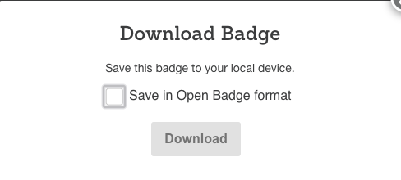

- Hover over your badge again, share, and click “Share link.” Click “copy link” in the pop up box. The link is now copied to your clipboard.

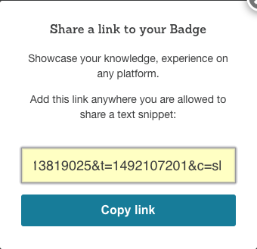

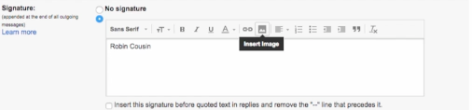
- Return to your Gmail settings page. In the signature box, click “Insert Image.” Locate the downloaded badge image on your computer and hit “upload” on the pop up or drag and drop it.

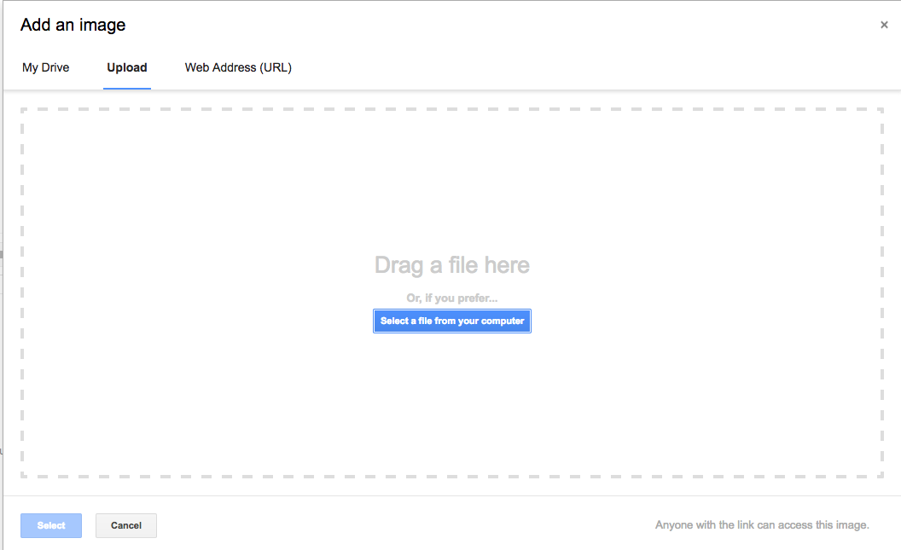
- Your badge image will likely appear very large in the signature box. To size it down, click the image, and click “Small”.
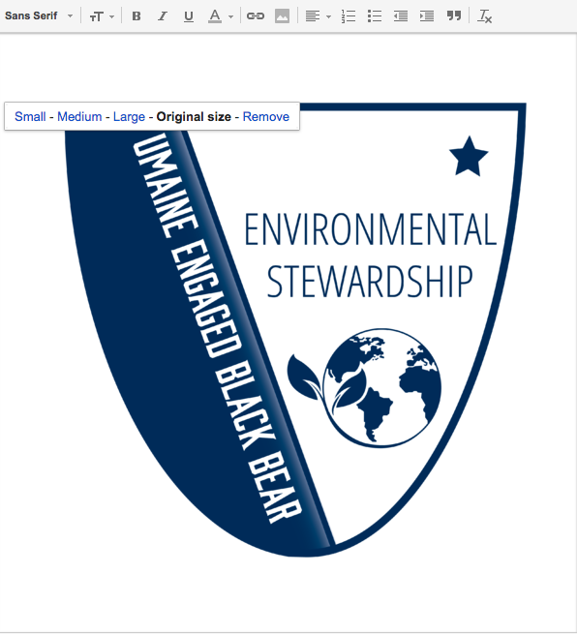

- Highlight the image by dragging your cursor over it. A blue tint should cover the image. Click the chain link icon next to the “add image” icon. Then, click “change” in the pop up.

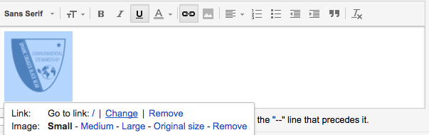
- In the Edit Link pop up, paste the link that you copied earlier to your clipboard from your Credly site. There is no need to enter anything into the “text to display” field as you are adding a link to an image. Click “ok” when finished.
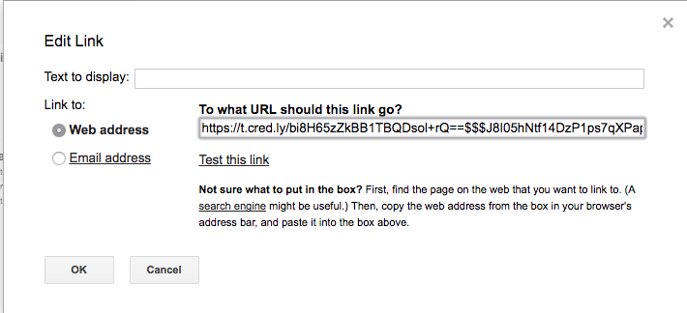

- Scroll down to the bottom of your Settings page in Gmail and hit “Save Changes.”

Sharing your Badge to Mozilla Backpack
Mozilla Backpack is an open badging platform that allows storage of badges from multiple sources. The badges can then be shared and sorted from the Backpack platform, and will always be safe if something happens to another account.

- Create a Mozilla Backpack account. Go to https://backpack.openbadges.org/backpack/signup and use your @maine.edu email address to create an account.
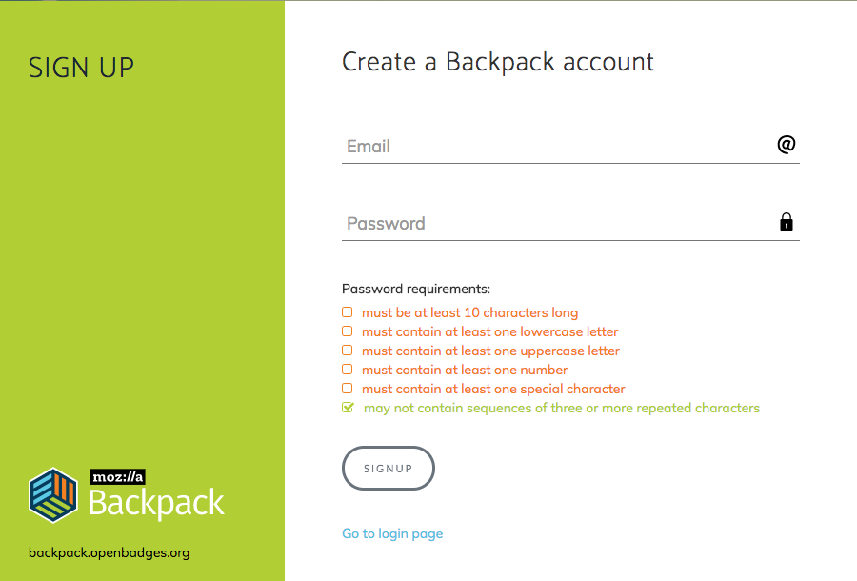

- Go to credly.com/my-credit. Hover over your name in the top right corner of the page and click “Account Settings” in the drop-down menu. On the settings page, scroll to the lower right of the page to find “Social Settings and Auto Share.” Hover over openbadges.org and click “Link.”
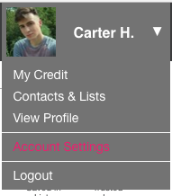

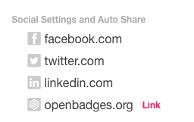

- Confirm that the @maine.edu email address you used to sign up for your Backpack account appears in the pop-up menu. Click connect. Now, the openbadges.org option will be bolded in your settings.
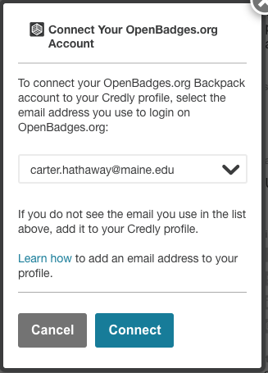

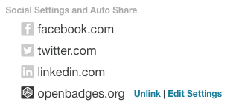

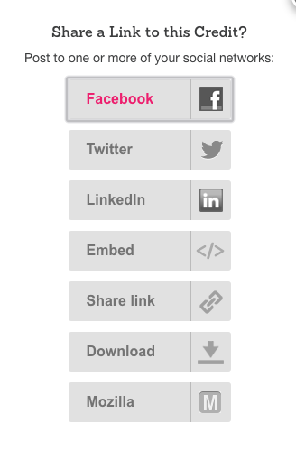

4. Return to credly.com/my-credit. Hover over the badge you want to share to your Backpack. Click the ‘share’ icon to the right of the trash can and then select “Mozilla” in the pop-up menu.
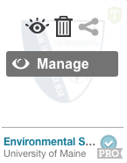

- Click “send” on the pop up menu. After a few moments, a new menu will pop up asking you to accept the badge through Backpack. Finally, hit “Thanks” in the last pop-up to finalize the process.
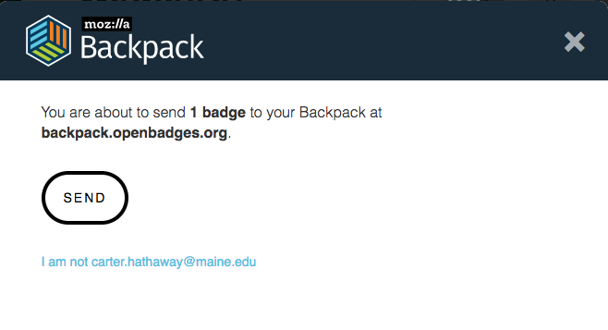
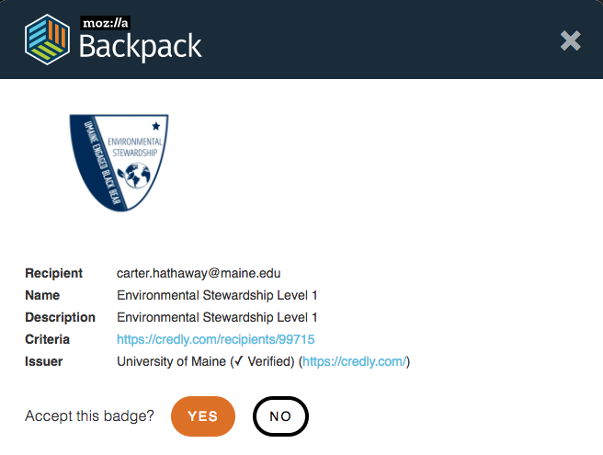
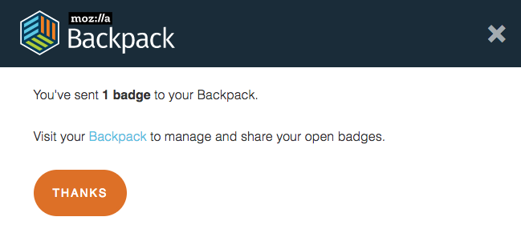

Any questions, please contact:
Claire Sullivan, Ph.D., Coordinator of Community Engagement, (207) 581-2473, claires@maine.edu

