Maine’s Alternative Certification Mentoring
program

Mentor Handbook 2019-20

Appendix

MACM Mentor Handbook 2019-20
Appendix Contents

Tool | Page
MACM Stipend Process -Vendor ID | 3
MACM Stipend Invoice Template | 4
MACM Monthly Mentor Log | 5
Sample Confidentiality Agreement | 6
Reflection Guide for Quarterly Reflections (Douglas School District) | 7
Gut-Level Teacher Reflection | 8
Discussion Log- Year 1 (Delaware DOE) | 12
Pre-Observation Meeting (Blackstone Valley Tech MA) | 13
Drop-In Observation Form (West Denver Prepatory Charter School) | 14
Walk-Through Observation Notes (West Denver Prep) | 15
“What To Do “ Observation (Giving Directions) (West Denver Prep) | 18
Collaboration Log (Mississippi DOE) | 20
Decision Points Checklist (Mississippi DOE) | 21
New Teacher Survey (Global Learning Charter Public School) | 22
MACM Mentee Needs Checklist (adapted from Duffy & Forgan, 2005) | 25
Mississippi Needs Assessment Beginning Teachers | 27
Special Education Mentee Needs Assessment (Arlington MA) | 29
NCIPP Special Educator Needs Assessments | 31
Monthly Checklist for Teacher Mentors (adapted from Duncan Public Schools, original source: University Colorado/Co. Springs TIRP) | 36
Month-by-Month Teacher Mentor Checklist (adapted from Wyandanch Union Free School District, NY | 46

MACM Mentor Information
Stipend Process

1. Log onto
https://meosc.hostams.com:1443/webapp/PRDVSS2J1/AltSelfService

2. You will be prompted through the process to create a vendor number with maine.gov.

3. Complete a W-9 form and upload to the site.

4. If you have trouble with any part of the process, contact Emily Gribben (Emily.Gribben@maine.gov ) for assistance.

Thank you,

Valerie Smith

Valerie.smith@maine.edu

Invoice Template

Instructions: Send invoice to valerie.smith@maine.edu

Project Sponsor: Maine Department of Education
Office of Special Services
23 State House Station
Augusta, ME 04333-0023

BILLING DATE: ____________________

Project Description: Maine Alternative Certification Mentoring Program

Mentor Name
Street Address:
City, State, Zip
Phone Number:
Vendor Code:Note: if this is your first invoice, Maine DOE will fill in this field.
Email Address:

Mentee Name | Stipend Due
1)
2)
3)
Total Due

MACM 2019-20
Monthly Mentoring Log

Month | Mentor | Mentee
Date/est. length of contact time | Topics discussed | Contact mode (i.e. in person, email, text, phone, FaceTime, Zoom)

Sample Confidentiality Agreement
Mentoring Program Confidentiality Statement
For a mentoring relationship to develop, both the mentor and mentee must feel that discussions of private issues or problems are being handled with discretion. The purpose of this agreement is to protect both the mentor and mentee from a breach in confidentiality during the mentoring process.
I, __________________________________, agree to keep confidential the specifics of my discussions with my mentor/mentee, unless given permission to share this information with others. I am also encouraged to discuss any concerns I have about my mentoring experience with the Mentoring Program Coordinator(s). The Mentoring Program Coordinator will maintain confidentiality unless a breach of confidentiality is necessary to maintain someone’s personal safety.
I understand that a copy of this agreement will be given to my mentee/mentor and I will also receive a copy of his or her signed agreement.
_________________________________________________________ __________________
Signature Date (MM/DD/YY)

Reflection Guide for Quarterly Reflections
Adapted from Douglas School District Educator Evaluation Guide: http://douglas.k12.ma.us/common/pages/DisplayFile.aspx?itemId=305198

These are questions you can use to track your thoughts- and growth- throughout this school year.

Reflection # 1 - October
. Your first reflection could include the following:

- One area of strength

- One goal for next term

- Reflection: My students are truly learning…

Reflection # 2 - December
Your second reflection could include the following:

- Something that is really working is…

- I continue to be challenged by…

- My students should know _________ by January/midterms

Reflection # 3 February
Your third reflection could include the following:

- I am frustrated by…

- I am proud of…

- One thing that would make a difference for the rest of the year is…

Reflection # 4 April
Your third reflection could include the following:

- The biggest challenge I faced this year was…

- Suggestions for next year include…

- Overall, this year was…

The Gut-Level Teacher Reflection
Adapted from: https://www.cultofpedagogy.com/gut-level-reflection-questions/
See website for more information and link to a related podcast.

These five questions can help you listen to your gut and uncover problem areas in your teaching. Under each question, space is provided for you to take notes on things that give you positive feelings (+), negative feelings (—), and mixed or unclear feelings (?).
1. Look around your classroom or work space. What parts of the room make you feel tense, anxious, or exhausted? What parts make you feel calm, happy, or proud?
+ | - | ?
2. Open your plan book and just start browsing, paying attention to how you’re feeling as your eyes meet certain events. What days and weeks give you a lift when you see them, a feeling of pride or satisfaction? Which make you feel disappointed, irritated, or embarrassed?
+ | - | ?
3. Look over your student list. What do you feel when you look at each name? Which make you feel relaxed, satisfied, and proud, and which ones make your chest tighten with regret, and which ones make your stomach tense?
+ | - | ?

4. Mentally travel from classroom to classroom, picturing each teacher in the building. What are your feelings as you approach each one? Which give you a generally positive feeling, which ones are neutral, and which make you feel nervous, angry, or annoyed?
+ |  | - |  | ?
5. Look at the professional practice “buzzwords” in the left column. As you read each one, do you have a positive, negative, or mixed feeling? Blank spaces are for you to add your own buzzwords or terms that impact your work.
 | + |  | - |  | ?
Technology

Data driven

Evidence-based

Standards based

Higher level thinking

PBIS

RTI

Social Emotional Learning

Priorities and Action Plan: For each of the five areas above, identify one or two priorities for change. They may be positives into which you want to put more energy, negatives you want to address, or ambiguities that need more investigation. Then, jot down a concrete plan to address each priority.
 | Priorities | Action Plan
Area 1: Classroom

Area 2: Planning

Area 3: Students

Area 4: Co-workers

Area 5: Professional Practice

Discussion Log- Year 1
Adapted from Delaware DOE Comprehensive Induction Program
https://www.doe.k12.de.us/cms/lib/DE01922744/Centricity/domain/522/teachers_year_1/discussion_log_4_y1_form.pdf

New Teacher:  Mentor: | Date:
What successes have you had with managing classroom procedures, managing student behavior, creating an environment to support learning and/or organizing physical space? | What challenges have you had with managing classroom procedures, student behavior, creating a learning environment and organizing physical space?
When you reflect on the challenges that you have faced, can you think of different ways that you could have addressed the situation? Describe the actions that you will take the next time that you face a similar situation. | When you consider the challenges that you have faced recently are there any that you would like guidance with from me as your Mentor or others that you feel could assist you in developing the skills and knowledge that you need?

Pre-Observation Meeting
(Blackstone Valley Tech MA New Teacher Induction Program)

Mentor’s Name: ____________________________________________________________

Mentee’s Name: ____________________________________________

Observation Date: ____________________ Observation Time: ____________

NOTES FOR PRE-OBSERVATION MEETING:

Class title – _________________________________________________________________________

Number of students – _________________________________________________________________

Description of students - ________________________________________________________________

Class topic - _______________________________________________________

- What are the objectives or goals for the class period? (What do you expect the students be able to do/know by the end of the class period?)

- What is the planned agenda/procedure for the class period?

- What strategies/methods do you plan to use to help the students to reach the objectives?

- Assessment - How will the students show that they know and can do what you expected of them?

- Is there anything that the mentor observer to pay special attention to (ex. A problem student, time or classroom management)?

With your mentee, please plan a Post-Observation Conference to discuss observation.

Date for Post-Observation Conference: ________________________
Drop In Observation Form West Denver Preparatory Charter School

<School Name>
Teacher Drop-In Observation Form
Teacher: | Observer: | Date:

Please indicate whether the following is true and provide observations to support your assessments.
Question | Observed (+/Δ) | Notes
1. Is the lesson objective clearly posted?
2. Is the lesson objective clearly articulated and student friendly?
3. Are instructional methods appropriately aligned to lesson objectives?
4. Does teacher assess student understanding (formally/informally) and is assessment aligned to lesson objectives?
5. Are classroom rules and procedures clear, specific, consistent, and evident?

Next Steps and Summary:

West Denver Preparatory Charter School
Walk-Through Observation Notes
Teacher: _________________________ Date:__________ Time in:________ Time out:_______
Observer:________________________ Advisory and subject:________________________________
Classroom Management and Culture
CMC Teacher Behaviors/Actions | CMC Student Behaviors/Actions
___ Sense of urgency  ___ Respectful, supportive tone  ___ Assertive tone when appropriate  ___ High Expectations  ___ Stimulating classroom environment  ___ Positive reinforcement  ___ Redirecting inappropriate/off-task behavior  ___ Strong procedures/routines/transitions | ___ On task and actively participating  ___ Following directions/expectations  ___ Respectful/courteous  ___ Sense of responsibility/initiative for learning  ___ Productive risk-taking  ___Off task/disengaged  ___Disruptive/disrespectful

Instructional Planning and Delivery
IPD Teacher Behaviors/Actions | IPD Student Behaviors/Actions
___ Objective clearly posted/stated  ___ Lesson contributes to EQ and/or EU  ___ Lesson materials strongly align to the objective  ___ Engaging and effective instructional strategies  ___ Varied and effective grouping strategies  ___ Real world connections  ___ Effective questioning strategies  ___ Actively monitoring student understanding  ___ Effective pacing and sequencing  ___ Directions are clear, concise, and achievable  ___ Circulation around room to enhance CFUs and management | ___ Balance of student vs. teacher talk time  ___ Time to practice critical and higher order thinking  ___ Students are able to make cross-curricular connections  ___ Student responses are varied mode and depth  ___ Adequate time to practice independently  ___ Objective mastery is formally assessed at the end of class  ___ Students with IEPs are receiving appropriate accommodations

KEY TAKE-AWAYS
Keep Doing | Start Doing
Questions

ACTION STEPS FOR THE UPCOMING WEEK:

West Denver Preparatory Charter School
Teacher: _____________________ Observer: _______________________ Date: _____________

“What to Do” Observation

Summary of Directions:

_____________________________________________________________________________________

_____________________________________________________________________________________

Directions are:

Specific (“Stand with your eyes forward and your hands behind your back.”)
Concrete (“Put your feet on the floor and your legs under the desk.”)
Sequential (“Hands folded, feet on the floor, eyes on me.”)
Observable (“Pencils down and eyes on me in 3-2-1…”)
Brief (Time: ___________ )

When giving directions:

You are standing still (In this part of the classroom: _______________________________)

You are: __________________________________________________________________________

_________________________________________________________________________________

Your speech & volume are: ___________________________________________________________

You repeat yourself __________ times

When receiving directions:

Kids are: __________________________________________________________________________

The directions in your packet are:

Clear and concise: __________________________________________________________________
Easy to reference: __________________________________________________________________

After you give directions, you:

Monitor carefully to see if 100% of students are following your directions: ___________________
Correct students who do not follow the directions by _____________________________________
Never confuse ignorance with defiance: ________________________________________________

Collaboration Log
Retrieved and adapted from: https://www.mdek12.org/sites/default/files/Offices/MDE/OA/OTL/Teacher%20Center/2l---mod-2-collaboration-log_v1.pdf

New Teacher: Mentor:

School/Program: Date:

Meeting Duration:
_________________________________________________________________________________
Collaboration Type (check all that apply):
 | Analyzing student work |  | Discussing individual student needs |  | Observing a veteran teacher
 | Communicating with parents |  | Discussing student assessment |  | Planning lessons
 | Developing professional goals |  | IEP development |  | Pre-observation conference
 | Classroom culture |  | Modeling lesson |  | Post-observation conference
 | Discussing curriculum |  | Observing instruction |  | Reflecting
 | Using technology |  | Providing resources |  | Other:

Positives:

Key Points/Needs:

Next Steps:

Next meeting date/time:

Mentee Signature: Mentor Signature:

Decision Points Checklist
Retrieved and adapted from: https://www.mdek12.org/sites/default/files/Offices/MDE/OA/OTL/Teacher%20Center/2a-mod-2-decision-points-check-list_v1.pdf

This checklist is designed to assist in exchanging information and generating ideas in planning the mentoring year. Check the column if this is an area of discussion and make notes regarding interest and/or expected action.
DECISION POINTS | YES | NOTES/ACTIONS
Communication Plans
- Preferred types, phone, email, text, FaceTime, other
- Best time to be reached

- Scheduled communication check-ins (at least weekly)
- Planning visits (who initiates, how, etc)
- Reflective practices

Possible Areas of Discussion/Need
- Classroom and behavior management
- Time management

- Managing work load

- Managing data, recording and tracking
- Managing administrative and IEP responsibilities
- Instruction/learning activities and resources
- Using technology

- Communicating with families, working with colleagues
- Student motivation

- Professional organizations, resources
Additional Areas
- State reporting

- Certification requirements

Global Learning Charter Public School

New Teacher Survey

Name: ___________________________ Grade and Content _______________

Welcome to the faculty! To best assess your needs as a new teacher, please fill out this survey completely.

1. Did you complete a teacher education program? Yes ______ No _____

2. Identify the college attended for your teacher preparation program.

______________________________________________________________________

3. How many years have you spent in the classroom prior to this school year?

0 1-2 3-5 5+ years

4. What level of certification do you currently hold: _________________________

5. What content area and grade level is your certification? ______________________

6. Is your current position in your certified content area? ________________________

7. If you have teaching experience, please describe the setting(s).

__________________________________________________________________________________________________________________________________________________________________________________________________________________
8. Do you hold a Master’s Degree? Yes ______ No _____

9. Are you a career changer? Yes ______ No _____

10. If you are a career changer, what is your background?

_________________________________________________________________________________________________________________________________________________________________________________________________________________

11. List your three strongest assets as a teacher.
____________________________________________________________________________________________________________________________________________
______________________________________________________________________
12. List three areas of concern as a new teacher in this school?

_________________________________________________________________________________________________________________________________________________________________________________________________________________

13. I hope my mentor teacher will…

_________________________________________________________________________________________________________________________________________________________________________________________________________________
_________________________________________________________________________________________________________________________________________________________________________________________________________________

15. What skills or expertise to you want to share with the school community?

_____________________________________________________________________
__________________________________________________________________________________________________________________________________________________________________________________________________________________

Please choose the response that most indicates your anticipated level of need for assistance in each area.
1 – Little or no assistance
2 – Some need of assistance
3 – High need of assistance
_______ Find out what is expected of me as a teacher
_______ Communication with the principal
_______ Communication with other teachers (team and/or department)
_______ Communication with parents
_______ Organizing and managing my classroom
_______ Maintaining student discipline
_______ Obtaining instructional material
_______ Planning for instruction
_______ Diagnosing student needs
_______ Evaluating student progress
_______ Motivating students
_______ Assisting students with special needs
_______ Individualizing for student needs
_______Understanding the curriculum (Curriculum Frameworks, Common Core, Next
Generation Science, etc.)
_______ Completing administrative paperwork
_______ IEP Evaluations
_______ SchoolBrains
_______ Teacher Evaluation portfolio
_______ Other __________________________________________________
_______ Differentiating instruction
_______ Developing standards-based evaluations
_______ Understanding the school’s teacher evaluation process
_______ Understanding my legal rights and responsibilities as a teacher
_______ Becoming aware of special services provided or available at the school.
Any other areas you would like to work on:
MACM Mentee Needs Checklist
Adapted from:
Duffy, Mary Lou, & Forgan, James (2005). Mentoring New Special Education Teachers. Thousand Oaks, CA: Corwin Press.

Support Areas |  | High Need | Moderate Need | Low Need
Assessing Student Progress

Accommodations and Modifications to Curriculum

Lesson Planning, Co-Planning

Compiling IEP Assessments, writing parent-friendly summaries
Writing measurable, portable* IEP goals, objectives
*portable: applicable across environments
Managing student progress data collection

Following district IEP procedures, meeting IEP timelines
Using Maine’s IEP template and guidelines

Writing IEP

Organizing student artifacts, record-keeping

Organizing the classroom (physical space)

Getting and locating classroom materials, supplies, resources
Organizing myself, creating a time management system
Creating and enforcing class rules and procedures

Learning more about subjects

Ideas for teaching specific lessons

Motivating students

Managing challenging student behavior

Support Areas |  | High Need | Moderate Need | Low Need
Collaborating with general ed peers

Collaborating with related service professionals (i.e. SLPs, OTs, PTs)
Working with parents/caregivers

Supervising ed techs

Others not listed here:

Priority Goals for this year
Goal area | What will success look like? (describe)
1.

2.

3.

4.

5.

Mississippi Needs Assessment Questionnaire for Beginning Teachers v1

Needs Assessment Questionnaire for Beginning Teachers
Part A. Please choose the response for each item that most closely indicates your level of need for assistance in the area described.
Possible responses:
A. Little or no need for assistance in this area B. Some need for assistance in this area
C. Moderate need for assistance in this area D. High need for assistance in this area
E. Very high need for assistance in this area

- _____ Finding out what is expected of me as a teacher
- _____ Communicating with the principal
- _____ Communicating with other teachers
- _____ Communicating with parents
- _____ Organizing and managing my classroom
- _____ Maintaining student discipline
- _____ Obtaining instructional resources and materials
- _____ Planning for instruction
- _____ Managing my time and work
- _____ Diagnosing student needs
- _____ Evaluating student progress
- _____ Motivating students
- _____ Assisting students with special needs
- _____ Dealing with individual difference among students
- _____ Understanding the curriculum
- _____ Completing administrative paperwork
- _____ Using a variety of teaching methods
- _____ Facilitating group discussions
- _____ Grouping for effective instruction
- _____ Administering standardized achievement tests
- _____ Understanding the school system’s teacher evaluation process
- _____ Understanding my legal rights and responsibilities as a teacher
- _____ Dealing with stress
- _____ Becoming aware of special services provided by the school district

Part B. Please respond to the following items.
25. List any professional needs you have that are not addressed in the items above.
______________________________________________________________________________
______________________________________________________________________________
______________________________________________________________________________
______________________________________________________________________________
______________________________________________________________________________
______________________________________________________________________________
______________________________________________________________________________
______________________________________________________________________________
______________________________________________________________________________
______________________________________________________________________________
______________________________________________________________________________
______________________________________________________________________________
26. What additional types of support should the school district provide you and other beginning teachers?
______________________________________________________________________________
______________________________________________________________________________
______________________________________________________________________________
______________________________________________________________________________
______________________________________________________________________________
______________________________________________________________________________
______________________________________________________________________________
______________________________________________________________________________
______________________________________________________________________________
______________________________________________________________________________
______________________________________________________________________________
______________________________________________________________________________

www.doe.mass.edu Arlington Mentee Needs Assessment- adapted for MACM

Special Education
Mentee Teacher Needs Assessment Date:

This is a tool to use as a self-assessment of your personal strengths and needs. This will not be used as an evaluative tool by anyone. The information that you collect here through your own reflection will help to shape your mentor/mentee experience.

Please describe yourself on the following three questions. You may record your comments or just discuss each point with your mentor and/or your mentoring group.

  - What are your previous experiences as an educator, including student teaching, internship, or other teaching assignments? Be specific

  - What are your three strongest assets as an educator?

  - What are three areas of concern as a new educator in Arlington?

Please rate yourself in the following areas according to the descriptors:

Novice: General idea of what needs to be done
Proficient: Comfortable with responsibilities but have room to grow
Expert: Mastery of the area and could train others/share expertise

Areas to Consider | Fall |  |  | Winter |  |  | Spring
Course Management | E | P | N | E | P | N | E | P | N
Setting up the learning environment

Creating classroom rules

Enforcing classroom rules

Dealing with crisis in the classroom

Behavior management

Knowledge of relevant disabilities and related accommodations/strategies
Ability to set up and follow routines

Areas to Consider | Fall |  |  | Winter |  |  | Spring
Expectations | E | P | N | E | P | N | E | P | N
Working knowledge of special education regulations and practices
Using technology as a tool

Understanding and implementing emergency protocols (bldg, health, beh.)
Teaching | E | P | N | E | P | N | E | P | N
Locating and using grade-level district and state standards
Differentiating Instruction

Motivating students

Using a variety of teaching strategies

Familiarity with content for grade levels taught
Understanding testing materials and procedures
Familiarity with district materials and programs at grade levels taught
Relationships | E | P | N | E | P | N | E | P | N
Communicating with parents

Working with related service providers

Working with general education staff

Working with administration

Giving direction

Taking direction

Asking for help

IEPs | E | P | N | E | P | N | E | P | N
Administering standardized tests, interpreting results, writing evaluations
Writing goals and objectives

Data collection and analysis
Presenting information/facilitating meetings
Knowing your caseload and related timelines
NCIPP Needs Assessments
Introduction
NCIPP www.ncipp.org
Additional Needs Assessments Information
Needs assessments can be a first step in developing a focus and goals for mentoring sessions.
Needs assessments help the mentor organize the beginner teacher’s needs. The brief survey can be used to focus both the mentor and mentees attention. In this way, mentoring sessions become more productive and the mentor is better able to plan the content of their sessions prior to meeting.
There are 3 steps in conducting a needs assessment:
- Choose an assessment
  - Create a needs assessment based on the district’s evaluation tool or use a pre-made needs assessment.
  - See an example of a needs assessment for special education below.
- Ask your mentees to complete the assessment and rank highest to lowest needs.
- Focus subsequent conversations on your mentee’s highest needs.
NCIPP www.ncipp.org
Needs Assessment
The New Teacher Self-Assessment/Needs Form on the next pages should be introduced during early contacts. Using this form will provide the mentor with a starting point in working with the new teacher. The form also provides a mechanism for the new teacher to reflect upon his/her immediate needs. The new teacher should check those areas in which he/she would like some assistance and, in the space allotted, describe his/her concerns or perceptions of need. When completed, the form can be discussed.
From LDE New Teacher Handbook
NCIPP www.ncipp.org
Teacher Self-Assessment/Needs Form Special Education II
Teacher: __________________________ Mentor: _______________________ Date: ________
Directions: Please rate your level of expertise with each Attribute listed b elow. Note: “1” indicates very limited expertise and “4” indicates a great deal of expertise.
DOMAIN I: PLANNING
1 | 2 | 3 | 4 | Component A: The teacher plans effectively for instruction.
 |  |  |  | IA1. Specifies learner outcomes in clear, concise objectives
 |  |  |  | IA2. Includes activities/environments that develop objectives
 |  |  |  | IA4. Identifies materials/equipment/resources/adaptations, other than standard classroom materials, as needed for lesson/activity
 |  |  |  | IA5. States method(s) of evaluation to measure learner outcomes
 |  |  |  | IA6. Develops/implements an Individualized Education Program (IEP), and/or Individualized Family Service Plan (IFSP), when appropriate
Assistance/Resources Requested: Please describe what you perceive to be a need or the type of assistance or resources you would like to receive.
DOMAIN II: MANAGEMENT
1 | 2 | 3 | 4 | Component A: The teacher maintains an environment conducive to learning.
 |  |  |  | IIA1. Organizes available space, materials, and/or equipment to facilitate learning
 |  |  |  | IIA2. Promotes a positive learning climate
 |  |  |  | IIA3. Promotes a healthy, safe environment
1 | 2 | 3 | 4 | Component B: The teacher maximizes the amount of time available for instruction.
 |  |  |  | IIB1. Manages routines and transitions in a timely manner
 |  |  |  | IIB2. Manages and/or adjusts allotted time for activities and provision of auxiliary services.
From LDE New Teacher Handbook

NCIPP www.ncipp.org
1 | 2 | 3 | 4 | Component C: The teacher manages learner behavior to provide productive learning opportunities.
 |  |  |  | IIC1. Establishes expectations for learner behavior
 |  |  |  | IIC2. Uses monitoring techniques to facilitate learning
Assistance/Resources Requested: Please describe what you perceive to be a need or the type of assistance or resources you would like to receive.
DOMAIN III: INSTRUCTION
1 | 2 | 3 | 4 | Component A: The teacher delivers instruction effectively.
 |  |  |  | IIIA1. Uses technique(s) which develop(s) lesson/activity objective(s)
 |  |  |  | IIIA2. Sequences lesson/activity to promote student learning/development
 |  |  |  | IIIA3. Uses available teaching material(s), equipment, and environment to achieve lesson/activities objective(s)
 |  |  |  | IIIA4. Adjusts lesson/activity when appropriate
 |  |  |  | IIIA5. The teacher integrates technology into instruction.
Assistance/Resources Requested: Please describe what you perceive to be a need or the type of assistance or resources you would like to receive
1 | 2 | 3 | 4 | Component B: The teacher presents appropriate content.
 |  |  |  | IIIB1. Presents functional content appropriate to the learners’ capacities
 |  |  |  | IIIB2. Presents relevant subject matter/curriculum content in appropriate settings
 |  |  |  | IIIB3. Illustrates application of content through examples, unexpected situations, and other means
Assistance/Resources Requested: Please describe what you perceive to be a need or the type of assistance or resources you would like to receive.
From LDE New Teacher Handbook
NCIPP www.ncipp.org
1 | 2 | 3 | 4 | Component C: The teacher provides opportunities for student involvement in the learning process.
 |  |  |  | IIIC1. Accommodates individual differences
 |  |  |  | IIIC2. Demonstrates ability to communicate effectively with students
 |  |  |  | IIIC3. Stimulates and encourages independent performance and optimal levels of thinking
 |  |  |  | IIIC4. Promotes student participation
Assistance/Resources Requested: Please describe what you perceive to be a need or the type of assistance or resources you would like to receive.
1 | 2 | 3 | 4 | Component D: The teacher assesses student pro gress.
 |  |  |  | IIID1.Consistently monitors ongoing performance of students
 |  |  |  | IIID2. Uses appropriate and effective assessment technique(s)
 |  |  |  | IIID3. Provides timely feedback to students
 |  |  |  | IIID4. Produces evidence of student academic growth under his/her instruction
Assistance/Resources Requested: Please describe what you perceive to be a need or the type of assistance or resources you would like to receive.
From LDE New Teacher Handbook
NCIPP www.ncipp.org
DOMAIN IV: PROFESSIONAL DEVELOPMENT
1 | 2 | 3 | 4 | Component B: The new teacher plans for professional self-development.
 |  |  |  | IVB1. Identifies areas of instruction that need strengthening and develops with mentor and/or principal a plan for improvement and works to complete the plan
 |  |  |  | IVB2. Seeks ideas and strategies from resources (i.e., books, professional journals, websites, etc.) or colleagues that will improve teaching and learning and employs them
Assistance/Resources Requested: Please describe what you perceive to be a need or the type of assistance or resources you would like to receive.
DOMAIN V: SCHOOL IMPROVEMENT
1 | 2 | 3 | 4 | Component A: The teacher takes an active role in building-level decision making.
 |  |  |  | VA1. Participates in grade level and subject area curriculum planning and evaluation
 |  |  |  | VA2. Serves on tasks force(s) and/or committees
 |  |  |  | VA3. Implements school improvement plan at the classroom level
1 | 2 | 3 | 4 | Component B: The teacher creates partnerships with parents/caregivers and colleagues.
 |  |  |  | VB1. Provides clear and timely information to parents/caregivers and colleagues regarding classroom expectations, student progress, and ways they can assist learning
 |  |  |  | VB2. Encourages parents/caregivers to become active partners in their children’s education and to become involved in school and classroom
 |  |  |  | VB3. Seeks community invol vement in instructional program
Assistance/Resources Requested: Please describe what you perceive to be a need or the type of assistance or resources you would like to receive.
From LDE New Teacher Handbook

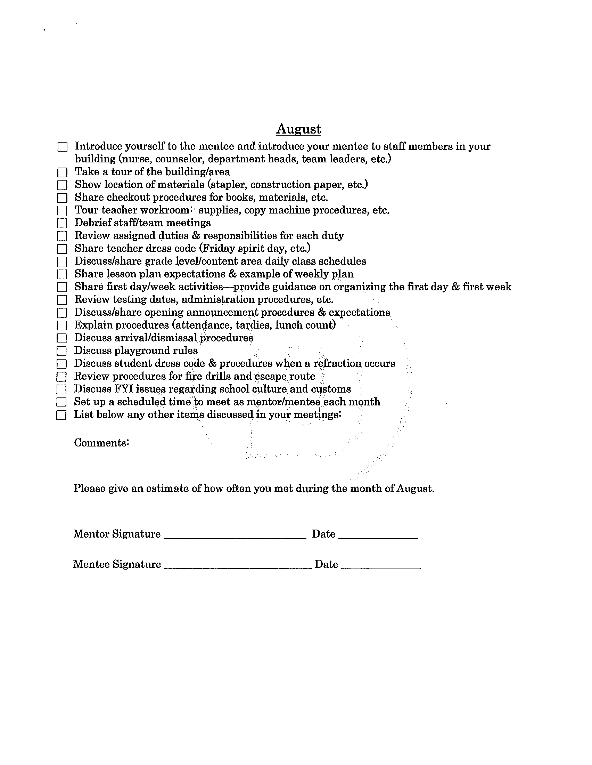
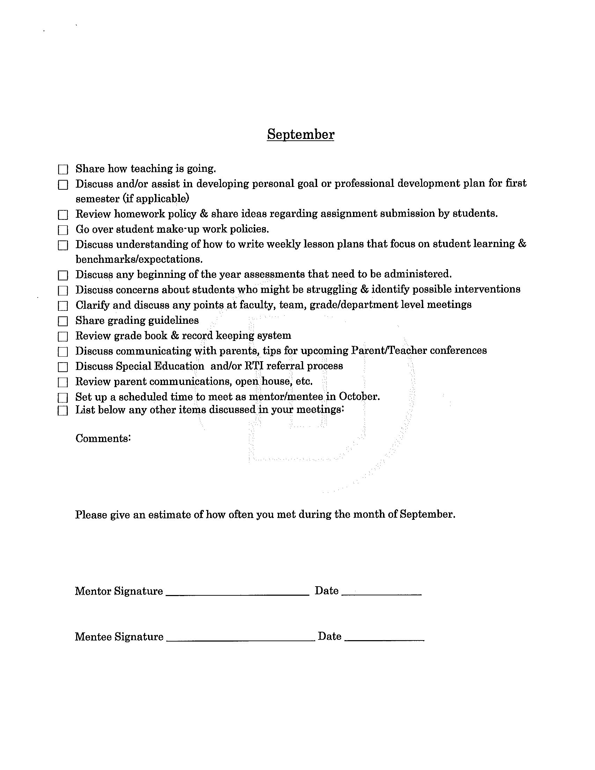

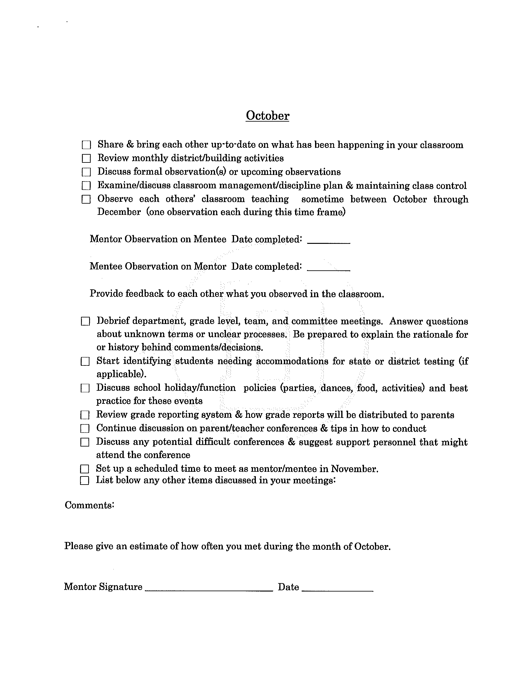

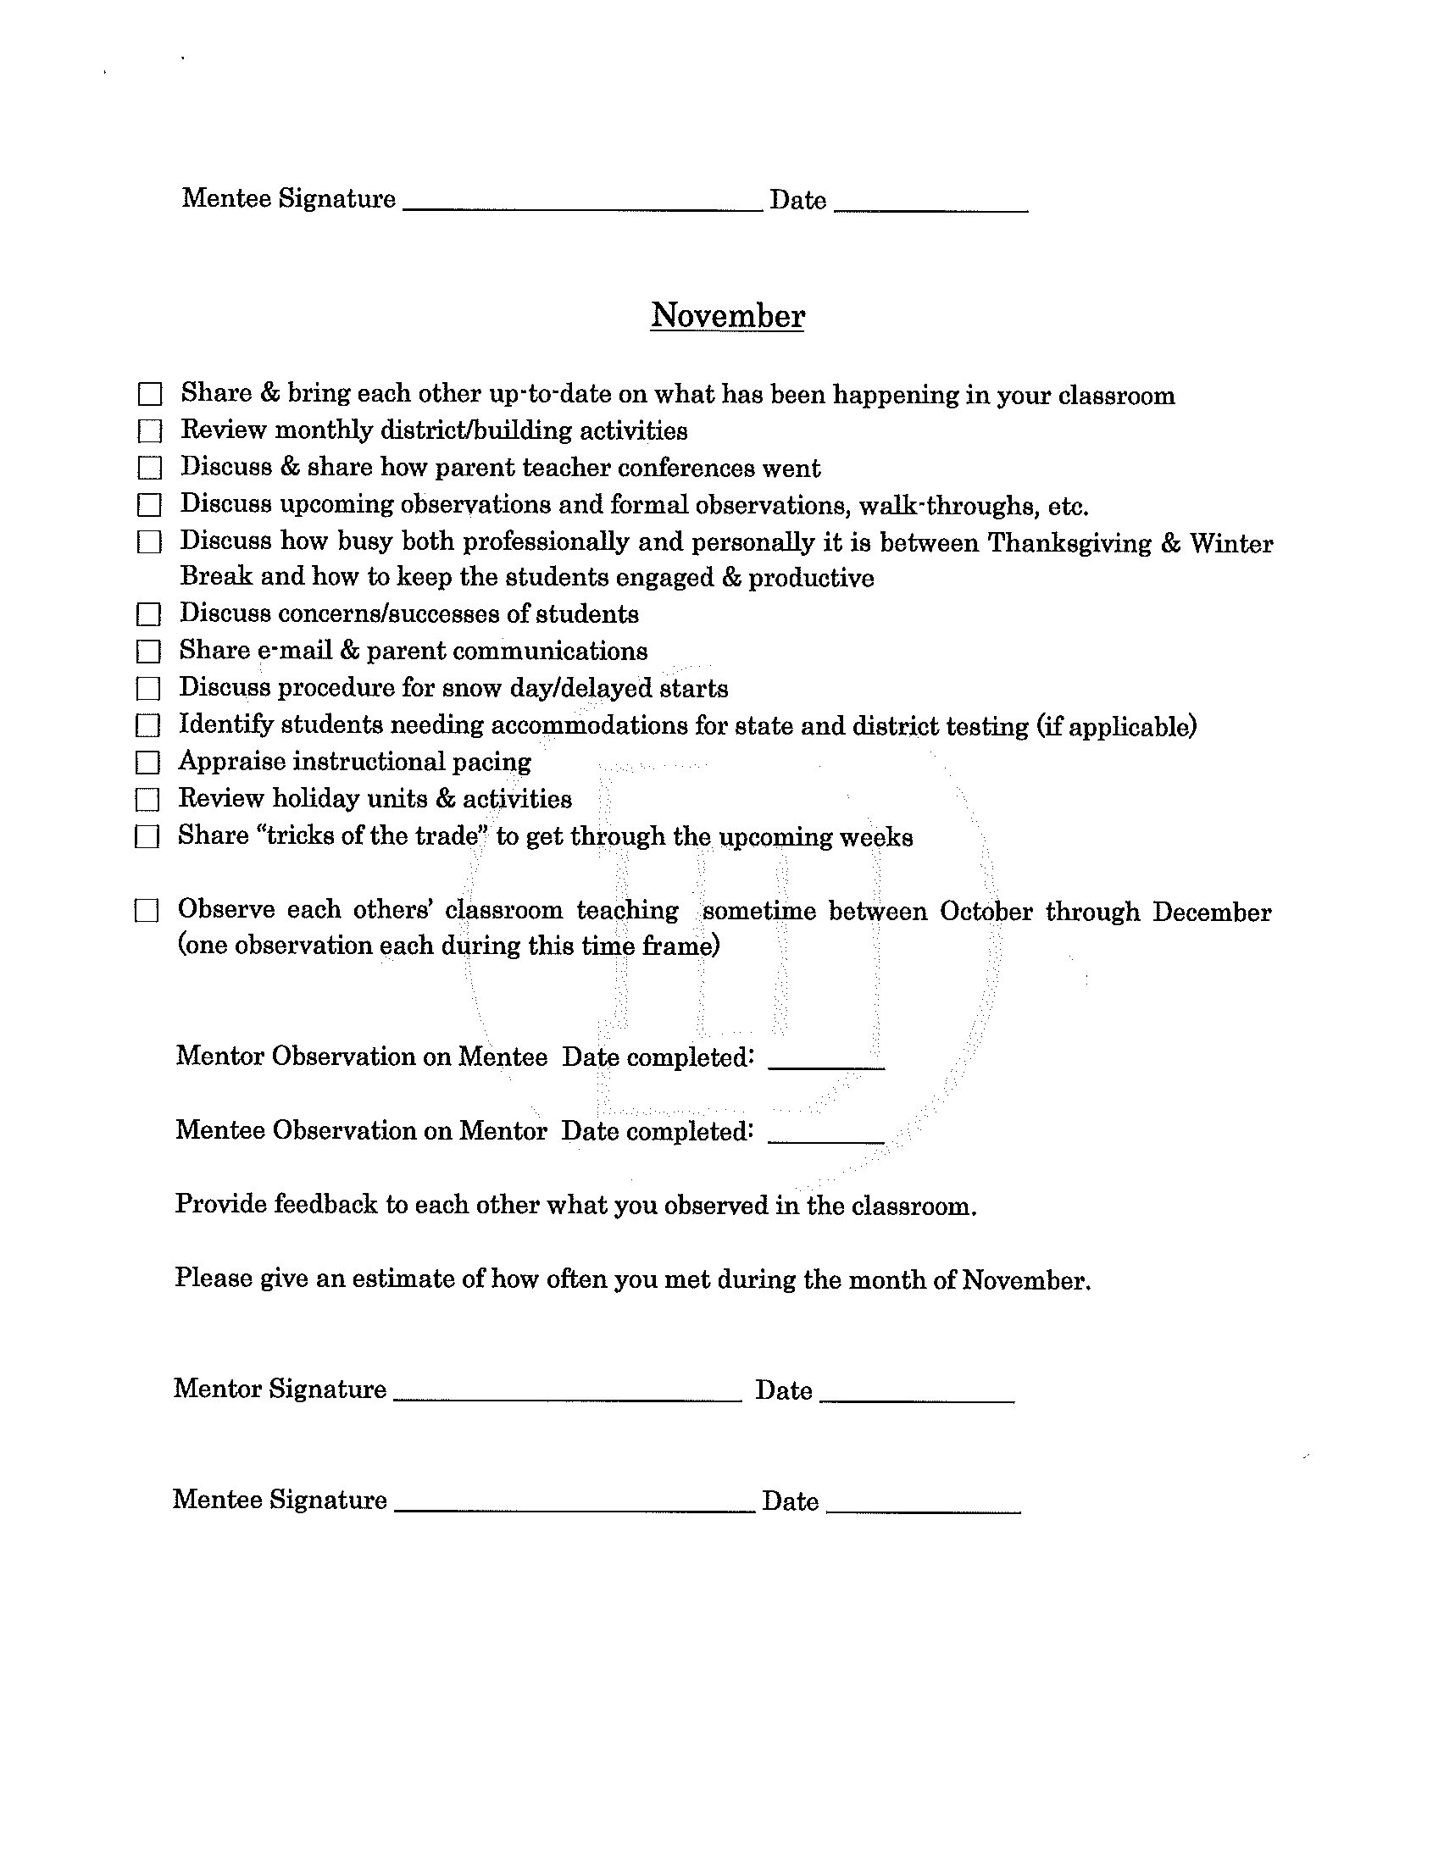

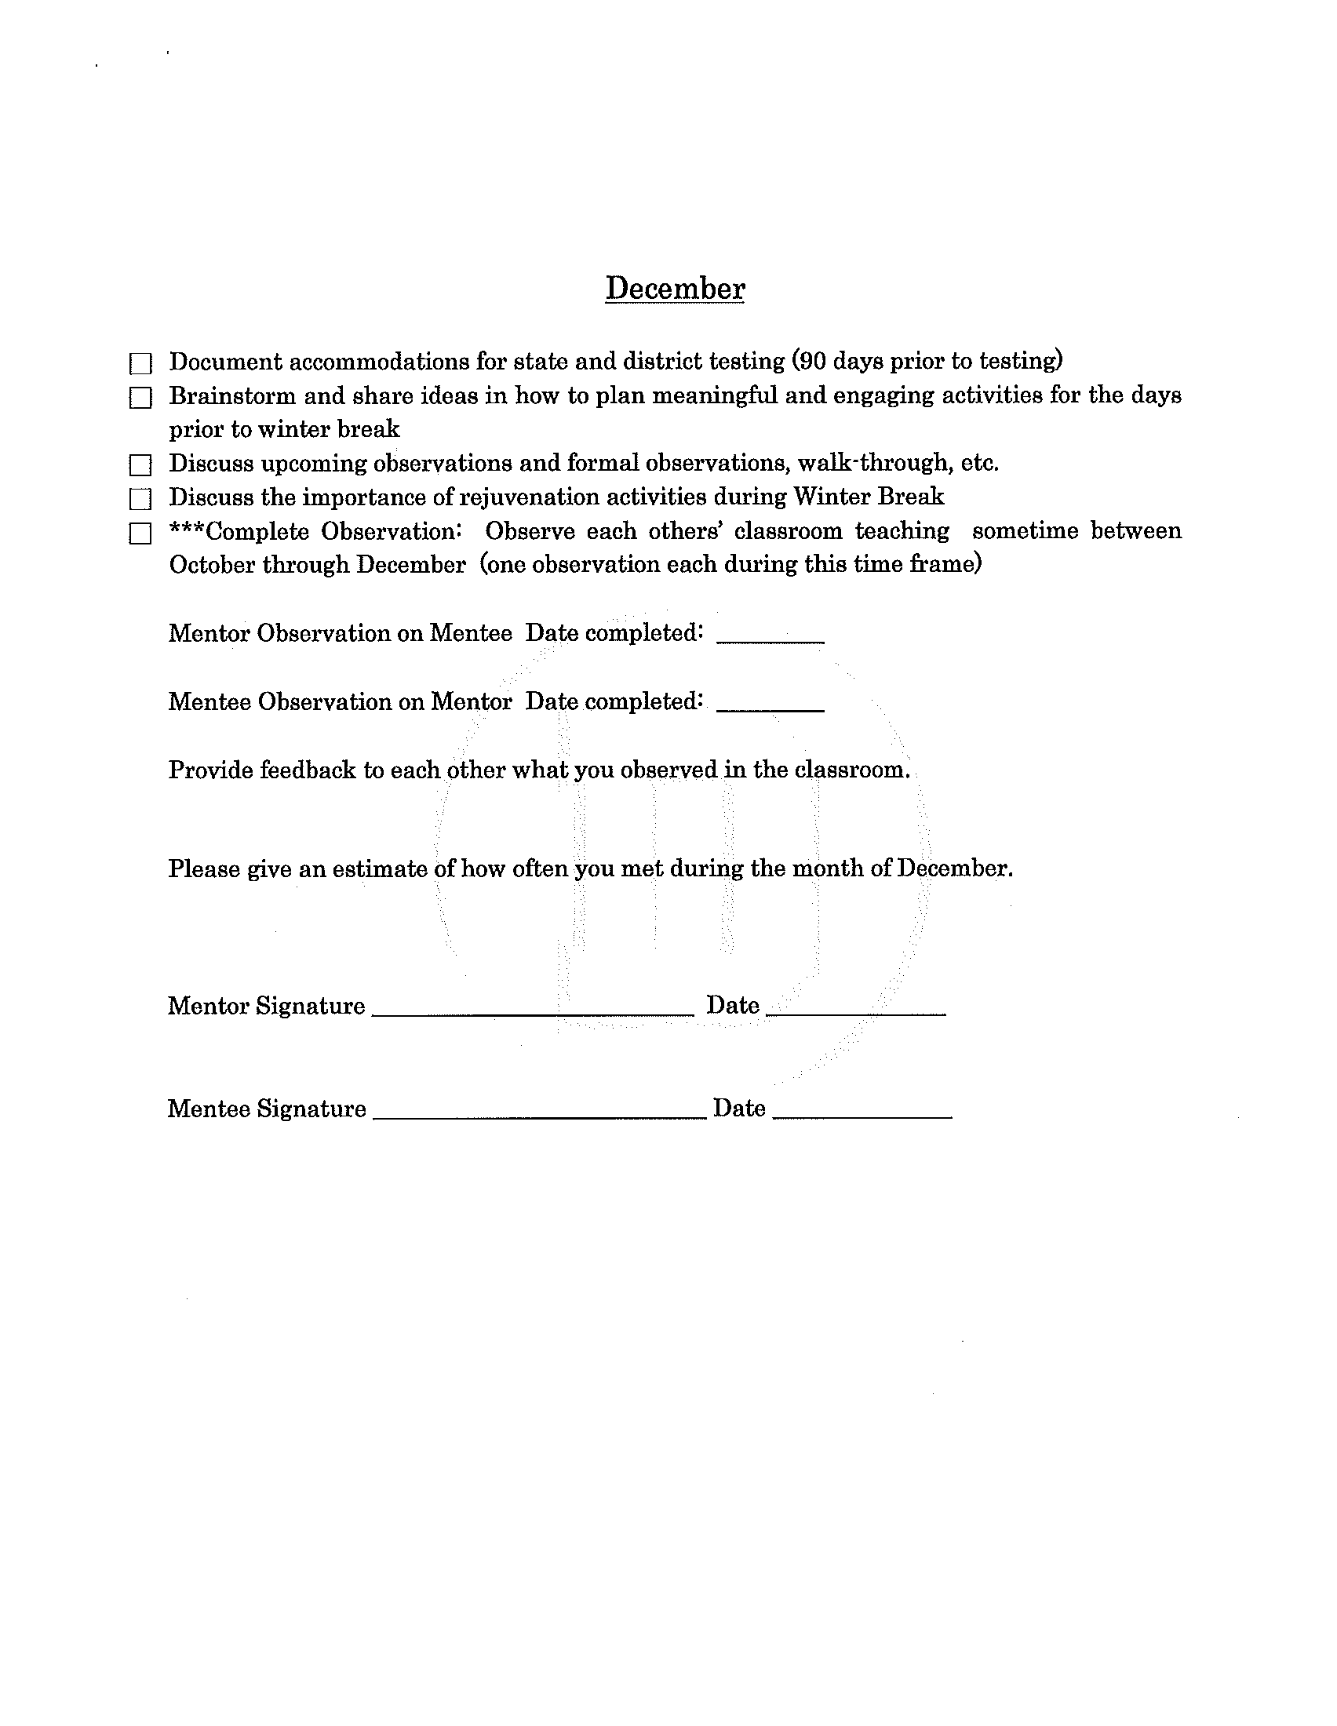

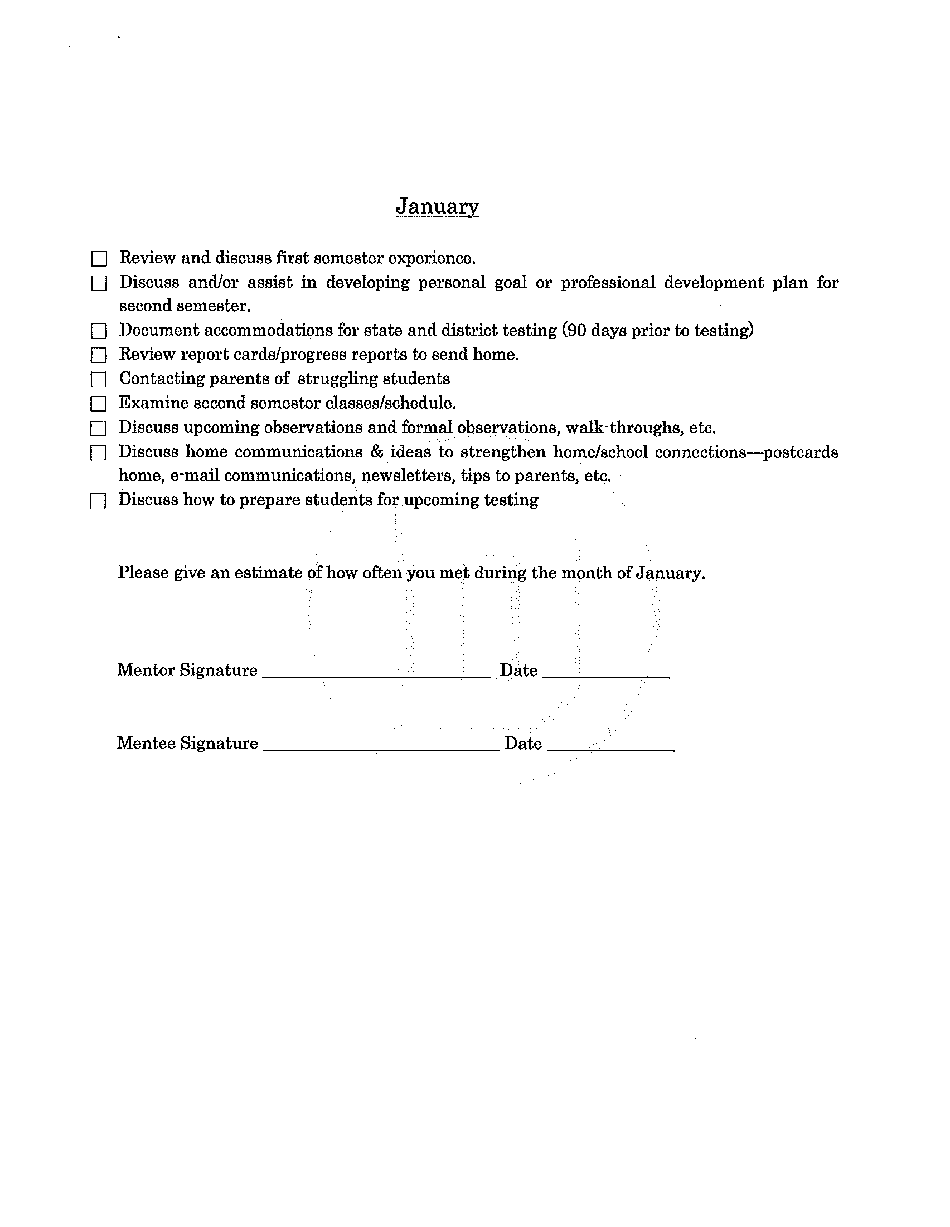

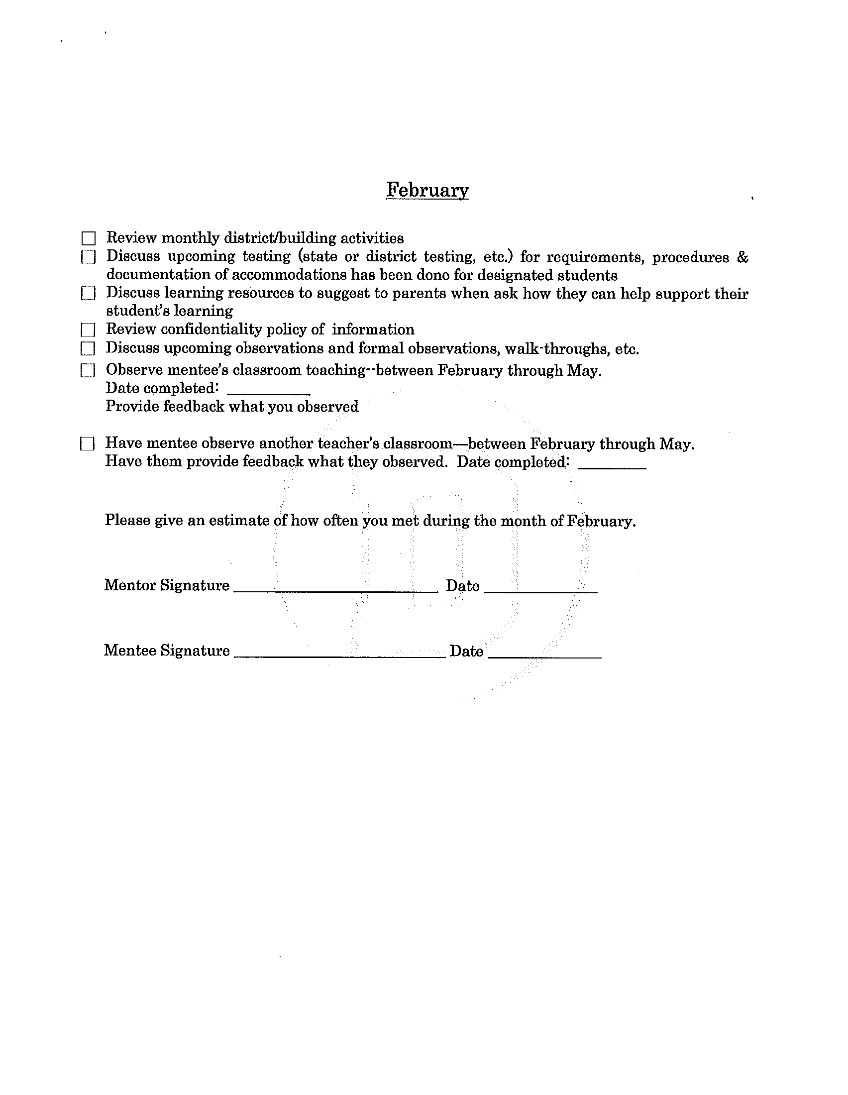

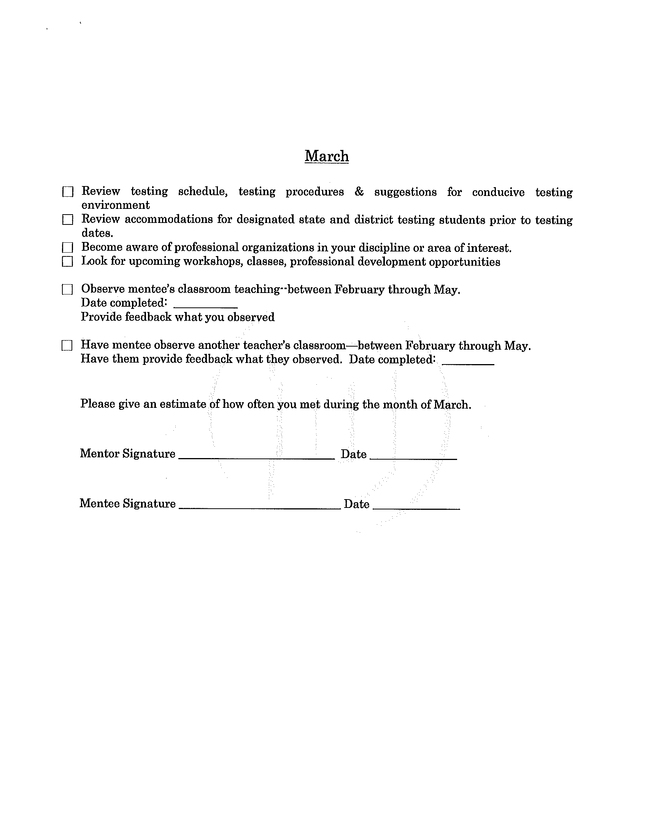

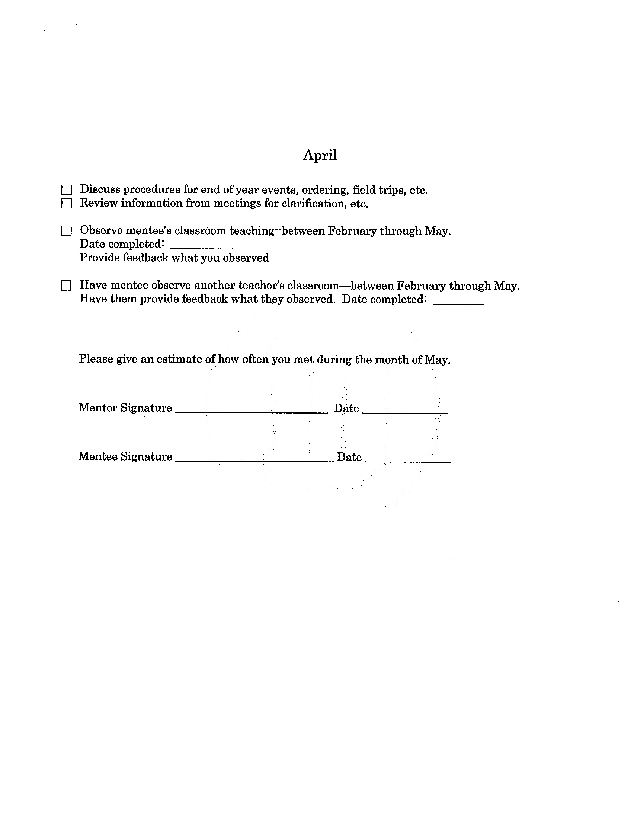

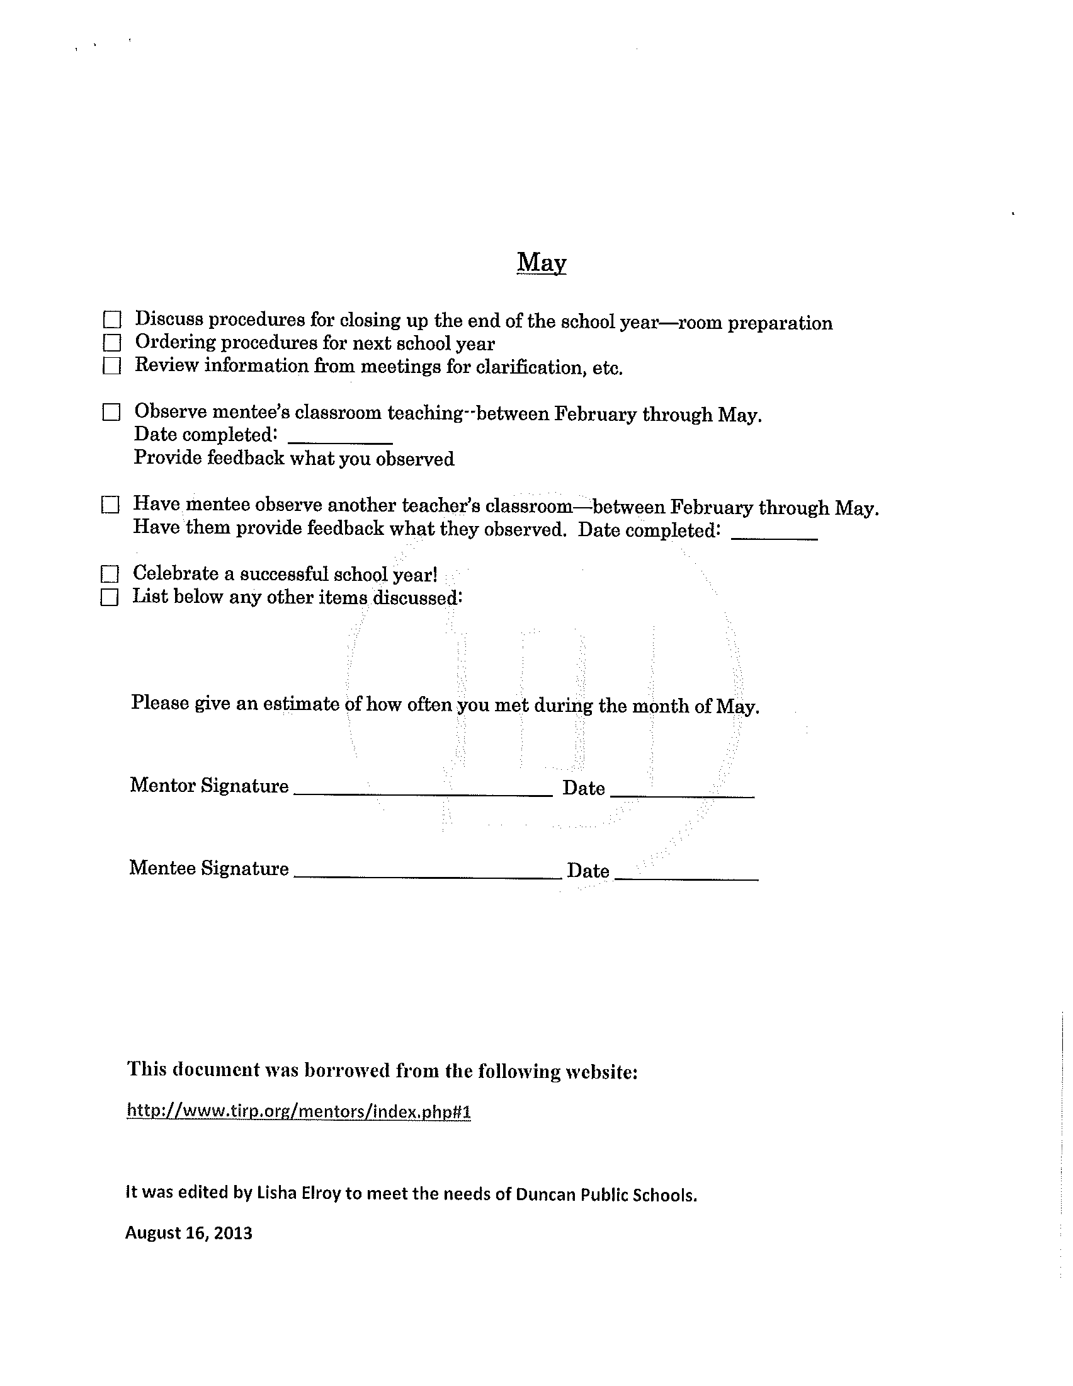

(adapted from Rochester Schools, original source appears to be Wyandanch Union Free School District, Wyandach, NY https://www.wyandanch.k12.ny.us/cms/lib/NY02212272/Centricity/Domain/88/Mentor_Checklist.pdf)

September Checklist for Teacher Mentors

Mentoring is a partnership created to help support new teachers by providing them with a veteran teacher to confidentially discuss topics and to provide guidance. Remember, we all faced our first days in our classroom with excitement, anxiety and feelings of being overwhelmed. Hopefully you had a wonderful mentor who provided the guidance which made those first few years more bearable. This will be your chance to pass your wisdom and experiences to help your mentee to discover the how wonderful it is to be a special educator.

September Topics

Show location of resources (class room supplies, copy machines, lab materials, and other teacher resources)

Share first day/week activities—provide guidance on organizing the first day & first week.

Established a scheduled time to meet with your mentee for the first semester.

Introduce your mentee to key teachers who work with her/his students, help establish how they will work together and how the gen ed teacher will get resources to the special ed teacher.

Introduce your mentee to other teachers, particularly staff members in their department and

close proximity to their room, gen ed teachers responsible for your mentee’s students, and related services professionals (i.e. SLPs, OT/PTs)

Make sure the technology including all necessary computer programs are working properly. Also make sure all equipment is in the classroom and in good working order.

Discuss and/or provide samples of classroom procedures, grading policies, attendance policies, and classroom set up.

Make sure your mentee understands the evacuation and take cover procedures.

Discuss staff norms such as dress code, lunch, and the social events which occur throughout the year (i.e. over the hump days, cook offs, and homecoming traditions.)

Show your mentee how to use any special ed software used by the district.

Help your mentee create a calendar to record all IEP dates for the year. Make sure they are aware of all related timelines (a chart could help).

Talk about strategies for supervising ed techs. Share resources as needed.

Help your mentee establish an organizational system for managing paperwork and keeping files.

October Checklist for Teacher Mentors

For new teachers, after the anticipation of the first couple of weeks subsides they often reach a phase of survival. The survival phase is often a product of information overload. In the first month or so of teaching there are so many firsts that they often don’t know if they are coming or going. During this month, your mentee will need some extra attention, so please take a moment to discuss the following topics and anything else that may be on your mentee’s mind.

October Topics

Check to make sure emergency lesson plans are in place. Encourage the teacher to have

enough material for 2-3 days just in case.

Discuss formal observation(s) or upcoming observations (especially if you are conducting

them).

Observe each others’ classroom teaching sometime between October through December

(one observation each)

Debrief department, grade level, team, and committee meetings. Answer questions about

unknown terms or unclear processes. Be prepared to explain the rationale for or history

behind comments/decisions.

Discuss how their classroom management & discipline plans are going. Encourage the teacher

to keep a list of changes they may want to make for the following semester.

Review grade how grades are reported & how grade reports will be distributed to parents

Discuss parent/teacher conferences including tips in how to conduct, handling parent issues,

support staff available and what to prepare.

Review upcoming IEP meetings and help your mentee make a timeline or calendar to meet

deadlines.

Work with your mentee on IEP DRAFT goals/objectives, model how to write these to be observable, measurable, and portable across environments.

Ask about instructional resources and strategies, help mentee find new resources, share what

you use when applicable.

Discuss your mentee’s action plan and goals; discuss how progress will be assessed toward each.

Show the teacher where to find opportunities for staff development or conferences.

November/December Checklist for Teacher Mentors

The months of November and December often bring about a lot of stress in a person’s professional and personal lives. Unfortunately for new teachers, this is compounded by the fact that the rose-colored glasses about their career choice start to fade, and they may be growing frustrated because everything did not work out as perfectly as they imagined. Your mentee may feel overwhelmed, mental and physical fatigue may be setting in, and they may question their ability as an educator. In addition to list below, take some time to share with your mentee times currently or from the past which did not work out as you had planned and some of the strategies you used to get past them. Please take a moment and point out all the wonderful ways your mentee has been successful.

November/December Topics

Talk about ed tech supervision and teacher collaboration, brainstorm strategies and problem-

solve as needed. Ask to see ed tech plans and schedules.

Discuss how busy both professionally and personally it is between Thanksgiving & Winter

Break and how to keep the students engaged & productive

Discuss parent communication status and strategies.

Share “tricks of the trade” to get through the upcoming weeks and preventing burn out.

Self-care strategies will be particularly welcome these two months.

Discuss concerns/successes for students.

Review how your mentee’s organizational strategies are working, offer suggestions as

needed. Talk about paperwork management and ways to keep up with it all!

Talk about the end of semester procedures

Review snow day procedures and how they will be notified

Discuss district and school holiday events and local happenings

Start discussing changes the teacher would like to make for 2nd semester

Make sure the teacher has all necessary materials for classes they teach second semester.

Check in about upcoming standardized testing and help your mentee start planning for any

accommodations or alternative strategies needed.

Celebrate!

January Checklist for Teacher Mentors

Winter break provides everyone a chance to step away from the day to day and to rejuvenate the spirit. This gives your mentee a chance to find new promise in the career path they chose. Your mentee will return with new hope, now that they have completed the first ½ of the school year. Often you will find that your new mentee has emerged from survival mode, has started looking more at long term teaching strategies, is becoming more focused on curriculum, and has a sense of being more organized. As they look to the start of the new semester, your mentee will start reflecting on their practices from the first semester and may make adjustments to classroom procedures.

January Topics

Discuss common assessment practices including testing procedures

and testing ethics.

Integrating IEP objective progress into grading, assessing progress

Discuss the highs and lows of the semester

Help them implement changes they would like to make for second semester

Take a look at their new schedule and verify they have all necessary materials and are

connected to any new teachers working with their students

Review their ed tech supervision plans and strategies, help them plan for any needed

Changes.

Discuss home communications & ideas to strengthen home/school connections—

postcards home, e-mail communications, newsletters, tips to parents, etc. Remember to acknowledge something a student is doing right or well, not just to correct behavior or

discuss a concern.

Discuss how to prepare students for upcoming exams.

Establish times for mentor/mentee meeting for second semester.

Identify any instructional strategy or resource needs.

Talk about student assessment and evaluation needs, check in with your mentee about data collection and interpretation.

February/March Checklist for Teacher Mentors

During the months of February and March, your mentee should start adjusting to the new semester and possibly the new faces in front of them. February often brings about a sense of exhaustion for both students and staff. The effects of the winter blahs start sinking in, and people are starting to look forward to spring. Check in with your mentee to make sure they are keeping what they are feeling right now in perspective. One way you can help them is to have them reflect on positive changes they made throughout the year. Focus on how much they have learned about being a special educator over their short time in this position. This should help them see the big picture instead of the puzzle pieces they are still trying to figure out.

February/March Topics

Review upcoming district and building activities

Schedule a time to observe mentee’s classroom teaching--between February and May.

Have your mentee observe another teacher’s classroom—between February and May.

Discuss upcoming parent teacher conferences, status with parent collaboration and communication, strategies for enhancing these.

Talk about preparing for winter break, what to expect from students just before and after

break and, how to manage behavior during these times.
Share some professional organizations or resources in your mentee’s areas of interest.

Look for potential workshops to help guide your mentee with areas they wish to pursue or

may want additional strategies or knowledge.

Review their progress collaborating with their gen ed peers and discuss any problems and possible strategies to address each.

Do something to acknowledge your mentee for something outstanding

they have done or something they worked hard to accomplish.

April Checklist for Teacher Mentors

April brings to the school new challenges for all new teachers. Students are shedding their heavy clothing, the winter blahs are starting subside, and spring fever starts to set in. Students are spending less time focused on what they can be doing in the classroom and more time thinking about the approaching summer or spring break. Keeping a student who has always been motivated and focused on the task at hand becomes a huge challenge even for the most seasoned veteran. Your mentee may face new frustrations and need to lean on you again at this midpoint in the semester

April Topics

Discuss their evaluations, ask them to talk about their progress to date, and review their successes.

Discuss your observations of your mentee’s classroom. Remember to keep feedback

constructive, highlight improvements and things they do well, and provide references to

people, websites, or other resources that will help them.

Discuss their visit to another teacher’s classroom. Inquire what they liked, what they thought might work well for them, and observations they made about how the teacher related to the students.

Review upcoming district and building events.

Make sure they are aware of ordering procedures for the upcoming year.

Discuss strategies for dealing with spring fever and senioritis.

Review their action and discuss their goals and if they felt they were on track to accomplish. Discuss ideas about their goals for next year.

Help your mentee start planning for the upcoming year- identifying needed resources,

procedures or practices that they would like to do differently next year.

Work with your mentee to plan for students’ upcoming transitions (i.e. to new schools,

programs, classes, and teachers).

May/June Checklist for Teacher Mentors

The end of the year is quickly approaching with still so much to do. Your mentee is probably feeling a great sense of relief and success. During this time take a moment to celebrate both your guidance as a mentor, and the growth your mentee has made. May and June are great times to reflect on what happened over the course of the year and build anticipation for a great year to come.

May/June Topics

District and building level activities including prom, honors convocation, graduation,

step-up days.

Prepare for school traditions for the end of the year.

Talk about ways to organize, store files and organize paperwork, and prepare for the end

of the school year.

If your mentee is teaching for the Extended School Year, talk about making the

transition to ESY and retooling activities for the summer.

Review any building or district check-out procedures.

Look at next year’s calendar.

Discuss any changes coming in the new school year and any necessary preparations. Share

ideas for closing up their teaching space in ways that make opening it back up easier.

Make sure you share summer contact information just in case.

Talk about preparing students for the end of the school year, especially those who have a

difficult time with transitions.

Discuss ways that your mentee can end the year on a positive note with parents of her/his students.

Celebrate the year!

