

College-wide Meeting Minutes
Friday, January 21, 2021, 1:00 p.m.
Zoom Meeting

Attendees: Penny Bishop, Heather Worster, Amy Cates, Eric P, Karen Keim, Sarah Flanagan, Tammy Mills, Shannan Fotter, Janet Fairman, Catherine Biddle, Maria Frankland, Josh Taylor, Chris Nightingale, Alicia Lacey, Julie D, Valarie Smith, Jared Beal, Kathie (?), Melissa Cuba, Mia Morrison, Vi Thai, Casey Kelly, Elizabeth Allen, Kathleen Gillon, Lauren Jacobs, Steve Allen, Betsy Webb, Beth Hufnagel, Deb Rooks-Ellis, Debra Hogate, Sandra Caron, Dominick Varney, Ian Cameron, Leah Hakkola, Michelle Gumbs, Faith, Dee Nichols, Susan BA, Sid Mitchell, Shihfen Tu, Richard Ackerman, Patricia Lech, Mila Morrison, Rebecca Buchanan, Bob Lehnhard, Bryan Silverman, Diane Jackson

Meeting Minutes from last meeting – Approved, no discussion

Dawnland Micro-credentials
Marsh Island & territorial issues are ongoing. Remind us to think about how we live and work on these lands.

College Committee Updates
- Graduate Affairs Jim Artesani
  - Graduate Affairs – have not met yet, Feb 18th first meeting
- Accreditation Jim Artesani
  - Accreditation met this am – tried to identify alternatives to PRAXIS, also spoke about annual data review and report writing process
- Faculty Advisory Council Tim Reagan
  - Have not met yet this semester, continue to work P&T Documents
  - Public Hearing on at 9:30 this Tuesday
- Faculty Senate Dee Nichols
  - Have not met yet this semester, academic affairs meeting looking at how students start and change majors, COEHD looks pretty good, revisit electronic student evaluations
- Curriculum Committee Report Rebecca Buchanan
  - 11 New Course Proposals
  - 9 Course Modifications
Celebration Shout-outs!
Casey - thank you for weekly announcements!
National Science foundation (Ask penny)
Mia Morrison - Defended dissertation successfully!

Diversity and Difference Committee's Strategic Planning Dialogues
Cat Biddle & Leah Hakkola

Equity Mindedness - What does this mean?
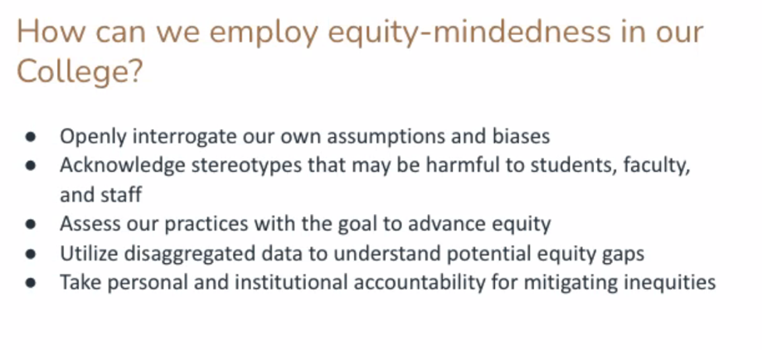
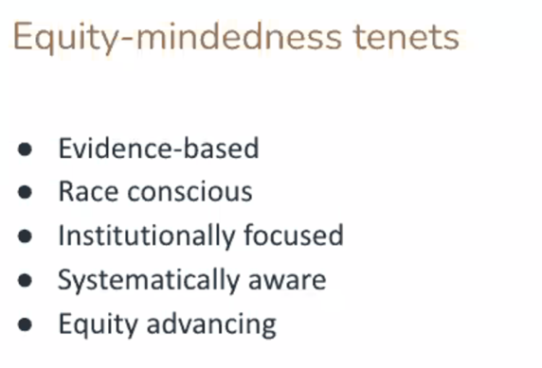
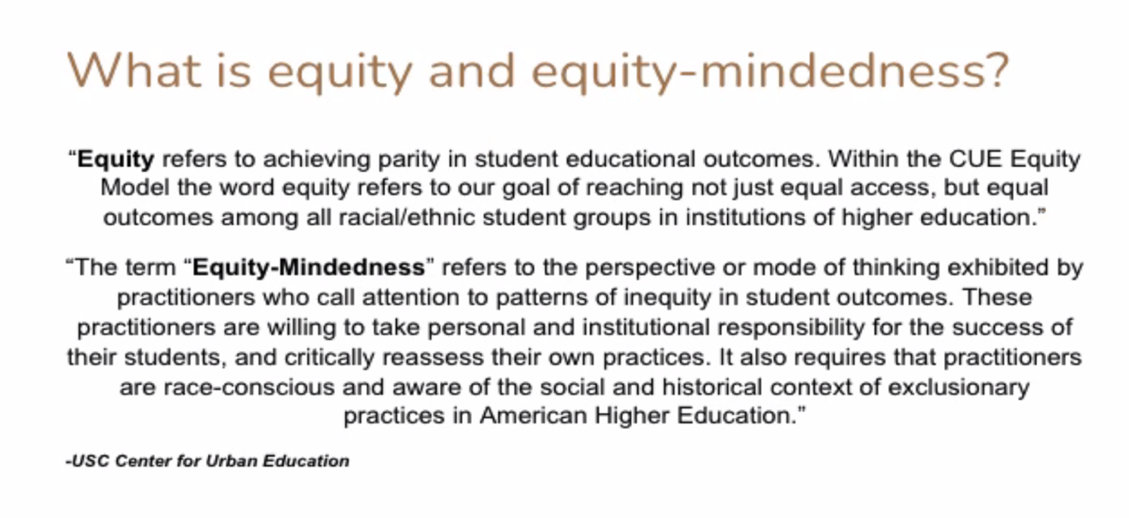

Outcomes of breakout rooms
Gain deeper understanding of how we are engaging in this already
Acquire direction and guidance to aid this committee in forming a college wide __ strategic plan
How can we become the leaders in this area?

Notes coming back from breakout rooms to be reviewed by the committee and brought back to us with more notes feedback

Last thoughts by Penny
- Thank you
- I am available
- Best wishes for the weekend and semester!

