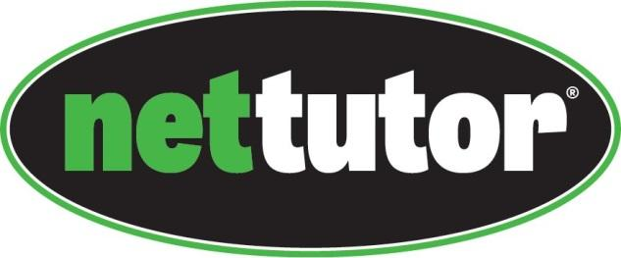

To access free online tutoring support from NetTutor, first sign in to the Portal. Then select Bb from the LaunchPad to access Blackboard.
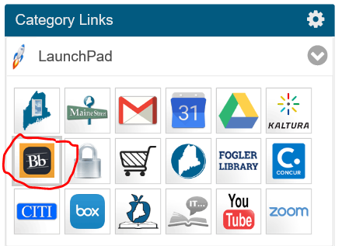
On the right hand side, find My Courses
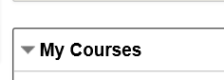
Select NetTutor for Early College, which will have the campus listed in parenthesis.
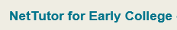

Select NetTutor
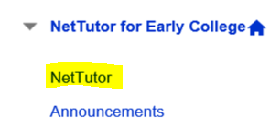
Click on the link for online tutoring:

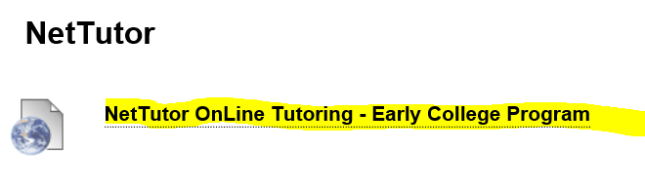
You will need to read and accept the terms and conditions.
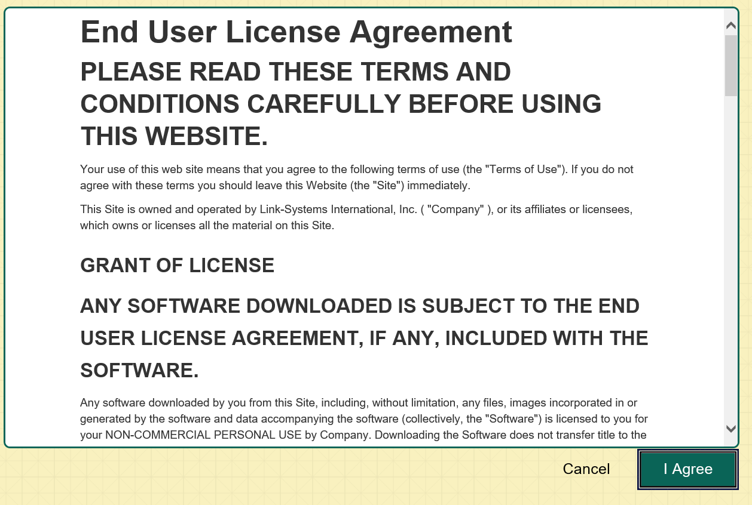

To watch a video of how to use NetTutor, click here:
https://www.youtube.com/watch?v=Vq6J84Sv2ro

Choose the content area for which you need help.

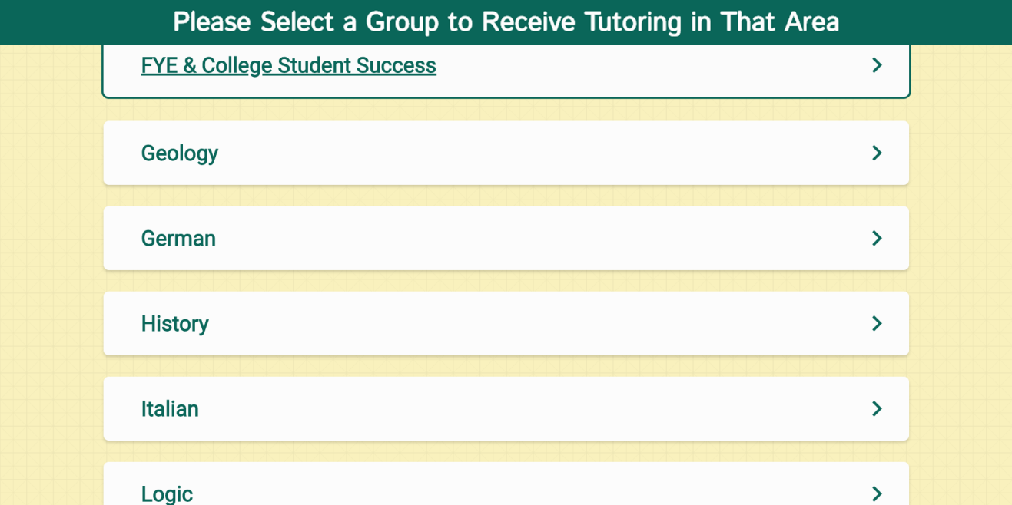

The NetTutor dashboard provides 3 support resources, as well as a locker.

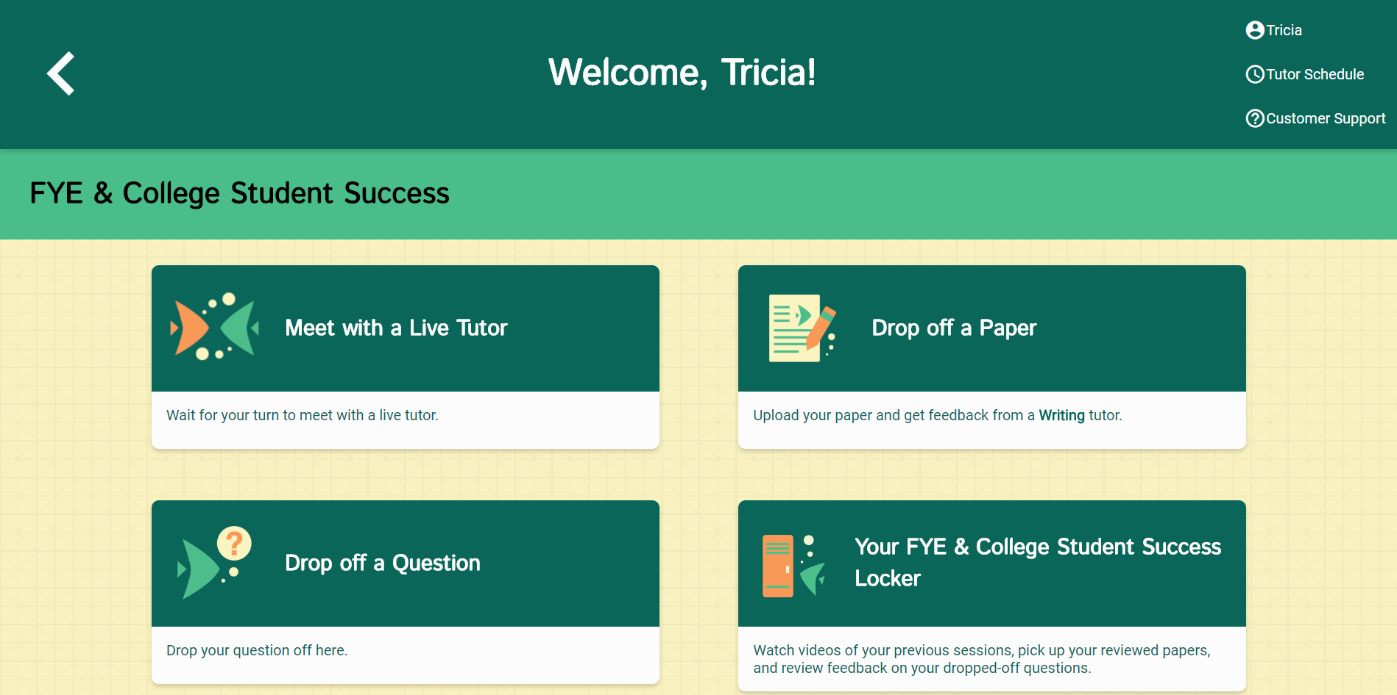

The NetTutor Dashboard
Meet with a Live Tutor: 3
Drop off a Paper: 3
Drop off a Question: 5
The Locker: 6

Meet with a Live Tutor:
Directs you to an information page where a tutor will be available soon.

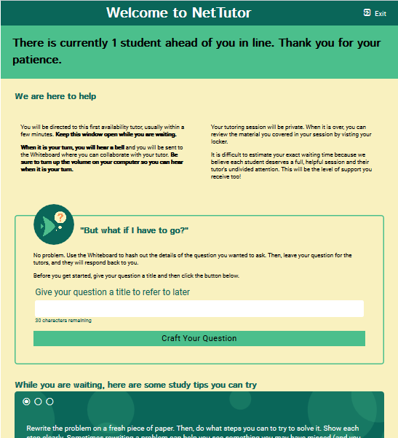

Drop off a Paper:
(Note UMA students will use the UMA Writing Center, so you will not see this feature)
Directs you through three prompt to drop off your paper.

First, name your paper and describe the assignment.

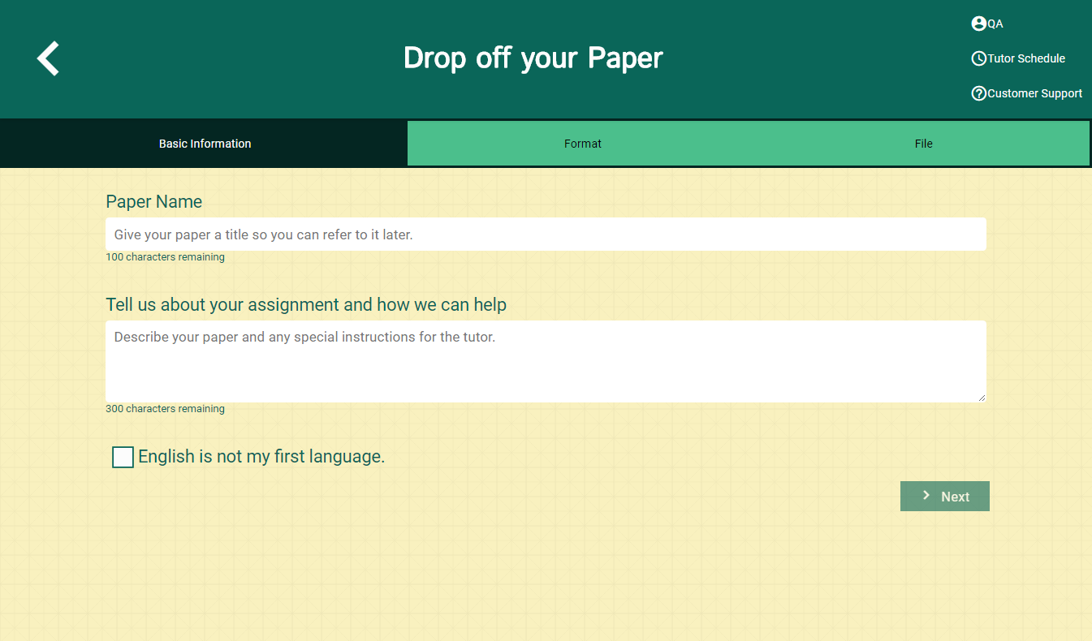

Second, tell the tutor what you need help with.

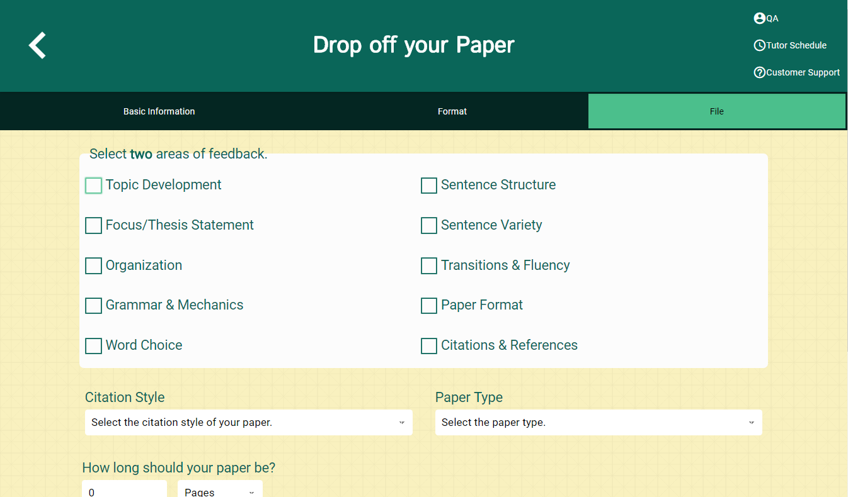

Third, upload your paper. Papers have a turnaround time of 48-72 hours.

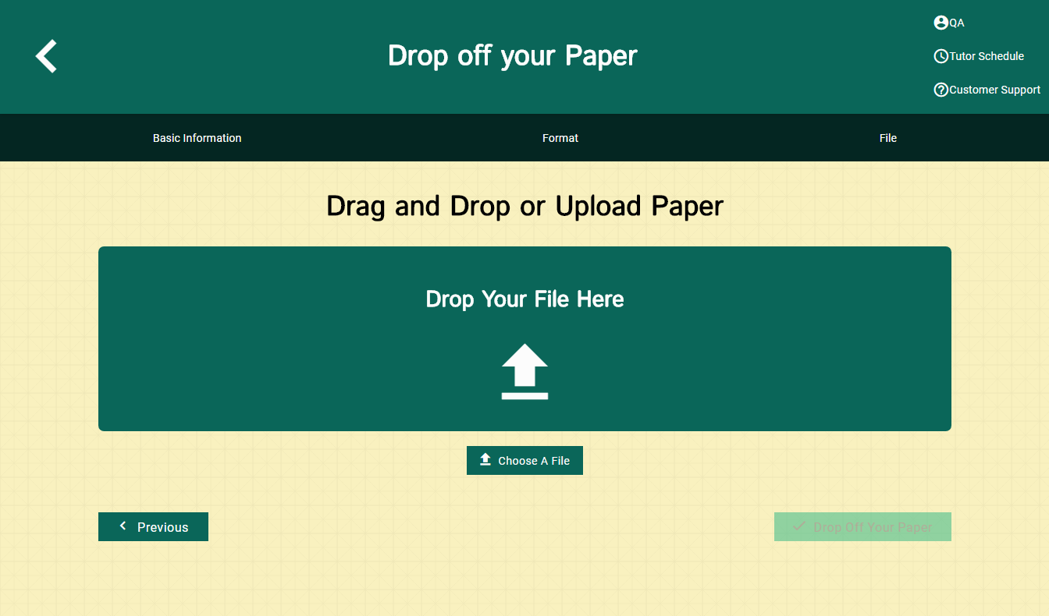

Drop off a Question:
Directs you through two prompt to drop off your paper

First, name your question.

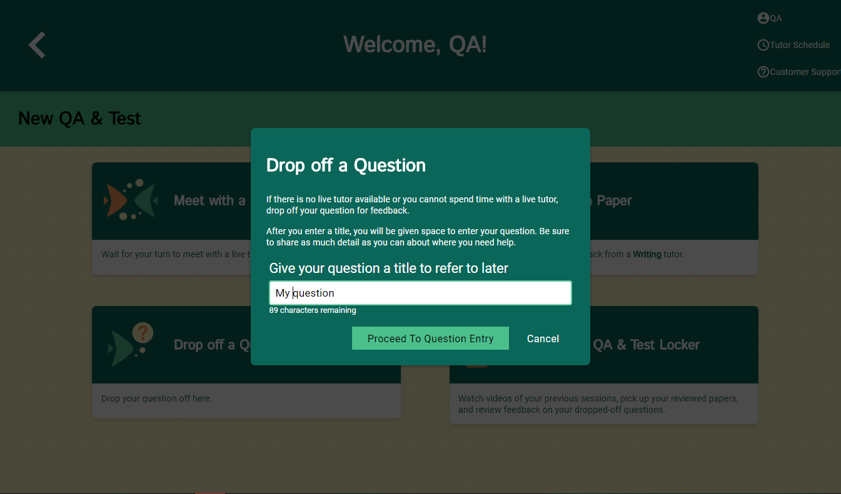

Second, use the white board to ask your question. Once you have finished your question, click the “Submit” button in the lower left-hand corner.
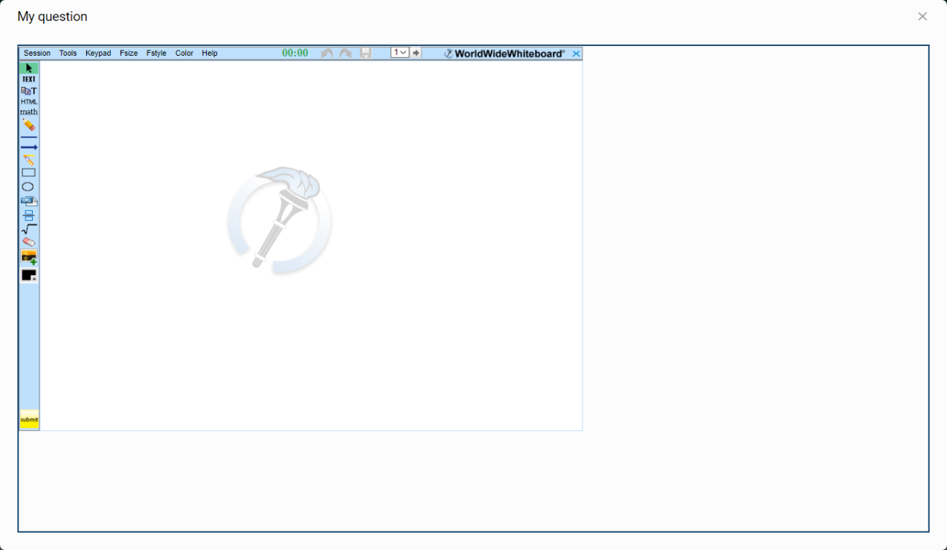

The Locker:
Your locker stores all your NetTutor sessions. You can review your live tutoring sessions, retrieve papers you have submitted for feedback, or gather responses to your submitted questions.

