Imposter Syndrome
Facilitated by Lexie Brown, Doctoral Intern

What is Imposter Syndrome?
Imposter syndrome is the experience of feeling like you’re not as competent as others perceive you to be. Someone who is experiencing imposter syndrome might think they are a phony or a fraud.

Who Struggles with Imposter Syndrome?
Anyone can struggle with imposter syndrome! Imposter syndrome can affect anyone, regardless of social status, work background, skill level, or degree of expertise.

Many very successful people have struggled with imposter syndrome. Some examples include David Bowie, Serena Williams, Lady Gaga, Tom Hanks, Michelle Obama, Maya Angelou, and many more!

How can Imposter Syndrome Impact Us?
- We beat ourselves up in the face of a perceived failure
- We might pass on opportunities because we feel inadequate
- We devalue our worth
- We undermine our experience or expertise
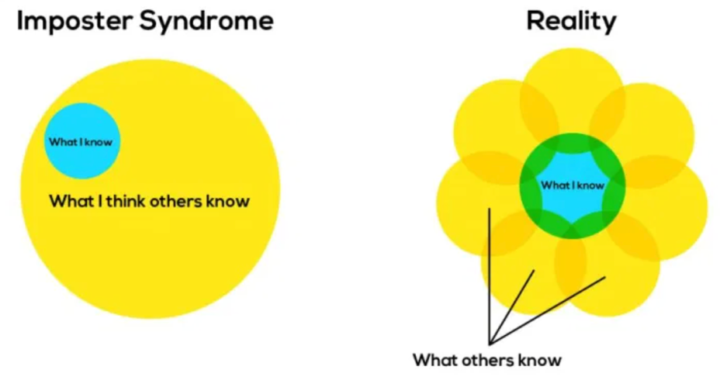

How to Overcome Imposter Syndrome:
- Focus on your value and let go of trying to obtain perfection
- Be kind to yourself!
- Make a list of 10 things that show you are just as qualified as others in your position
- Own your successes
- Cease comparisons
- Being wrong or failing at something does not make you an impostor
- Journal, stream-of-conscious writing
- Recognize that nobody knows what they’re doing all the time
- Acknowledge we’re all just trying our best!
- Realize that you are constantly growing and changing
- Seek support from friends/family

Resources:

Andrea Pereira- Former Counseling Center GA

Bennett, J. (N.D.). How to Overcome Imposter Syndrome. Retrieved from https://www.nytimes.com/guides/working-womans-handbook/overcome-impostor-syndrome
What is Imposter Syndrome? (2020). Verywell Mind. Retrieved February 22nd, 2021 from https://www.verywellmind.com/imposter-syndrome-and-social-anxiety-disorder-4156469#:~:text=Impostor%20syndrome%20(IS)%20refers%20to,perfectionism%20and%20the%20social%20context.
Warrell, M. (2014). Afraid of being ‘found out’? How to overcome Impostor Syndrome. Retrieved from https://www.forbes.com/sites/margiewarrell/2014/04/03/impostor-syndrome/#4af6564848a9

