University of Maine Counseling Center
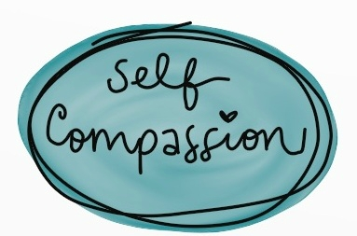

What is it?

- Treating yourself with the same level of empathy and kindness you would show a close friend.
- Recognizing how you are feeling.
- Being non-judgmental about how you are feeling
- Being understanding and patient with yourself.

“Instead of mercilessly judging and criticizing yourself for various inadequacies or shortcomings, self-compassion means you are kind and understanding when confronted with personal failings – after all, who ever said you were supposed to be perfect?” -Dr Kristin Neff

Three Elements of Self-Compassion

- Self-kindness vs. Self-judgement:
“Self-compassionate people recognize that being imperfect, failing, and experiencing life difficulties is inevitable, so they tend to be gentle with themselves when confronted with painful experiences rather than getting angry when life falls short of set ideals…”
- Common humanity vs. Isolation:
Self-compassion involves recognizing that suffering and personal inadequacy is part of the shared human experience – something that we all go through rather than being something that happens to “me” alone…
- Mindfulness vs. Over-Identification:
“Mindfulness is a non-judgmental, receptive mind state in which one observes thoughts and feelings as they are, without trying to suppress or deny them. We cannot ignore our pain and feel compassion for it at the same time. At the same time, mindfulness requires that we not be ‘over-identified’ with thoughts and feelings, so that we are caught up and swept away by negative reactivity.” – Dr. Neff

Why is it hard?

- We tend to be very hard on ourselves.
- We often hold ourselves to unreasonable standards.
- We can judge ourselves when we are struggling.
- Other contributing factors: pressure from family and others to do well, the weight of helping a friend through a hard time, the desire to appear strong and unwavering during tough situations.

What Self-Compassion Is Not What Self-Compassion Actually is

- Self-compassion is not self-pity | - Self-compassion allows you to feel connected with others and self through a shared sense of experience
- Self-compassion is not self indulgence | - Self-compassion promotes long term healthy habits
- Self-compassion is not self-esteem | - “Self-compassion is not based on self-evaluations. People feel compassion for themselves because all human beings deserve compassion and understanding, not because they possess some particular set of traits (pretty, smart, talented, and so on). This means that with self-compassion, you don’t have to feel better than others to feel good about yourself.” –Dr. Neff

How can you practice it?

- Self-compassion = goodwill / not good feelings
- Do not supress your pain
- Do not fight your pain
- Accept that the moment is painful
- Embrace yourself with genuine, healthy care
- Allow yourself to be imperfect

Everytime you find yourself thinking something negative about yourself – imagine your friend, or a small child, saying that about themselves.

Resources / Where to Learn More:

- www.selfcompassion.org – A website where you can read more on self-compassion, practice guided meditations, and take a quiz to test you current level of self-compassion!
- www.psychologytoday.com/blog/nurturing-self-compassion/201703/how-cultivat-more-self-compassion - An article written by Allison Abrams, LCSW-R, who specializes in depression, self-worth, women’s health, and relationships.
- www.youtube.com/watch?v=teVE3VGrBhM – A Ted Talk by Abria Joseph discussing our tendencies to self-judge and how to be more aware of this cycle to change it.

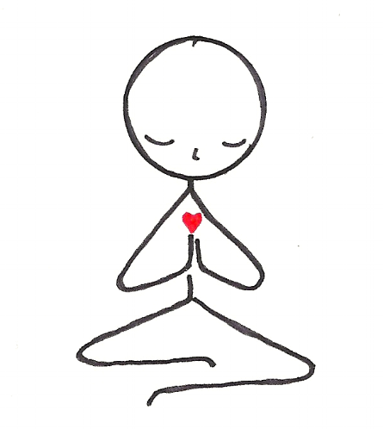

Want to Talk More?
Call us to schedule an appointment!
UMaine Counseling Center
207-581-1392
Mon-Fri: 9 AM-12 PM and 1 PM-4 PM

