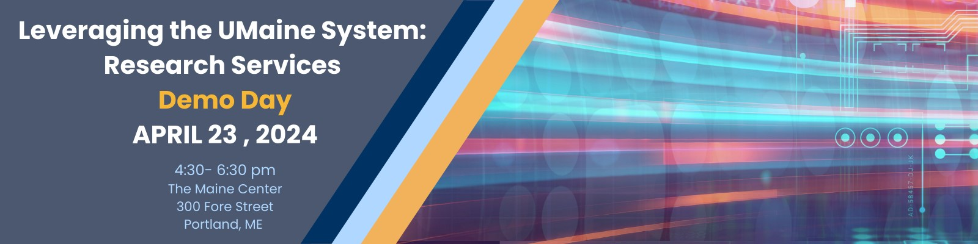
Join us for an evening to explore the vast array of research services offered by the University of Maine System.
Through interactive displays and demonstrations, experts from the University of Maine, the University of Southern Maine, and Maine Law will showcase how their services can help unlock the full potential of your enterprise.
Discover unparalleled access to cutting-edge research equipment and an extensive range of services tailored to meet your needs, from biological applications to logistics support.
Benefit from our high-performance research tools and services. Whether you require high-resolution imaging in our electron microscopy lab, 3-D printing at our IMRC Center, we have you covered.
Leverage high-performance computing, AI, data storage, and visualization. Or find out what's swimming in the water at our Environmental DNA Lab.
Our expertise extends to our library services for patent and trademark applications, business plan development, legal, and market research.
Don't miss this opportunity! Light refreshments will be served for your enjoyment.

REGISTER FOR FREE HERE!
