INT601 Instructions for Completing
Human Subjects Research and Conflict of Interest Training
and Submitting Completion Report to Instructor for Credit

- Establish a Collaborative Institutional Training Initiative (CITI) CITI Account

  - Go to www.citiprogram.org and click on the ‘Register’ button located in the upper right hand corner of the homepage.

  - In Step 1 search for ‘University of Maine System’ in the section titled ‘Select your Organizational Affiliation’ and agree to the CITI Terms of Service.
      - Proceed through Steps 2-6 to create a username, password and personal profile. NOTE: When asked which course you plan to take, please choose “Other.”

- Enroll in CITI Courses

  - New Users (if by chance you already have a CITI account, follow instructions at the end for returning users* – do not create a new account if you have one already!).

    - Step 7 of the registration process asks you to select a desired curriculum. The two courses you are required to take for INT601 are: human subjects research and conflicts of interest.

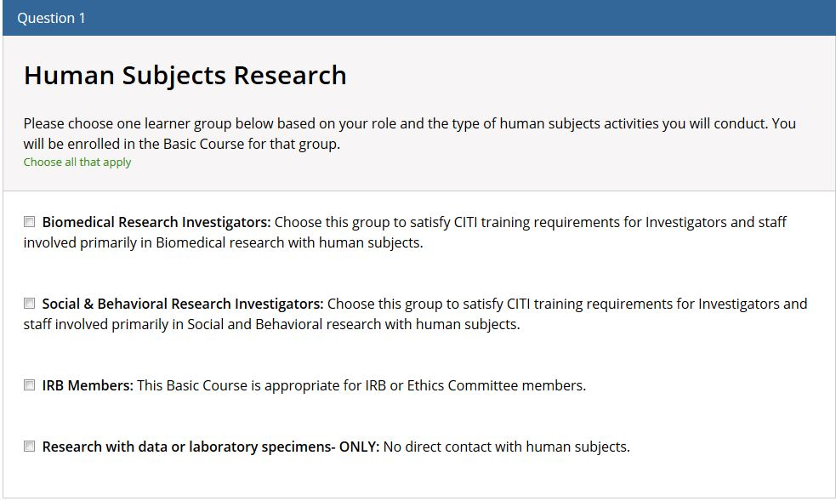
      - Question 1 – Human Subjects Research – choose EITHER OF THE FIRST TWO – Biomedical Research Investigators OR Social & Behavioral Research Investigators.

      - Question 5 – Conflicts of Interest: Check the 2nd box ‘Conflicts of Interest (All OTHER University of Maine System Campuses)’.
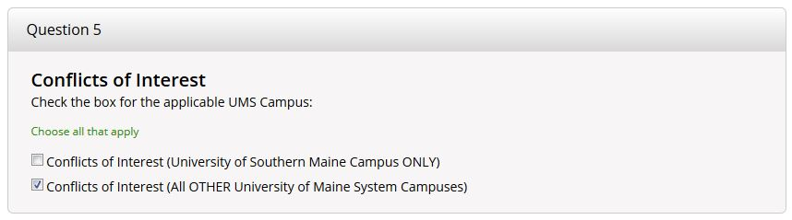
    - When done, click ‘Complete Registration’, then on the next screen select ‘Finalize Registration’ to complete your registration and enrollment.

    - Click on the course name to begin. Note:
a) For Conflict of Interest, you must complete the three modules that are required (and they are listed under a heading “required modules.”
b) For Human Subjects, you must complete the six required modules PLUS one elective module.

    - For each course, you will need to click on the ‘Complete the Integrity Assurance Statement’ link. Once you have agreed, you will be directed back to the course ‘Modules List’.

III. Download Completion Report to Submit for Credit:

A. Click on Main Menu/My Courses. Your courses are listed with status. It will state “Passed” with a date. If it doesn’t, you either haven’t finished (will state “Incomplete,” or you failed (will state “Not Passed”). (See image below.) Click on the “view-print-share” for the course you completed/passed. There is a link to the completion report – you can copy the link into an email or download the report and email. Send link or downloaded report to:
Instructor email:

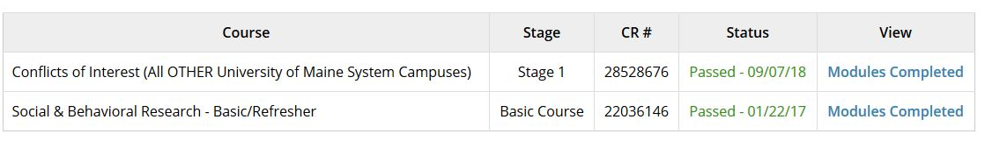

*Returning Users – Follow if you already have a CITI account
    - After logging in to CITI, you will land on the ‘Main Menu’ page. Click on ‘University of Maine System Courses’ to expand the menu.
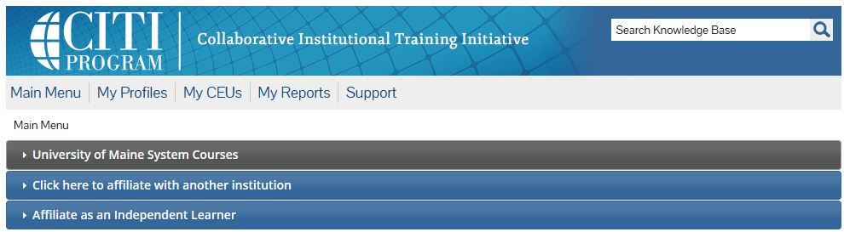

    - Under ‘My Learner Tools for University of Maine System,’ choose, ‘Add a Course.’ Follow the instructions for New Users above (II.A.) to enroll in and complete courses.

