Exercise 5A – Digital Elevation Models

Introduction:
Before beginning this exercise, download and read: 1 Stereoscopy and 3-D measurement There are a number of methods ... from www.edc.uri.edu/nrs/classes/nrs415/Lectures/415WK302052009.pdf to see how elevation data can be obtained from aerial images

The data for Part A of this exercise was obtained from: https://www.ngdc.noaa.gov/dem/squareCellGrid/download/592. This is an ASCII file containing elevation data covering over 100 miles of the Maine coastline, including Acadia National Park. The file is too large to be opened in MS Word, but it does open in Excel. You will use this file to create a digital elevation model (DEM).

In this Part B you will use a digital elevation model (DEM) and a triangulated irregular network (TIN) to analyze the area in and around Attean Lake, Maine. You will then view the TIN in ArcScene.

Procedures:
Part A:
- Start Excel and open the file: bar_harbor_me_mhw.asc.
- The following “wizard” will appear:
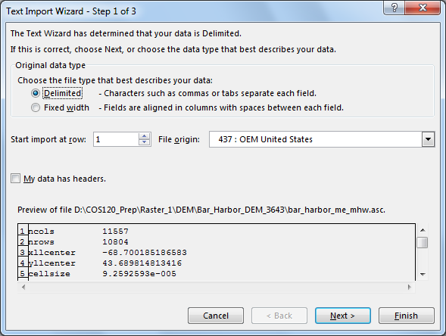

- Click Next.
- In the next screen put a checkmark next to Space, as it is a “Space Delimited” file.
- Click Next, then on the final screen click Finish. This will take a while to load.
- Look at the first few rows:
  - Row 1 and 2 tell us the number of rows and columns in the file.
  - Rows 3 and 4 give us the coordinates of the lower left hand corner. These are geographic coordinates, WGS84 datum.
  - Row 5 gives us the size of each cell in scientific notation.
  - The above information, can be used to calculate the coordinates of the lower left hand corner of any cell in the grid.

  - Row 6 is the value used for missing data.
  - The remainder of the file gives floating point elevations in meters.
  - Close Excel. We will now convert this file into a digital elevation model (DEM).
- Open ArcMap, to a blank map.
- Select Customize > Extensions from the Menu Bar, and place a check mark next to the 3D Analyst and Spatial Analyst Extensions. Then close the dialog box.

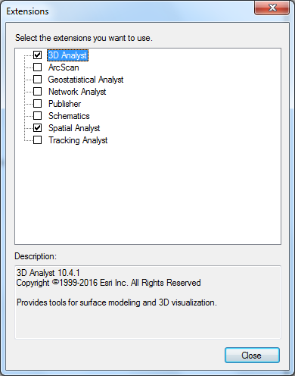

- Click on the Toolbox icon.
  - Expand Conversion Tools
  - Select To Raster > ASCII to Raster.
- Fill in the dialog box:
  - The Input file is the bar_harbor_me_mhw.asc.
  - Save the output in your Ex_05A folder as Acadia_DEM.
  - Change the output data type from Integer to Float.
  - Click OK. Again this will take a while, and you can see that ArcGIS is processing the information as ASCII to Raster will scroll across the lower right corner of the screen. If all goes well, when it has completed, a blue box will appear with a green checkmark, and the DEM will appear.
  - At this point, your DEM will not provide you with much information, you will see from the Table of Contents that the lighter values are the higher elevations and the darker ones the lower elevations.
- The first thing we want to do to our DEM is to define the projection.
  - In Arc Toolbox expand Data Management Tools.
  - Select Projections and Transformations > Define Projection.
  - Click on the icon to open the Spatial Reference Properties dialog box.
    - Select Geographic Coordinate Systems.
    - World
    - WGS84
  - Click Ok, and OK again to close both dialog boxes.
- Since most data for the State of Maine is in UTM zone 19N, NAD83, we will want to project the DEM so that we can combine it with other data. Another advantage of changing the projection is that the UTM coordinate system is in meters rather than decimal degrees, so that both our linear and vertical units are the same.
  - Again open ArcToolbox to Data Management Tools > Projections and Transformations.
  - Select Raster > Project Raster.
    - The input raster is Acadia _DEM
    - The input coordinate system should be automatically filled in as GCS_WGS_84.
    - Save it in you Ex_05A folder as Acadia_DEM_UTM.
    - Open the Spatial Reference Properties Box and select: Projected Coordinate System > UTM > NAD 1983 > Zone 19N.
    - For the Geographic Transformation select: WGS 1984 (ITRF00) to NAD 1983
    - Click OK
- Zoom in to a light grey area until you can see individual pixels, use the Identify tool to see what information is displayed. The pixel value is the elevation of that pixel, and is the value obtained from the table.

The resolution of this file is 1/3 arc second and does not provide a lot of detail. For the next part of this exercise you will use a 10 meter resolution DEM of the China Lake region.

Part B:
1. Start ArcCatalog.
2. Create a new personal geodatabase named Attean.
3. Import the AtteanDEM, and depth.shp into your geodatabase, keeping the names without the extensions.
4. Close ArcCatalog

5. From the ArcMap File menu select New to start a new project.
6. From the Customize menu, select Extensions and verify that there is a check mark next to 3D Analyst and Spatial Analyst.
7. From the Customize menu, select Toolbars, and add the 3D Analyst Toolbar to your project.
8. Save your project.

- Add AtteanDEM , and depth to your project.

10. Examine the DEM. There appears to be very little detail.
a. Right-click on Attean DEM in the Table of Contents (TOC) and select Properties.
b. Click on the Symbology Tab.
c. In the dialog box where it says Stretch Type, change “Standard Deviation” to “Histogram Equalize” and click OK.
d. Click “Yes” to the question about the histogram.

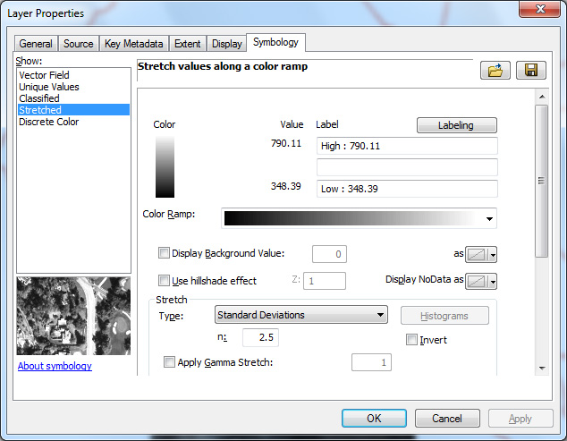

The dark areas are bodies of water (Big Wood Lake at the top and Attean Pond in the bottom of the DEM), and the white areas are mountains.

- Use the identify tool to determine the elevation of Attean Pond

12. Open ArcToolbox > 3D Analyst Tools > Raster Surface Hillshade.
a. The Input Raster is your DEM
b. Save the output in your geodatabase.
c. Check Model Shadows.
d. Click OK.
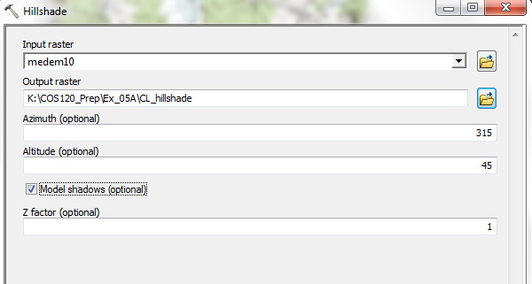

- When the hillshade is completed, go to the Add Data icon drop down arrow and select add Basemap and select USA Topo Map, and drag it above the hillshade.

14. From the Menu bar, select Customize > Toolbars > Effects.
15. Click on the Adjust Transparency button and adjust the transparency to about 45%.

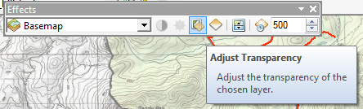

16. Zoom in to the narrow region of the lake that lies between two mountains. It should have a “3D-like “ appearance. If you don’t see it, try zooming out until you do.

17. Remove the Basemap from your project and “uncheck” the hillshade in your TOC.
18. Zoom to full extent.

19. Again open ArcToolbox and select 3D Analyst Tools > Conversion > From Raster > Raster to TIN.
a. The Input raster is the AtteanDEM.
b. The output TIN is atteanTIN and it should be saved in your geodatabase.
c. Change the number of points to 6500000.
d. Click OK.

Next we will edit the TIN to add the lake depth to it.

20. From ArcToolbox, select 3D Analyst Tools > select Data Managament > TIN > Edit TIN.
a. The input TIN is atteanTIN.
b. The input feature class is depth.
c. Set the Height Field and the Tag Field to DepthM (depth in meters).
d. Click OK.
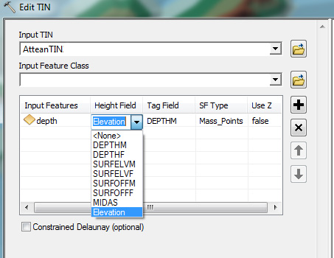

21. Uncheck the AtteanDEM and depth in the TOC. It will appear as if there is a hole in your TIN.

22. Right-Click on AtteanTIN in the TOC.
a. Select Properties > Symbology.
b. Uncheck Edge Types, and select Elevation.
c. Click on the Classify button in the upper right.
d. Set the lowest break value to the elevation of the pond.

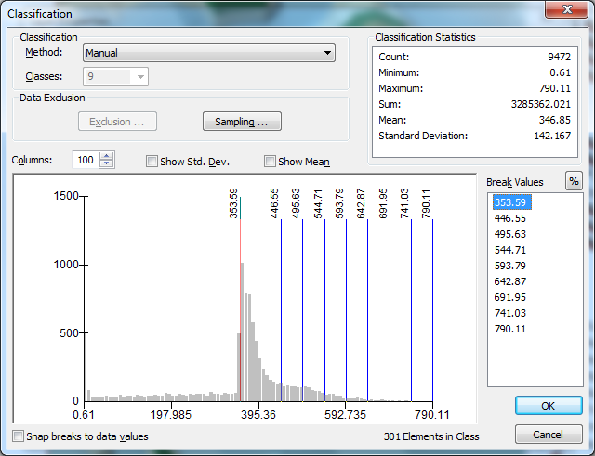

23. Click OK, to return to the Properties dialog box, and change the color of the lowest elevation to lake blue, and the next one up to a green. Click OK to close the properties dialog box.
24. If you are unhappy with the appearance, you can adjust the break values and colors to make the TIN more attractive. If you want to return to the original, simply remove it from the TOC and re-add it.

25. Save your project.

26. From the Start menu, open ArcScene to a blank scene.
27. Add your AtteanTIN.
28. Right-click on the TIN in the TOC and select Properties, and select the Base Heights Tab.
29. Type “4” in the box labeled Custom.
30. Select the Symbology Tab and recreate the symbology you liked in ArcMap, then click OK.
31. Use the navigational tools to explore the scene.

