ACADEMIC INTEGRITY FACILITATION GUIDE
Instructions for Faculty

The Report Form on the following page will assist faculty members in resolving or referring students suspected of academic integrity violations. Only the faculty member overseeing the academic exercise in question may refer a case to OCSRR using this form. For a detailed description of how to confront and report violations of the Academic Integrity Policy, please visit The Managing Academic Integrity page.

REPORTING PROCESS
Prior to submitting a report, you are encouraged to review the applicable section(s) of the UMS Student Conduct Code and the UMS Academic Integrity Policy.

Academic Integrity violations are listed on pp. 8; hearing procedures are located on pp. 17-26. You are strongly encouraged to consult with OCSRR regarding the applicability of the Student Conduct Code, potential courses of action, and guidance on imposing appropriate sanctions (please note: graduate students are normally reviewed for suspension or dismissal, even for a first academic integrity violation). A staff member in OCSRR can be reached by calling (207) 581-1409.

You should submit a referral to OCSRR within ten (10) business days of the alleged violation’s discovery. Submitting written referrals is essential to the University’s ability to address patterns of academic dishonesty, and to developmentally determine appropriate sanctions based on the totality of the student’s record.

RESOLUTION OPTIONS
You are encouraged to meet with the student prior to submitting a referral in order to discuss the allegation and/or seek a voluntary resolution. If you meet with the student and the student denies the allegation, or you believe the severity of the alleged violation warrants a response greater than a grade sanction, you should refer the matter directly to OCSRR for a hearing.

If you meet with the student, the student acknowledges the violation, and you are satisfied that the incident can be effectively resolved with a grade sanction, you should ask the student to sign the Report Form on the following page (or email you from their UMaine-supplied student email account) to indicate the student’s acceptance of your proposed resolution. You should then submit a complete referral to OCSRR.

WHAT TO INCLUDE IN YOUR REFERRAL
Please include the following materials (when available/appropriate):
- A description of the information giving rise to the allegation
- The names of any witnesses
- A copy of the course syllabus
- The student’s accumulated grade for the course (notwithstanding the academic exercise in question)
- The grade sanction you intend to impose if the student is found responsible
- Copies of any relevant communications between you and the student regarding the incident
- Copies of written assignment instructions (if not contained in the syllabus), or a summary of any oral instructions you provided related to the academic exercise in question;
- Copies of assignments or exams (when relevant to cheating, though please note the student may have full access to these assignments/exams and any answer keys provided);
- In cases of plagiarism, faculty should provide a copy of the student’s paper and the source text(s) from which the faculty member suspects the student has plagiarized. The student paper should have suspicious passages highlighted and numbered to correspond to highlighted and numbered passages in the source text(s). These copies will help identify passages and sources of concern.

If you submit a referral online in lieu of hand delivery or campus mail, you should retain the original documents.

ASSIGNING A GRADE OF “I” WHILE A CASE IS PENDING
No grade sanction should be assigned by the faculty member until the referral is finally resolved, including the process of considering the student’s appeal, if any. Should the referral not be resolved prior to the end of the semester, a grade of “I” should be assigned. You should allow the student to remain enrolled in your course and grade all other assignments as you normally would. You will receive written notification of the final outcome of the case so that you may assign the appropriate grade for the semester.

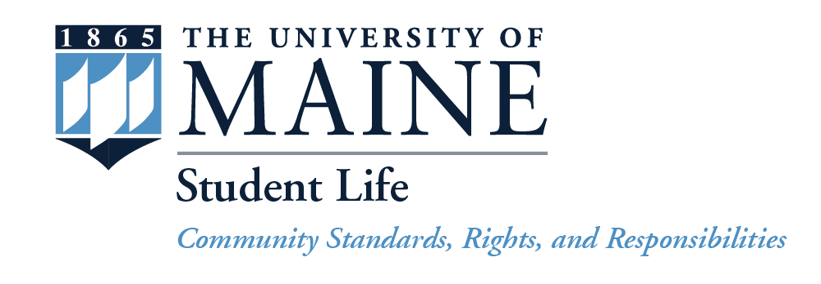
ACADEMIC INTEGRITY FACILITATION GUIDE
Office of Community Standards, Rights and Responsibilities
315 Memorial Union ● Orono, ME 04469 ● Telephone: (207) 581-1409 ● Fax: (207) 581-4215

Name of Student: Student ID:

Date of Alleged Violation: Report Date:

Faculty Member: 5-digit CRN:

Faculty Email Address: Faculty Phone:

Witness (if any): SUBJ & Level:

ACADEMIC INTEGRITY VIOLATIONS (University of Maine System, Student Conduct Code, Section III)

1. Cheating: The act or attempted act of deception by which a student seeks to misrepresent that he/she has mastered information on an academic exercise that he/she has not mastered.
2. Fabrication: The use of invented information or the falsification of research or other findings in an academic exercise.
3. Plagiarism: The submission of another's work as one's own, without adequate attribution.
4. Facilitating Academic Misconduct: Assisting in another person’s academic misconduct.

REFERRAL MATERIALS Please attach a written description of the incident as well as all supporting materials.

RESOLUTION OPTION Select option A or B, complete the relevant section, and obtain signature(s).

A. ☐ I am directly referring this case to the Office of Community Standards, Rights and Responsibilities.

Faculty Signature: Date:

The student ☐has / ☐has not seen this referral and ☐is / ☐is not aware of this allegation.

B. ☐ The student and I have agreed to the following sanctions (check all that apply):

☐ “F” on assignment/exam ☐Reduced Grade on Assignment:

☐ “F” in course ☐Reduced Grade in Course:

☐Rewrite plagiarized passages & resubmit by: ☐Academic Integrity Module by:

☐Other

In addition to the above-noted sanction(s), this student record will be placed on file and will not be addressed through the Student Conduct Code but maintained for “information purposes only”. The student may also be required to attend a meeting with a staff member in the Office of Community Standards to review the standards of behavior related to Academic Integrity. If the student is currently on disciplinary probation, or if the student has previously acknowledged an academic integrity violation, a hearing may be instituted to determine if additional sanctions are appropriate.

Faculty Signature: Date:

Student Signature: Date:

This referral form, and any supplemental materials which contain personally identifiable information, may be reviewed by the above-named student in compliance with the Family Educational Rights and Privacy Act of 1974.

