This is a coordinated effort between northern Maine landowners/managers, Maine Forest Service, US Forest Service, and the Cooperative Forestry Research Unit (CFRU). Sample locations on property you own or manage are based on previous year’s locations; if sites are to be moved or added please contact [Angela Mech](mailto:angela.mech@maine.edu) to help maintain orderly records. Having accurate GPS locations of where the L2 samples are collected is extremely important. Sampling may begin immediately and should be completed by November 30th for timely results. A USFS/CFRU-funded project will cover the cost of the existing 350-site monitoring program. CFRU members wishing to process additional sites may do so at a cost of $35 per site. Additional sites can be purchased through the Spruce Budworm Store [here](https://secure.touchnet.com/C22921_ustores/web/store_main.jsp?STOREID=199&SINGLESTORE=true). Contact [sprucebudworm@maine.edu](mailto:sprucebudworm@maine.edu) for any questions about processing additional samples.

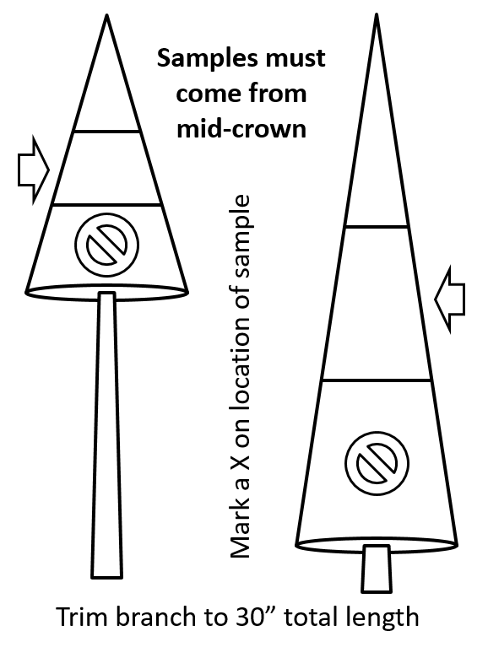

Directions: At each L2 sampling location, sample one branch from each of three dominant or co-dominant balsam fir or spruce trees within a roughly 30-foot radius. The sample branches should not overlap each other. **Each branch should come from the mid-crown of trees representative of the stand (i.e. half-way up the living portion).** [**Review this video**](https://www.youtube.com/watch?v=zYXOv6xZ0SU) before heading out into the field for sampling protocol.

Supplies needed:

1. GPS unit
2. Pole pruners & clippers
3. Paper bags (3 per location)
4. Stapler
5. Permanent marker

At each site:

1. Take one GPS point, centrally located among the tree sampled trees.
2. Using pole pruners (with extensions if needed), sample one mid-crown branch from each of three dominant or co-dominant spruce or fir trees. Felling the sample trees is a viable alternative.
3. For each branch sample (3 per site, each from a different tree):
   1. Trim the branch to exactly 30 inches long, measured from the tip along the midline of the branch. The 30-inch branch sample can be cut into smaller pieces to fit inside the bag.
   2. Label the outside of a paper bag, legibly, in permanent marker with:
      1. **Location ID:** Preassigned for each location
      2. **Township:** Could be more than one location per township
      3. **Pheromone Trap ID:** If applicable. Unique identifier for each trap location
      4. **Latitude & Longitude:** Decimal degrees to four decimal places (i.e. 44.8968°, -68.6672°)
      5. **Tree #:** Assign a unique number to each tree sampled (1, 2 or 3)
      6. **Sample Date:** Date samples collected
      7. Place each branch into a separate, individually labeled paper grocery bag (one branch per bag). Branches may be folded or cut so they easily fit into the bag.
4. Bundle 3 bags together with flagging or string.
5. Samples need to be stored in a cold(<40F), shaded, dry location until they can be transported to a central holding facility.

Dropping off samples:

1. For samples in the north, contact Neil Thompson [neil.thompson@maine.edu](mailto:neil.thompson@maine.edu) 207-706-9228 to arrange sample drop-off at The University of Maine at Fort Kent.
2. Contact [sprucebudworm@maine.edu](mailto:sprucebudworm@maine.edu) or call 207-581-4834 for drop-off at the [Spruce Budworm Lab in Orono, ME.](https://goo.gl/maps/w6vZ8gMeG4UfyoRo9)

Defoliation will be estimated by University of Maine Students following regionally accepted protocol. Samples will then be processed for L2 larvae at the UMaine Spruce Budworm Lab in Orono and final maps and results will be available by spring. Weekly results will be provided by email to the addresses on file, please provide any additional addresses that should receive results. If you are a CFRU member, you will receive a link to a site that hosts an ArcGIS map that is updated weekly with L2 counts and model estimates.