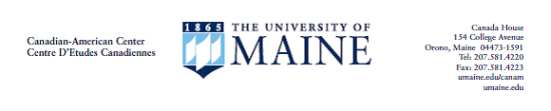

Foreign Language and Area Studies Fellowship (FLAS)
Language Instructor Recommendation
Applicant: Complete the top portion of this form, save as a Word .docx and send it by email to your language instructor.

Fellowship for which you are using this recommendation ___ Summer ___ Academic Year
Applicant Name | (Last name, First name, Middle initial) |  |  | UMaine ID #
Recommender’s name
Recommender’s title
Recommender’s Department
Applicant Signature |  |  | (Type your full legal name) Date:

Language Instructor: The student whose name appears above is applying for a Foreign Language and Area Studies (FLAS) Fellowship for this Summer or next Academic Year. These fellowships, awarded in a campus-wide merit-based competition, provide tuition and stipend for students studying French (or the less-commonly taught Canadian First Nations languages, or Michif, or Inuktitut) in a combination with Canadian Studies or international aspects of professional studies. To help the selection committee in assessing the student’s candidacy, please complete the following:
If this evaluation is not based primarily on courses taught to the applicant, please indicate how your evaluation was determined (proficiency test, daily contact, etc.)

Please provide the following information on language courses you have taught to the applicant.
Course Title/Language Level | # Weeks in course/ Contact hours per week | Textbook or Teaching Materials

Please rate the applicant on the following language skills in comparison with others whom you have known at similar stages in their careers by marking X in appropriate area.
 |  | Poor | Fair | Good | Excellent | Fluent
Speaking and Listening
 | Listening Comprehension
 | Fluency of Self Expression
 | Vocabulary Control
 | Pronunciation
Reading
 | Grasp of Grammar
 | Knowledge of Vocabulary
 | Reading Speed
Writing
 | Vocabulary Control
 | Control of Sentence Structure

Please indicate any special linguistics strengths or weaknesses.

Please write a statement evaluating the applicant’s strengths and weaknesses, taking into account his/her seriousness of purpose, potential for high academic achievement, as well as the significance of French language and area studies on his/her training and career goals. You may add your text below or prepare the statement in a separate document.
(Please save this document as a Word .docx and email as an attachment or print and fax to the Canadian-American Center, address at top of this form. If your statement is a separate document, please forward it and this form together. The application deadline is February 15th.)

