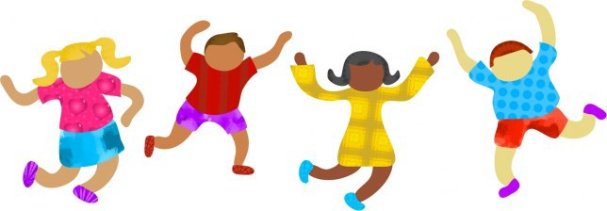
Adaptive Sports and
Recreational Opportunities in Maine

“In my 20 years as a family physician, I have observed the importance of maintaining a physically active lifestyle. Currently, the Centers for Disease Control and Prevention (CDC) recommendations for healthy living include one hour of physical activity each day. The State of Maine is a vast recreational region filled with opportunities to be physically active. We are fortunate to have numerous organizations offering adaptive services to those requiring accommodation so that everyone can be healthy and fit.” Daniel C. Gott, D.O.

Listings
Adaptive Outdoor Education Center (Carrabassett Valley, Maine)
https://www.adaptiveou tdooreducati onc enter.org/ Phone: 207-237-2676 Email: infoAOEC@gmail.com AOEC offers persons with disabilities opportunities to experience adaptive outdoor recreation and education opportunities with adaptive equipment and support. Activities include skiing, snowshoeing, climbing, hiking, fishing, biking, sailing, arts and crafts, and more! AOEC strives to teach recreational skills that will give participants self-confidence, self-motivation, increased physical strength, and an improved self-image and the ability to keep active with family and friends throughout their lives. AOEC also offers hostel style accessible hostel
-style accommodations at reasonable rates for participating families.
Bambino Buddy Baseball (Eastern Maine/Old Town)
https://www.thecou rageou ss teps projec t.org/ https://www.eas ternm ainebas eball.c om /
This program is a collaboration of The Courageous Steps Project and the Eastern Maine Baseball League and is a fun opportunity for children and young adults with various disabilities to learn skills and play baseball. Cost is $10 per person to participate, but scholarships are available.

Horseback Riding
Many local riding centers offer horseback riding lesson options for persons with disabilities. Cost is typically $40/ hour and sometimes includes opportunities to compete in adaptive riding events. Contact your local riding schools for options or the Special Olympics Maine for a list of participating farms in your area.
Maine Adaptive (Newry, Maine) https://www.mai neadaptive.org/
Phone: (207) 824-2440/(800) 639-7770 Toll free Email: i nfo@m ai neadaptive.o rg
Maine Adaptive Sports & Recreation promotes year-round education and training for individuals with disabilities in order to develop skills, enhance independence, and provide enjoyment through active recreation. They offer a wide variety of sporting options for both summer and winter recreation, including biking, rock climbing, paddling, tennis, golf, snowshoeing, skiing and snowboarding. Lessons and equipment are provided at no cost to participants. Locations for recreation vary, so check out their website or call Maine Adaptive for more information.

*Be sure to check with your health care providers regarding concerns related to engaging in adaptive sports and recreation.

To learn more about the Maine Autism Institute for Education and Research, visit our website
https://umain e. edu/au tismins titute/ or contact us at 207-581-2352 or maineautisminstitute@maine.edu

Special Olympics: h t t p s : / / w w w . s o m a i n e . o r g / Phone: (207) 879-0489
Their mission is to provide year-round sports training and athletic competition in a variety of Olympic-type sports for children and adults with intellectual disabilities, providing continuing opportunities to develop physical fitness, demonstrate courage, experience joy and participate in a sharing of gifts, skills and friendship with their families, other Special Olympics athletes, and the community. Maine Special Olympics serves over 4400 athletes and offers 70+ events year round at the local, state, national and international levels. To find the Special Olympics program near you, call (207) 879-0489 or check their webpage: https ://www.s om ai ne.o rg/
who-we-are/fi nd-s pec i al-olympi cs-near-you /

Special Surfers (Kennebunk, Maine) : http://www.s pec i alsurfe r.org/ Email: info@specialsurfer.org Special Surfers is a non-profit organization that provides the opportunity for people of all ages and abilities to experience surfing. There is no cost to participants or their families, all equipment and instruction is provided, and no experience is necessary. Special Surfer events are held on the third Tuesday of each month in June, July, and August at Gooch’s Beach in Kennebunk, Maine. These events are attended by hundreds of special surfers and volunteers, providing a real sense of community and accomplishment for all. A Maine parent describes Special Surfers as an “Amazing event and well worth the drive!”

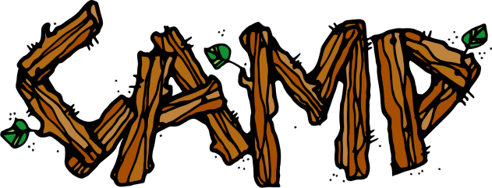Summer Camps: The Autism Society of Maine (ASM) maintains an up-to- date listing of summer camp and recreational programs for children, teens and adults on the autism spectrum. Contact the ASM or check out their webpages for more information on summer camps in Maine, including ASM’s own Camp Summit in Farmington and Finding the Pieces Summer Camp in Biddeford https ://www.as monli ne.org/News /107/Arti c le/6683/
ASM Phone: 1-800-273-5200 Email: info@asmonline.org

Maine YMCAs (see your local YMCA listings)
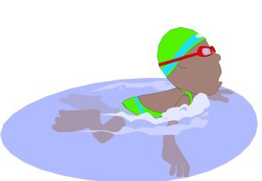The YMCA mission includes a commitment to inclusion. They work to ensure that everyone, regardless of ability, age, cultural background, ethnicity, faith, gender, gender identity, ideology, income, national origin, race or sexual orientation has the opportunity to reach their full potential with dignity. Programs vary across Maine YMCAs, so contact your local YMCA to explore appropriate opportunities and accommodations.

Note: These listings are just a start. Talk with others in your community and check out the Maine Autism Institute for Education and Research “Places and Spaces” webpages ( https://umaine.edu/auti sminsti tute/maine-
famil y-partnership/pl aces-and -spaces/ for more options.

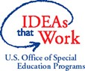The Maine Autism Institute for Education and Research receives significant support and funding from the Maine Department of Education, Office of Special Services.

