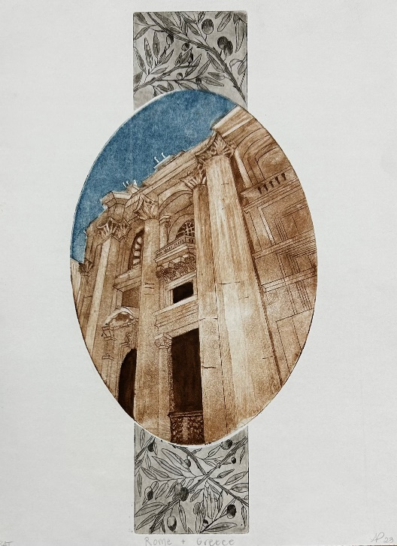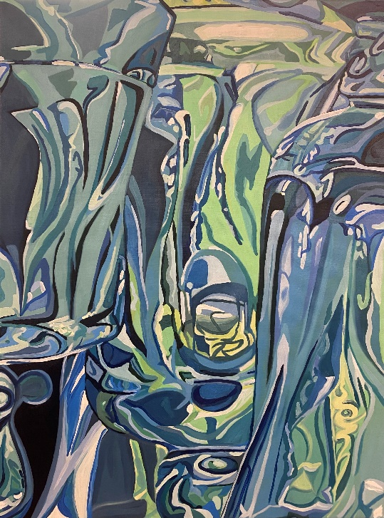

Personal Threshold: 2023 Senior Exhibition
For Immediate Release

Lord Hall Gallery proudly presents Personal Threshold: 2023 Senior Art Exhibition. The exhibition runs from November 10, 2023 - January 19, 2024. An opening reception with food and refreshments will be held on Friday November 10th from 5-7pm.

This exhibition is as a culmination of their studies in the Department of Art at UMaine. Participating students include: Kayla Sickler (Milford, NH), Declan Riordan (Bangor, ME), Nicole Sheehan (Newbury, MA), Mariette Waterhouse (Acton, ME), Kae Northway (Baltimore, MD), Freya Drew (Vernon, NJ), Alyssa Paquin (Waterboro, ME), Brooke Soctomah (Waddell, AZ), Cassidy Climo (Bradley, ME), Zoey DeAngelis (Waterboro, ME), Charlie Marks (Orono, ME), Haley Rodriguez (New Bedford, MA), Will Brewster (Portland, ME), and Nella Maynard (Lincoln, ME).

Students participated in all aspects of the exhibition including creating artwork, promoting the exhibition, coordinating the reception, community outreach, installation/de-installation, lighting, labeling, curating, and more.

All events are free, accessible and open to the public. Please join us in celebrating the work of these UMaine Art students! Lord Hall Gallery is open Monday-Friday from 9am-4pm. Contact: Diana Baumbach, diana.baumbach@maine.edu
